22AIE449 – Introduction to Digital Manufacturing
Project Report
Explainable and Uncertainty-Aware Machine Learning for LPBF Ti-6Al-4V:
Predicting Porosity and Mechanical Properties from Process–Structure–Property Features
Team: G. Subhash Guptha (23015), R. Gautam (23022), K. Mithul (23025), S.V. Sai Sashank (23043)
Submitted to: Dr. Sathies T

Abstract
We use the open process–structure–property (PSP) dataset of Luo et al. [1, 2] for laser powder bed fusion (LPBF) Ti-6Al-4V to test how far machine learning can go on a small engineering dataset: 42 laser power–scan speed combinations, 35 of which have X-ray computed tomography (XCT) pore data. Six regression models (Ridge, SVR, random forest, XGBoost, Gaussian process and a small PyTorch neural network) were compared on five targets and three nested feature groups. Every score was computed out-of-fold with cross-validation grouped by laser power, so the test fold always contains power levels the model has not seen. Strength and ductility were predictable from the two machine settings alone (best grouped R² = 0.65 for UTS, 0.71 for yield strength and 0.81 for elongation). Adding the measured pore and grain descriptors changed the two strength scores by at most 0.03 and lowered the elongation score. XCT porosity itself could not be predicted from the process inputs (best R² = -0.06), and microhardness did not vary between conditions by more than its own measurement scatter. Measured porosity is nevertheless strongly tied to strength and ductility (Spearman ρ = -0.78 with UTS and -0.78 with elongation) and is the largest SHAP contributor in the tree model. Gaussian-process 95 % intervals covered 90 % of held-out conditions, and a cross-conformal wrapper reached its nominal coverage at the price of wide intervals. A three-objective search restricted to the tested region points to the same moderate-power, high-speed corner where the densest and strongest measured specimens lie. During the work we also found and corrected a swapped yield-strength/UTS column in the printed source table.

1. Introduction
In LPBF a laser melts thin layers of metal powder track by track. The choice of laser power P and scan speed v decides how much energy each track receives. Too little energy leaves unmelted gaps between tracks (lack-of-fusion pores), too much can create vapour-depression (keyhole) pores, and long, fast melt pools can break up into beads [1, 3]. These pores, together with the grain structure, then influence strength and especially ductility. Mapping this chain experimentally is slow because every point requires a build, CT scans and mechanical tests.
Machine learning is an obvious way to interpolate between experiments, but with datasets of only a few dozen conditions three practical questions come up, and they define this project:
- Validation: how should the data be split so that the reported score reflects performance on process settings that were not part of training?
- Value of characterisation: how much does knowing the pore and grain structure add over knowing only P and v?
- Trust: can each prediction be given an honest uncertainty, and can queries outside the tested region be flagged?

2. Dataset

2.1 Source
All data come from Luo, Yin, Simpson and Beese [1, 2]; the summary tables are published in Data in Brief [1] and the files are on Zenodo (record 6587905) [4]. The specimens were built on a 3D Systems ProX DMP 320 machine with hatch spacing 82 µm and layer thickness 60 µm kept fixed. Interior laser power ranged from 75 to 500 W and scan speed from 400 to 1600 mm/s. All parts were stress-relieved at 670 °C for 5 h and furnace-cooled in argon before testing [1].
The measurements reported per condition, and used here, are:
- porosity by XCT (10 µm voxels) and by the Archimedes method, pore counts by size class, mean pore equivalent diameter, sphericity and projected area on the plane normal to the load;
- surface roughness (Ra and RMS) and prior-β grain equivalent diameter and aspect ratio;
- yield strength, ultimate tensile strength (UTS), elongation to necking and to fracture, and elastic modulus from four tensile tests (two flat, two round) per condition, plus Vickers microhardness (10 indents, 100 gf).
XCT data, and therefore all pore and roughness features, exist for 35 conditions; sets 19, 22, 23, 24, 25, 26, 27 have process, grain and mechanical data only. These gaps were not imputed. Models that use structure features are trained on the 35 complete conditions; the uncertainty study and the optimisation surrogates for strength and elongation use all 42.
The per-pore files from Zenodo were also summarised (35 files, 496,480 pore records). These do not match the published pore counts (Table 4 of [1] sums to 1,273,500), so the per-pore summary is used only for the descriptive plots in Figure 5 and not as model input.

2.2 Corrections and checks made on the data
- Yield strength and UTS columns. In the printed Table 8 of [1] the first strength column is headed "yield strength", but for every condition its values are larger than those in the "UTS" column, which is physically impossible. The Zenodo feature table and the per-specimen mechanical file label the larger values as UTS (set 1: UTS 1020.8 MPa, yield 942.3 MPa). We therefore use the Zenodo labelling. An earlier version of this project had copied the printed headers, so all its "UTS" results were really yield-strength results and vice versa.
- Energy-input labels. Each condition carries a label (low energy input, intermediate, high energy / high Pv) from simple thresholds on LED, P and Pv. This is our own rule for colouring plots, not a measured defect type, and measured porosity does not follow it: the "low energy input" bin contains porosities from 0.0097 % to 2.9905 %, including the densest specimens of the whole study.
- Surface roughness origin. The Zenodo table states that roughness was extracted from the XCT data.

3. Process descriptors and feature groups
Besides P and v, the descriptors used in [1] were recomputed from them, together with the usual volumetric energy density:
- linear energy density LED = P/v (J/m);
- volumetric energy density VED = P/(v·h·t) (J/mm³), with h = 0.082 mm and t = 0.060 mm;
- modified energy density MED = P/√v, which follows from a heat-conduction argument in which melt depth scales with 1/√v [1, 5];
- Pv, to which [1] relates the squared length-to-width ratio of the melt pool and uses as an indicator of beading-up.
All four are fixed functions of P and v. They add no new information about the specimen, but they give the models physically meaningful coordinates. Three nested feature groups were compared:
- Group 1: Process-Only (6 features): P, v, LED, MED, Pv, VED.
- Group 2: Process + Defects (11): adds XCT porosity, pore count, mean pore diameter, mean sphericity and mean projected area.
- Group 3: Full PSP (15): adds Ra, RMS roughness, prior-β grain diameter and aspect ratio.
XCT porosity is predicted only from Group 1. Using Group 2 or 3 for that target would feed the model other measurements from the same CT scan, which is a form of target leakage. Figure 1 summarises the workflow.
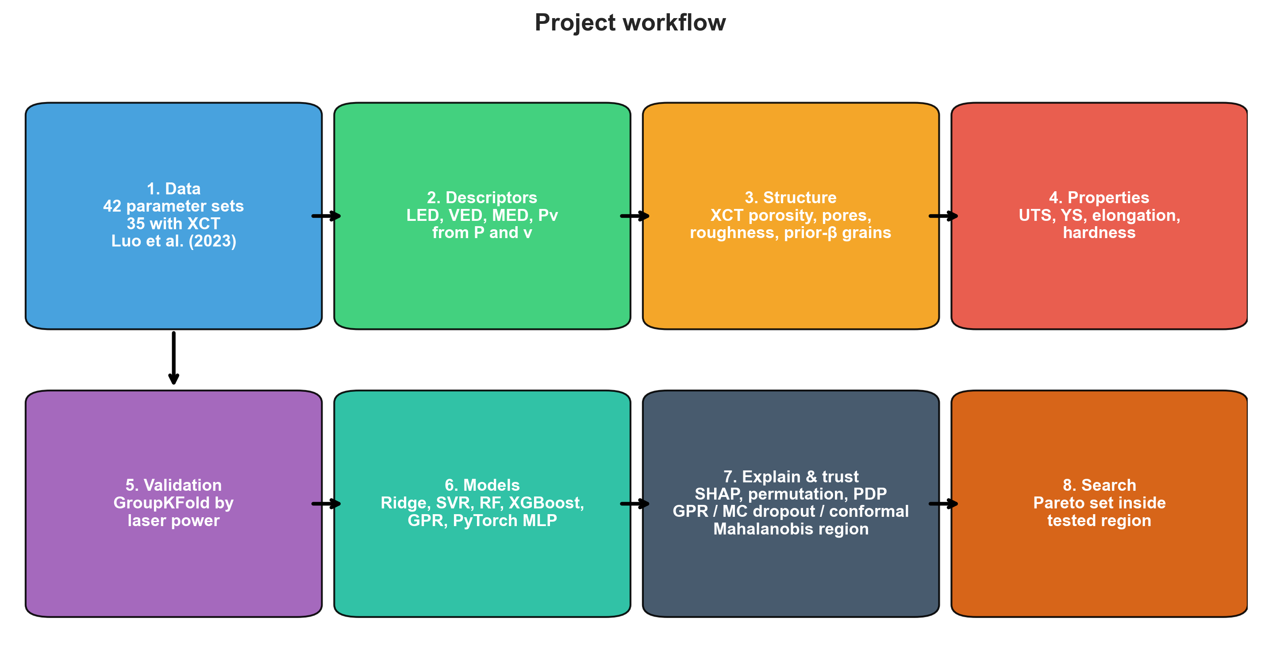
Figure 1: Project workflow.

4. Exploratory analysis
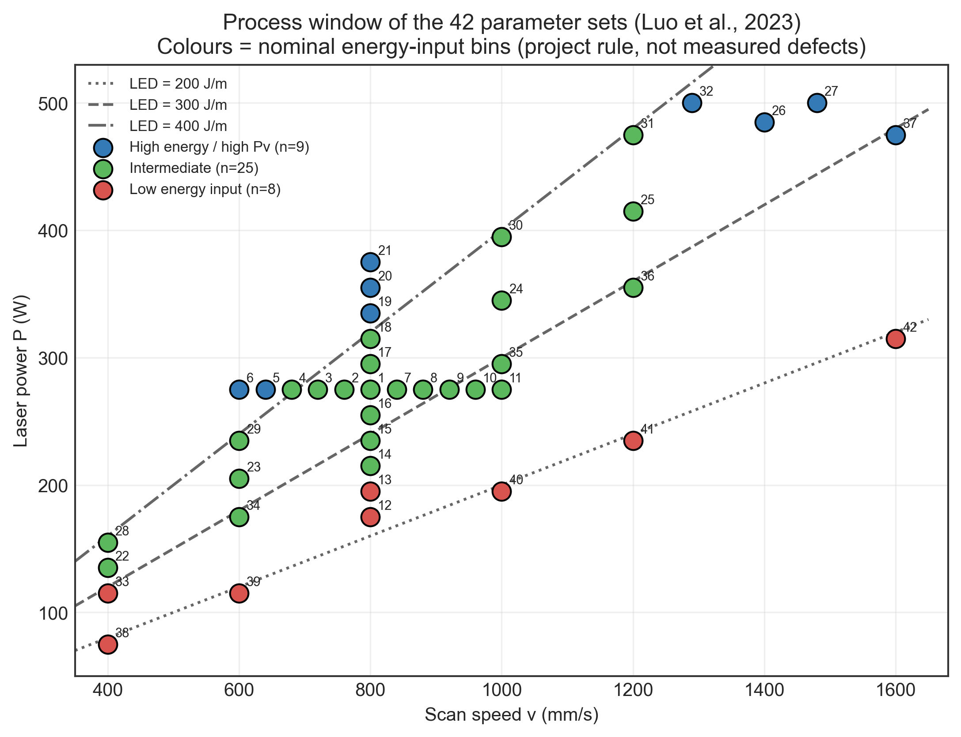
Figure 2: The 42 parameter sets in (v, P) space with LED iso-lines. Colours are the nominal energy-input bins described in Section 2.2.
Figure 3 shows the measured responses. The lowest porosities are found at high speed and moderate power: set 42 (315 W, 1600 mm/s, 0.0097 %) and set 41 (235 W, 1200 mm/s, 0.0132 %), both at LED ≈ 196 J/m, near the low end of the tested range. Set 41 also has the highest UTS (1113 MPa) and elongation (15.38 %) in the dataset. The highest porosities occur at the lowest power (75 W) and at the highest Pv (475 W, 1600 mm/s).
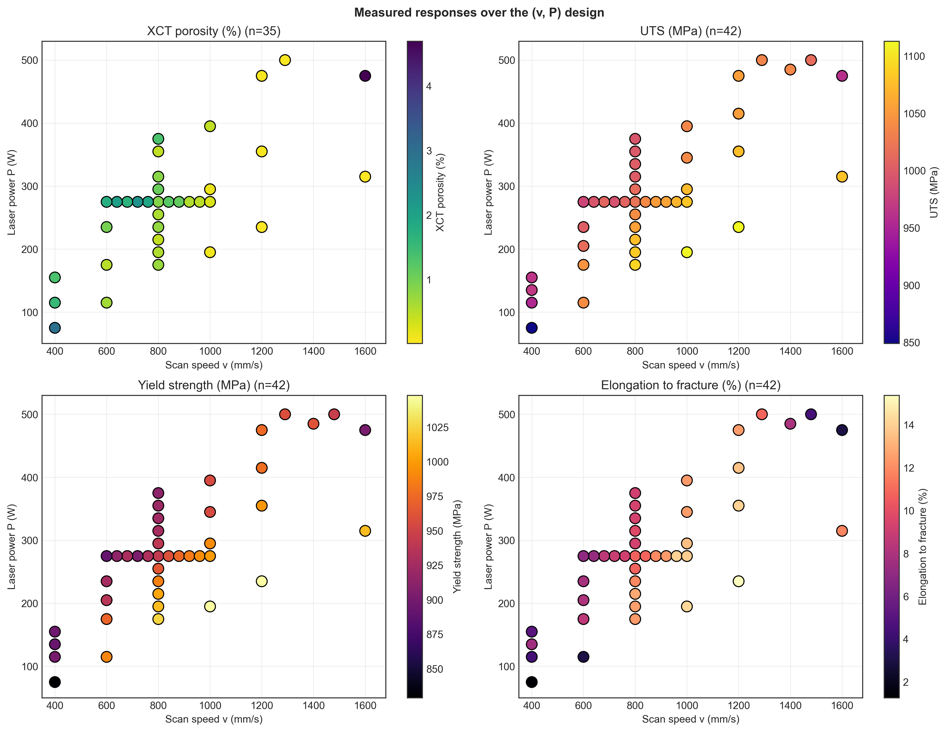
Figure 3: Measured XCT porosity, UTS, yield strength and elongation to fracture over the process window.
Four relationships were checked against the data (Figure 4):
- Porosity and strength. An exponential fit UTS = σ₀·exp(−b·p/100) gives σ₀ = 1073 MPa and b = 4.18 with R² = 0.57. The trend is clear, but porosity alone does not explain a large part of the scatter.
- Porosity and ductility. Elongation falls steadily with porosity (Spearman ρ = -0.78). Below 0.2 % porosity it ranges from 10.81 to 15.38 %; above 2 % it ranges from 1.26 to 8.98 %. The drop is strong, but it is not a sharp cliff at one porosity value.
- Grain size and yield strength. A Hall-Petch style fit of yield strength against d^(−1/2) of the prior-β grains gives a slightly negative slope (r = -0.26, p = 0.09), so finer prior-β grains give no significant strengthening in this dataset. Strength in Ti-6Al-4V is generally linked to the finer α/α′ structure inside the prior-β grains, which was not measured here.
- Archimedes vs XCT. Archimedes porosity is higher than XCT porosity in 30 of 35 conditions, while the two rank the conditions similarly (ρ = 0.85). One possible reason is that XCT reliably detects only pores larger than about 30 µm (three voxels) [1].
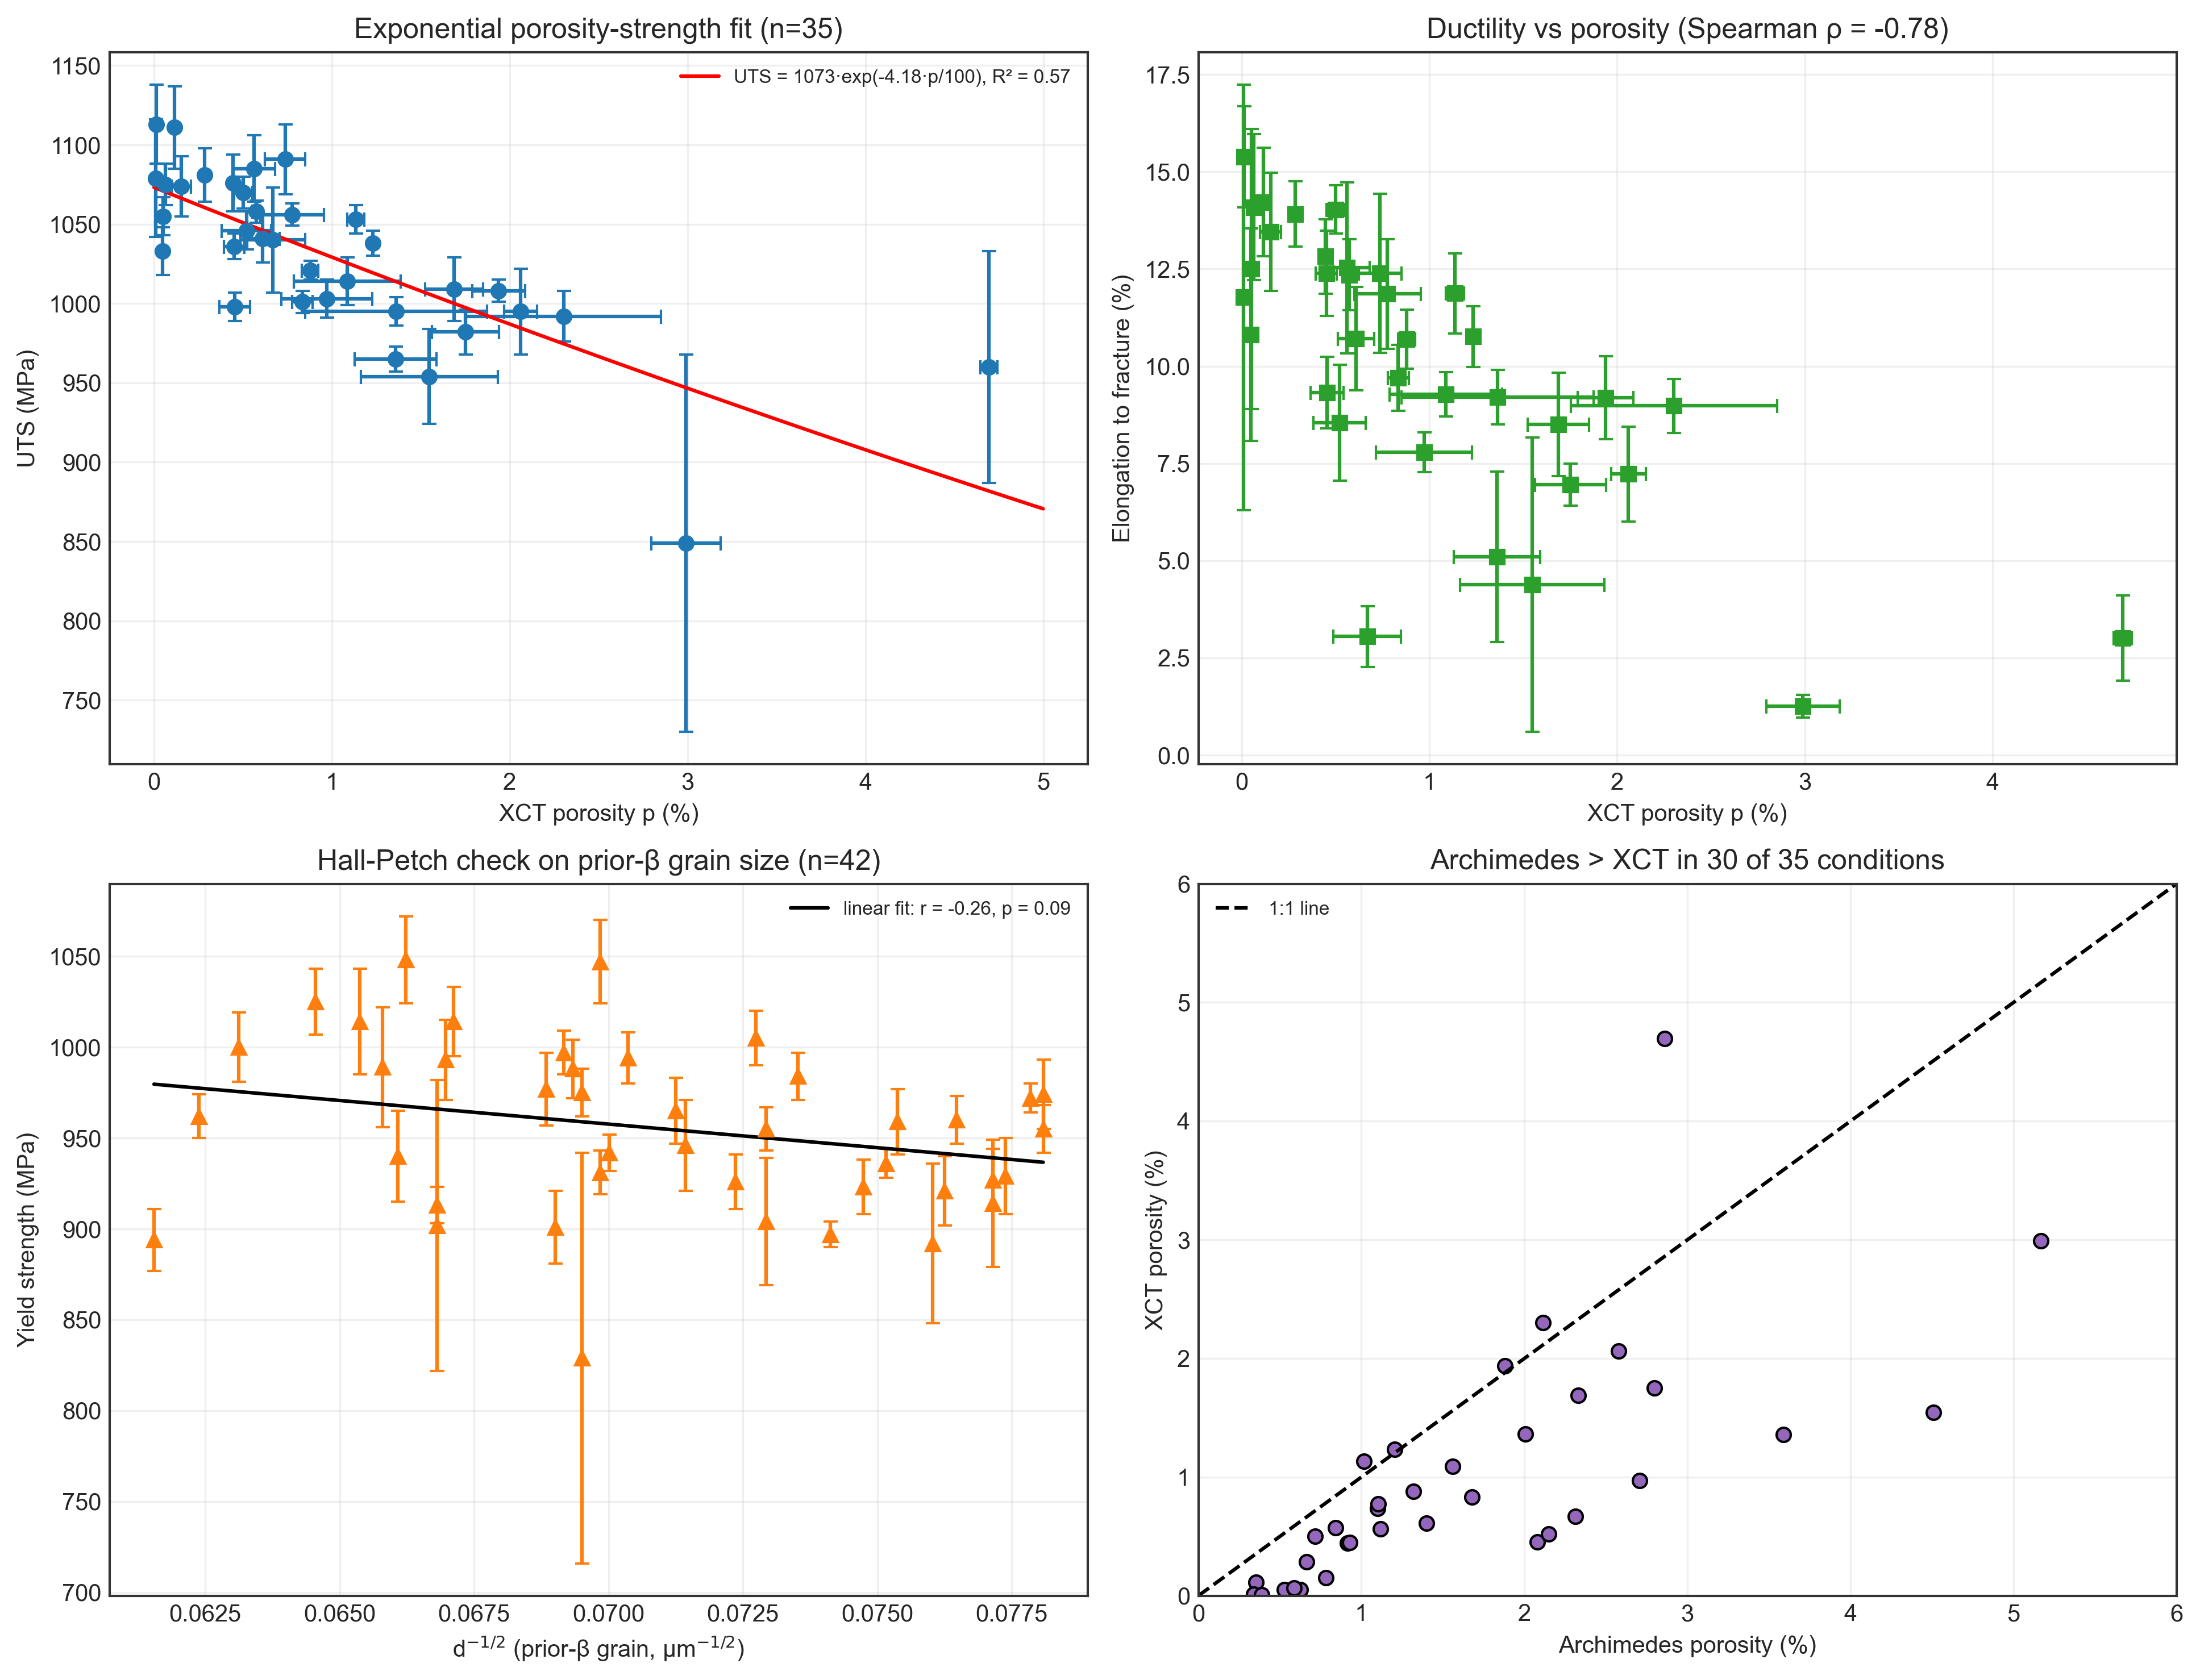
Figure 4: Porosity–UTS fit, porosity–elongation scatter, Hall-Petch check and Archimedes vs XCT porosity.
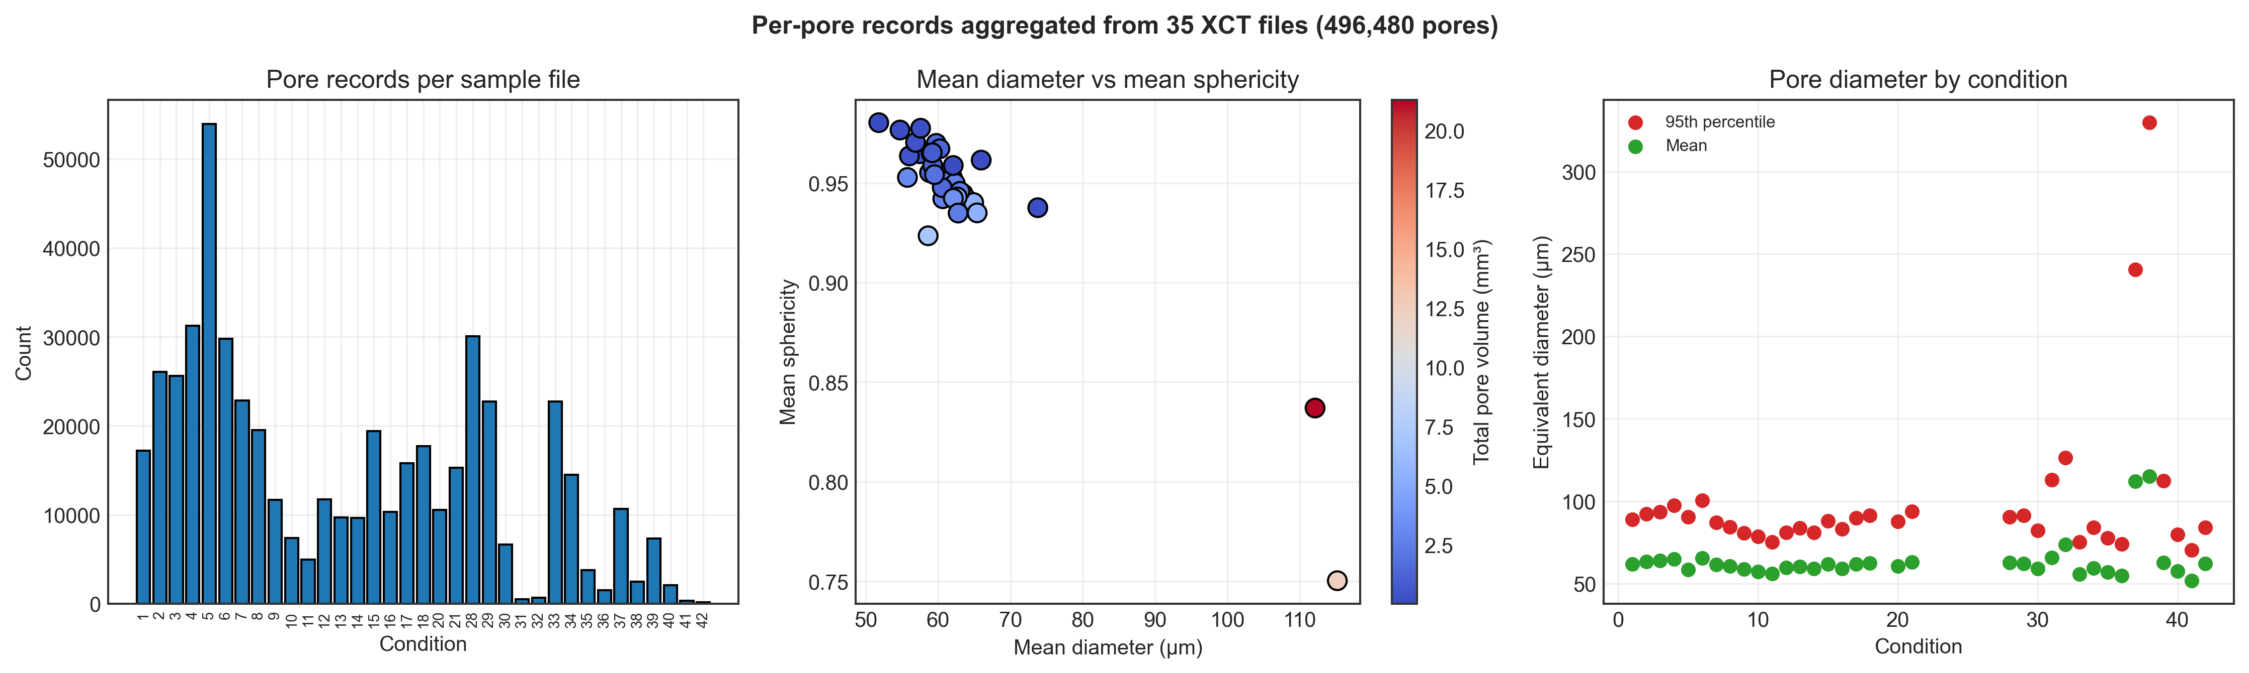
Figure 5: Summary of the per-pore XCT files: records per file, mean diameter vs sphericity, and mean / 95th-percentile diameter per condition.
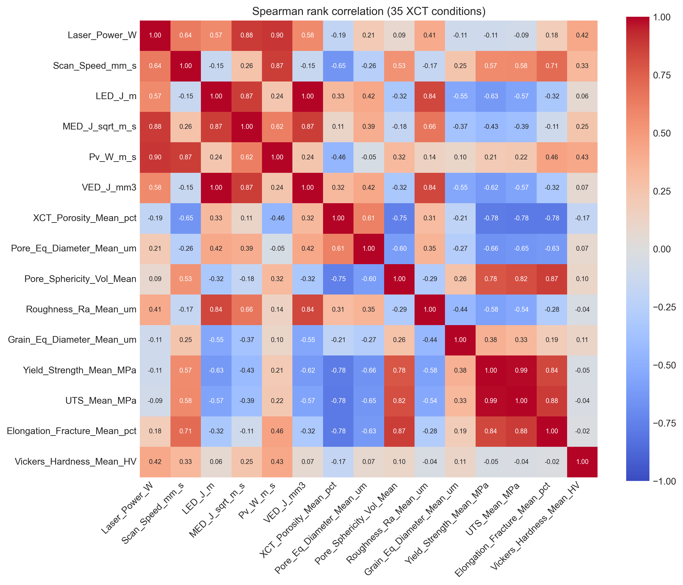
Figure 6: Spearman rank correlations between process, structure and property features (35 XCT conditions).

5. Validation design
Each row of the dataset is the mean of one processing condition, so no repeated rows of the same condition can leak between folds. The leakage concern from the proposal applies in a weaker form: many conditions share the same laser power (the 275 W series alone has 11 of the 35 XCT conditions), so a random split usually leaves close neighbours of every test point in the training set. To measure performance on unseen power levels we use five-fold GroupKFold with laser power as the group (16 distinct power levels among the 35 XCT conditions). All scores below are pooled out-of-fold R², RMSE and MAE.
Table 1 and Figure 7 compare this grouped split with ordinary random 5-fold CV (averaged over 10 random seeds) for the same models. For UTS, random CV scored higher than grouped CV for only 1 of 6 models (mean difference -0.06). For porosity it scored higher for 5 of 6 (mean difference 0.08). In this dataset, random splitting therefore did not produce a large, consistent optimism, and the differences are mostly of the same size as the spread between random seeds. We still report grouped scores because they answer the more relevant question for a new build: how well does the model do at a power level it has not seen?
Table 1: Random vs grouped cross-validation, process-only inputs (out-of-fold R²).
Target | Model | Random CV R² (mean) | Random CV R² (sd, 10 seeds) | Grouped CV R²
Ultimate Tensile Strength | Ridge | 0.12 | 0.13 | 0.33
Ultimate Tensile Strength | SVR (RBF) | 0.50 | 0.07 | 0.59
Ultimate Tensile Strength | Random Forest | 0.23 | 0.17 | 0.41
Ultimate Tensile Strength | XGBoost | 0.37 | 0.14 | 0.05
Ultimate Tensile Strength | Gaussian Process | 0.54 | 0.11 | 0.65
Ultimate Tensile Strength | PyTorch MLP | 0.56 | 0.17 | 0.65
XCT Porosity | Ridge | -0.51 | 0.11 | -0.58
XCT Porosity | SVR (RBF) | -0.00 | 0.06 | -0.10
XCT Porosity | Random Forest | -0.10 | 0.10 | -0.20
XCT Porosity | XGBoost | -0.45 | 0.46 | -0.77
XCT Porosity | Gaussian Process | -0.01 | 0.06 | -0.06
XCT Porosity | PyTorch MLP | -0.49 | 0.22 | -0.31

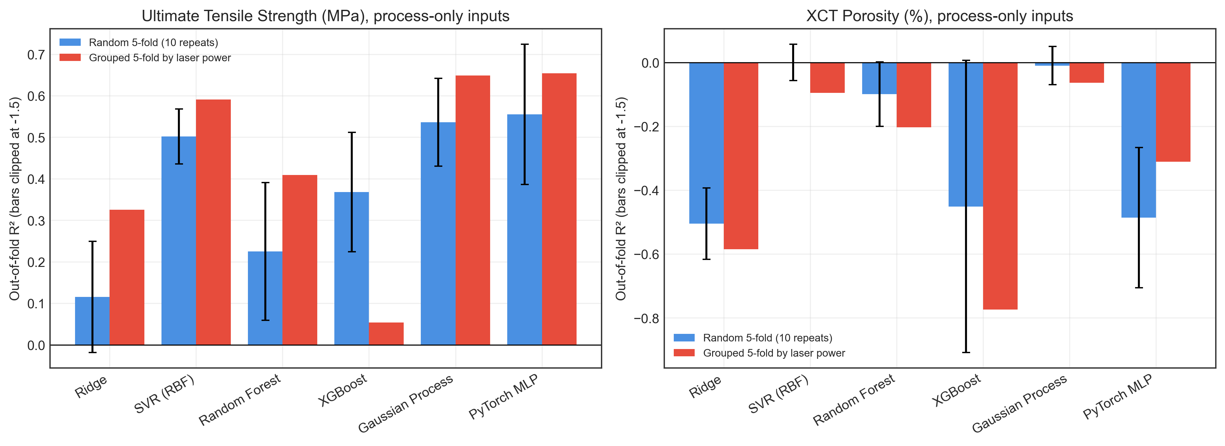
Figure 7: Random 5-fold vs grouped 5-fold CV for UTS and porosity.

6. Model benchmark and feature-group ablation
Models: ridge regression, support-vector regression with an RBF kernel, random forest (300 trees, depth 5), XGBoost (200 trees, depth 3), a Gaussian process with an RBF + white-noise kernel, and a two-hidden-layer PyTorch network (32 and 16 SiLU units, dropout 0.1, AdamW). Inputs, and for all but the tree models the targets, were standardised inside each training fold. Hyper-parameters were fixed in advance rather than tuned, because nested tuning on 35 rows would itself be unstable.
Table 2: Best model per target and feature group (grouped CV, 35 conditions). The last column is the standard deviation of the target, roughly the RMSE of always predicting the mean.
Target | Features | Best model | R² | RMSE | SD of target
XCT Porosity (%) | Group 1 | Gaussian Process | -0.06 | 0.98 | 0.97
Ultimate Tensile Strength (MPa) | Group 1 | PyTorch MLP | 0.65 | 30.43 | 52.52
Ultimate Tensile Strength (MPa) | Group 2 | XGBoost | 0.68 | 29.53 | 52.52
Ultimate Tensile Strength (MPa) | Group 3 | PyTorch MLP | 0.65 | 30.59 | 52.52
Yield Strength (MPa) | Group 1 | PyTorch MLP | 0.71 | 26.01 | 49.00
Yield Strength (MPa) | Group 2 | XGBoost | 0.74 | 24.68 | 49.00
Yield Strength (MPa) | Group 3 | XGBoost | 0.74 | 24.76 | 49.00
Elongation to Fracture (%) | Group 1 | SVR (RBF) | 0.81 | 1.48 | 3.50
Elongation to Fracture (%) | Group 2 | PyTorch MLP | 0.64 | 2.06 | 3.50
Elongation to Fracture (%) | Group 3 | PyTorch MLP | 0.60 | 2.18 | 3.50
Vickers Hardness (HV) | Group 1 | Ridge | 0.09 | 12.26 | 13.01
Vickers Hardness (HV) | Group 2 | Random Forest | 0.10 | 12.17 | 13.01
Vickers Hardness (HV) | Group 3 | Ridge | 0.14 | 11.87 | 13.01

Table 3: All models for UTS (MPa), grouped CV.
Features | Model | R² | RMSE | MAE
Group 1 | Ridge | 0.33 | 42.5 | 26.5
Group 1 | SVR (RBF) | 0.59 | 33.1 | 17.5
Group 1 | Random Forest | 0.41 | 39.8 | 20.4
Group 1 | XGBoost | 0.05 | 50.4 | 26.5
Group 1 | Gaussian Process | 0.65 | 30.7 | 16.5
Group 1 | PyTorch MLP | 0.65 | 30.4 | 15.9
Group 2 | Ridge | 0.65 | 30.5 | 19.6
Group 2 | SVR (RBF) | 0.59 | 33.2 | 16.2
Group 2 | Random Forest | 0.58 | 33.5 | 21.8
Group 2 | XGBoost | 0.68 | 29.5 | 18.4
Group 2 | Gaussian Process | 0.45 | 38.4 | 19.4
Group 2 | PyTorch MLP | 0.63 | 31.4 | 16.7
Group 3 | Ridge | 0.56 | 34.1 | 21.9
Group 3 | SVR (RBF) | 0.51 | 36.4 | 20.2
Group 3 | Random Forest | 0.52 | 36.0 | 23.0
Group 3 | XGBoost | 0.65 | 30.8 | 19.2
Group 3 | Gaussian Process | 0.36 | 41.3 | 24.2
Group 3 | PyTorch MLP | 0.65 | 30.6 | 18.6

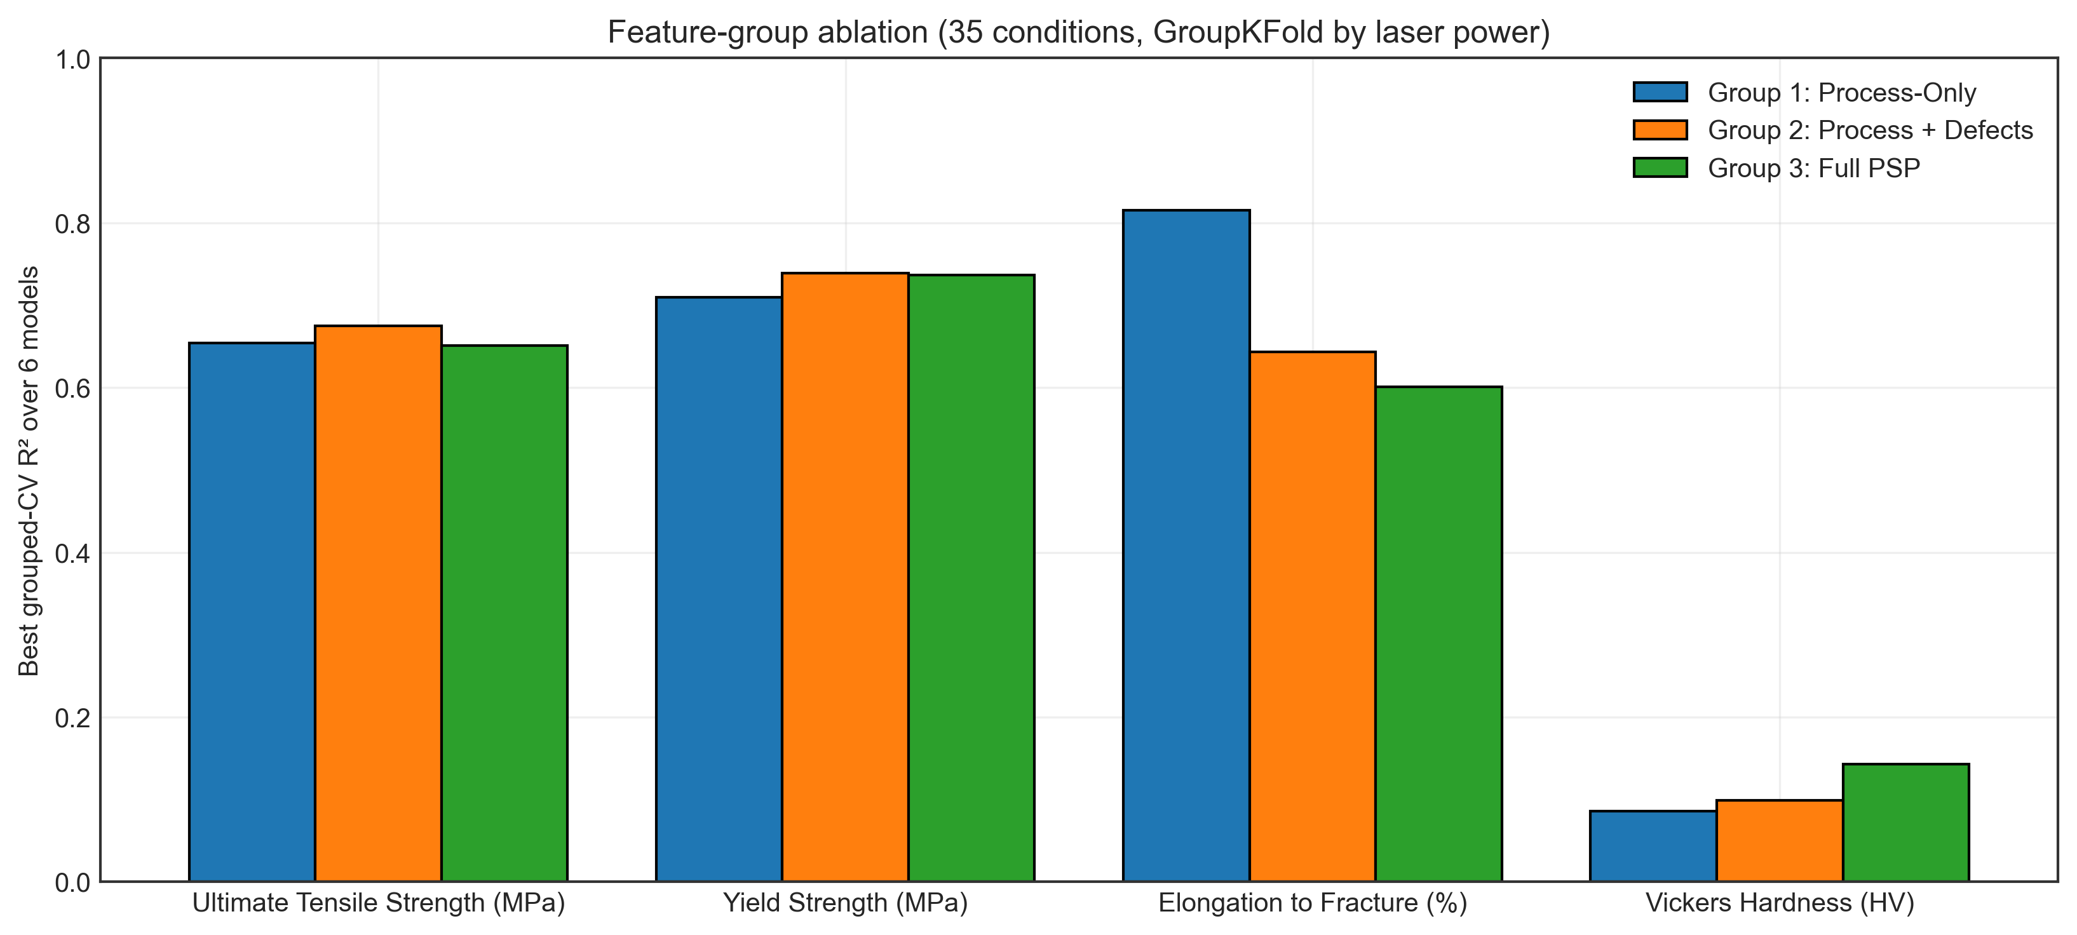
Figure 8: Best grouped-CV R² per feature group for each mechanical target.
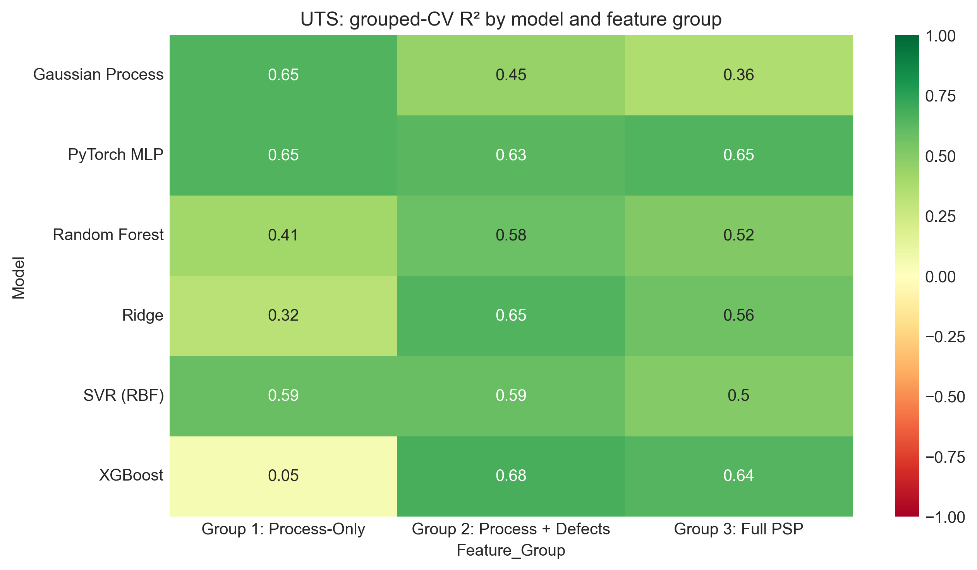
Figure 9: Grouped-CV R² of every model and feature group for UTS.
Main observations:
- Strength and ductility follow from P and v. With only the process inputs, the best models reach R² = 0.65 for UTS (RMSE 30.4 MPa), 0.71 for yield strength and 0.81 for elongation, on power levels that were held out.
- Structure features add little on top. Group 2 gives R² = 0.68 for UTS and 0.74 for yield strength, close to Group 1, and for elongation the larger groups are worse (0.64 and 0.60). With 35 rows, extra columns add variance faster than information, and for these specimens the pore features largely re-encode what P and v already determine.
- Porosity is not predictable from P and v here. Every model has R² ≤ -0.06. Porosity spans more than two orders of magnitude and is dominated by a few extreme conditions, so leaving out a power level often means extrapolating to a porosity unlike anything in training.
- Hardness is not predictable. The best R² is 0.14. The condition means vary with a standard deviation of 12.7 HV, smaller than the average scatter between indents within one condition (19.1 HV), so there is little process signal to learn.
- No single model wins. The neural network, Gaussian process, SVR and XGBoost trade first place between targets, and their differences are mostly smaller than the change from one feature group to another.

7. Explainability
To see which inputs drive the strength predictions, an XGBoost model was fitted to all 35 conditions with the full 15-feature set. It was explained with SHAP (TreeExplainer) [6], permutation importance and partial dependence. These tools describe how this fitted model uses its inputs. They are not causal evidence, and because the model is fitted to all the data they are in-sample.
Table 4: Largest mean |SHAP| contributions to predicted UTS. The last column is the rank correlation between a feature's value and its SHAP value (negative = a higher value lowers predicted UTS).
Feature | Mean |SHAP| (MPa) | Spearman(value, SHAP)
XCT_Porosity_Mean_pct | 21.4 | -0.93
LED_J_m | 9.4 | -0.83
Scan_Speed_mm_s | 7.3 | 0.87
Laser_Power_W | 5.3 | -0.05
Pore_Eq_Diameter_Mean_um | 2.1 | -0.92
Projected_Area_RMS_Mean_um2 | 2.1 | -0.56

XCT porosity is the largest contributor by a wide margin. High porosity lowers predicted UTS by up to 85 MPa and very low porosity raises it by up to 29 MPa. LED comes next, acting in the negative direction (higher LED, lower predicted UTS), consistent with the measured maps in which the strongest specimens sit at low LED and high speed. Permutation importance puts the same features at the top (XCT_Porosity_Mean_pct, Laser_Power_W, LED_J_m, Scan_Speed_mm_s). Porosity dominating the explanation while adding little in the ablation is not a contradiction: within this design porosity is largely set by P and v, so a model given only P and v can learn the same pattern.
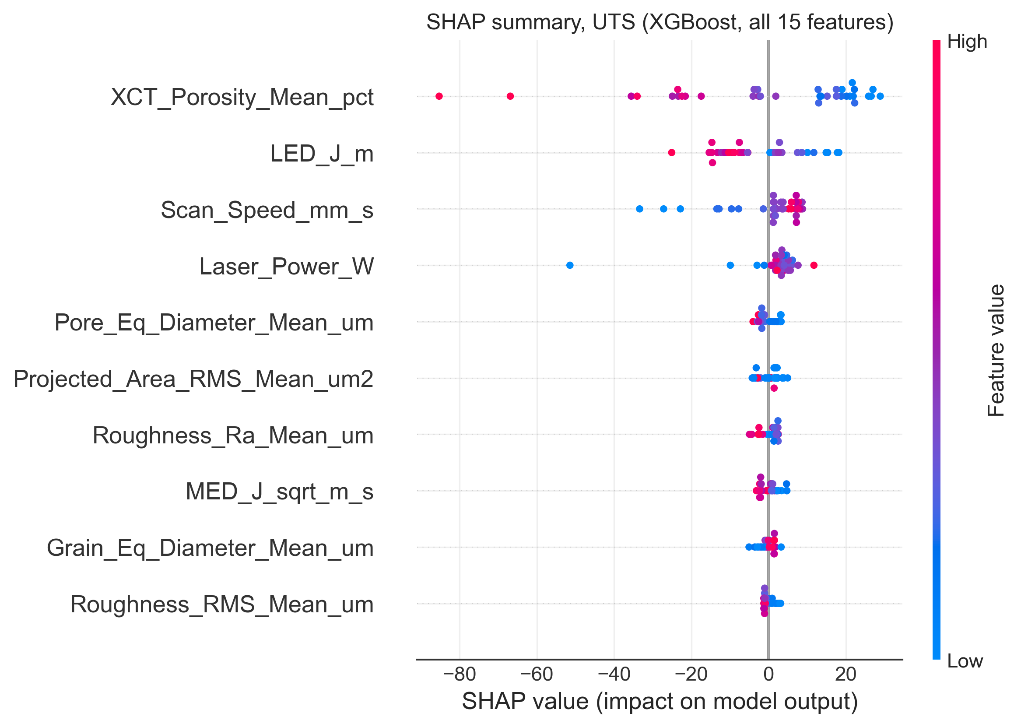
Figure 10: SHAP beeswarm for UTS (XGBoost, 15 features).
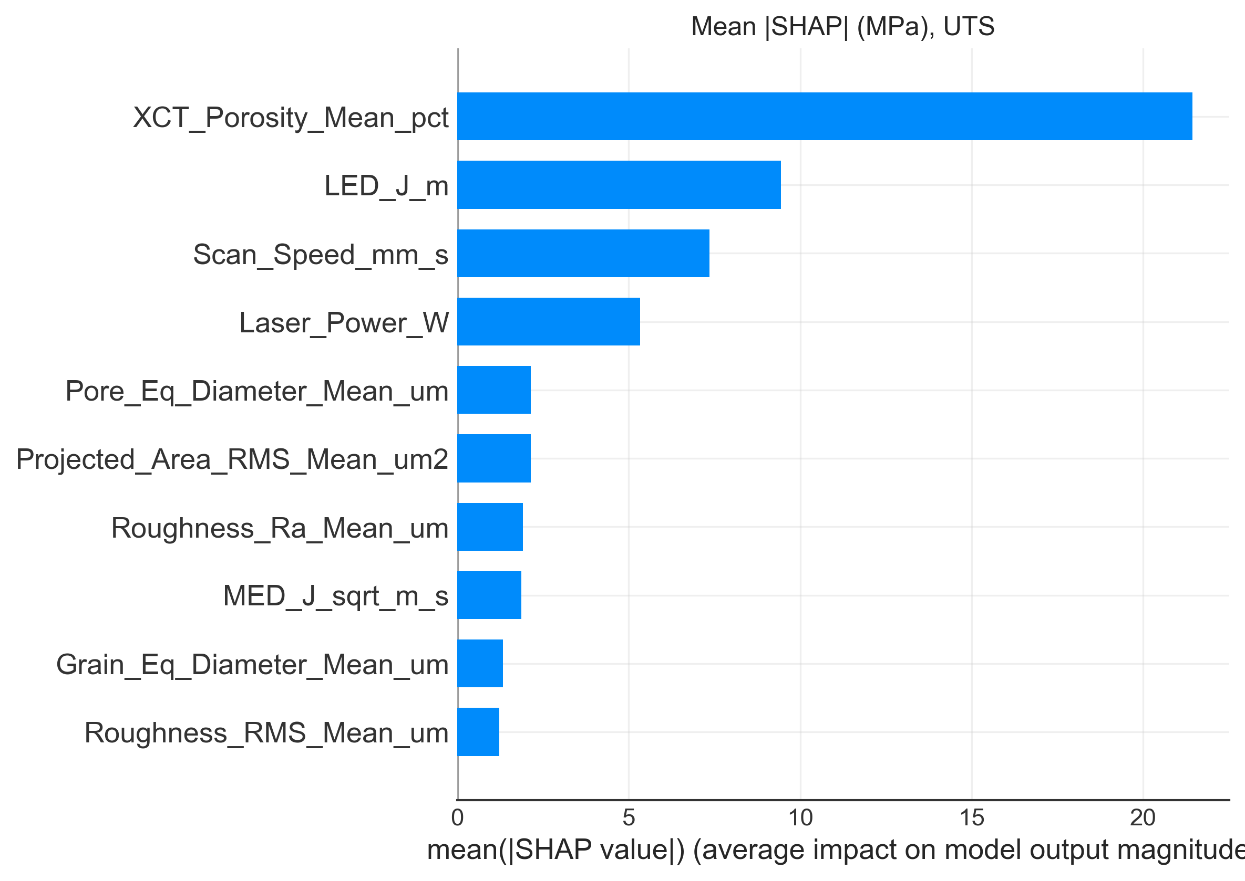
Figure 11: Mean |SHAP| ranking for UTS.
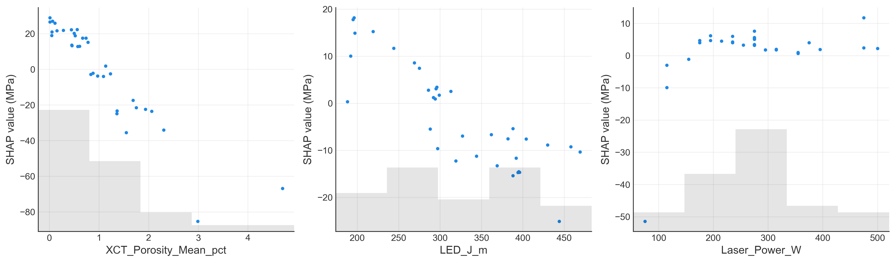
Figure 12: SHAP dependence on XCT porosity, LED and laser power.
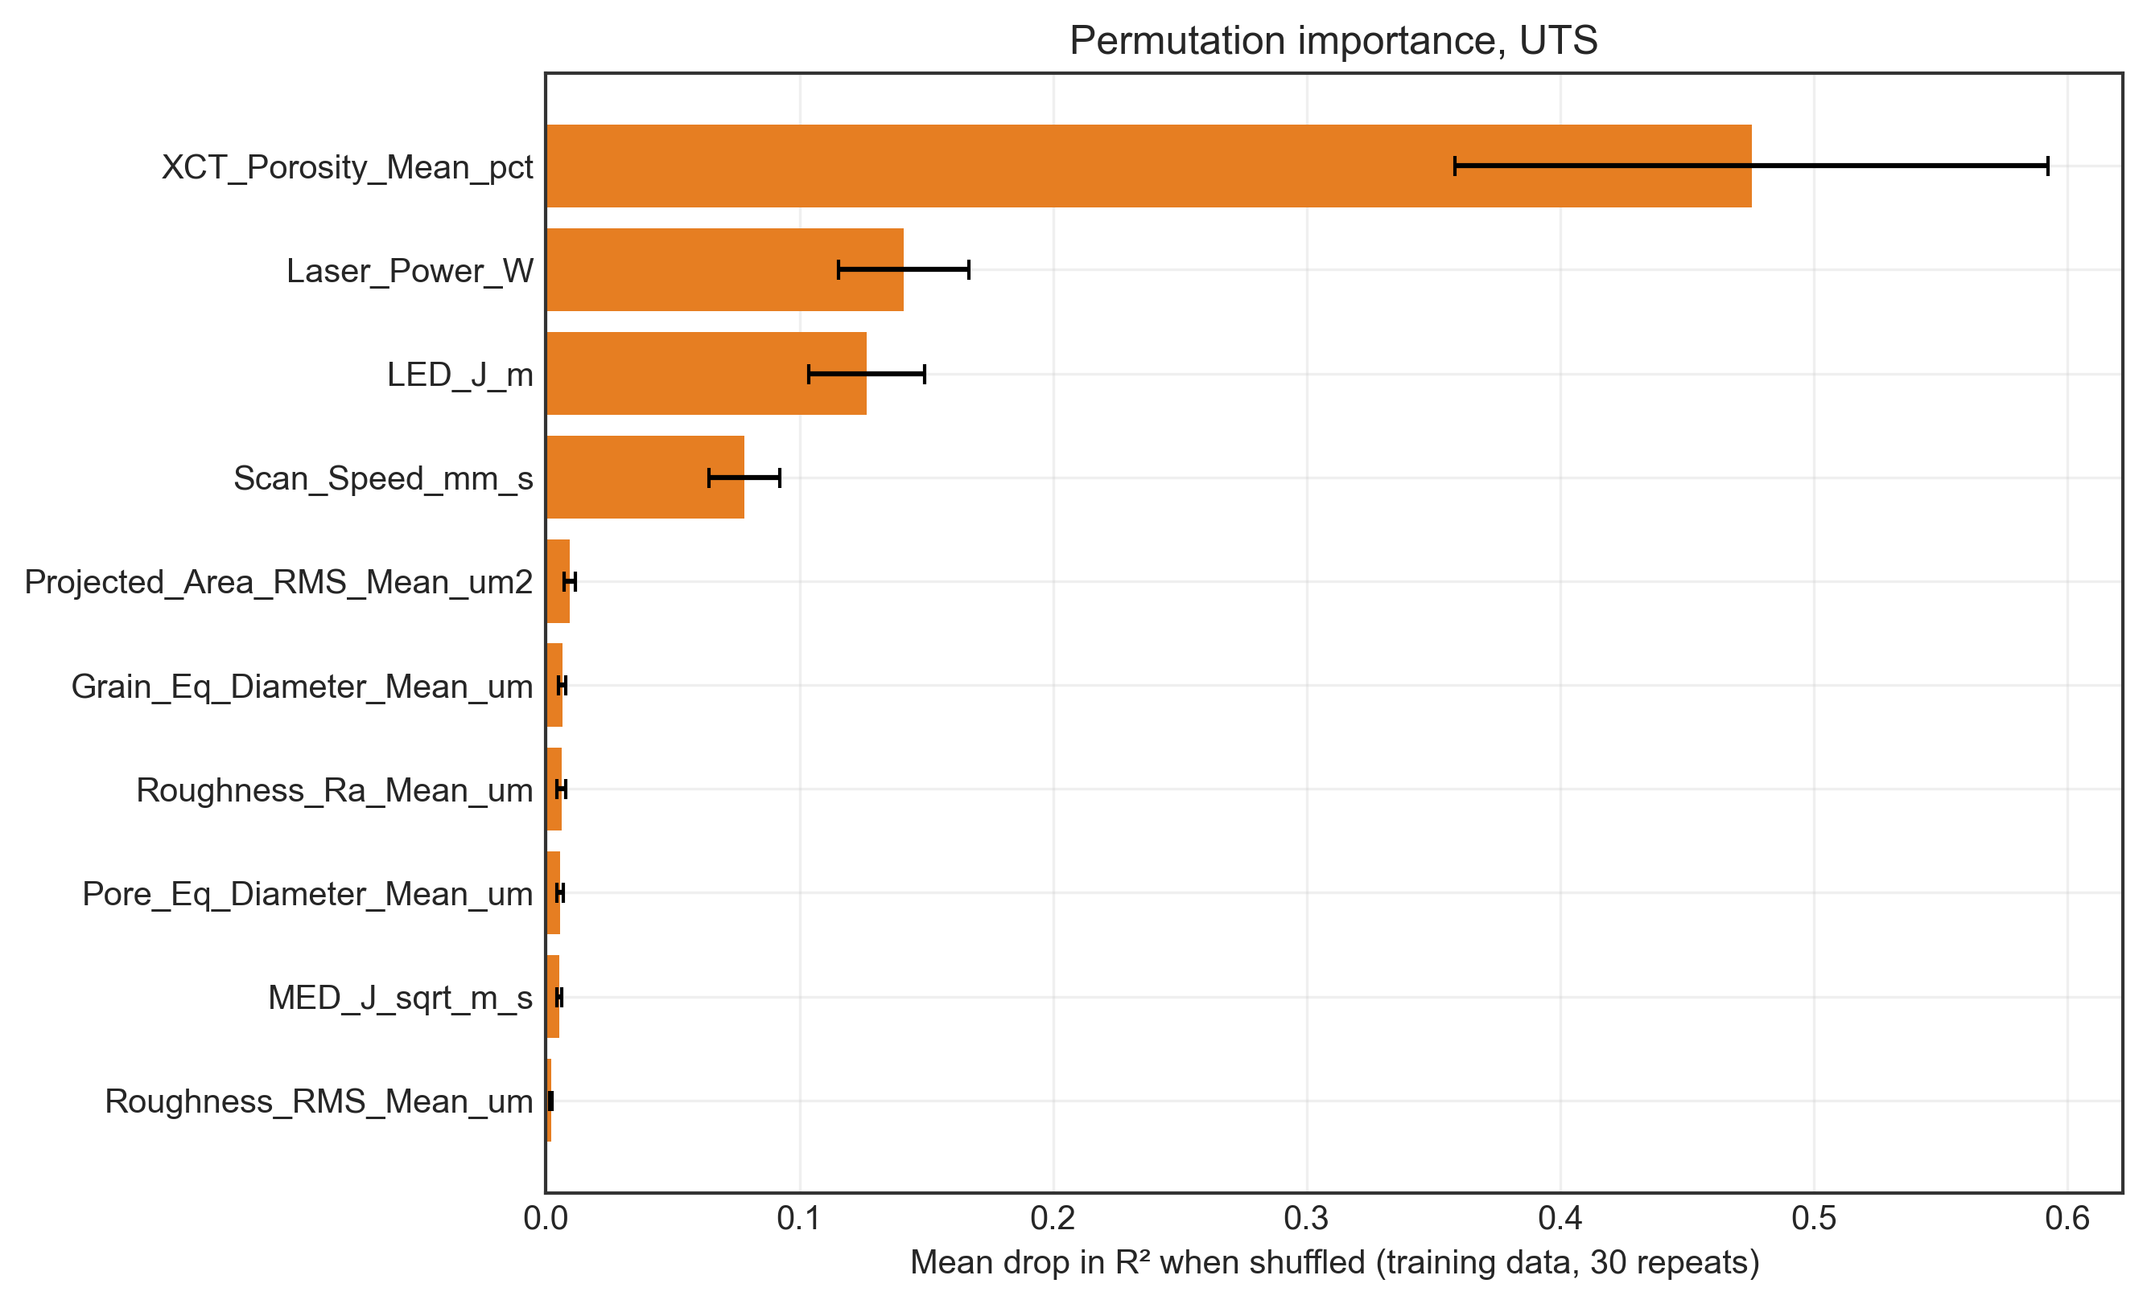
Figure 13: Permutation importance (30 repeats, training data).
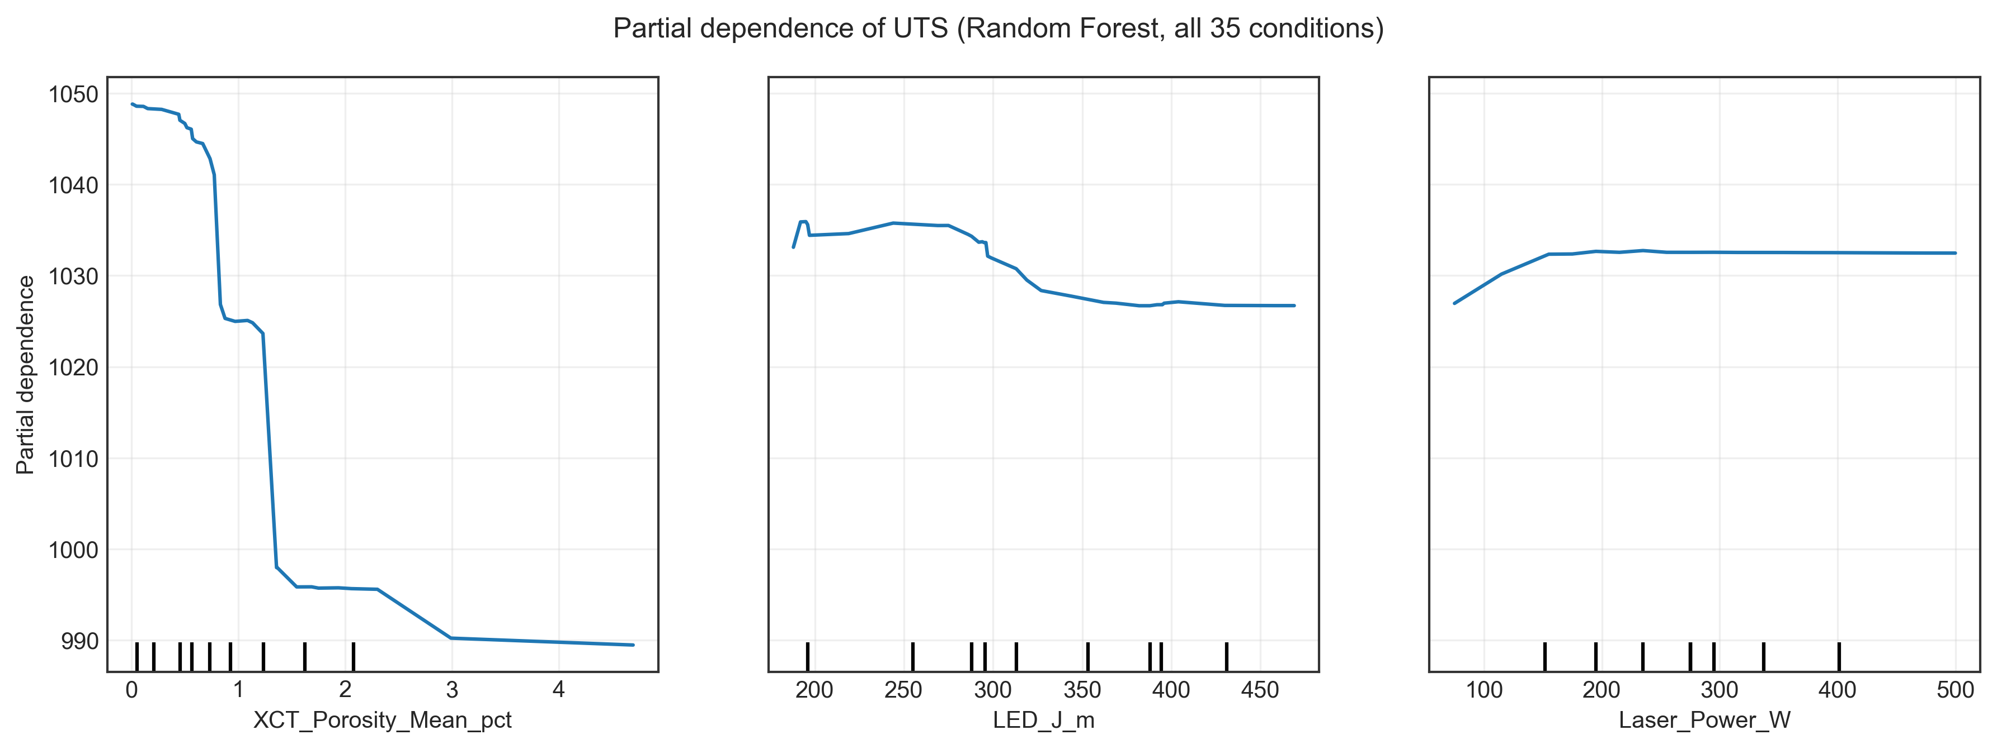
Figure 14: Partial dependence of UTS on porosity, LED and power (random forest).

8. Uncertainty and trust region
Uncertainty was studied for UTS predicted from the process inputs, which is how a new build would be planned. All 42 conditions and the same grouped folds were used, so every interval below is for a condition whose power level was held out.
- Gaussian process. The predictive mean gives R² = 0.67. The ±1.96σ band (mean half-width 27.4 MPa) contains 90 % of the measured values, a little below the nominal 95 %.
- Monte Carlo dropout [7]. The neural network was re-trained with dropout 0.2 and sampled 100 times with dropout active. Its mean gives R² = 0.62, but its band (mean half-width 21.5 MPa) covers only 81 %, so dropout variance alone underestimates the error here.
- Cross-conformal intervals [8]. For each held-out power group, the interval half-width is a quantile of the absolute Gaussian-process residuals of the other groups. Coverage reached 95 % at the 90 % level and 98 % at 95 %. However, the mean interval width grew to 118 and 254 MPa, because a few conditions (above all the 75 W set) have very large errors. The method delivers the coverage it promises, but at high confidence levels the intervals become too wide to be useful.
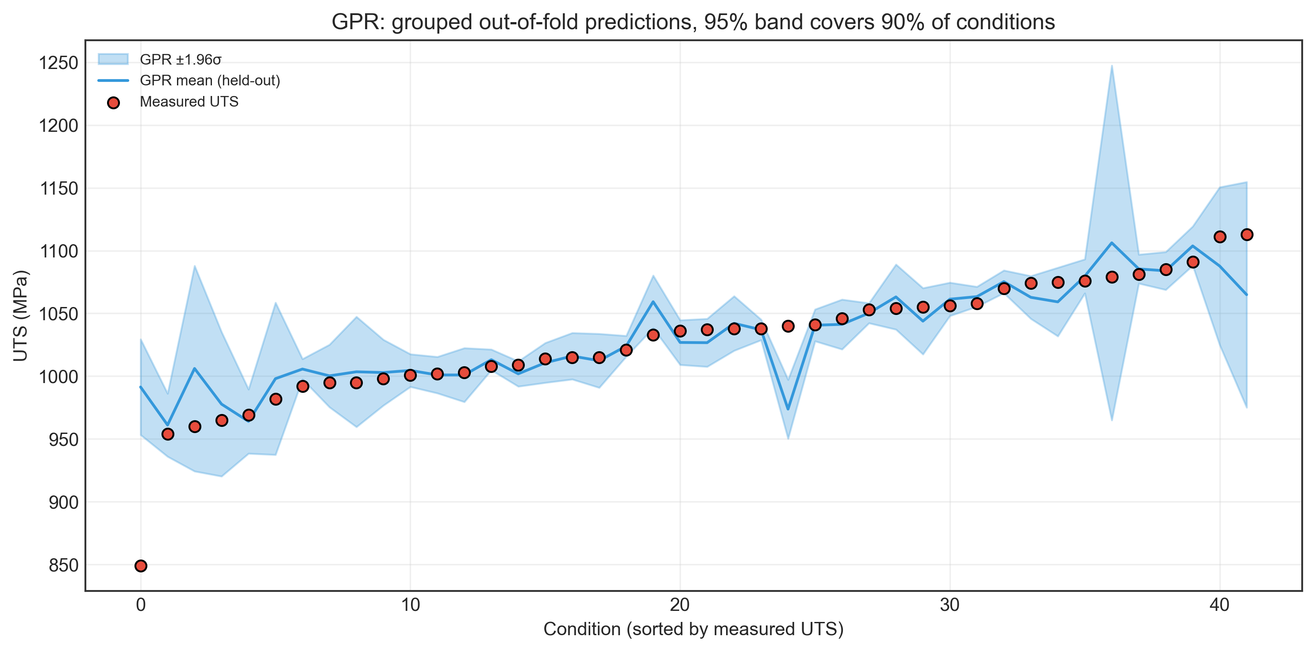
Figure 15: Gaussian-process held-out predictions and 95 % bands for UTS.
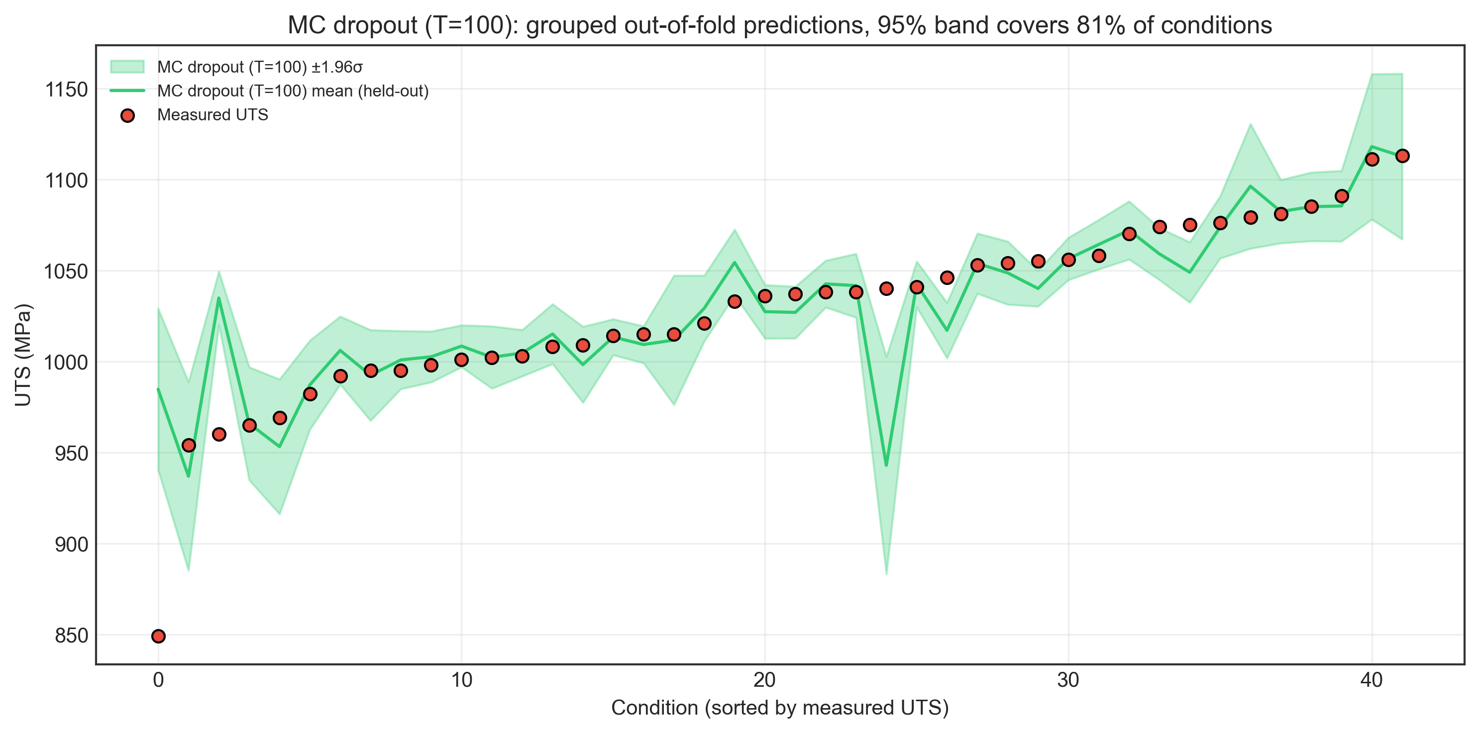
Figure 16: MC-dropout held-out predictions and 95 % bands for UTS.
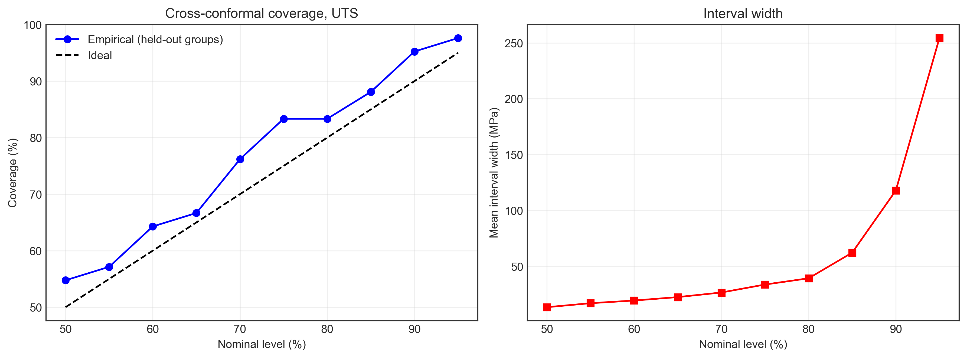
Figure 17: Cross-conformal coverage and interval width vs nominal level.
To flag queries outside the experimental design, the Mahalanobis distance of a (P, v) pair from the 42 tested points is computed in standardised units. The boundary is the largest distance of any tested condition, 3.45 (Figure 18). P and v can each lie inside their ranges while their ratio does not, so the optimisation also keeps LED within the tested range (188–469 J/m).
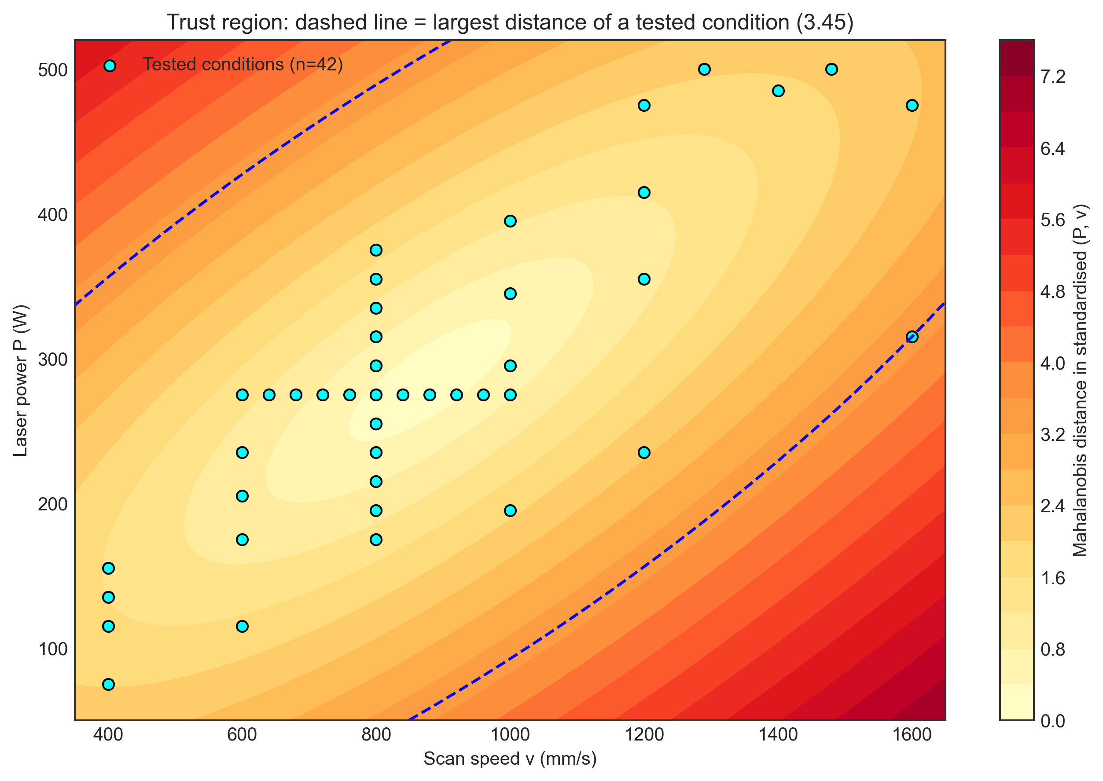
Figure 18: Mahalanobis distance over (v, P); dashed line = trust boundary.

9. Multi-objective process search
Gaussian-process surrogates using only the process inputs were fitted to all conditions for UTS, elongation and log10(XCT porosity); the log transform keeps predicted porosity positive. A grid of P = 75–500 W (5 W steps) and v = 400–1600 mm/s (10 mm/s steps) was filtered to the trust region and the tested LED range, leaving 5,456 candidates. Of these, 156 are non-dominated for the three objectives: minimum porosity, maximum UTS and maximum elongation.
The Pareto set lies at P = 230–275 W, v = 1080–1460 mm/s and LED = 188–223 J/m. The next table lists the five Pareto points with the highest predicted UTS; the full set is in pareto_optimal_conditions.csv.
Table 5: Pareto points with the highest predicted UTS.
P (W) | v (mm/s) | LED (J/m) | Porosity (%) | UTS (MPa) | UTS σ (MPa) | Elongation (%)
260 | 1380 | 188 | 0.005 | 1124 | 13 | 13.8
265 | 1400 | 189 | 0.005 | 1124 | 13 | 13.7
260 | 1370 | 190 | 0.006 | 1123 | 12 | 13.9
270 | 1430 | 189 | 0.005 | 1123 | 14 | 13.4
255 | 1350 | 189 | 0.006 | 1123 | 12 | 14.1

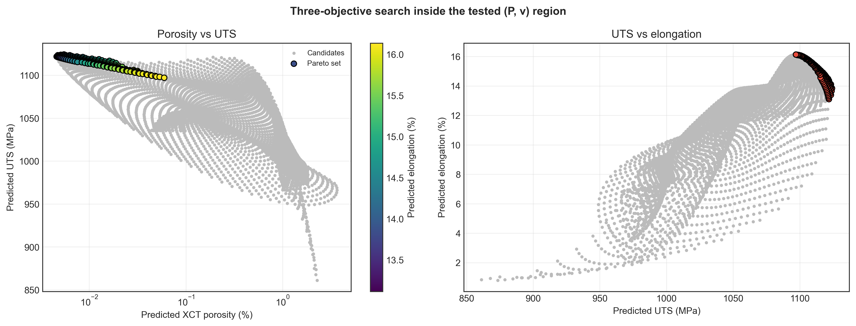
Figure 19: Candidates and Pareto set in objective space.
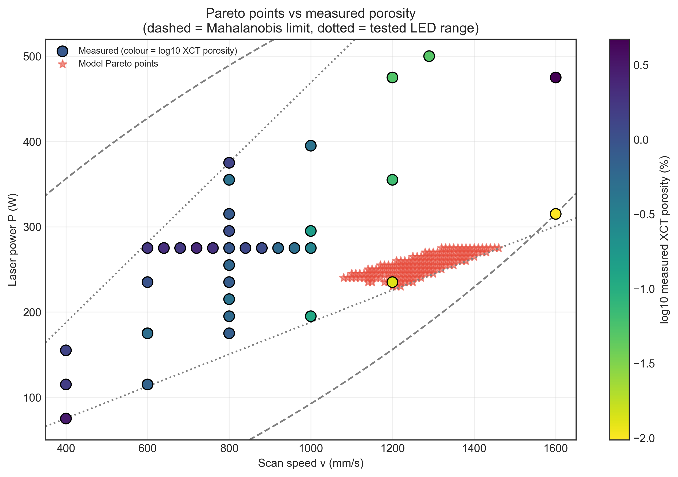
Figure 20: Pareto points (stars) over the measured porosity map.
These suggestions mostly confirm what the experiment already shows. The Pareto region contains the setting of measured set 41 (235 W, 1200 mm/s), the strongest and most ductile specimen in the study, and lies at the same low-LED edge as the densest set 42. Two cautions apply. First, the porosity surrogate failed grouped validation (Section 6), so its predicted values should be read only as a ranking. Second, the predicted UTS of the top candidates differs by only 0.9 MPa, much less than their GPR standard deviation (about 13 MPa), so the model cannot rank them against each other. Several candidates also sit on the lowest tested LED (188 J/m), where the data are thin. Any suggested setting would need to be built and tested before use.

10. Conclusions and limitations
- On this dataset, laser power and scan speed alone predict UTS, yield strength and elongation at unseen power levels with grouped R² between 0.65 and 0.81. Adding the measured pore, roughness and grain features did not improve these predictions meaningfully.
- Porosity is the property most closely tied to strength and ductility, but under grouped validation it could not itself be predicted from P and v. Microhardness showed no process signal above its measurement scatter.
- Random and grouped cross-validation gave similar scores here. Grouping by power is still the more relevant test for new process settings.
- Gaussian-process intervals were close to calibrated, MC-dropout intervals were too narrow, and conformal intervals reached nominal coverage only by becoming very wide.
- Restricted to the tested region, the multi-objective search recommends the moderate-power, high-speed, low-LED corner that the measurements already identify as best.
Limitations: 42 conditions (35 with XCT) is a very small sample, the group folds are unequal in size, hyper-parameters were not tuned, and the explanations are in-sample. The prior-β grain size measured here is not the microstructural length scale that controls strength in Ti-6Al-4V. More conditions near the low-LED, high-speed boundary and repeated builds would be the most useful additions.
Reproducibility: build_dataset.py rebuilds the dataset and run_analysis.py produces every number, table and figure in this report (run time 415 s; Python 3.13.9, PyTorch 2.6.0+cu124, scikit-learn 1.6.1, XGBoost 3.4.1, SHAP 0.53.0; device: NVIDIA GeForce RTX 3050 Ti Laptop GPU). The project was first developed on a laptop with an NVIDIA RTX 4060; the numbers in this report were regenerated on the device listed above. The networks are small enough that the choice of GPU or CPU does not change the conclusions.

References
[1] Q. Luo, L. Yin, T.W. Simpson, A.M. Beese, Dataset of process-structure-property feature relationship for laser powder bed fusion additive manufactured Ti-6Al-4V material, Data in Brief 46 (2023) 108911. https://doi.org/10.1016/j.dib.2023.108911
[2] Q. Luo, L. Yin, T.W. Simpson, A.M. Beese, Effect of processing parameters on pore structures, grain features, and mechanical properties in Ti-6Al-4V by laser powder bed fusion, Additive Manufacturing 56 (2022) 102915. https://doi.org/10.1016/j.addma.2022.102915
[3] M. Tang, P.C. Pistorius, J.L. Beuth, Prediction of lack-of-fusion porosity for powder bed fusion, Additive Manufacturing 14 (2017) 39–48. https://doi.org/10.1016/j.addma.2016.12.001
[4] Q. Luo, L. Yin, T.W. Simpson, A.M. Beese, Processing, microstructure, mechanical property dataset for laser powder bed fusion additively manufactured Ti-6Al-4V, Zenodo, record 6587905. https://zenodo.org/record/6587905
[5] D. Rosenthal, Mathematical theory of heat distribution during welding and cutting, Welding Journal 20 (1941) 220–234.
[6] S.M. Lundberg, S.-I. Lee, A unified approach to interpreting model predictions, Advances in Neural Information Processing Systems 30 (2017).
[7] Y. Gal, Z. Ghahramani, Dropout as a Bayesian approximation: representing model uncertainty in deep learning, Proceedings of the 33rd International Conference on Machine Learning (2016) 1050–1059.
[8] A.N. Angelopoulos, S. Bates, A gentle introduction to conformal prediction and distribution-free uncertainty quantification, arXiv:2107.07511 (2021).

