We would like to build a beneficiary management system to record beneficiary profiles & beneficiary services, we need to develop it in PHP programming language, you may use pure PHP or Laravel Framework.

The objective of this test is to measure the following skills:

Object oriented programming, error handling, PHP, MySQL, CSS, JS, coding best practices, database design, system user-friendly, SEF URL (URL rewrite)

System requirement:

1. Beneficiaries:
2. We will capture (name, date of birth, gender, phone number, national ID Number, mother name, marital status, employment status, monthly income, beneficiary photo)
3. System will auto calculate the score of the beneficiary based on the following indicators:

|  |  |  |  |  |
| --- | --- | --- | --- | --- |
| **Indicator** | | |  | **Score** |
| Gender | Male | |  | 0 |
| Female | |  | 10 |
| Marital status | Single | |  | 0 |
| Married | |  | 10 |
| Divorced | |  | 5 |
| Age | 0-17 | |  | 5 |
| 18-60 | |  | 0 |
| 60+ | |  | 10 |
| Employment | Employed | |  | 0 |
| Un-Employed | |  | 10 |
| TOTAL SCORE |  | 40 | | |

1. User will be able to approve/reject the beneficiaries and write justification if rejecting.

For example:

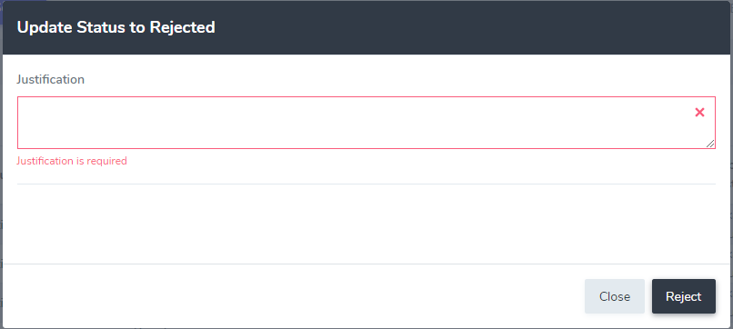

1. User should be able to delete a single beneficiary profile or deleting multiple beneficiary profiles at once.
2. User should be able to export beneficiary list and do amendments to the data and re-import them, in case of adding additional data to the beneficiary profile the export/import code should not need to be amended to support exporting/importing the newly added field.
3. Beneficiary Services:
4. Each beneficiary might receive multiple services
5. Types of available services: Training Session, Shelter Rehabilitation.
6. We should be able to mark the service as Ongoing/Cancelled/Delivered

* The Code + DB should be uploaded to your google drive and provide access to the link, the system should have all dependencies included in the project code directory.