Exploratory Data Analysis (EDA) Report
ApexPlanet Sales Transactions Dataset
Data Analytics Internship — Task 2: EDA & Business Intelligence
Prepared by: Sivaram
Dataset: ApexPlanet_Cleaned_Dataset.xlsx (1,000 orders x 18 fields)
July 2026

1. Executive Summary
This report presents an exploratory analysis of 1,000 cleaned sales transactions from the ApexPlanet dataset, covering the period January 2025 to January 2026 across 8 Indian cities, 6 products, and 5 categories. The goal is to surface patterns, relationships, and business-relevant findings using descriptive statistics, univariate and multivariate visualizations, and SQL-based analysis.
Key findings:
- Total revenue across the dataset is ₹13.94 crore (₹139,399,440), from 1,000 orders averaging ₹139,399 each.
- Electronics is the dominant category by order volume (354 orders, 35%) and by revenue, driven mainly by Laptop and Mobile.
- Order value is right-skewed (skewness ≈ 0.99) — most orders cluster below ₹150K, with a longer tail of high-value Electronics/Furniture orders.
- Total_Sales correlates moderately with both Unit_Price (r = 0.69) and Quantity (r = 0.65) — both drive revenue roughly equally; Age has virtually no correlation with order value (r ≈ 0.00).
- Revenue is fairly evenly spread across cities (Kolkata, Bengaluru and Patna lead) — no single city dominates, suggesting a genuinely pan-India customer base.
- Male customers contribute slightly more revenue (52.4%) than female customers (47.6%), a modest, not dramatic, split.
- Monthly revenue is volatile (no strong seasonal trend) with growth swinging from +36% to -20% month-over-month; September 2025 was the weakest month, October the strongest rebound.

2. Descriptive Statistics & Univariate Analysis

2.1 Numeric Fields
Field | Mean | Std Dev | Min | Median | Max
Age (years) | 41.3 | 13.7 | 18 | 41 | 65
Quantity (units) | 5.4 | 2.8 | 1 | 5 | 10
Unit Price (₹) | 25,487 | 14,179 | 146 | 25,399 | 49,998
Total Sales (₹) | 139,399 | 114,100 | 437 | 108,594 | 493,678

Age and Quantity are close to uniformly distributed across their ranges (near-zero skew), consistent with how they were generated. Total_Sales is the most interesting field: its mean (₹139,399) sits noticeably above its median (₹108,594), and its positive skew (≈0.99) confirms a distribution with a long right tail — a smaller number of very high-value orders pull the average up. This matters for reporting: median or trimmed-mean order value is a more representative 'typical order' figure than the mean alone.
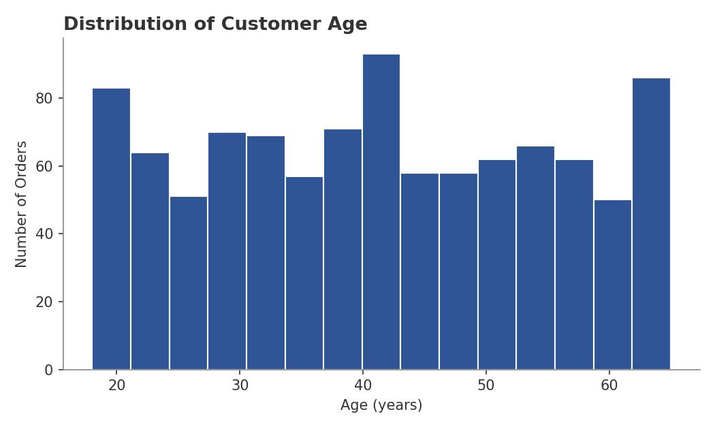
Figure 1. Distribution of Customer Age — broadly uniform across 18-65.
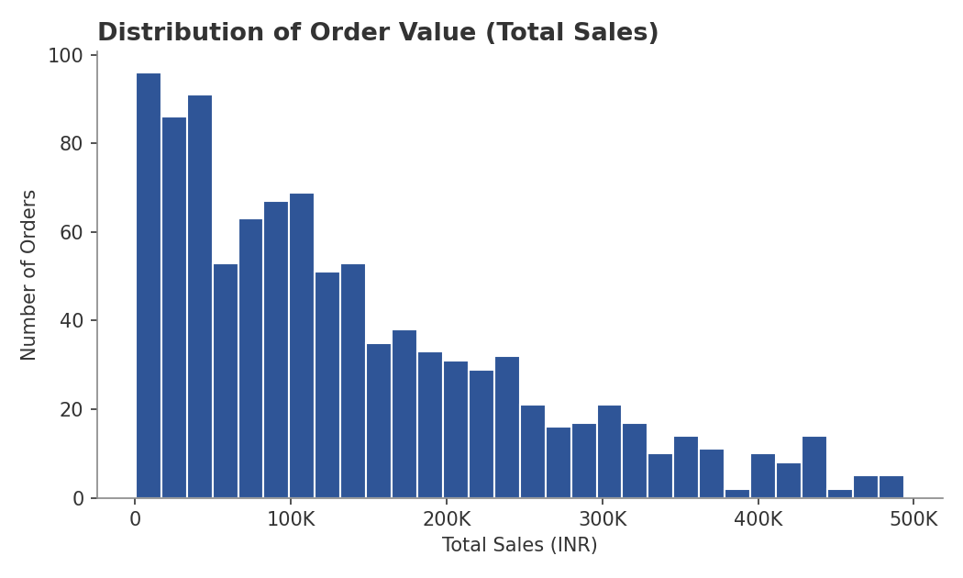
Figure 2. Distribution of Total Sales — right-skewed with a long tail of high-value orders.

2.2 Categorical Fields
Field | Top Value | Share | Notes
Category | Electronics | 35.4% | 354 of 1,000 orders; Mobile + Laptop combined
Gender | Male | 51.1% | Fairly balanced — 511 Male vs 489 Female
City | Patna | 13.5% | 8 cities + 13 'Unknown' (was missing City)
Age Group | 36-45 | 22.3% | Broadly even spread across 5 age bands
Revenue Tier | High (100k-250k) | 36.8% | Engineered tier; 17% of orders are 'Very High' (>250k)

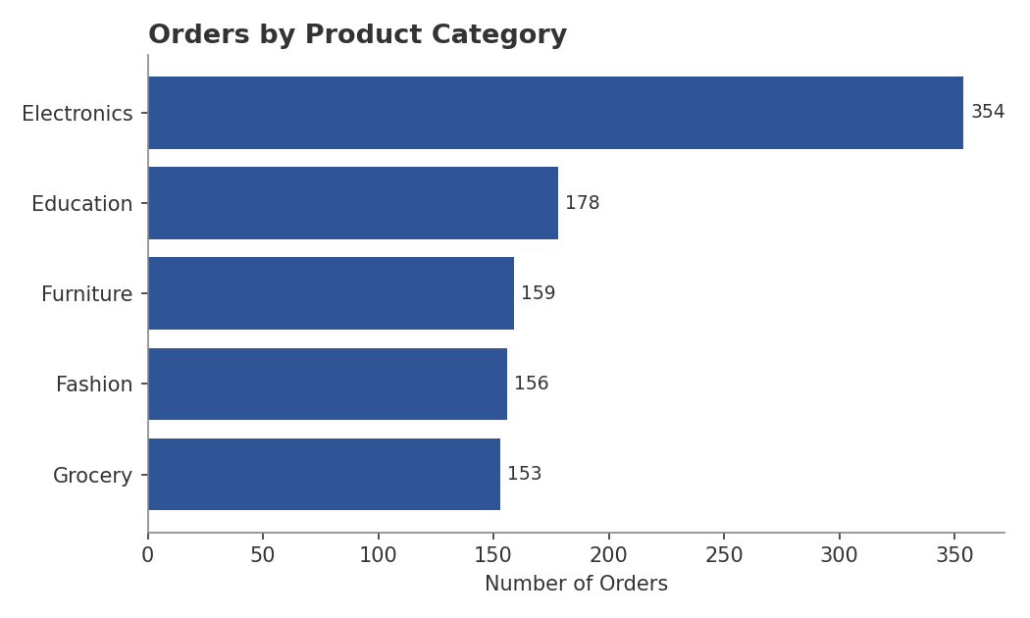
Figure 3. Order counts by product category — Electronics leads by a wide margin.
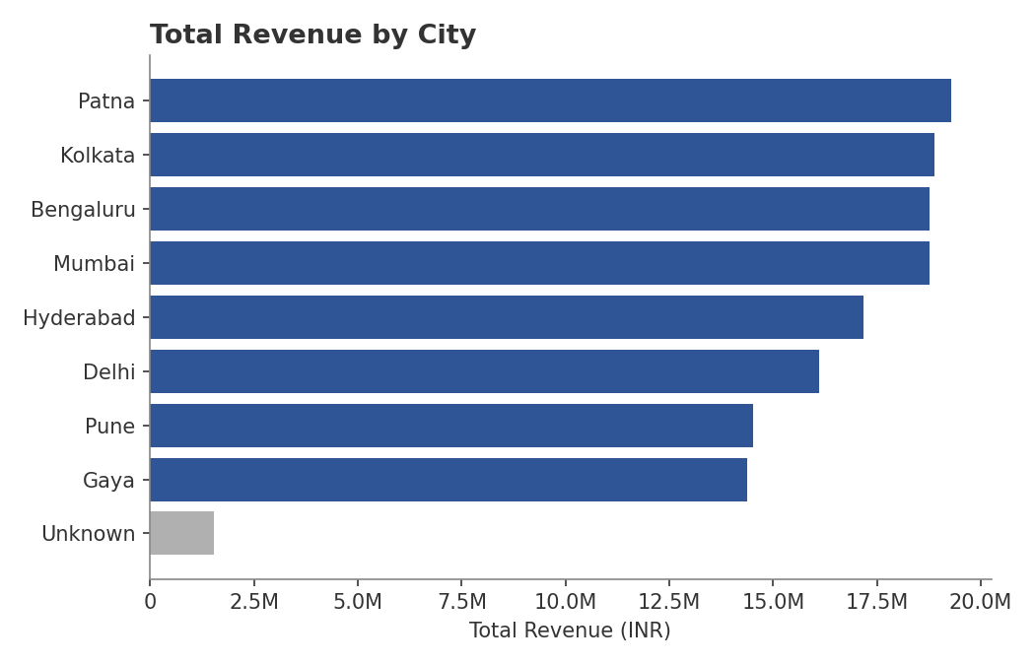
Figure 4. Total revenue by city — a fairly even geographic spread; 'Unknown' bucket (grey) holds the 13 orders with missing city data and trails well behind, as expected.
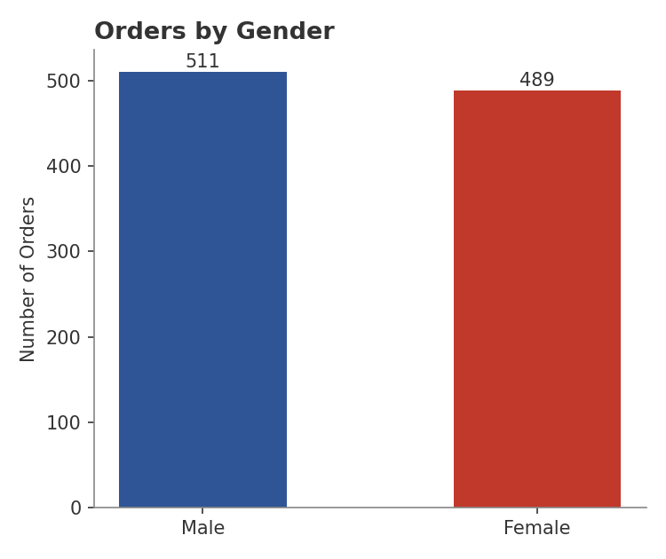
Figure 5. Orders by gender — a near-even split.
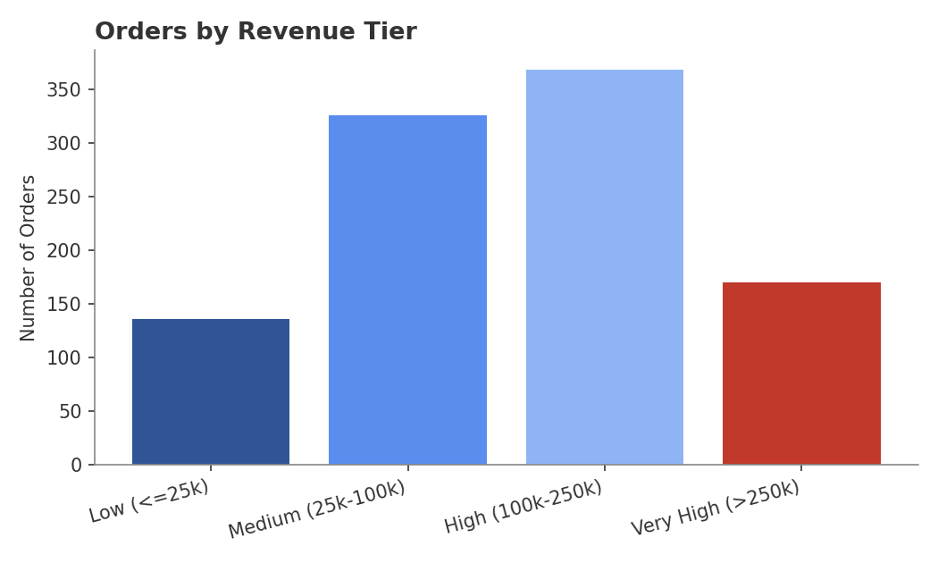
Figure 6. Orders by revenue tier — most orders fall in the Medium-High range.

3. Multivariate Analysis & Correlation
This section explores relationships between two or more variables to identify what actually drives revenue, rather than looking at each field in isolation.

3.1 Revenue Trend Over Time
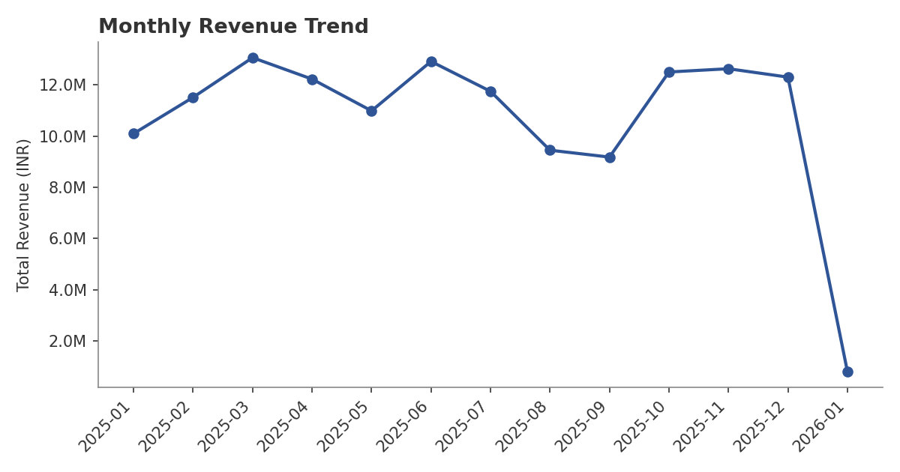
Figure 7. Monthly revenue trend, Jan 2025 - Jan 2026 (Jan 2026 is a partial month, 5 orders only).
Revenue does not show a strong seasonal or growth trend — it oscillates between roughly ₹9.2M and ₹13.1M per month with no clear upward or downward trajectory. October 2025 (+36.2% MoM) was the sharpest rebound, following the weakest month, September 2025 (-2.8% MoM, the second month of decline after August's -19.6%). This volatility, more than any trend, is the headline finding — it suggests revenue is currently driven by order-mix variance rather than a structural growth or decline pattern.

3.2 Age vs. Order Value, by Category
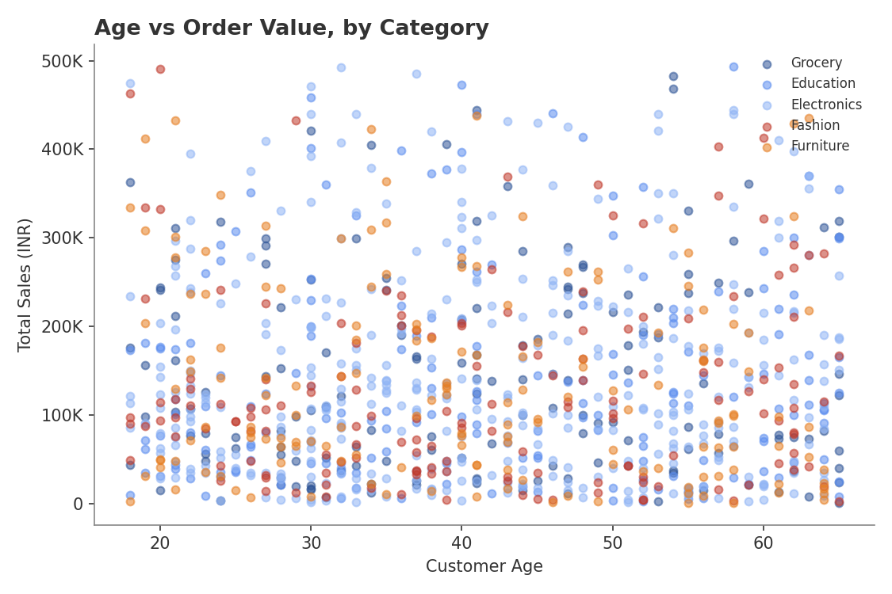
Figure 8. Order value vs. customer age, colored by product category.
The scatter shows no visible relationship between customer age and order value — high and low-value orders occur across every age band, for every category. This is confirmed numerically in the correlation matrix below (r = 0.00 between Age and Total_Sales). Practically, this means age-based targeting is not a useful lever for predicting order size in this dataset, though it may still matter for category preference.

3.3 Correlation Between Numeric Fields
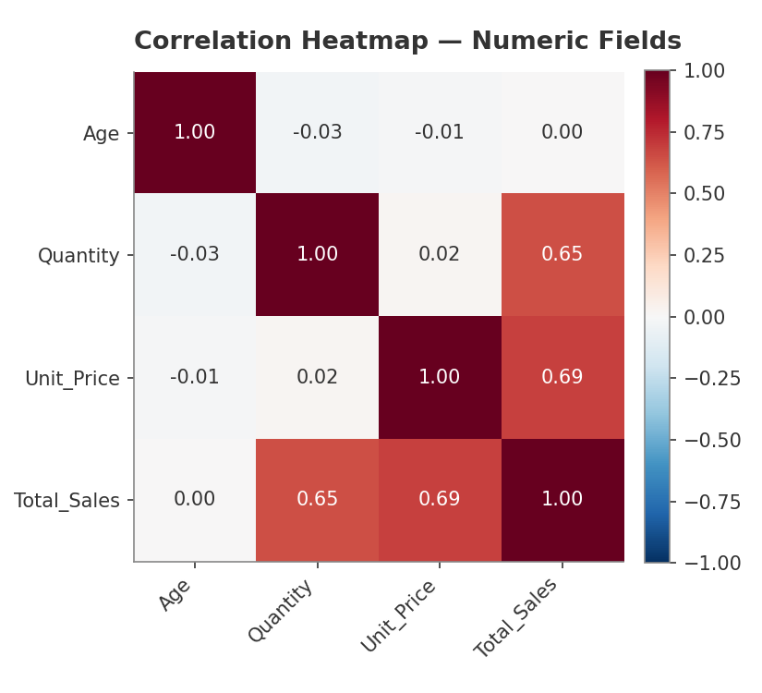
Figure 9. Correlation heatmap — Age, Quantity, Unit Price, Total Sales.
Total_Sales correlates moderately with Unit_Price (r = 0.69) and with Quantity (r = 0.65) — both roughly equal contributors, confirming Total_Sales is a genuine product of the two (by construction) rather than being dominated by one factor. Quantity and Unit_Price themselves are not correlated with each other (r = 0.02), meaning higher-priced items are not systematically bought in smaller or larger quantities. Age is essentially uncorrelated with every numeric field.
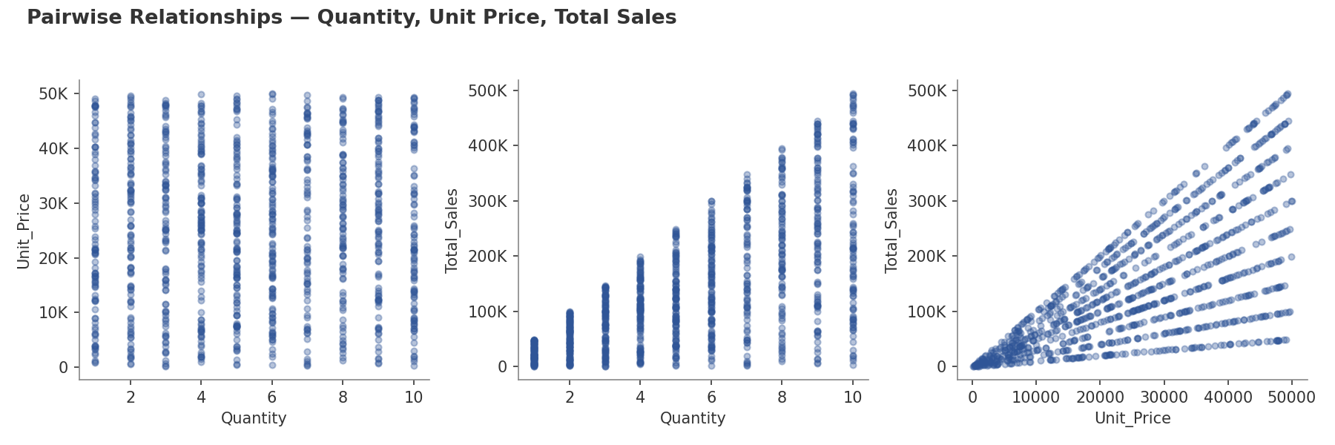
Figure 10. Pairwise relationships between Quantity, Unit Price, and Total Sales.

3.4 Category Performance by Gender and Age Group
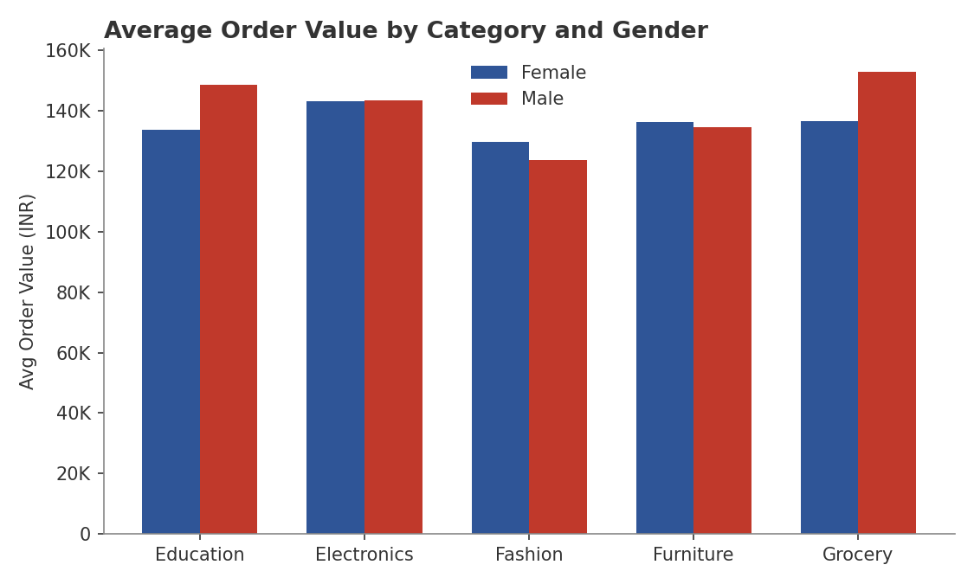
Figure 11. Average order value by category and gender.
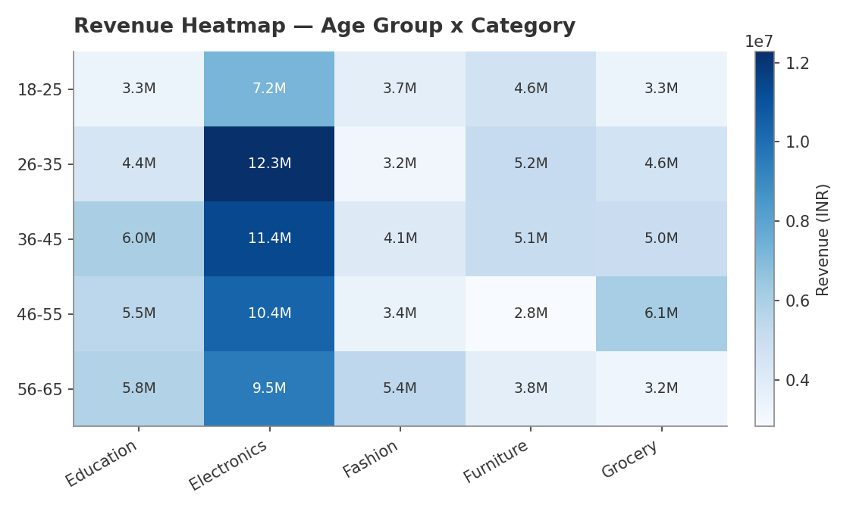
Figure 12. Total revenue by age group and category (₹, millions).
Electronics dominates revenue in every single age group — it is the top-earning category for all five age bands, not just on average. The 26-35 and 36-45 age groups are the two largest revenue contributors overall, consistent with them also being the two largest customer segments by order count.

4. SQL-Derived Business Insights
Seven business questions were answered using SQL against a normalized two-table schema (orders fact table + customers dimension table) in SQLite. Full queries and result sets are provided separately in business_questions_sql.sql and SQL_Query_Results.xlsx. Headline findings:
- Top 5 products by revenue (last 6 months, Jul 2025-Jan 2026): Laptop (₹1.30 crore) leads narrowly over Book, Chair, Shoes and Rice — the gap between #1 and #5 is under 22%, meaning revenue is well diversified across products, not concentrated in one.
- Kolkata is the top city by revenue (₹1.99 crore), but only marginally ahead of Bengaluru and Patna — no single city drives the business.
- Electronics is the top revenue category for every customer age group (18-25 through 56-65) — it is a universal best-seller, not a niche driven by one demographic.
- Male customers generate 52.4% of revenue vs. 47.6% for Female — a real but modest gap.
- Wednesday has the highest average order value (₹147,599), narrowly ahead of Tuesday; Sunday has both the lowest average order value and the most orders — suggesting Sunday brings more, smaller purchases.
- Month-over-month revenue growth is highly volatile: from +36.2% (Oct 2025) to -19.6% (Aug 2025) — there is no steady growth trend to report on this data.

5. Recommendations
- Investigate the Aug-Sep 2025 revenue dip and the Oct 2025 rebound with the business team — was it a promotion, stockout, or seasonal event? This is the single most actionable pattern in the data.
- Since Electronics outperforms in every age group, prioritize Electronics inventory and marketing spend broadly rather than targeting a specific age segment.
- Resolve the 13 orders with 'Unknown' city at the source system level — even though small, they are the only true blind spot in geographic reporting.
- Use median (not mean) order value when reporting a 'typical' order, given the right-skewed distribution driven by high-value outlier orders.
- Track order value by weekday going forward — the Wednesday-high / Sunday-low pattern could inform staffing or promotional timing, but one year of data is not enough to confirm it is not noise.

