DevSecOps with AWS - 88S

Table of Contents
27-JAN-2026 Session-14 2
Inode Symlink Hardlink 2
Version control system 5
Centralised vs distributed 6
Git commands 7

27-JAN-2026 Session-14

Inode Symlink Hardlink
[ec2-user@ip-172-31-31-187 ~]$ ls linux.txt
[ec2-user@ip-172-31-31-187 ~]$ ls -li total 0
8768976 -rw-r--r--. 1 ec2-user ec2-user 0 Jan 30 11:34 linux.txt [ec2-user@ip-172-31-31-187 ~]$ stat linux.txt
File: linux.txt
Size: 0 Blocks: 0 IO Block: 4096 regular empty file Device: 10301h/66305d Inode: 8768976 Links: 1
Access: (0644/-rw-r--r--) Uid: ( 1000/ec2-user) Gid: ( 1000/ec2-user) Context: unconfined_u:object_r:user_home_t:s0
Access: 2026-01-30 11:34:36.344353743 +0000
Modify: 2026-01-30 11:34:36.344353743 +0000
Change: 2026-01-30 11:34:36.344353743 +0000
Birth: 2026-01-30 11:34:36.344353743 +0000

[ec2-user@ip-172-31-31-187 ~]$ vim linux.txt [ec2-user@ip-172-31-31-187 ~]$ stat linux.txt File: linux.txt
Size: 13 Blocks: 8 IO Block: 4096 regular file
Device: 10301h/66305d Inode: 8768996 Links: 1
Access: (0644/-rw-r--r--) Uid: ( 1000/ec2-user) Gid: ( 1000/ec2-user) Context: unconfined_u:object_r:user_home_t:s0
Access: 2026-01-30 12:58:21.325056651 +0000
Modify: 2026-01-30 12:58:21.325056651 +0000

Change: 2026-01-30 12:58:21.325056651 +0000
Birth: 2026-01-30 12:58:21.325056651 +0000

Inode
Stores metadata of the file/directory File type -> file/directory/link Owner group
Permissions Size
Create, update, etc
Actual memory block address
Inode does not store actual file content.

Symlink == shortlink == softlink
- Short cut to the file/folder
- Inode number is different for symlink
- If actual file is removed, then symlink will break
- Uses for backward compatability, switching versions and rollback is easy
- You can create symlink for folders and files also
- You can create symlink across different filesystem

Steps:
  - Create one directory(links)
  - Go to link directory
  - Create link for linux.txt
Command: ln -s
$ ln -s ../linux.txt link
  - Check link status
Command: stat link

File: link -> ../linux.txt
Size: 12 Blocks: 0 IO Block: 4096 symbolic link
Device: 10301h/66305d Inode: 8768976 Links: 1
Note: Inode numbers of Symlinks are different
which dnf
/usr/bin/dnf
$ ls -l /usr/bin/dnf
lrwxrwxrwx. 1 root root 5 Feb 7 2025 /usr/bin/dnf -> dnf-3
$ ls -l /usr/bin/yum
lrwxrwxrwx. 1 root root 5 Feb 7 2025 /usr/bin/yum -> dnf-3

YUM -> Before RHEL-8 YUM is the package manager RHEL-8 DNF is the package manager

$ touch dnf-3
$ ls
dnf-3 links
$ ln -s dnf-3 dnf
$ ls
dnf dnf-3 links
$ touch dnf-4
$ ls
dnf dnf-3 dnf-4 links
$ ls -l
lrwxrwxrwx. 1 ec2-user ec2-user 5 Jan 31 13:20 dnf -> dnf-3
-rw-r--r--. 1 ec2-user ec2-user 0 Jan 31 13:16 dnf-3
-rw-r--r--. 1 ec2-user ec2-user 0 Jan 31 13:25 dnf-4
drwxr-xr-x. 2 ec2-user ec2-user 18 Jan 31 12:13 links

$ ln -sfn dnf-4 dnf
$ ls -l

lrwxrwxrwx. 1 ec2-user ec2-user 5 Jan 31 13:26 dnf -> dnf-4
-rw-r--r--. 1 ec2-user ec2-user 0 Jan 31 13:16 dnf-3
-rw-r--r--. 1 ec2-user ec2-user 0 Jan 31 13:25 dnf-4
drwxr-xr-x. 2 ec2-user ec2-user 18 Jan 31 12:13 links

This is the switching versions safely without downtime.

If anything, problem occurs in dnf -4 we can revert back

$ ln -snf dnf-3 dnf
$ ls
dnf dnf-3 dnf-4 links
$ ls -l
total 0
lrwxrwxrwx. 1 ec2-user ec2-user 5 Jan 31 13:46 dnf -> dnf-3
-rw-r--r--. 1 ec2-user ec2-user 0 Jan 31 13:16 dnf-3
-rw-r--r--. 1 ec2-user ec2-user 0 Jan 31 13:25 dnf-4
drwxr-xr-x. 2 ec2-user ec2-user 18 Jan 31 12:13 links

App-3 App-4

$ mkdir app-3
ls
app-3 dnf dnf-3 dnf-4 links
$ ln -s app-3 app
$ ls -l
total 0
lrwxrwxrwx. 1 ec2-user ec2-user 5 Jan 31 13:56 app -> app-3
drwxr-xr-x. 2 ec2-user ec2-user 6 Jan 31 13:53 app-3

$ mkdir app-4
$ ln -s app-4 app
$ ls -l
total 0
lrwxrwxrwx. 1 ec2-user ec2-user 5 Jan 31 13:56 app -> app-3

$ ln -sfn app-4 app
$ ls -l
total 0
lrwxrwxrwx. 1 ec2-user ec2-user 5 Jan 31 13:57 app -> app-4

/var/lib/jenkins -> jenkins-2.8 Jenkins-2.9
/var/lib/jenkins -> jenkins-2.9

Hardlink
- You can't create hardlink in another filesystem
$ touch aws.txt
$ vim aws.txt
$ ls -l
-rw-r--r--. 1 ec2-user ec2-user 20 Jan 31 14:18 aws.txt
$ ln aws.txt /tmp/aws-1.txt
ln: failed to create hard link '/tmp/aws-1.txt' => 'aws.txt': Invalid cross-device link
- Hardlink is same as original file but can be different name
ln aws.txt aws-1.txt
$ ls -l
-rw-r--r--. 2 ec2-user ec2-user 20 Jan 31 14:18 aws-1.txt
-rw-r--r--. 2 ec2-user ec2-user 20 Jan 31 14:18 aws.txt
- Hardlink inode numbers are same.
$ ls -li
8769002 -rw-r--r--. 2 ec2-user ec2-user 20 Jan 31 14:18 aws-1.txt
8769002 -rw-r--r--. 2 ec2-user ec2-user 20 Jan 31 14:18 aws.txt
- They points to same memory location, so memory is not wasted
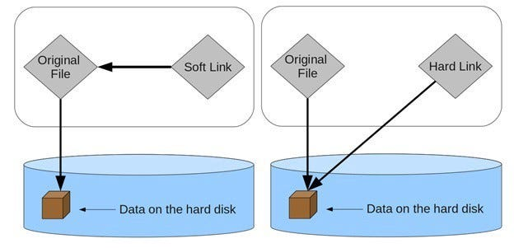

- You can't create hardlink to folders
- Hardlinks are used for backup.
- When all links are deleted, then only file will be deleted.

$ rm aws.txt
$ ls -l
-rw-r--r--. 1 ec2-user ec2-user 20 Jan 31 14:18 aws-1.txt
$ cat aws-1.txt
I am learning linux

Using inode number and find command within the same File System.
$ ln aws-1.txt app-3/aws.txt
$ ln aws-1.txt app-4/aws.txt

cd app-3/
$ ls
app-4 aws.txt
$ cd app-4
$ ls
aws.txt
[ec2-user@ip-172-31-28-112 ~]$ ls -li
1639586 drwxr-xr-x. 2 ec2-user ec2-user 34 Jan 31 15:40 app-3
8768999 drwxr-xr-x. 2 ec2-user ec2-user 21 Jan 31 15:40 app-4
8769002 -rw-r--r--. 3 ec2-user ec2-user 20 Jan 31 14:18 aws-1.txt
$ sudo find / -inum 8769002
/home/ec2-user/app-3/aws.txt
/home/ec2-user/app-4/aws.txt
/home/ec2-user/aws-1.txt

Disadvantages of doing manual
- Time taking
- Human errors
- Everytime from the scratch
- Can't rely
- If scale is increased manual way is not possible

Scripting

Commands in a file and run it called scripting.

Where to store scripts?

Version control system
Git -> VCS
- Version control
- Who did the changes, when did the changes
- You can track who did the changes
- Restoring is easy
- Review is also easy -> Pull Requests
- Secure place to store the code
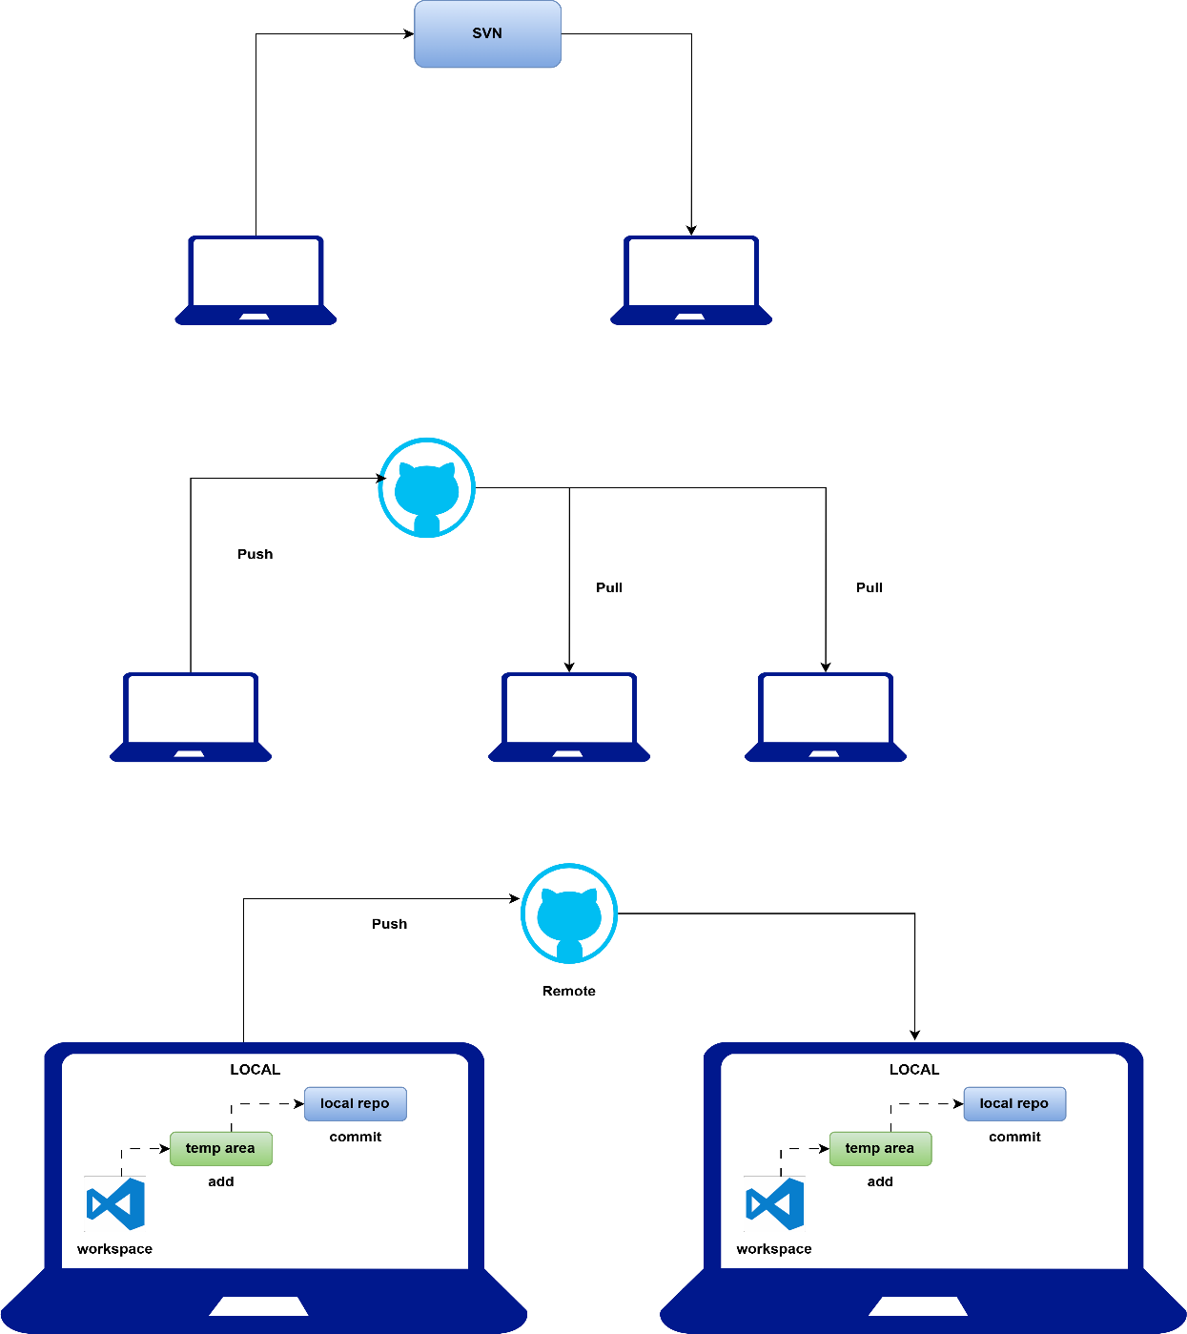

Centralised vs distributed
SVN -> sub version control 10 files
9 files
Staging/temp area -> add 9 files to staging area Then commit to local repo

Git commands
- Clone the repo -> first time download Main/master is the default branch #!/bin/bash -> shebang
Shebang is the interpreter of the code in shell script that checks and compiles for errors
Bash scripting == shell scripting
- Add files to staging area Git add <filename>
Git config --global user. email "info@joindevops.com" Git config --global user.name "Sivakumar Reddy M"
- Commit to local repo
Git commit -m "hello world completed" Git push origin main
Don't edit files inside linux server...

28-JAN-2026 Session-15
1. Create repo either in organization or directly
2. Clone repo in laptop
3. write something
4. git add., git add <filename>
5. git commit -m "message"
6. git push origin main

git config --global user.name
git config --global user.email

write only in laptops
don't write in linux servers
only pull linux
95% thinking+design 5% coding
pseudo code -> no syntax, just assumption

if today is sunday, enjoy the holiday otherwise go to school
today=Wednesday
if(today != sunday){
print ("goto school")
}
else{
print("take holiday, enjoy")
}

15
15/2 -> 1
if reminder is 0 -> even
otherwise, odd
number=15
reminder=15%2
reminder=1
if(reminder == 0){
print("even number")
}
else{
print("odd number")
}

variables
data types
conditions
functions
loops
error handling

let x=1, y=0
derive the formula
submit finally
variables are like containers that holds something

DRY -> Don’t repeat yourself
change in one place reflect everywhere you refer
easy to maintain
readable

PERSON1=Suresh
PERSON2=Ramesh
$VAR_NAME
${VAR_NAME}
sh 03-conversation.sh Suresh Ramesh
args == parameters
$1=Suresh
$2=Ramesh

echo "Enter your password"
read -s PASSWORD
read -s encrypts the password
[ec2-user@ip-172-31-28-112 Shell-practice]$ sh 05-Variables.sh
Enter your username::
Sivaram
Username is
Enter your password

I want a command to be executed and take the output into variable, how to do that?
VAR_NAME=$(command)

Special variables
=================
$1 $2 ... $N args passed to script
All variables passed to script: $@
Number of variables passed to script: $#
Script name: $0
Present which directory you are in: $PWD
Who is running this script: $USER
Home direcory of the user: $Home
PID of the script: $$
sleep 100 &
Background process id: $!
Exit status of previous command: $?

$@ vs $*
=========
$@ treats args separately
$* treats as single args

data types
==============
variables are holding data..

mobile number -> numbers
integers -> -33,768 -> 33,768
float -> 45.90
decimanl -> long number
complex -> 4+8i
names -> string
major? -> yes or no boolean
skills -> devops aws docker kubernetes -> list of skills
skills -> map or dictionary
devops: 4 -> key -> value
docker: 3
kubernetes: 2

areane4 -> 5
speed round up -> 8.2km/sec -> 8km/sec
copied code

integer speed=8km/sec
integer speed=8.2km/sec

number
string

everything is string in shell

position/index in coding starts from 0

conditions
==========

if or when

if [ expression ]; then
code here
fi

if [ expression ]; then
code here
elif [ expression ]; then
code here
else
code here
fi

EXIT code
==========
0-127

0 -> success
anything else -> failure

nginx

dnf install nginx -y

if root user then success
otherwise failure

root user id -> 0
other users -> greater than 0

