DevSecOps with AWS - 88S

Table of Contents
27-JAN-2026 Session-14 2
Inode Symlink Hardlink 2
Version control system 3
Centralised vs distributed 4
Git commands 5

27-JAN-2026 Session-14

lInode Symlink Hardlink
Inode
Stores metadata of the file/directory
File type -> file/directory/link
Owner group
Permissions
Size
Create, update, etc
Actual memory block address
Inode does not store actual file content.

Symlink == shortlink == softlink
1. Short cut to the file/folder
2. Inode number is different for symlink
3. If actual file is removed, then symlink will break
4. Uses for backward compatability, switching versions and rollback is easy
5. You can create symlink for folders and files also
6. You can create symlink across different filesystem

YUM -> Before RHEL-8 YUM is the package manager
RHEL-8 DNF is the package manager
App-3
App-4
/var/lib/jenkins -> jenkins-2.8
Jenkins-2.9
/var/lib/jenkins -> jenkins-2.9

Hardlink
1. You can't create hardlink in another filesystem
2. Hardlink is same as original file but can be different name
3. Hardlink inode numbers are same
4. They points to same memory location, so memory is not wasted
5. You can't create hardlink to folders
6. Hardlinks are used for backup.
7. When all links are deleted, then only file will be deleted.

Using inode number and find command within the same FS
1. Time taking
2. Human errors
3. Everytime from the scratch
4. Can't rely
5. If scale is increased manual way is not possible

Scripting
Commands in a file and run it called scripting
Where to store scripts?

Version control system
Git -> VCS
1. Version control
2. Who did the changes, when did the changes
3. You can track who did the changes
4. Restoring is easy
5. Review is also easy -> Pull Requests
6. Secure place to store the code

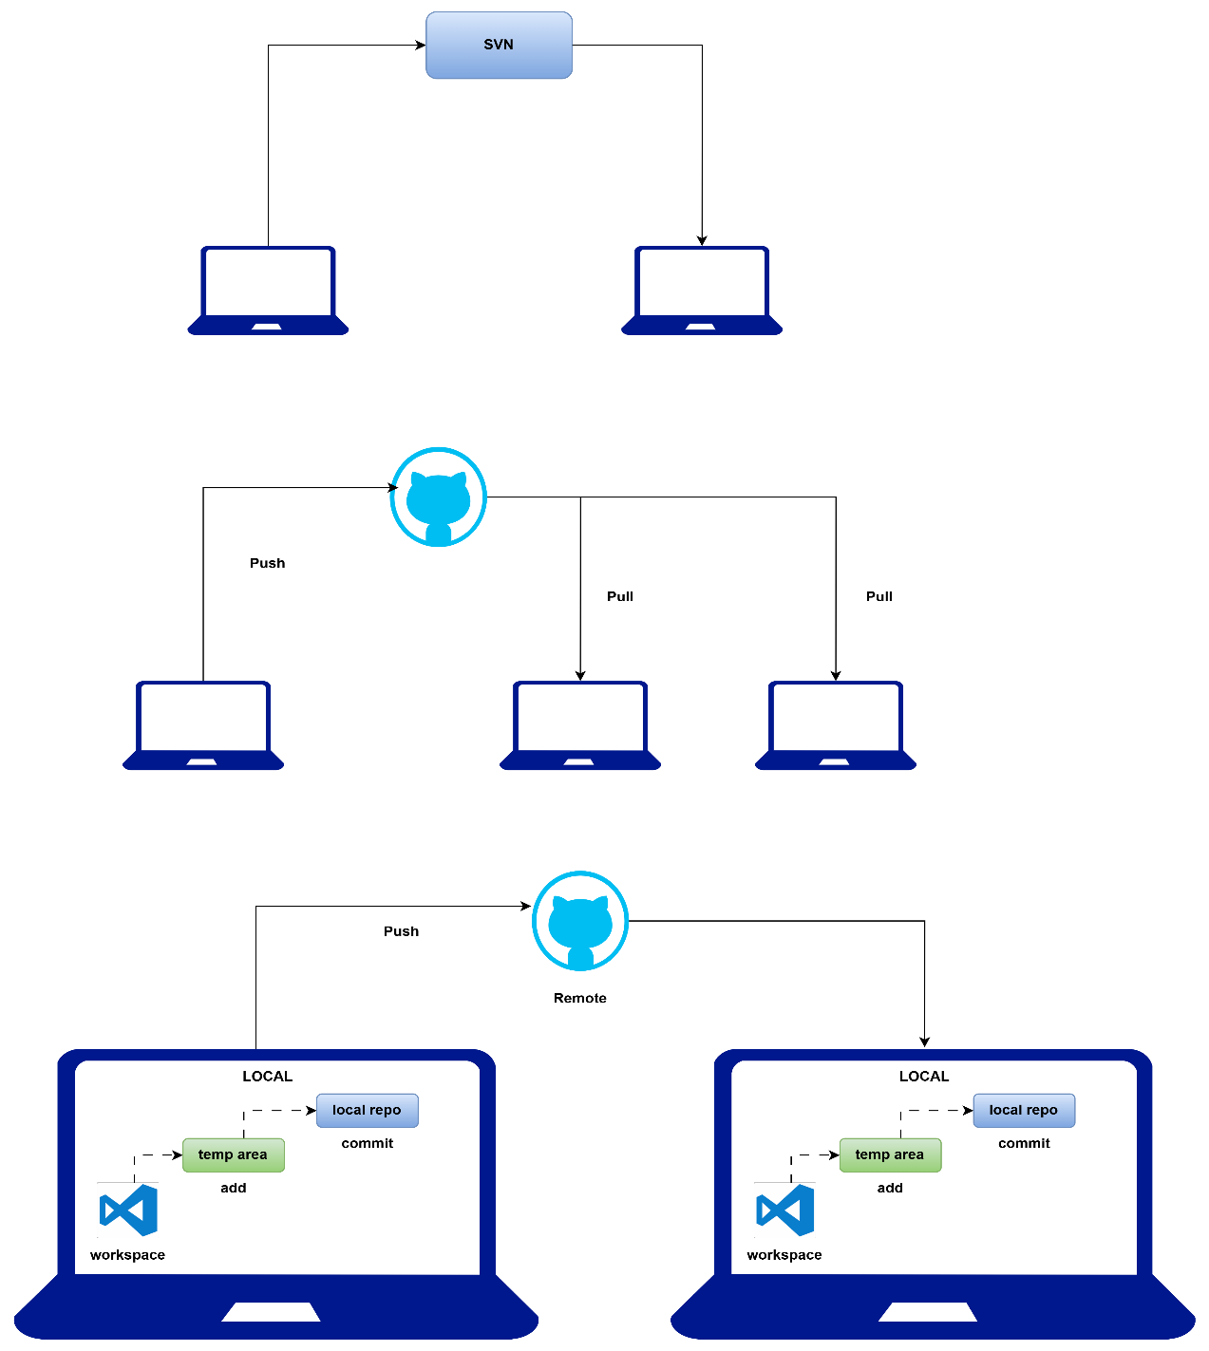

Centralised vs distributed
SVN -> sub version control
10 files
9 files
Staging/temp area -> add 9 files to staging area
Then commit to local repo

Git commands
- Clone the repo -> first time download
Main/master is the default branch
#!/bin/bash -> shebang
Shebang is the interpreter of the code in shell script that checks and compiles for errors
Bash scripting == shell scripting
- Add files to staging area
Git add <file-name>
Git config --global user.email "info@joindevops.com"
Git config --global user.name "Sivakumar Reddy M"
- Commit to local repo
Git commit -m "hello world completed"
Git push origin main
Don't edit files inside linux server...

