**Analysis of Reverse Mortgages**

A reverse mortgage is a series of monthly payments over some term to the borrower in return for some equity (ie. house) as a security.

In this model we are aiming to estimate the maximum payment amount per month without allowing the total debt over the term to exceed the future value of the house.

Parameters

Inflation rate: 1.6% based on RBA’s trimmed mean for March 2019

Life Expectancy: 12 years for Male aged 66 today, Based on Australian Institute of Health and Welfare (AIHW); for the main consumers of reverse mortgages of ages 65+

Interest Rates: 8.5% p/a based on CommBank’s value

Average annual Increase in House Value: 7.25% based on RBA paper regarding rise in house prices

Current House Value (HV): $600,000 - an arbitrary estimate of house price in Australia

Methods

**Spreadsheet method:**

* The total debt accumulated up to a certain period divided by the house price (affected by growth rate of house prices) at that period gives us the Debt to Equity (DE) ratio.
  + Using “Goalseek”: change DE ratio at the final period to 100% by changing the first payment amount – affects PV of payments, amount of debt accumulated and amount for following payments (due to inflation in indexed annuity).
  + This provides us a maximum payment amount per month, which can be used to determine maximum PV of payments over the term

**Theoretical method:**

* Using the PV of payments over the term from the spreadsheet method;
  + For Level annuity: determine the PV factor (for level annuity)
    - Determined using
    - PV of payments divided by this gives the payment value each period

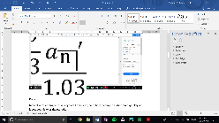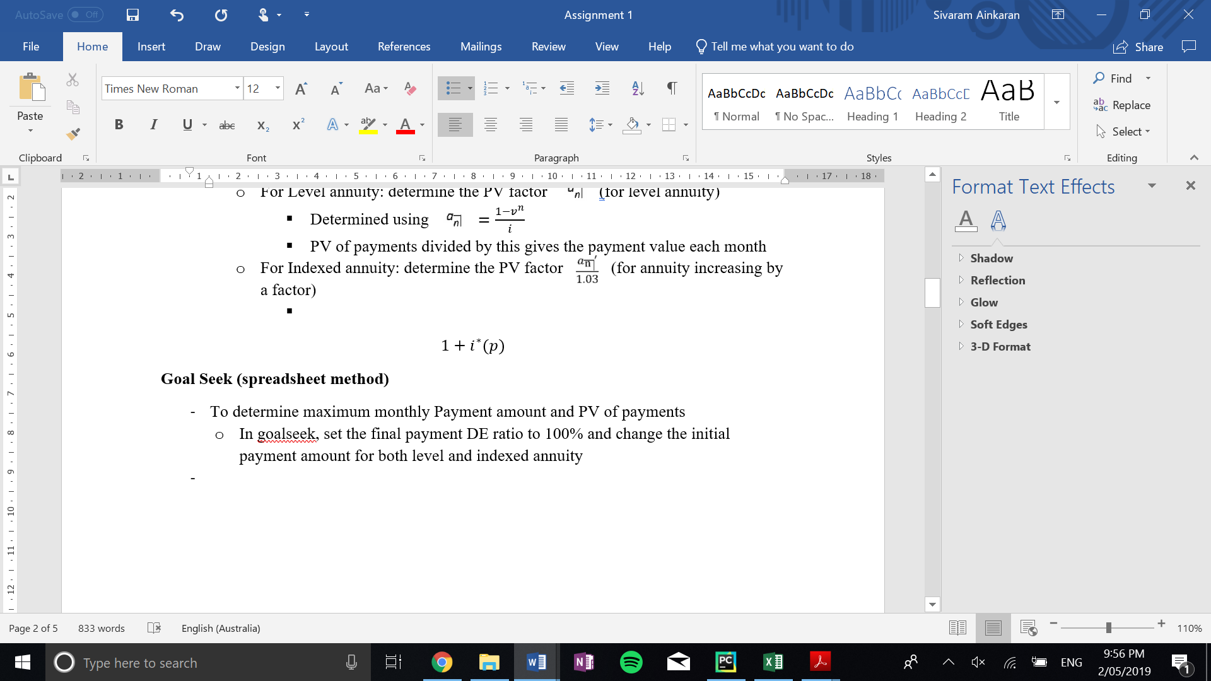

* + For Indexed annuity: determine the PV factor (for annuity increasing by a factor - inflation)
    - Determined using , where is pthly interest rate over pthly inflation rate ()
    - PV of payments divided by this gives the payment value for the first period – used to determine payments for the following periods

**Debt to Equity Ratio**

* Indexed annuity (IA) has a lower DE than Level annuity (LA) up to the final payment where DE ratio is 100%
* Due to inflation the payment amount from the IA is less than from the LA during the term, but the accumulated debt at term end is equal due to payment growth in the IA.

**(1.6% inflation rate)**

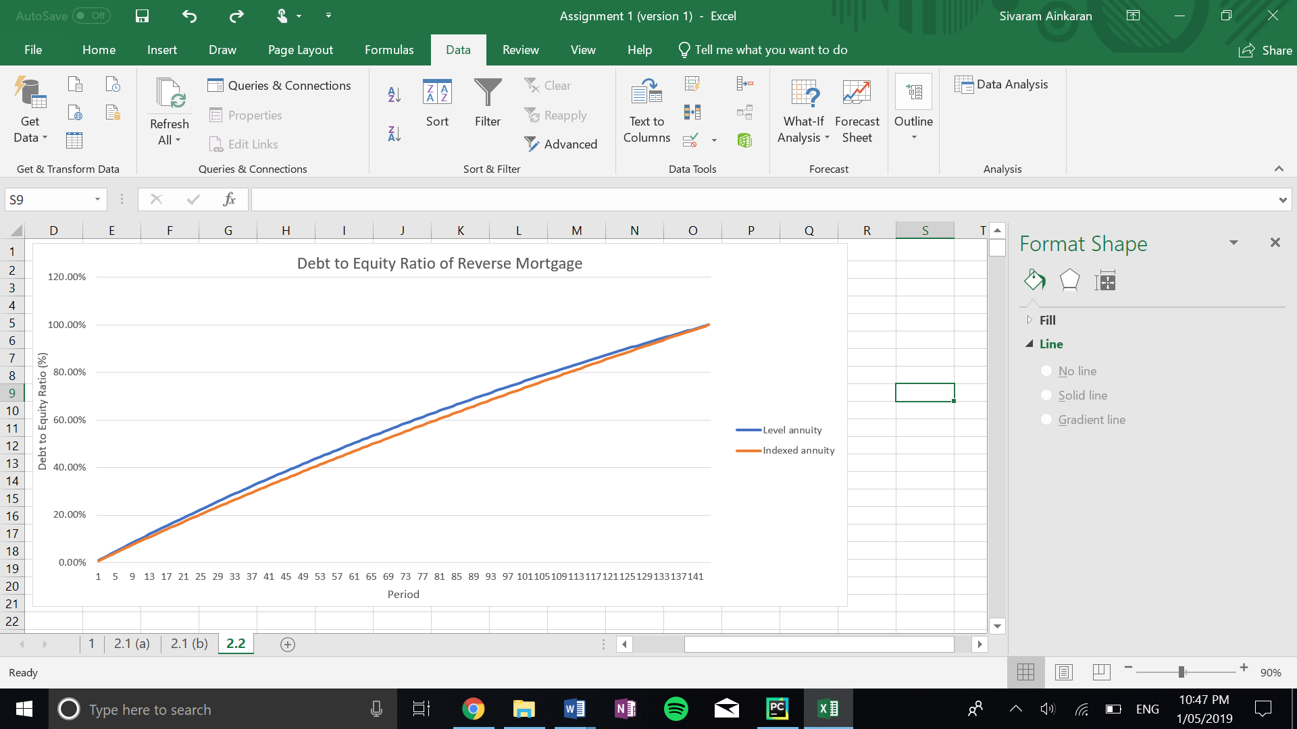

**Sensitivity Analysis**

DE ratio = Debt to Equity Ratio

For the following analysis, The DE ratio at the final payment of the term was used and monthly payments were kept the same.

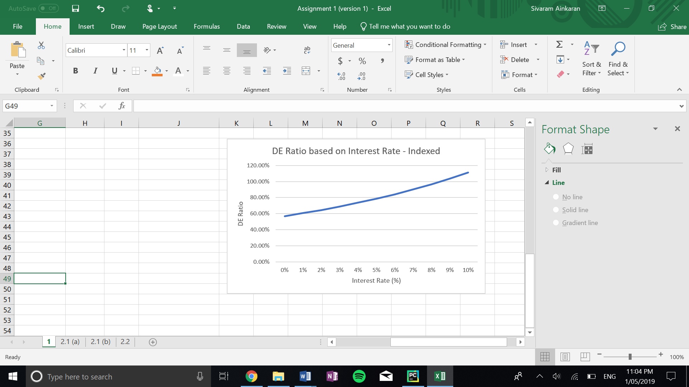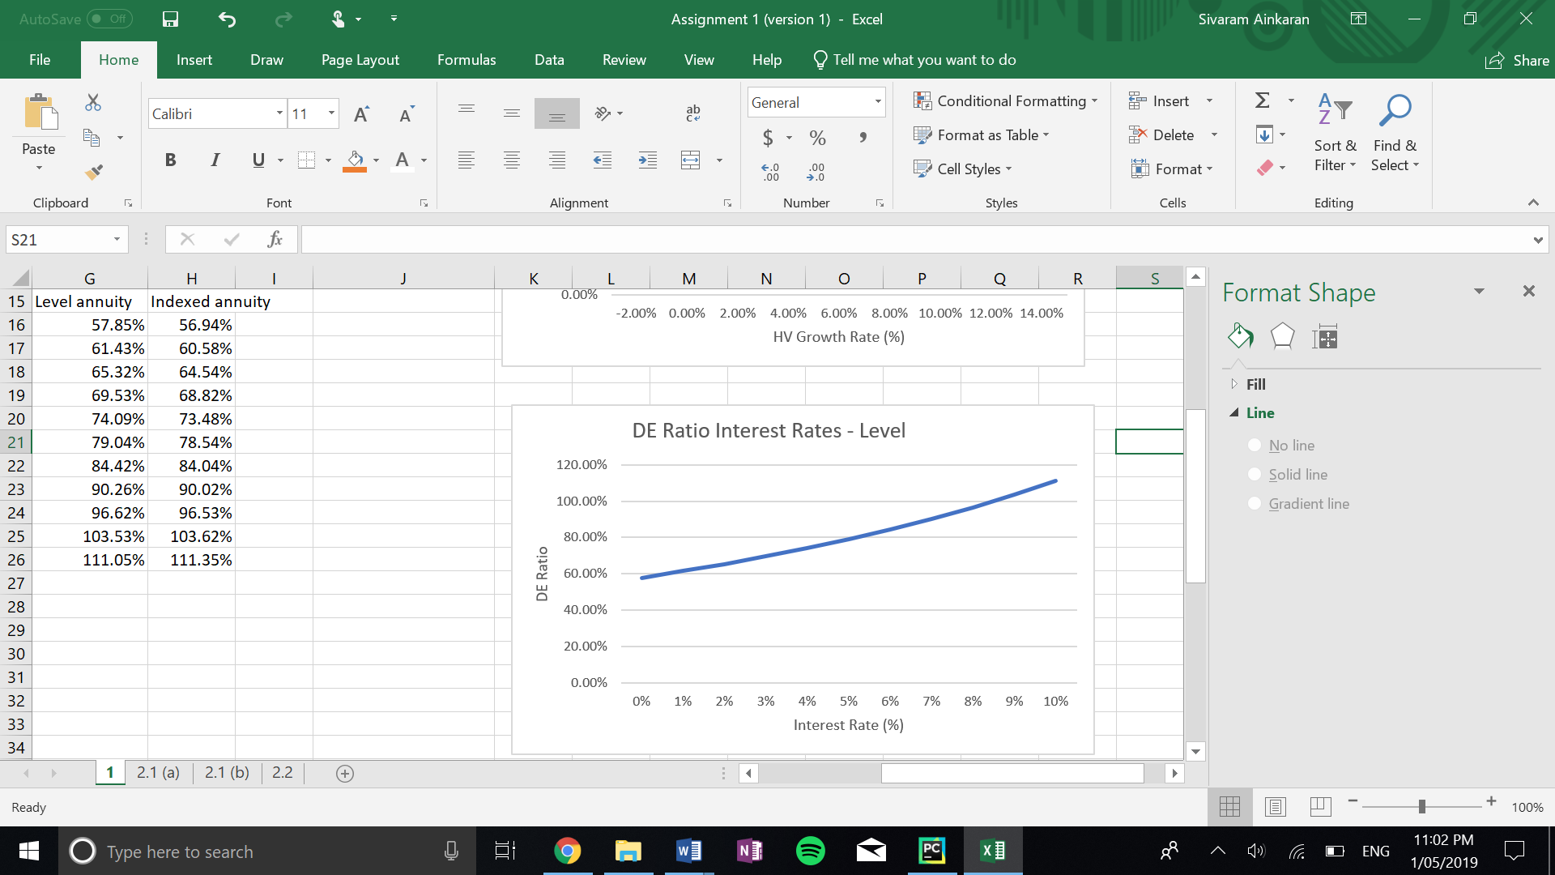Interest Rate:

As Interest Rate Increases:

* The DE ratio also increases for both annuities
* Any rate higher than current interest rate (8.5%) produces a DE ratio > 100%

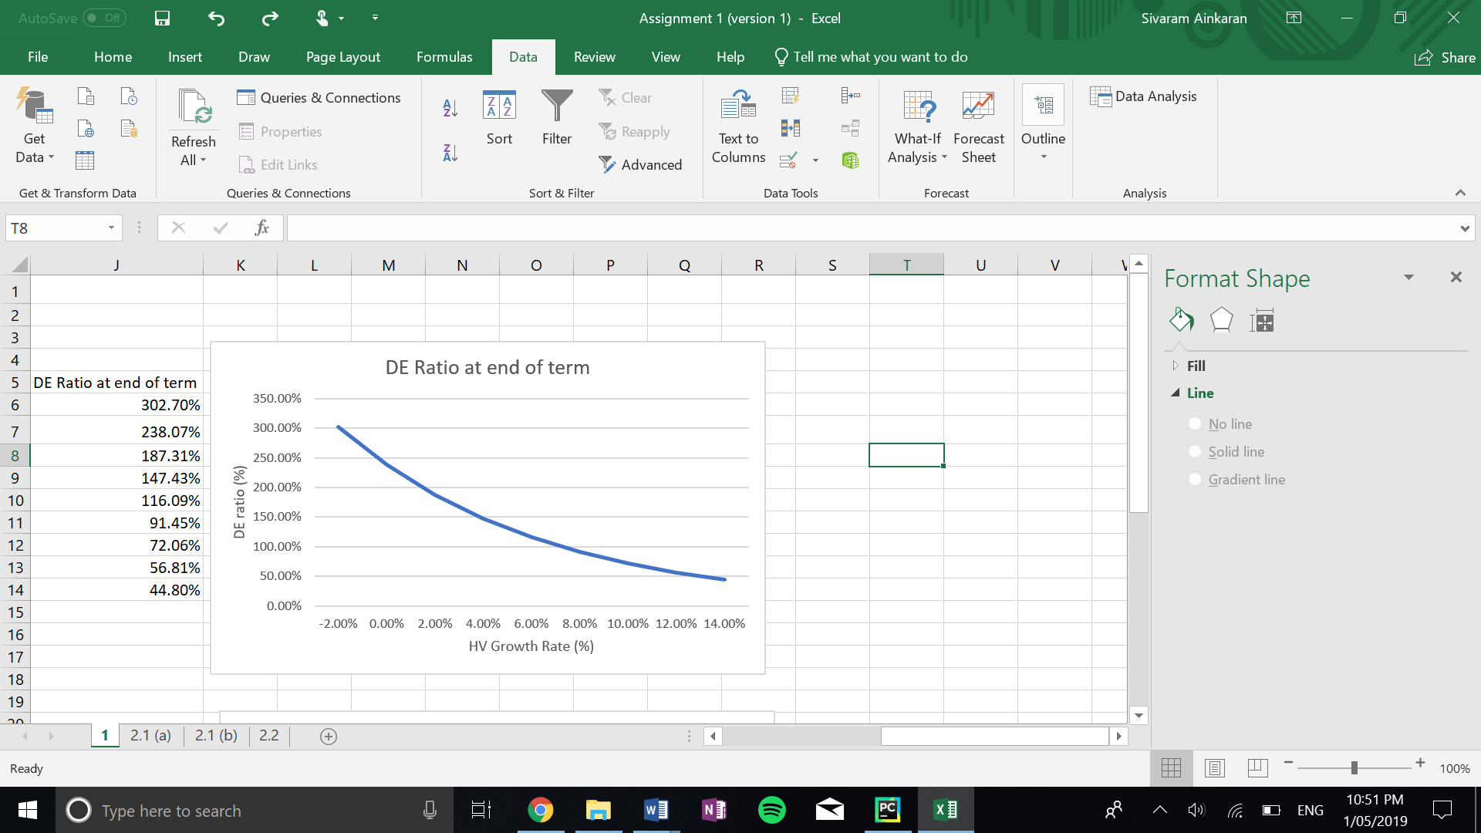House growth rate:

Level and Indexed annuities have the same DE ratio at term end for different House value growth rates (due to “Goalseek”).

As House growth rate increases:

* DE ratio decreases
* It decreases at a higher rate as growth rate increases
* Any rate lower than current growth rate (7.25%) produces a DE ratio > 100%

Risks of This Model

Interest rate:

* If Interest rate increases due to economical factors, debt will accumulate to be greater than house value.

House Value growth rate:

* If house value growth rate falls suddenly (it will not stay at one value), debt can quickly accumulate to be greater than the house value.

Term length:

* If borrower lives longer than mortgage term, they will accumulate debt greater than the value of their house.

The Loan issuer makes losses in these cases.

Appendix (links)

1. Inflation rate from RBA: <https://www.rba.gov.au/inflation/measures-cpi.html>

* Using Trimmed mean: 1.6% right now

1. Life expectancy from Australian Institute of Health and Welfare: <https://www.aihw.gov.au/reports/life-expectancy-death/deaths-in-australia/contents/life-expectancy>

* For a female born in the 1950s, aged 65 now will live to be approx. 80.7 years old
* For a male born in the 1950s, aged 65 now will live to be approx. 77.5 years old

1. Interest rate: <https://www.commbank.com.au/content/dam/commbank/personal/home-loans/fact-sheets/key-information-reverse-mortgages.pdf>

* Commbank charges about 8.5% interest on these loans

1. Average increase in house valuation: <https://www.rba.gov.au/publications/bulletin/2015/sep/pdf/bu-0915-3.pdf>

* Based on this RBA article house values have climbed at an average rate of about 7.25% per annum on average in Australia.