Week 10:

241001252

Question 1:

Given a string, s, consisting of alphabets and digits, find the frequency of each digit in the given string.

Input Format

The first line contains a string, num which is the given number.

Program:

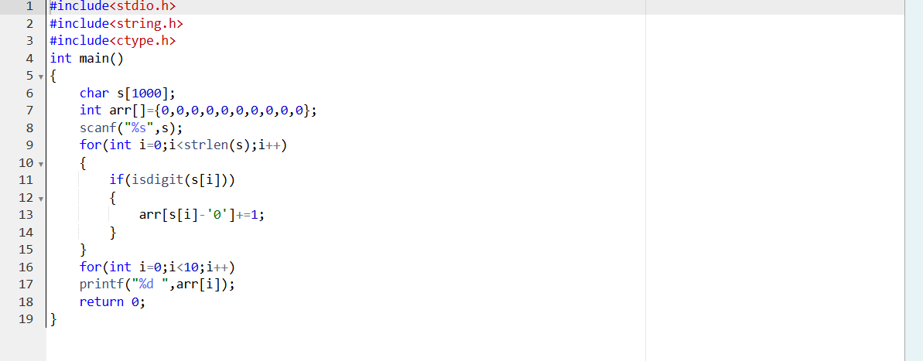

Output:

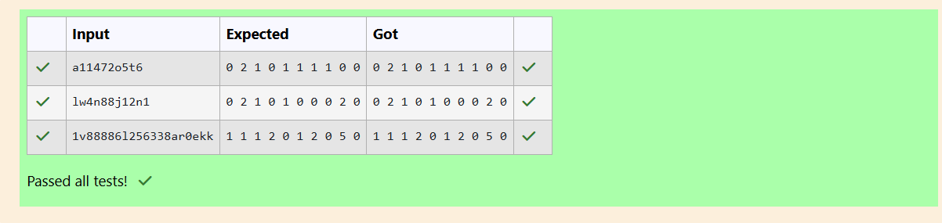

Question 2:

Today, Monk went for a walk in a garden. There are many trees in the garden and each tree has an English alphabet on it. While Monk was walking, he noticed that all trees with vowels on it are not in good state. He decided to take care of them. So, he asked you to tell him the count of such trees in the garden.

Note: The following letters are vowels: 'A', 'E', 'I', 'O', 'U', 'a', 'e', 'i', 'o' and 'u'.

Input Format:

The first line consists of an integer T denoting the number of test cases.

Each test case consists of only one string, each character of string denoting the alphabet (may be lowercase or uppercase) on a tree in the garden.

Output Format:

For each test case, print the count in a new line.

Constraints:

1 ≤ T ≤ 10

1 ≤ length of string ≤ 105

Program: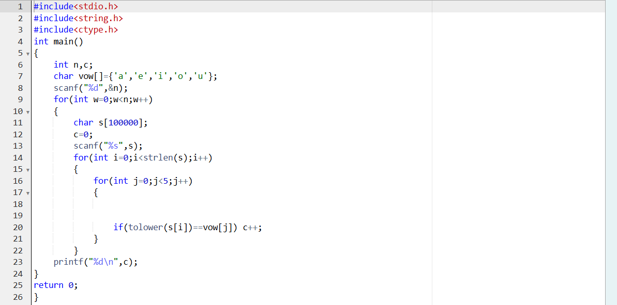

Output:

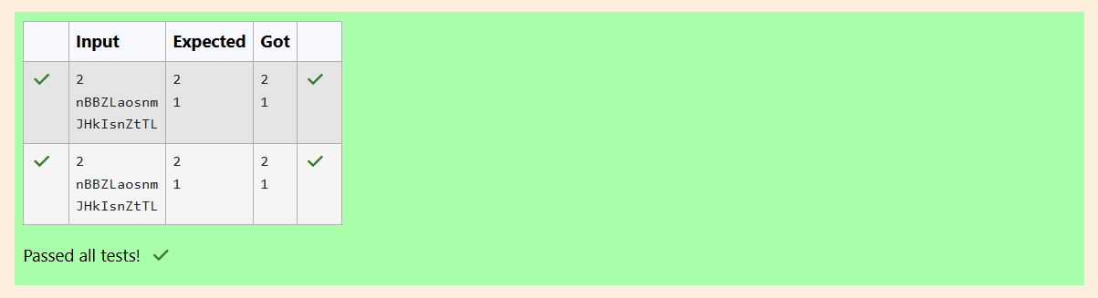

Question 3:

Given a sentence, s, print each word of the sentence in a new line.

Input Format

The first and only line contains a sentence, s. Constraints 1 ≤ len(s) ≤ 1000

Explanation

In the given string, there are three words ["This", "is", "C"]. We have to print each of these words in a new line.

Hint

Here, once you have taken the sentence as input, we need to iterate through the input, and keep printing each character one after the other unless you encounter a space. When a space is encountered, you know that a token is complete and space indicates the start of the next token after this. So, whenever there is a space, you need to move to a new line, so that you can start printing the next token.

Program: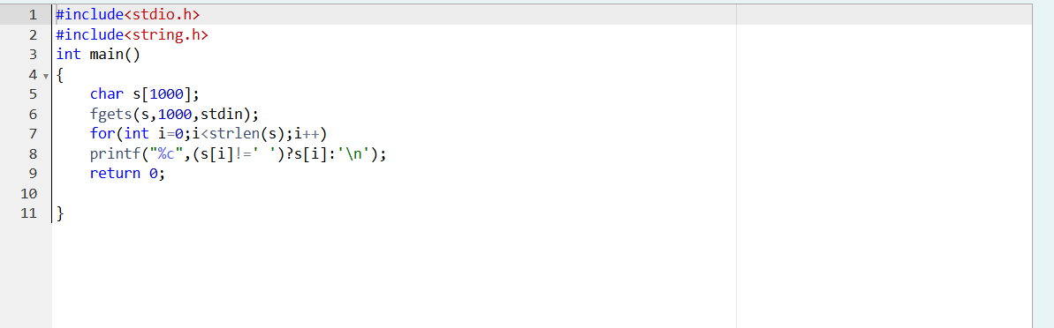

Output: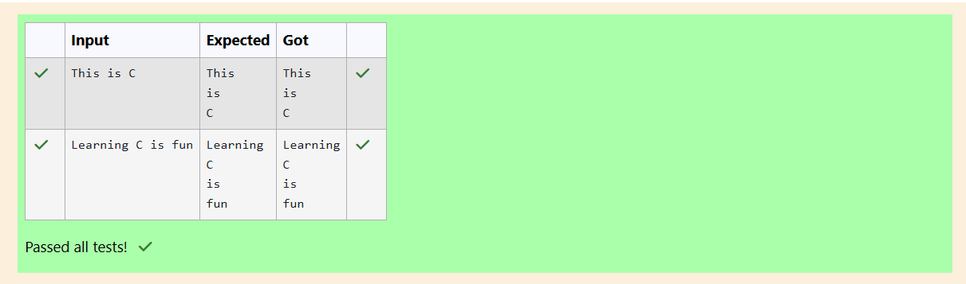

Question 4:

Input Format

You are given two strings, a and b, separated by a new line. Each string will consist of lower-case Latin characters ('a'-'z').

Program: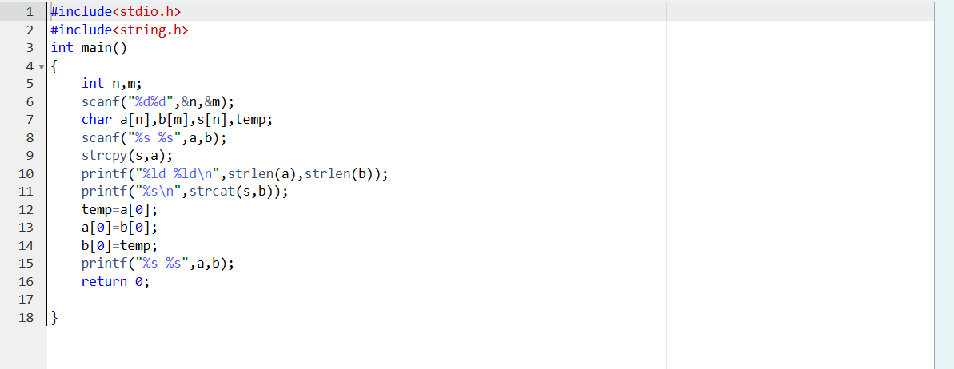

Output: