# INDRODUCTION :

1. overview

# Purpose

we Designed a business card using canva software. Canva is a user-friendly.

Our project is to creat a business card. Using canva we completed our project.

# Problems Deﬁnition&Design Thinking:

* 1. Empathy map:

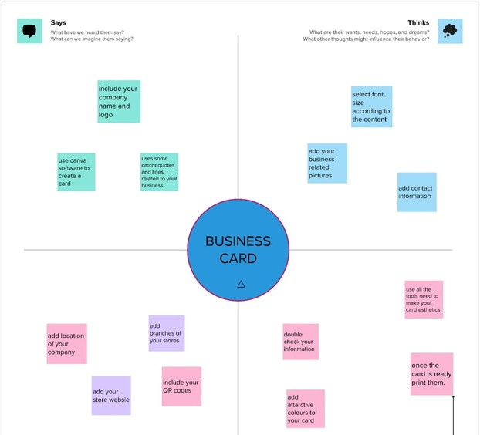

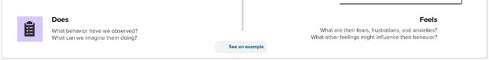

# Brain strom and idea prioritization

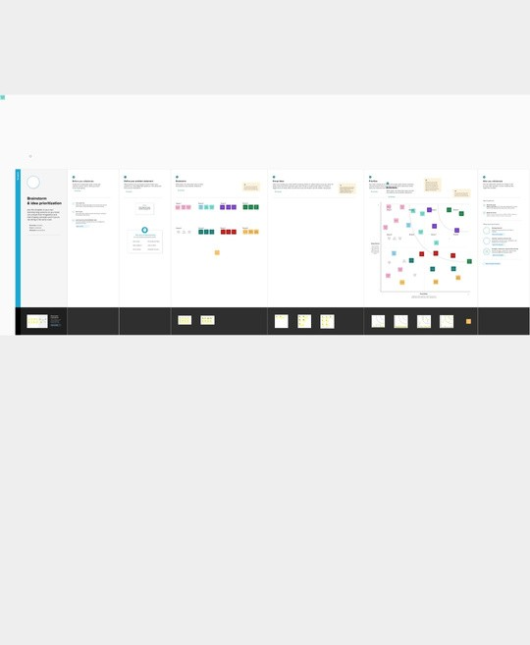

1. Result





4 ADVANDAGES AND DISADVANDAGES :

Easy to using this canva Beginers can use canva.

Can has many diﬀerent templets.

Canva is a very useful software for everyone.

# 5. CONCLUSION

Canva app is very useful to create my project on business card. It has

lots of designed templates. It is free to use, students can be easily able to edit like a professional editor with help of this app.