Ex No: ____ | Game Development – Jungle Rush: The Lost Temple | Date:

1. Aim
To design and develop a 2D adventure platformer titled Jungle Rush: The Lost Temple using GDevelop, demonstrating scene design, player movement, collision detection, collectibles, health tracking and scene transitions through visual event-based development.
2. Game Overview
Jungle Rush: The Lost Temple is a jungle-themed side-scrolling platform game. The player explores a mysterious jungle, jumps between platforms, collects coins and avoids obstacles while progressing toward an ancient temple.
The supplied screenshots show the main menu with Play and How to Play buttons, and a jungle gameplay scene with platforms, coins, health indicators, a coin counter, pause control and touch controls. Planned extensions include temple keys, a switch puzzle, a guardian encounter, Game Over and Victory scenes. These advanced features should be described as completed only after they are implemented and tested.
3. Tool Used
The game is designed using GDevelop, a visual game development platform that supports scene creation, object-based design, built-in behaviours and event-based logic. It enables 2D games to be developed without writing traditional programming code.
The scene editor is used to arrange backgrounds, sprites, platforms and interface objects. The event system can handle movement, jumping, collisions, coin collection, health changes, score updates and scene transitions.
Requirements
• A computer or mobile device with a web browser and internet connection.
• Access to the GDevelop editor.
• Original or legally usable assets for characters, backgrounds, platforms and sounds.
• Keyboard and/or touch screen for testing controls.
4. Components Involved
• Scenes – MainMenu, JungleRun, TempleLevel, GameOver and Victory.
• Sprite objects – player, enemies, coins, keys, power-ups and treasure.
• Platform objects – ground, ledges and moving platforms.
• Text objects – title, health, coin count, keys and score.
• Buttons – Play, How to Play, Pause, Try Again, Play Again and Main Menu.
• Behaviours – platformer character and platform behaviours.
• Events and variables – collisions, coin collection, health changes, score updates, scene changes and win/loss conditions.
5. Game Flow
The game is organised into stages, starting at the main menu and progressing through the jungle level toward the ancient temple.
Stage 1: Setting Up the Project
• Open GDevelop and create a new 2D game project.
• Name it Jungle Rush: The Lost Temple.
• Create MainMenu, JungleRun, TempleLevel, GameOver and Victory scenes.
• Set a suitable game resolution and layout for desktop and mobile play.
Stage 2: Designing the Main Menu
• Add a jungle/sky-and-forest background to MainMenu.
• Add the title “JUNGLE RUSH: THE LOST TEMPLE”.
• Add Play and How to Play buttons.
• Create an event so Play opens JungleRun.
• Provide instructions through a panel or a separate How to Play scene.
Stage 3: Creating the Jungle Level
• Add a player character and platforms across the level.
• Add trees, bushes, palm trees, bridges, ruins and jungle decorations.
• Apply platformer behaviour to the player and platform behaviour to the ground.
• Make the camera follow the player through the level.
• Place coins and create collision events that increase the coin counter and remove collected coins.
• Add gaps, rocks, spikes, enemies and moving platforms as required.
Stage 4: Health, Controls and Interface
• Set the player's starting health to three points and show health icons.
• Reduce health when the player touches an enemy or harmful obstacle.
• Change to GameOver when health reaches zero.
• Display the coin counter and a pause button.
• Add left, right and jump touch controls for mobile, or keyboard controls for desktop.
• Test movement, jumping, collecting coins and platform collisions.
Stage 5: Temple Level and Progression
• Design TempleLevel with stone platforms, torches, ancient symbols, traps and a treasure room.
• Add three keys and display “Keys: 0/3”.
• Increase the key count when a key is collected and open the door after all keys are found.
• Add a three-switch puzzle with a clue and check the switch order through events.
• Add a temple guardian with five health points and implement attack/damage events.
• Allow access to the treasure room after the guardian is defeated.
Stage 6: Game Over, Victory and Testing
• Design GameOver with final score, Try Again and Main Menu buttons.
• Design Victory with “YOU FOUND THE LOST TEMPLE!”, score, coins, Play Again and Main Menu buttons.
• Test menu navigation, movement, jumping, platform collisions and coin collection.
• Test health reduction, zero-health GameOver and victory transitions.
• Test touch controls on mobile and correct any issues.
6. Screenshot with Explanation
Figure 1: Main Menu of Jungle Rush: The Lost Temple. The screenshot shows the game title, jungle-themed background and Play and How to Play buttons. It serves as the starting screen for the adventure.
Figure 2: Jungle Gameplay Scene. The screenshot shows a side-scrolling platform environment with green platforms, trees, coins and the player character. Health icons and the coin counter are at the top-left, pause control is at the top-right, and touch controls are near the bottom for movement and jumping.
Figure 1: Main Menu
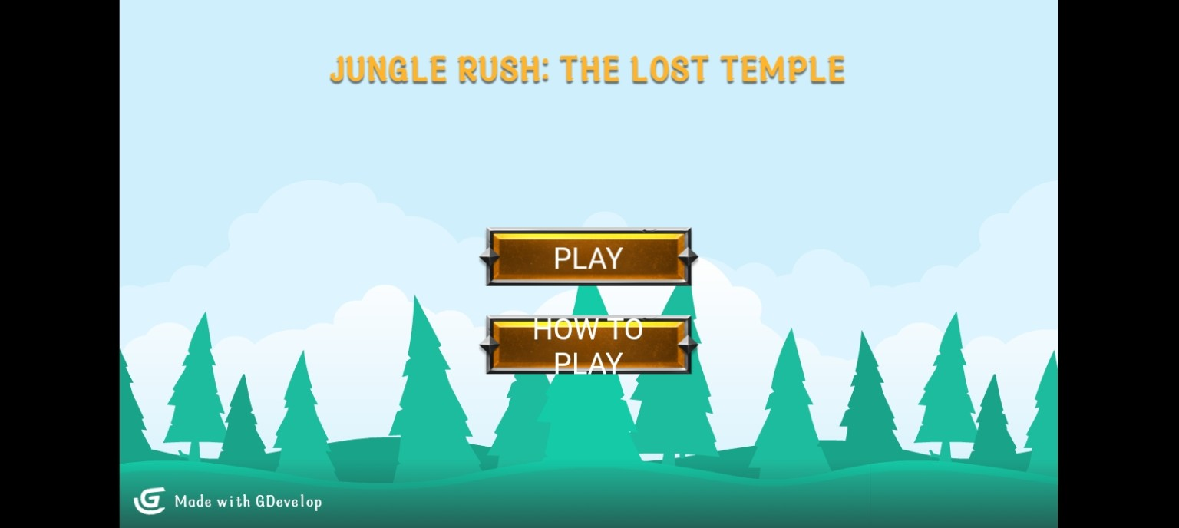
Figure 2: Jungle Gameplay
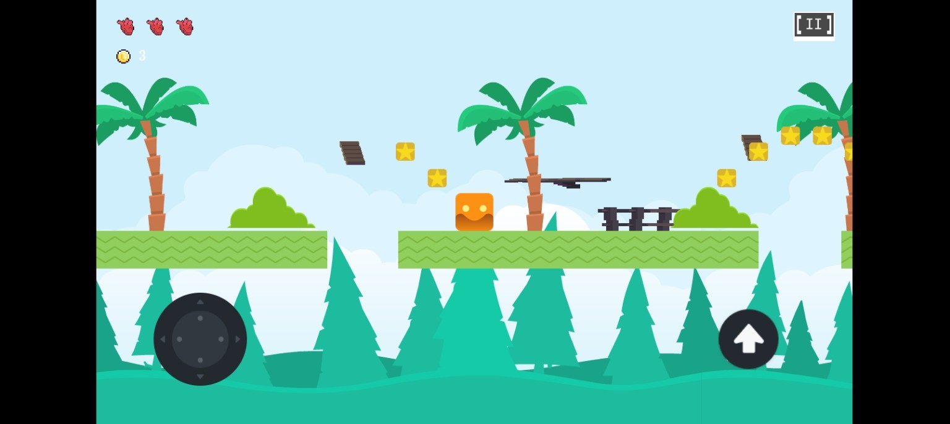
7. Result
The design and development record for Jungle Rush: The Lost Temple was prepared using GDevelop as the selected tool. The supplied screenshots demonstrate a main menu and a jungle platformer gameplay scene. The proposed game design covers movement, collectibles, health, obstacles, mobile controls and progression toward a temple level. Only features implemented and tested in GDevelop should be claimed as completed.
Main Features Shown / Planned
• Jungle adventure title screen with Play and How to Play options.
• Side-scrolling jungle platform gameplay.
• Player character, platforms, trees and collectible coins.
• Health indicators and coin counter.
• Pause control and on-screen movement/jump controls.
• Planned temple keys, puzzle, guardian, treasure, Game Over and Victory scenes.
Possible Improvements
• Add sound effects for jumping, collecting coins, damage and victory.
• Add checkpoints and gradually harder level sections.
• Add shield, speed boost and coin magnet power-ups.
• Add more enemies and moving platforms.
• Save best score between sessions.
• Improve animations, layered backgrounds and mobile controls.

