**08-06-2022**

**By**

**Sivarathri Brahmaiah**

**1)**It involves various steps

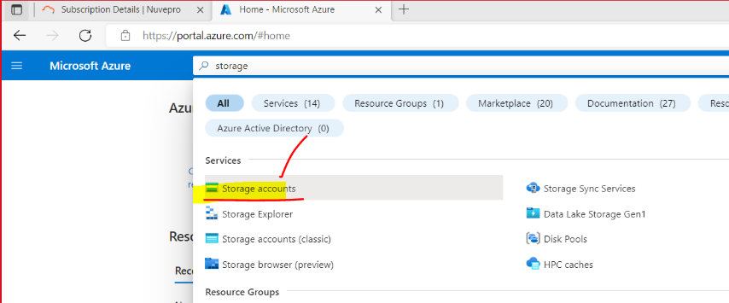First in azure account search storage accounts

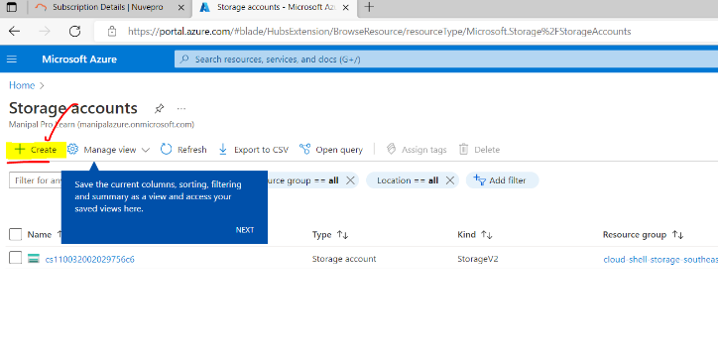Then click on the storage accounts then create new

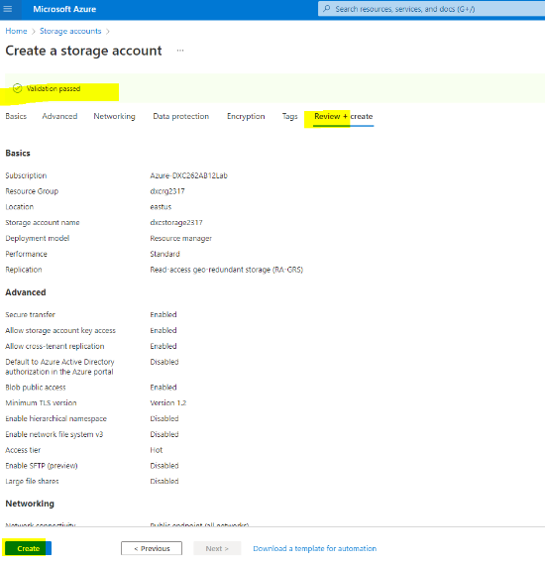Now give the basic information and click on review and create

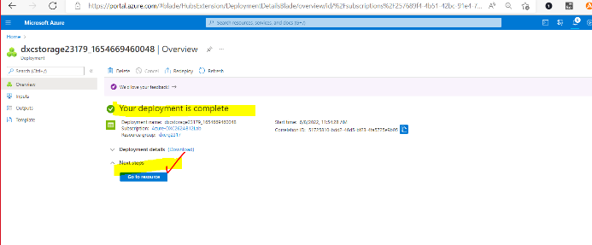After creation of the deployment then go to resources

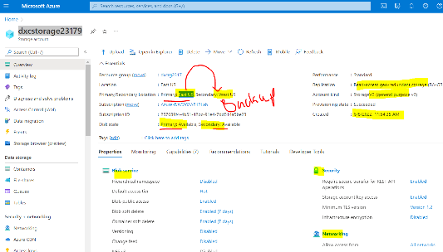Finally storage blob will be created

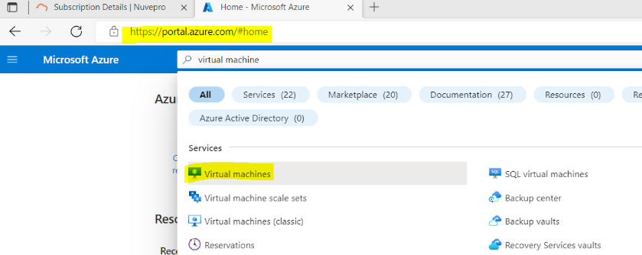**2)** Go to virtual Machines

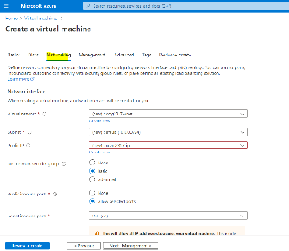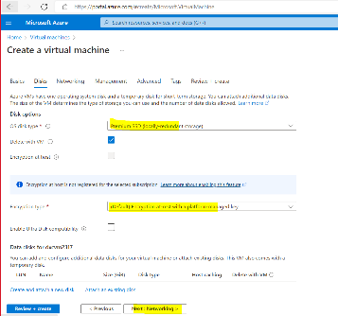Then click on virtual machine and create then give basic information and also give disk information.

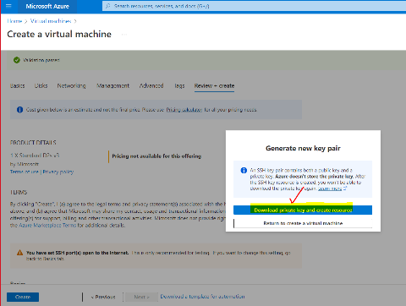Like that also fill management information then create. After that we need to download the some information

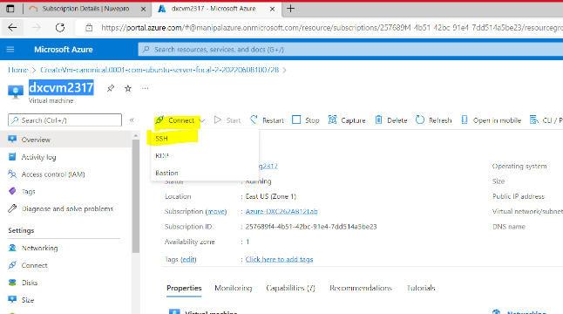Then you can connect the ssh

Here we can run it in 3 ways

a)Through cmd prompt

In command prompt we give command

b)Through Bastion:

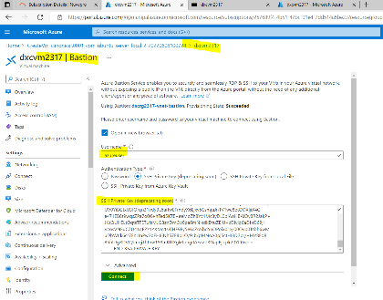 In bastion we need to copy all the address manually and paste it in SSH primary key section which is shown in below

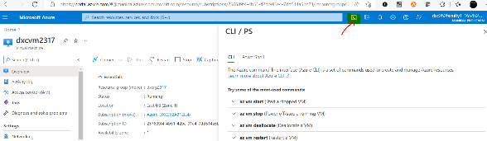c)Through cpl

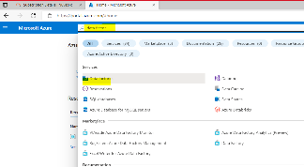**3)** Search as data factory in azure which is shown in below

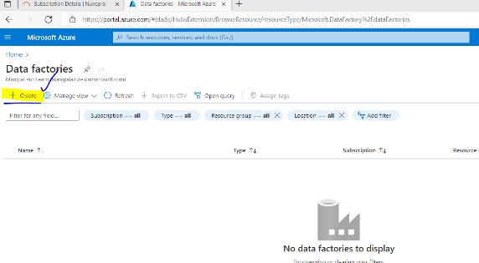Then create factory

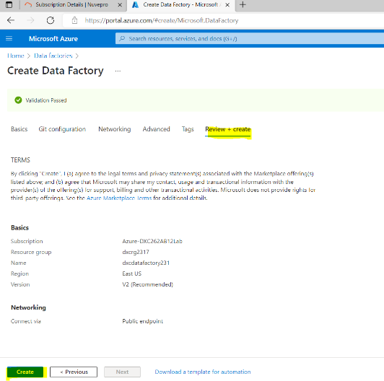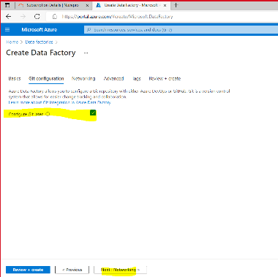And give the basic information and create

After click on the create then deployment will be created.

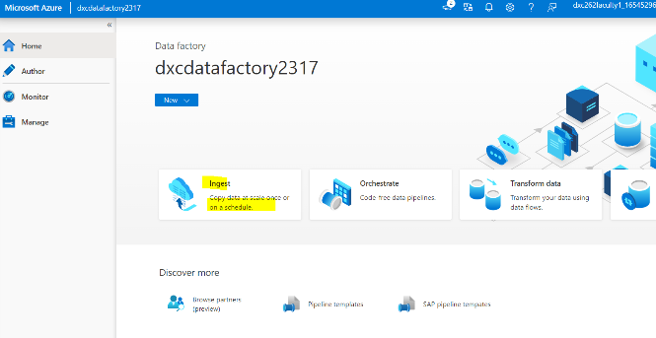**4)** In storage blob we already created in one file which has some information. And again create another file which is empty file. Then go to the data factory in the ingest. From ingest you need to some file information

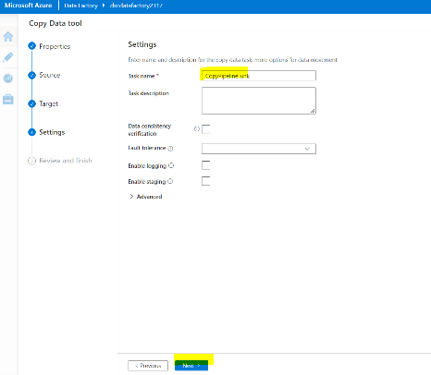After changing the all the settings click on next select the files then the information is copied into the empty file

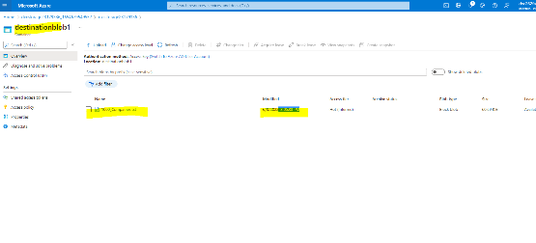

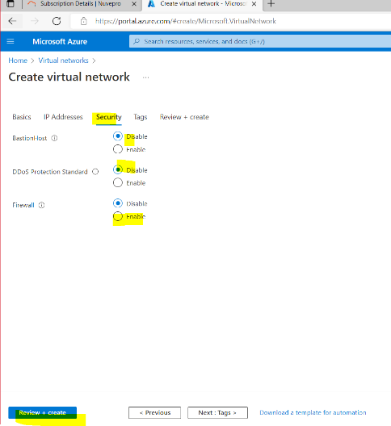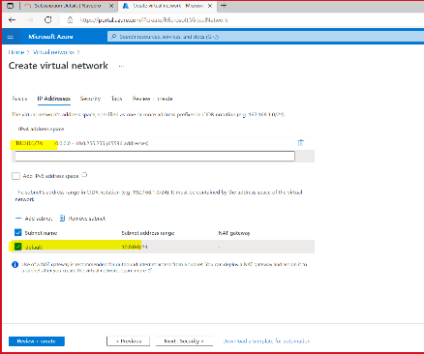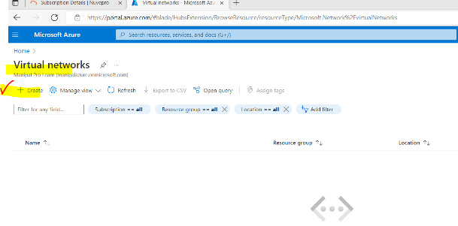**5)** Search virtual network

Fill the IP address and some requirement information and click on the review and create

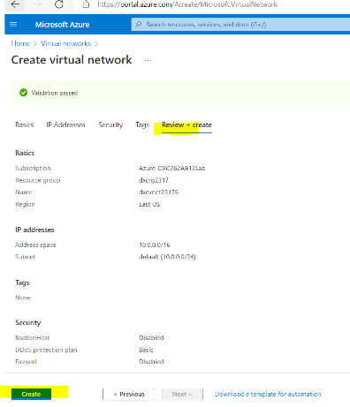After successful validation deployment will be created.

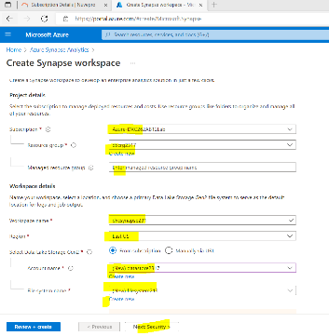**6)** Go to synopse . In that give the basic information. Here we have give some unique information or other wise it won’t take.

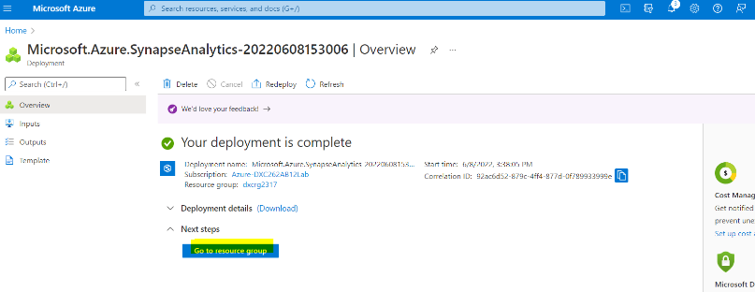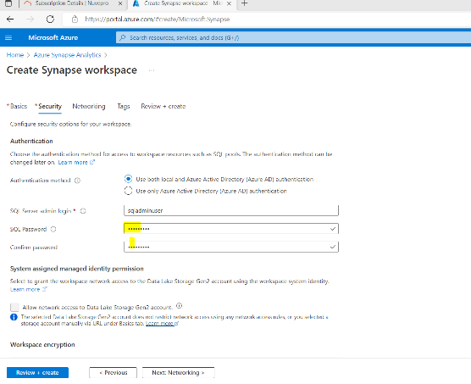And here we have to set one strong password and create

Finally go to resource and use from there.

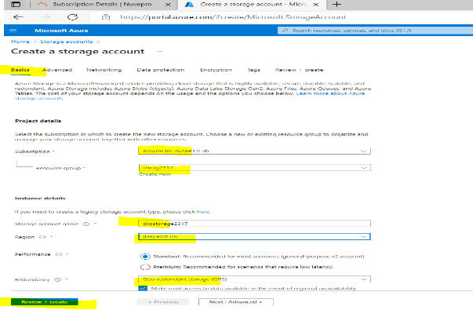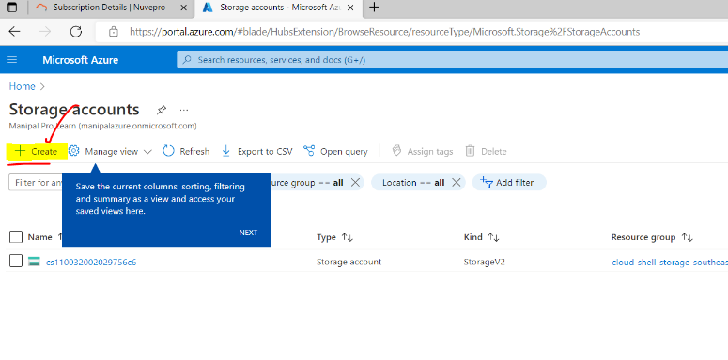**7)** Go to azure storage. Create new After that give the basic information.

After creation of the deployment go to resource and upload the any type of the files.

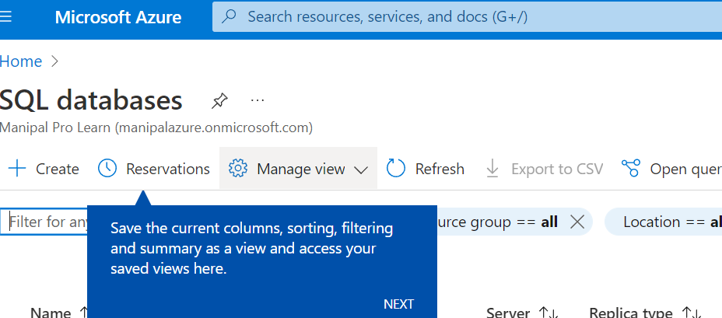**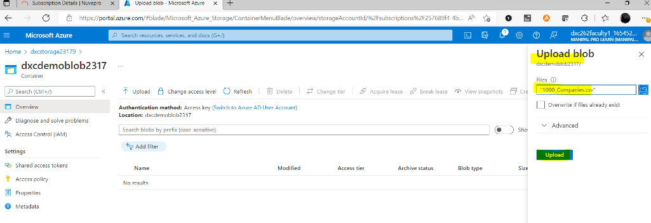8)** After creation of the storage blob go to the containers there we have to create the new one. Af ter creating the new file in the containers then we can upload data into storage blob.

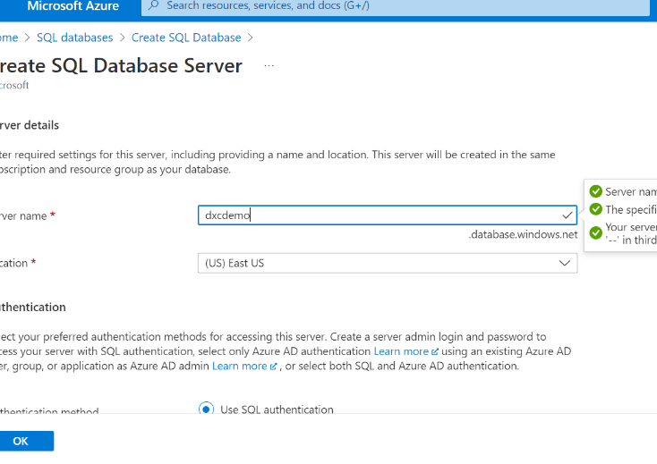**9)** Go to sql database and create

After creation of the fill the basic information and click on OK button. Then after some time deployment will be created.

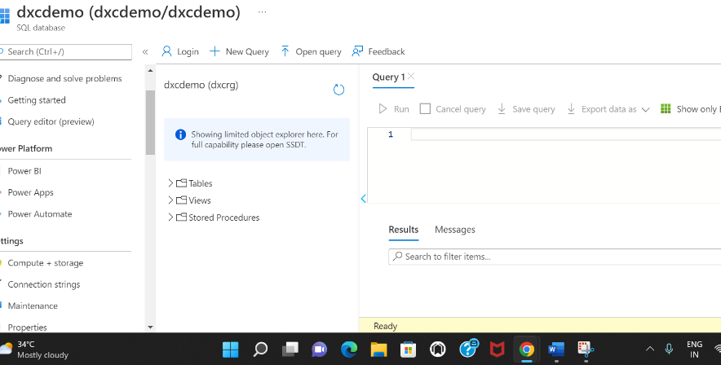10) In Sql database go to query editor there we have to give our credentials and also allow the fire walls and create the the tables and their information then run. It will give the result