**09-06-2022**

**By**

**Sivarathri Brahmaiah**

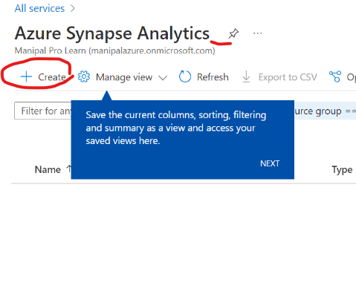**1)**

a) Go to azure synapse and click on create

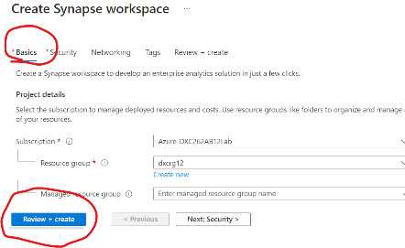 b) And fill the basic information and then click on the review

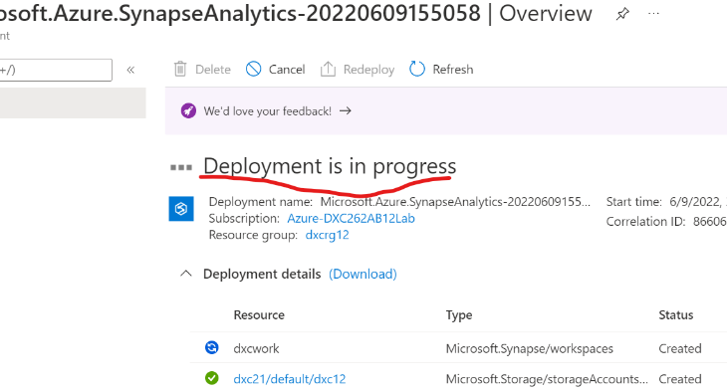 c)After completion of the validation click on create then it will show deployment is in progress

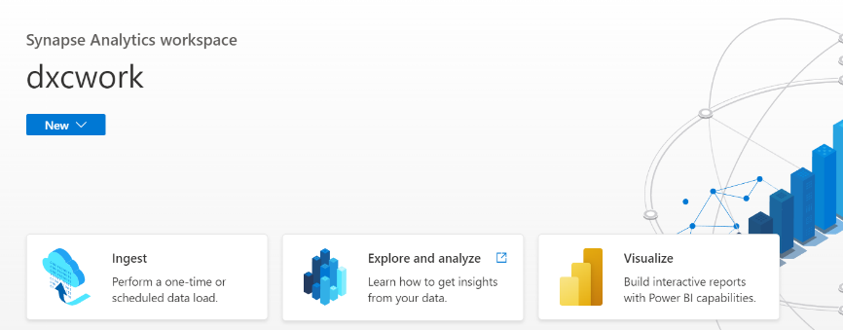d)After that it will show option like go to resource then azure analytics synopse will be created.

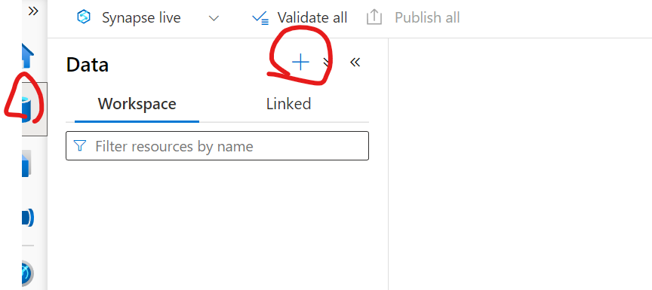**2)**

a) In synopse go to data and click on + symbol

b) Click on monitor and we have several options out of them we have to sql pool

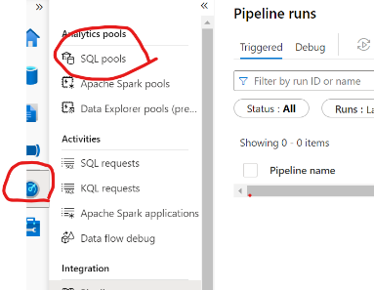

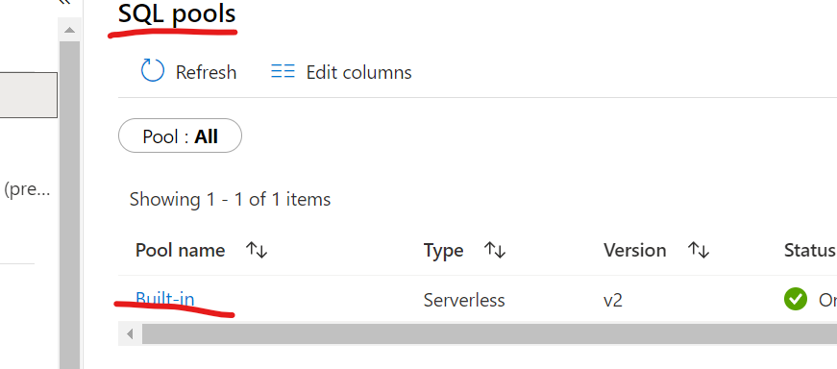c) In sql pool we can see the built in pool will exists.

**3)**

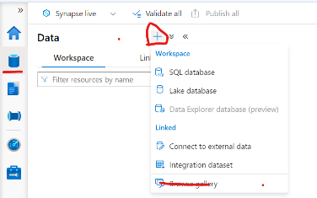a) Go to data field & click on + symbol then several options will be come. Out of them we need to select the browser gallery which is shown in below.

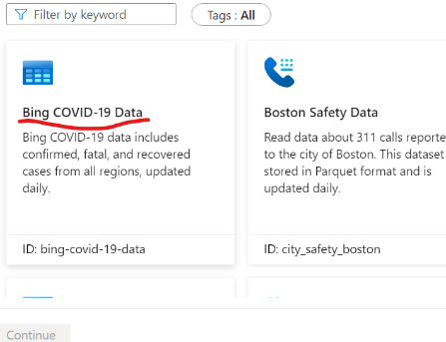b) Click on the covid 19 data then click on the add data

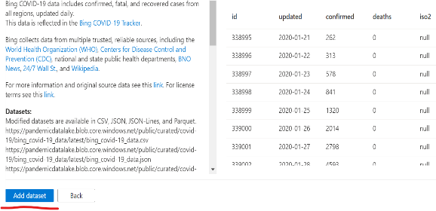

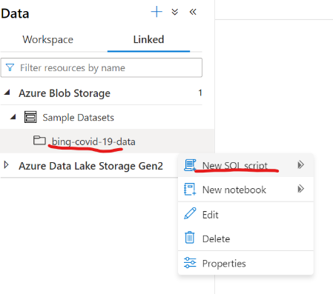c) Then uploaded data will be come and click on the new sql script which is shown in below.

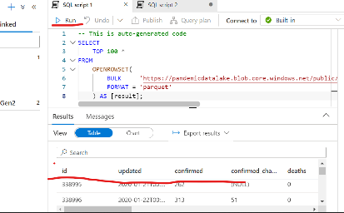d) Click on the run then the output will be come.

**4)**

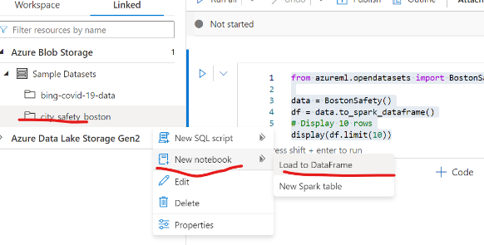a)In the storage we have baston data .Then click on the that different options will be come out them we choose note book as our option then click on the load to dataframe.

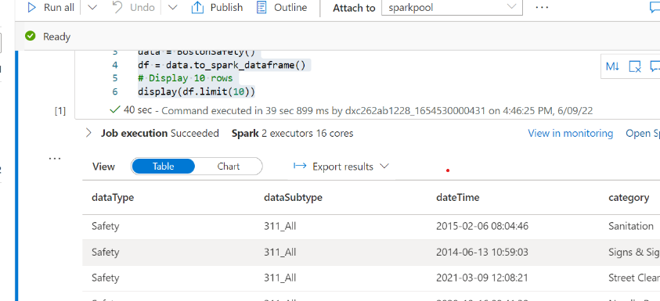b) Finally the data whatever we given is executed like this.

**5)**

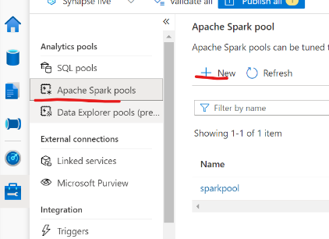a) Click on the apache spark pools then click on + symbol which is shown in below.

b) Then apche spark wil be created.

**6)**

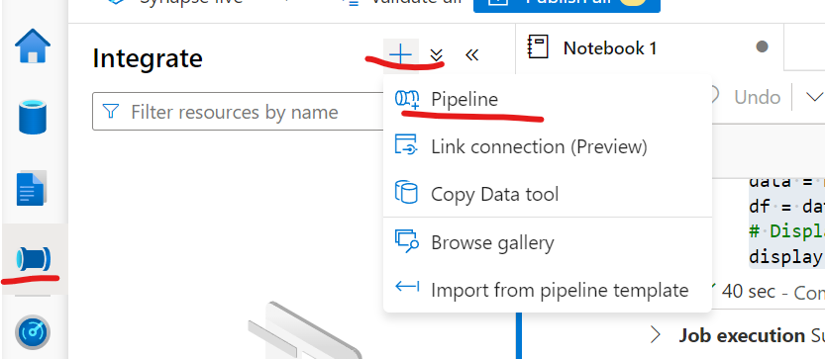a) Go to integrate and click on + symbol then click on the pipe line

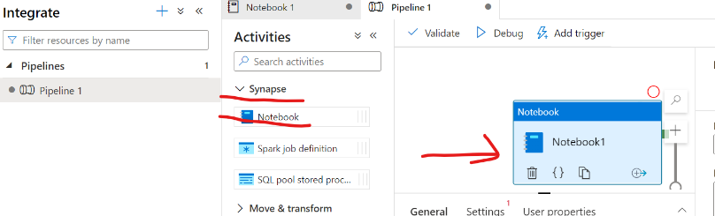b) Now click on the pipe line then various options will come. Then click on the synapse then note book option will come then drag and drop which is showing in below snap.

**7)**

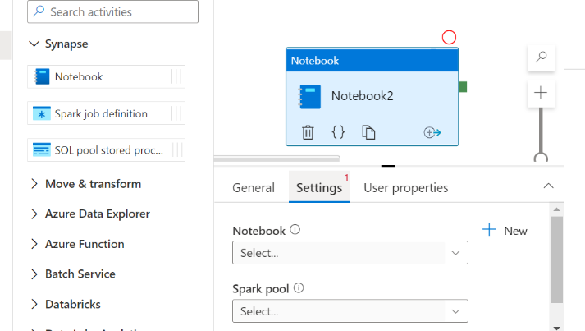a)Now go to note book and then drag and drop it. After that click on the seting then we have to fill the basic information which is shown in below.

b) Click on the Add trigger in that edit the trigger which is shown in below.

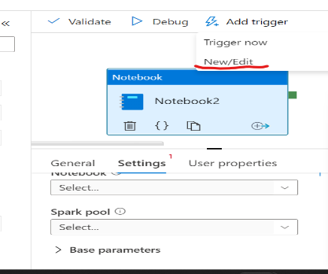

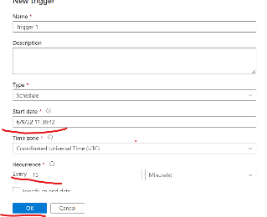c) And set time and occurance and click on ok button.Then automatically it will automate.

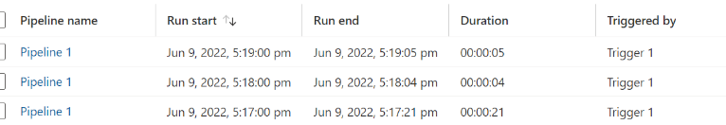

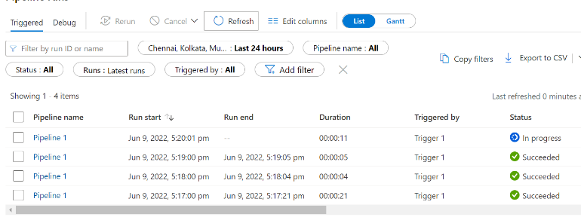d) Like this automatically updating the by every 1 minute(its our wish).

**8)**

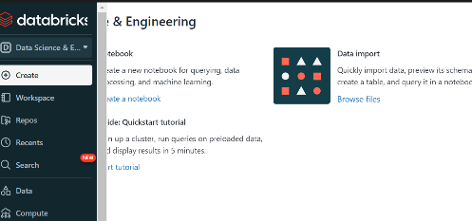a) Search data bricks then the following display will come.

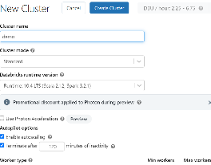b) go to compute give the cluster name, after that click on the create cluster.

**9)**

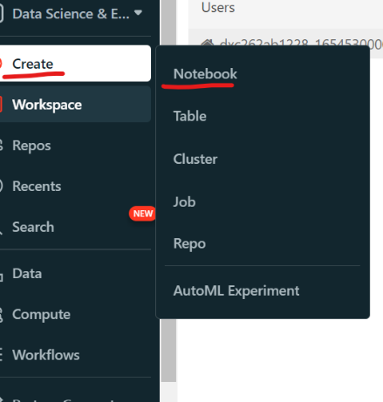a) Go to data bricks in that click on create button . Then note book option will come click on that.

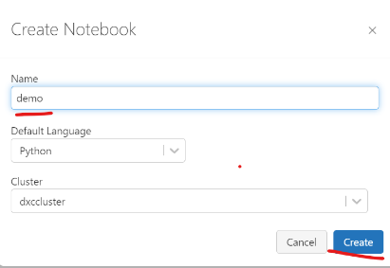b) Give valid name and then click on the create button.

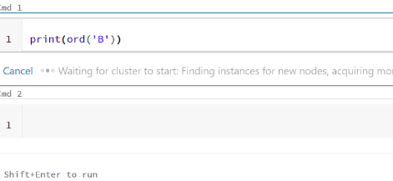c) After creation of the note book in data brick, we need to attach and then run.

**10)**

a)In data brick click on the note book and give name.

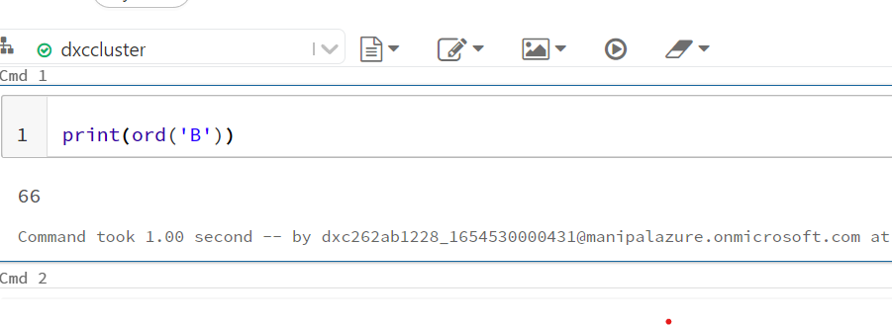b) And write the code in python and attach and run it.

**11)**

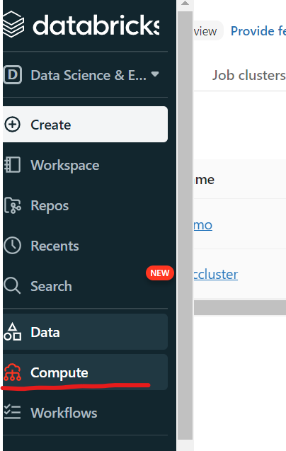a) In data bricks click on the compute

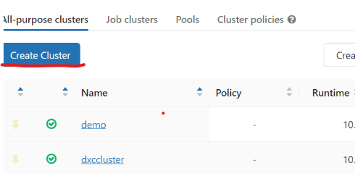b) Click on the new cluster.

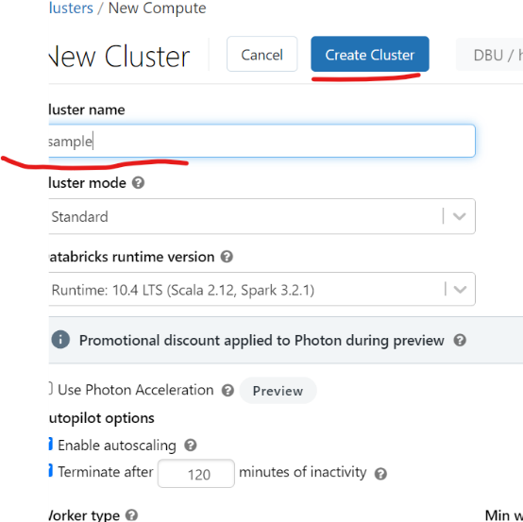C) Give the clusters names and click on the create cluster then cluster will be created.