**17-06-22**

**S.Brahmaiah**

1)

import matplotlib.pyplot as plt

y=[2010,2011,2012,2013,2014,2015,2016,2017,2018,2019,2020]

s=[169 ,199 ,262 ,301, 345 ,398 ,501, 595, 610 ,700,720]

plt.title('Scattering')

plt.xlabel('X axis')

plt.ylabel('y axis')

plt.plot(y,s,'o:y',marker='*',mec='g')

plt.show()

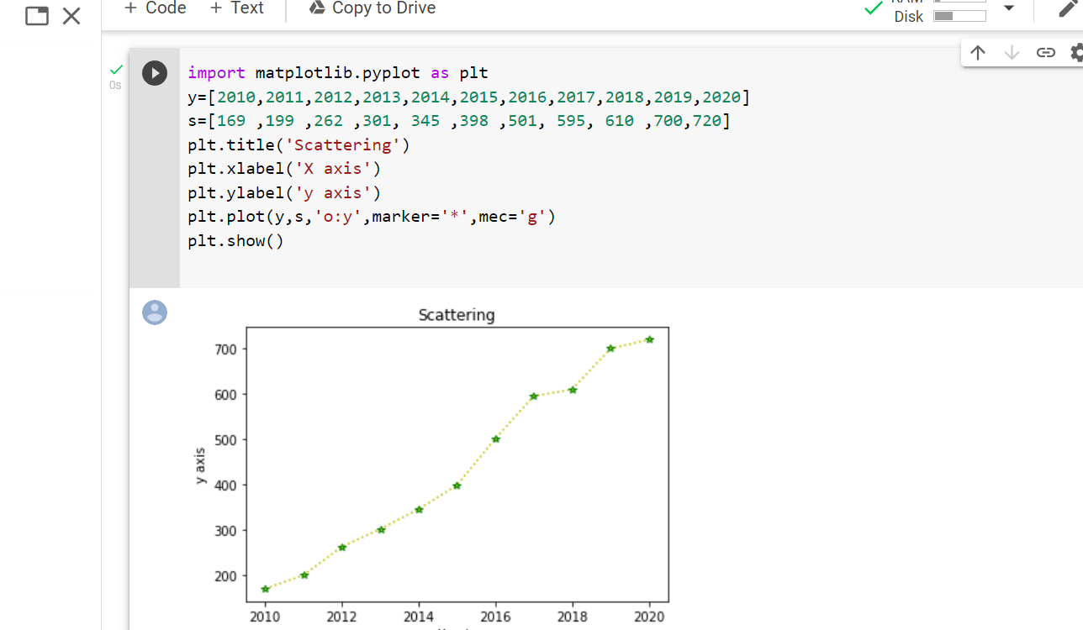

2)

l=list(map(int,input().split()))

m= list(input().split())

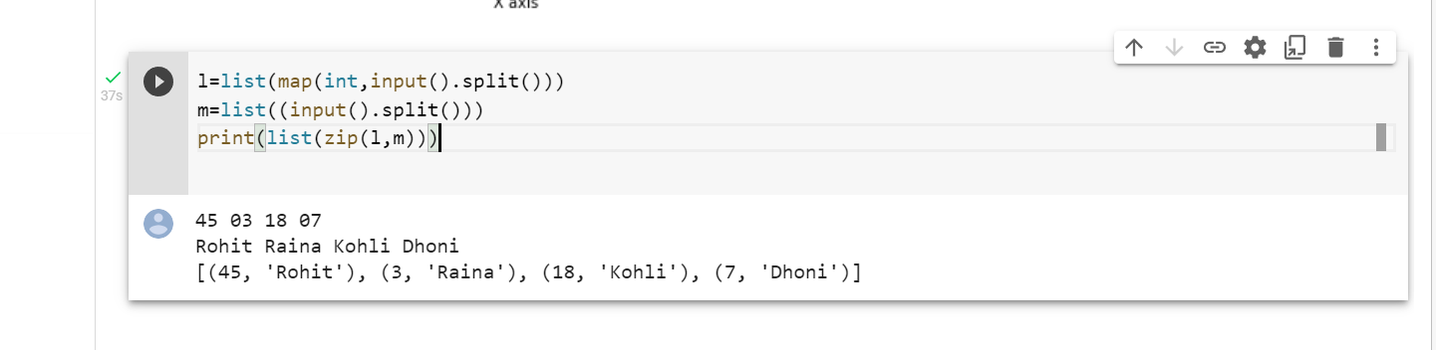print(list(zip(l,m)))

3)

For the creation of the databricks we need to click on the + symbol and fill the all the mandatory details. Then validate the data brick work space.

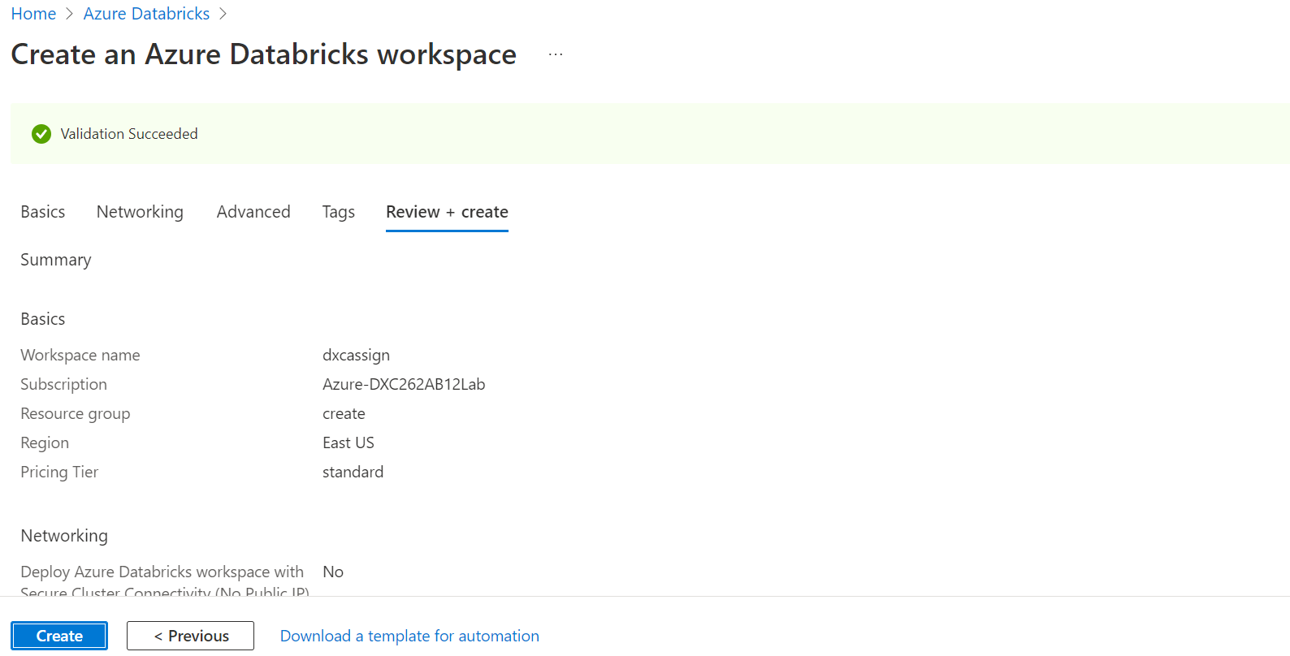

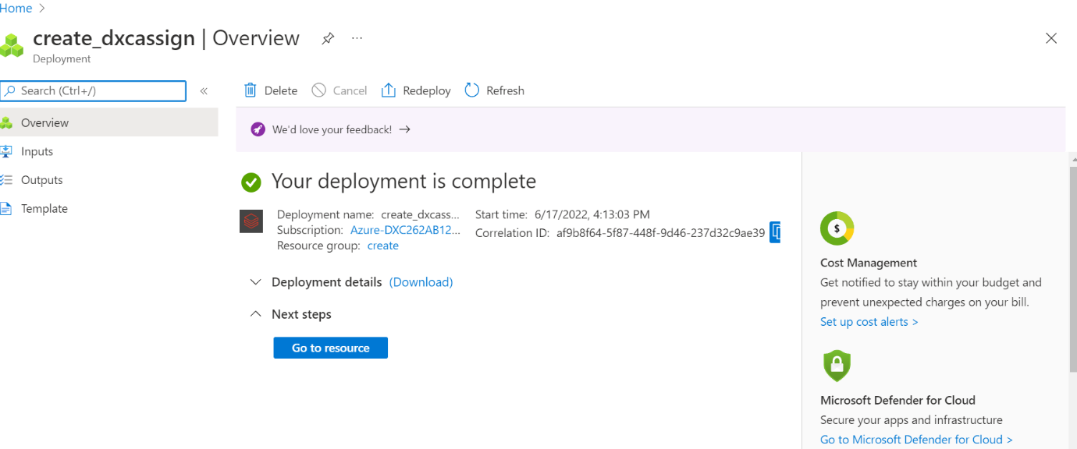Then we have to click on the create button then deployment will be initiated. After some time deployment will be created.

Then we have to click on the go to resource then entering into databricks go and click on the **launch workspace**

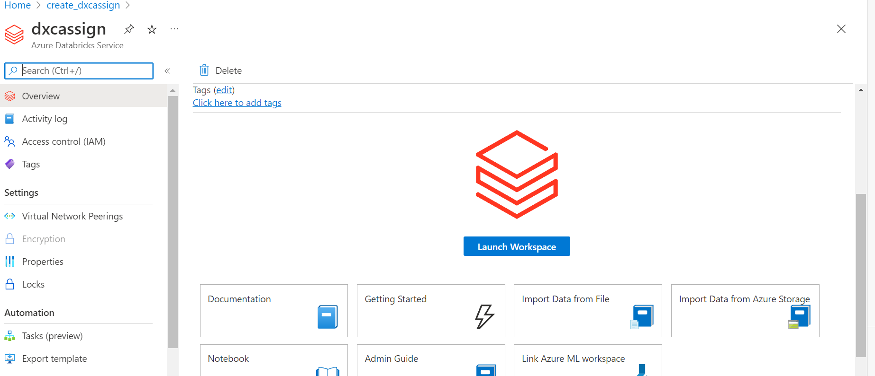

In databricks create a table for that we need to create the cluster at first then create the table. In that drag and drop the files. Click on the create table with UI

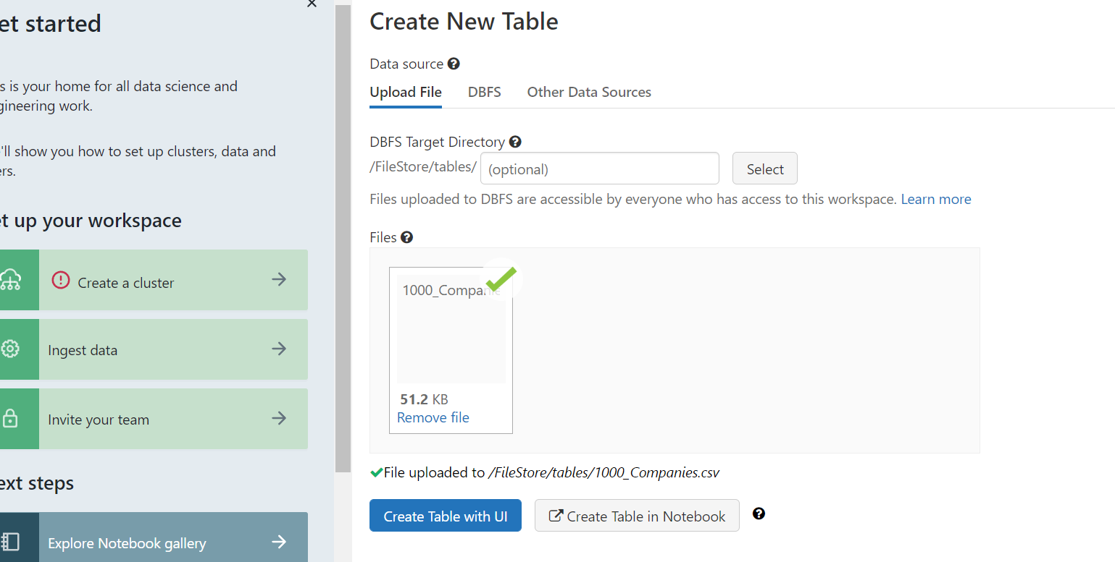

After creating the table then schema and sample data will come.

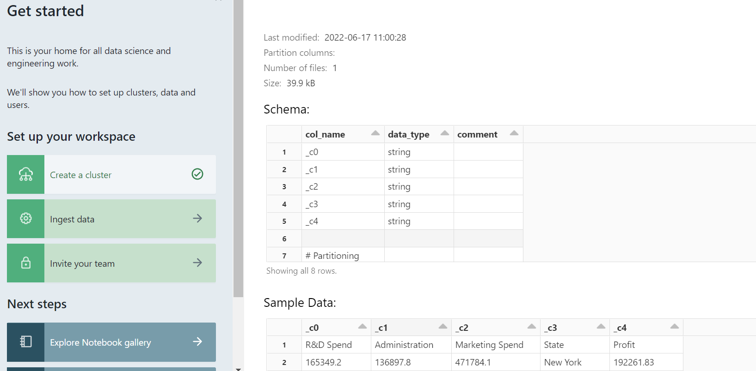

4)

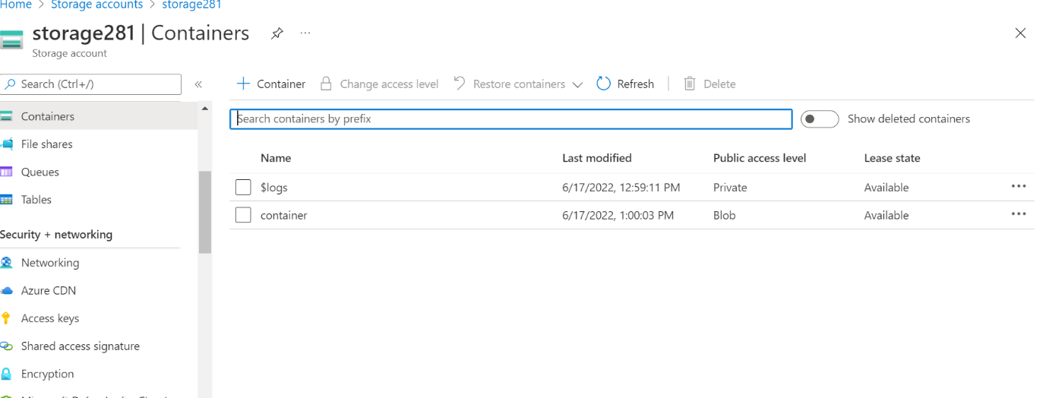Search blob storage and click on the + symbol and create by filling the all the required fields and click on the review and create. After deployment will be initiated. In the containers create new container by click on the + symbol

After creating the new container we need to upload files from the local computer.

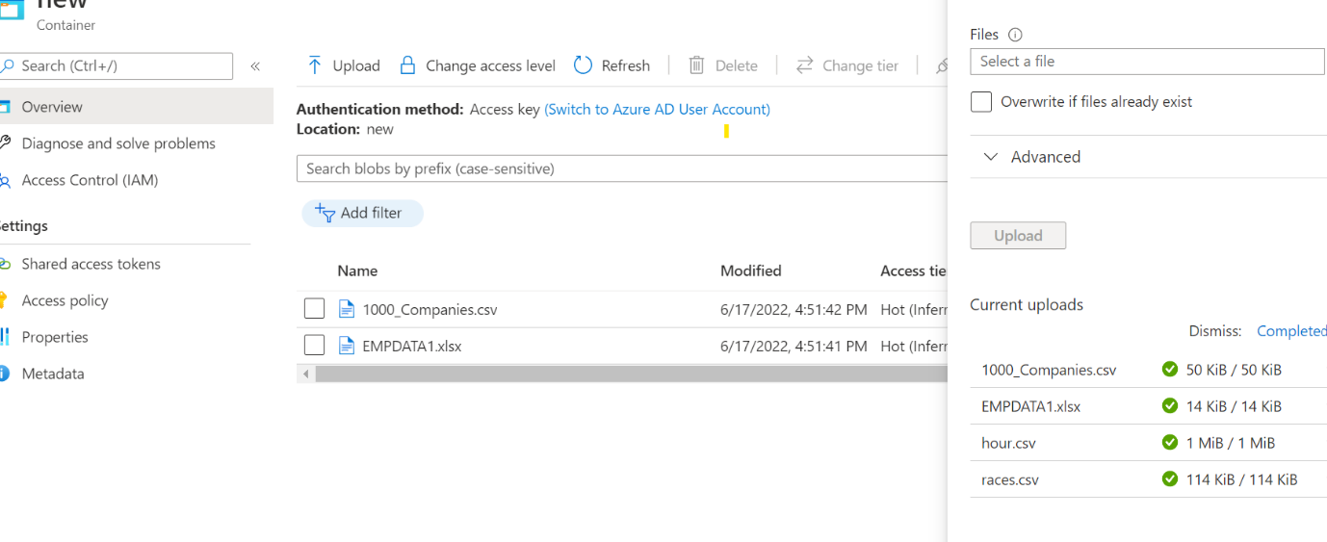

Similarly same steps follow to create synopse account

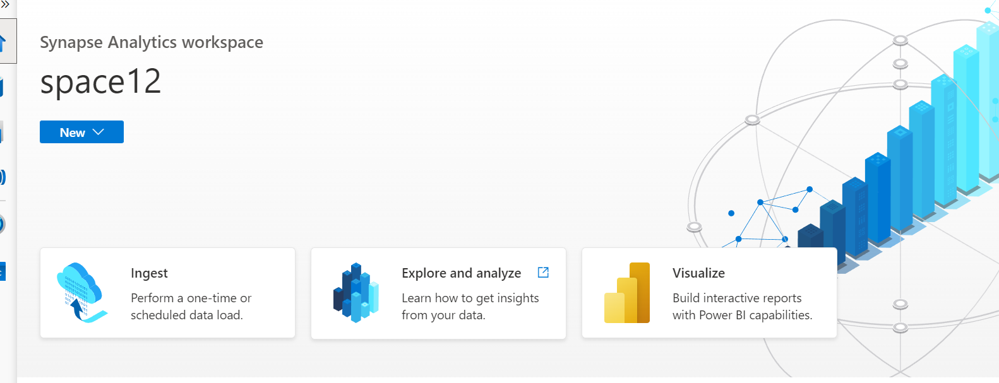

In the data tab click on the connect to the external data. And select the azure blob storage. The data in the blob is appeared in the synapse.

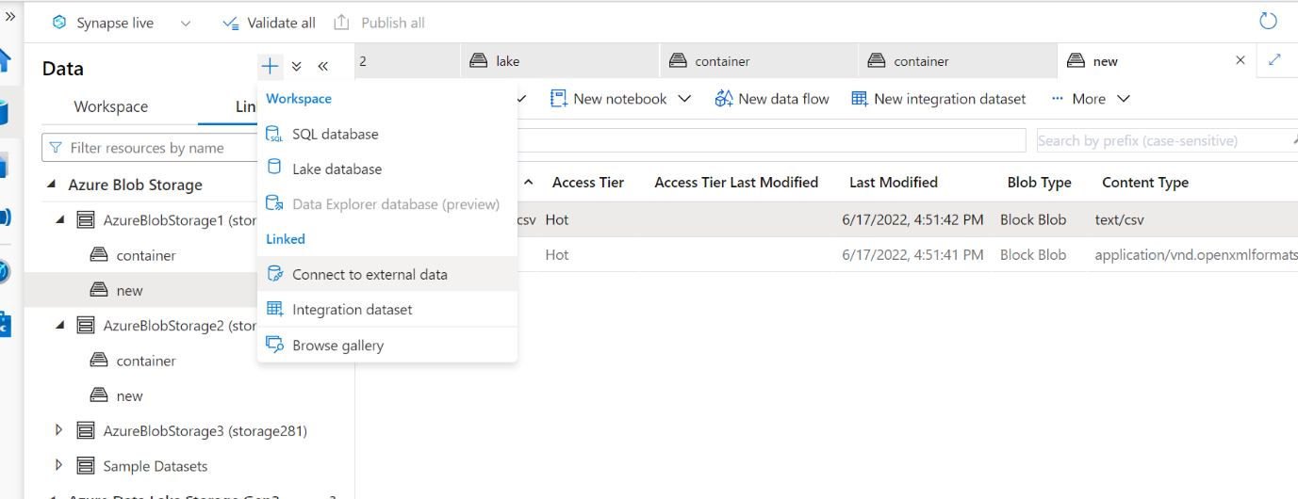

Now click on the note book and select on the spark pool.

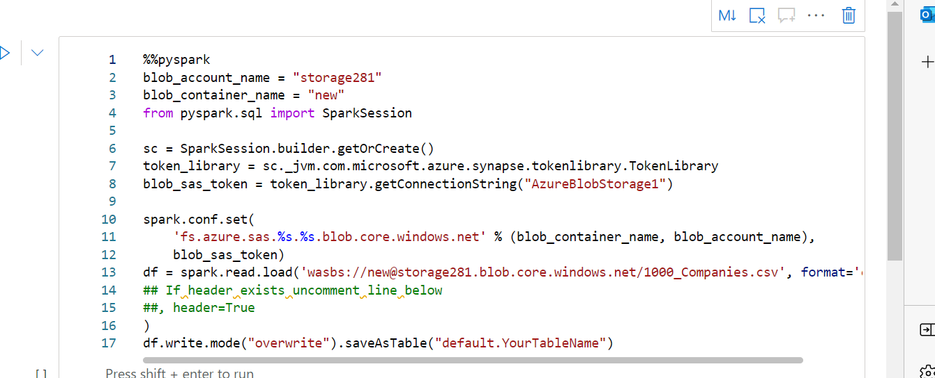5) In the synapse select the spark pool by click on the attached to then it will execute. By following the previous steps because already blob storage is created.



6)

Go to cosmosdb. Then create new account by click on the + symbol along with filling required fields. Then validation is completed.

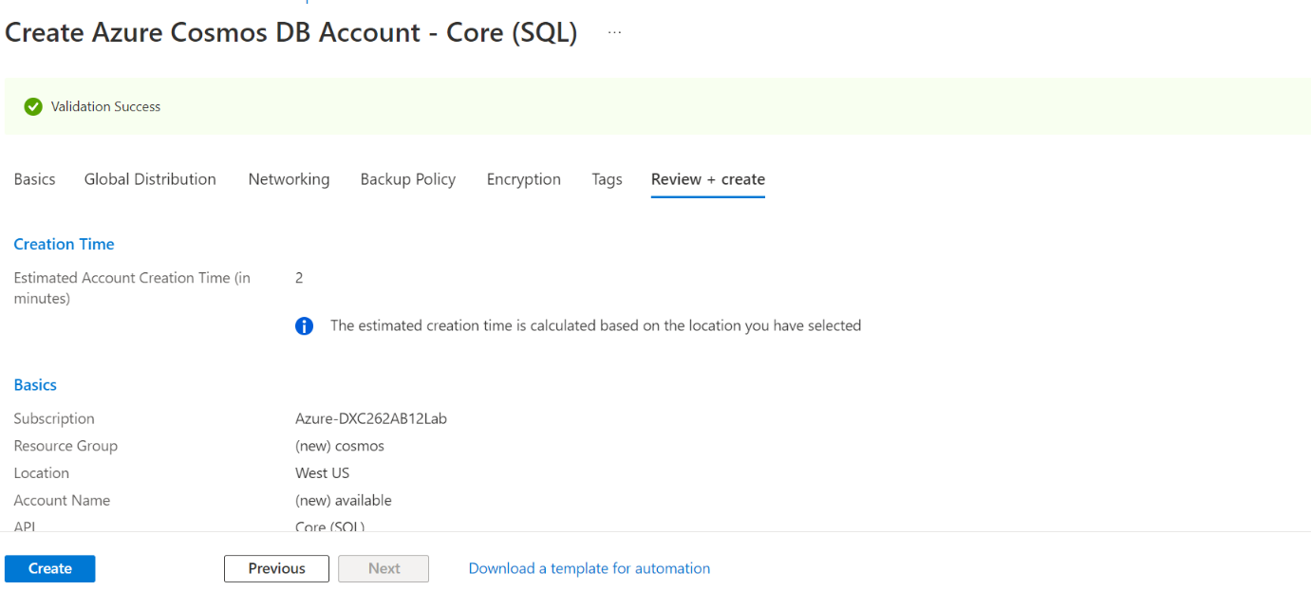

After creating of the cosmosdb account deployment will be initiated and then click on the go to resource group. After that go to data explore.

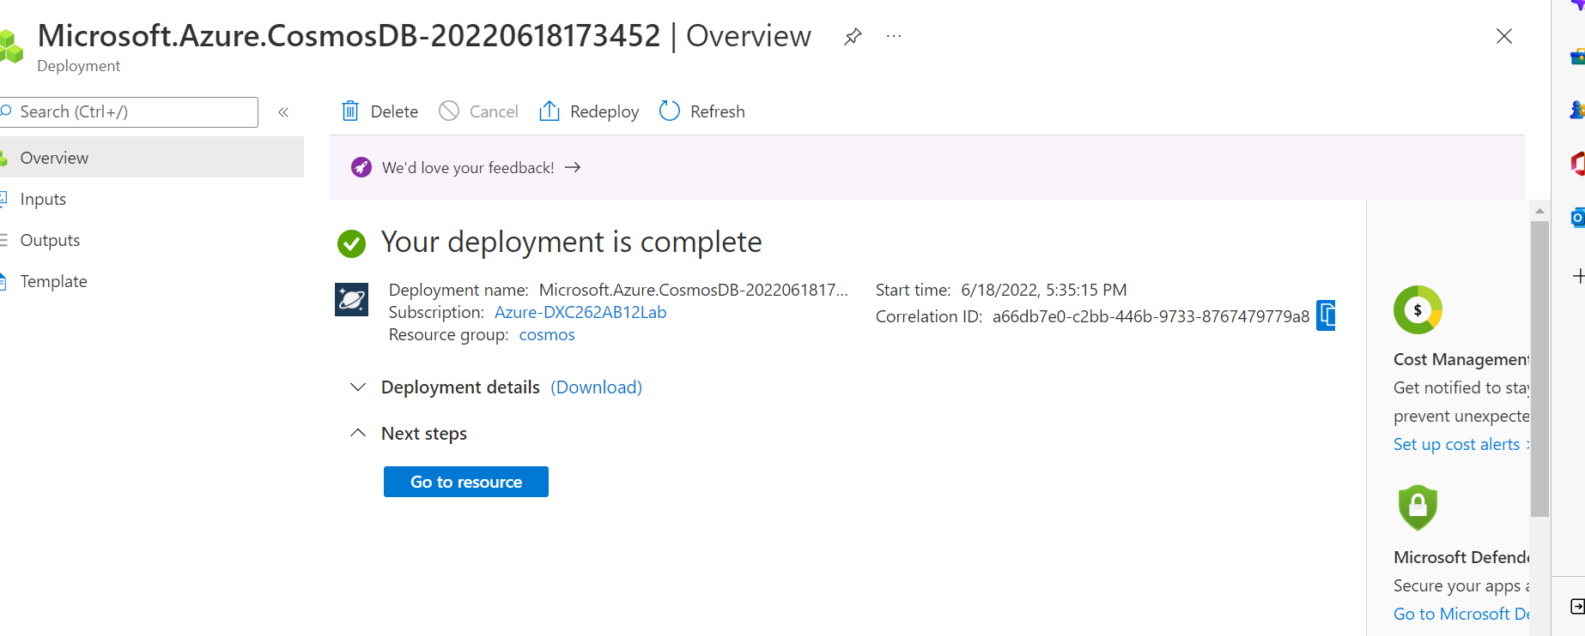

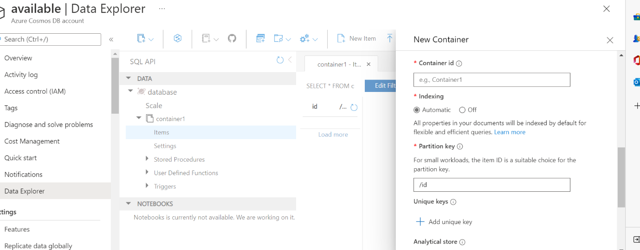In data explore create new container by giving the all required fields.

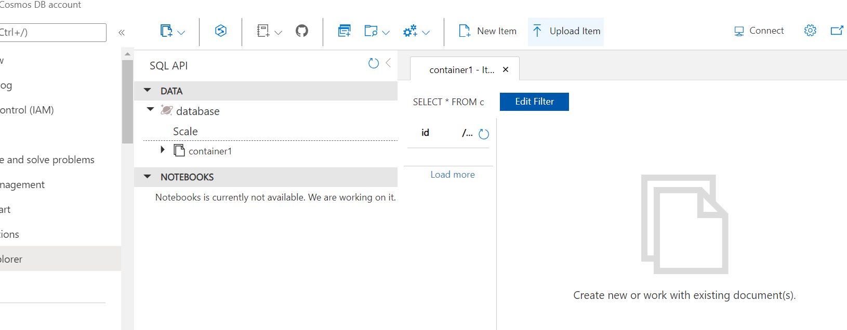After that upload the new json item and click on the execute button . Then query will come and run that query.

7)

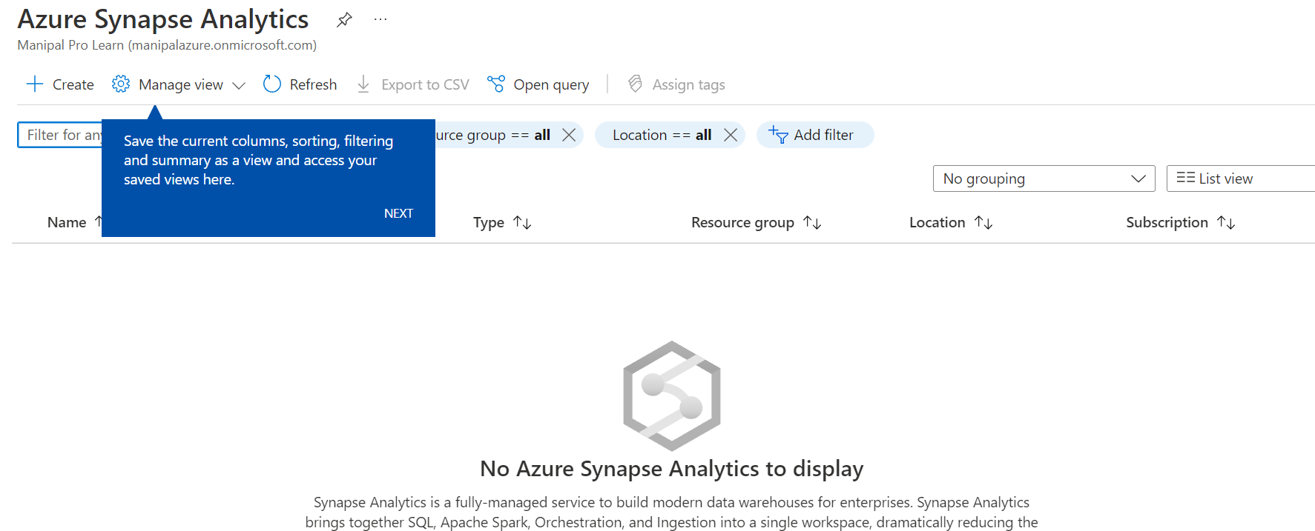

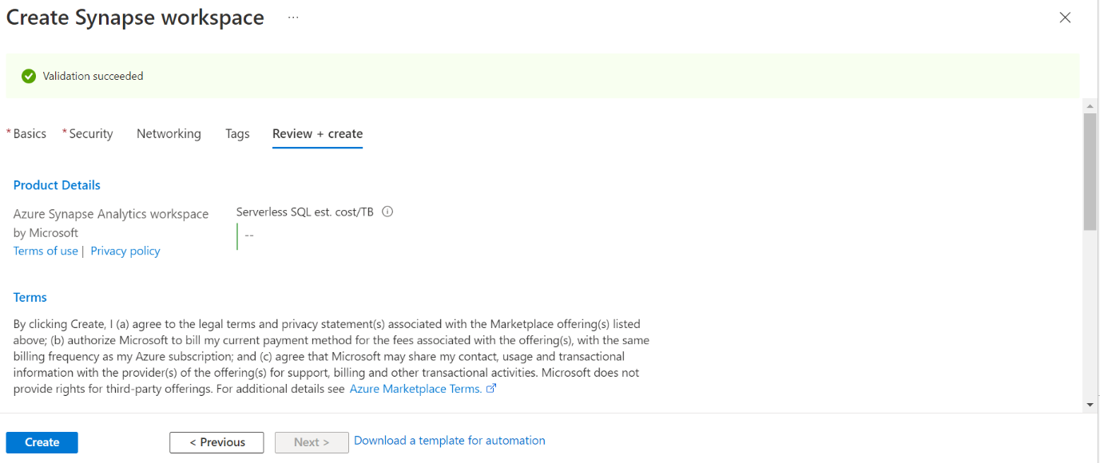Create azure synopse work space by giving all the mandatory fields.

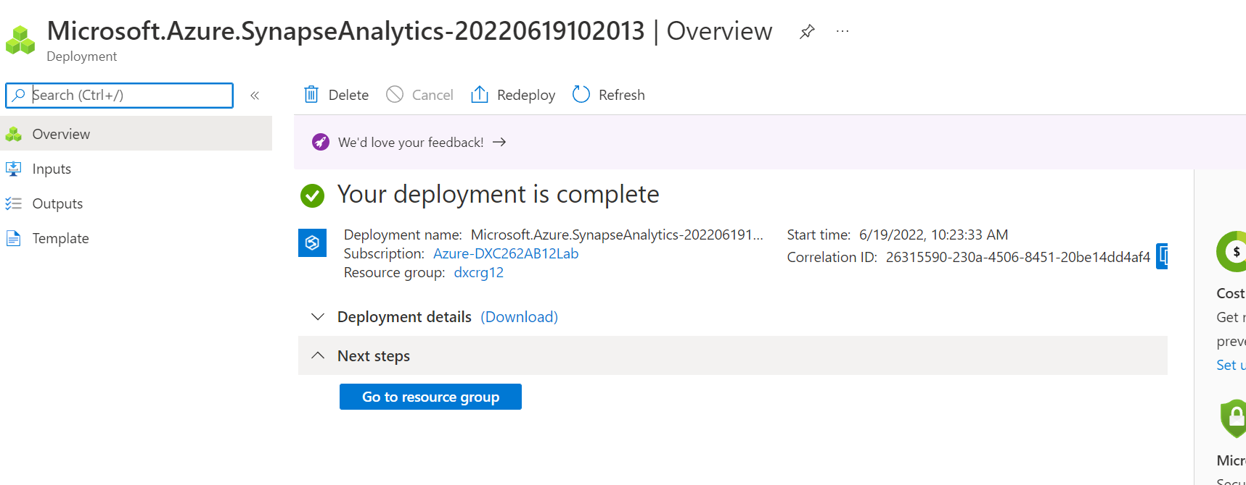After that deployment will be created.

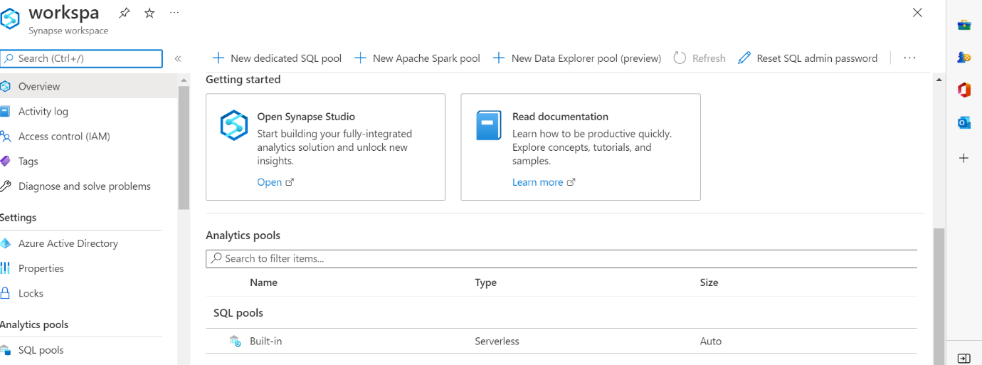Open the synapse studio by click on open.

In data SQL data base by click on the + symbol.

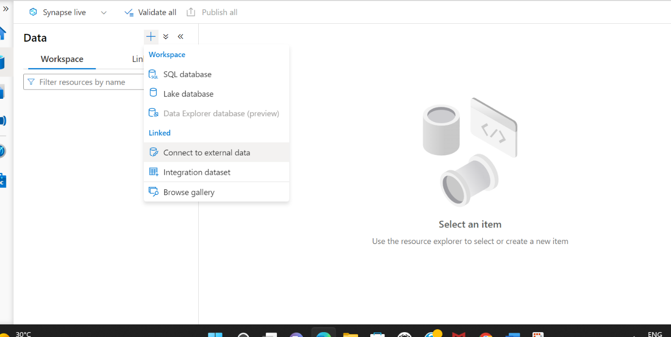

Then connected to the azure cosmosDB and click on continue.

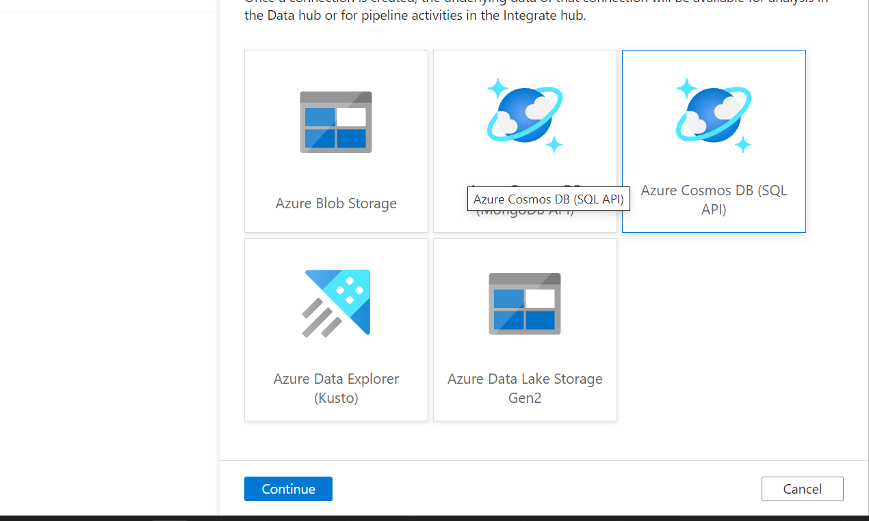

The information in the cosmosdb that will come here and execute that files.

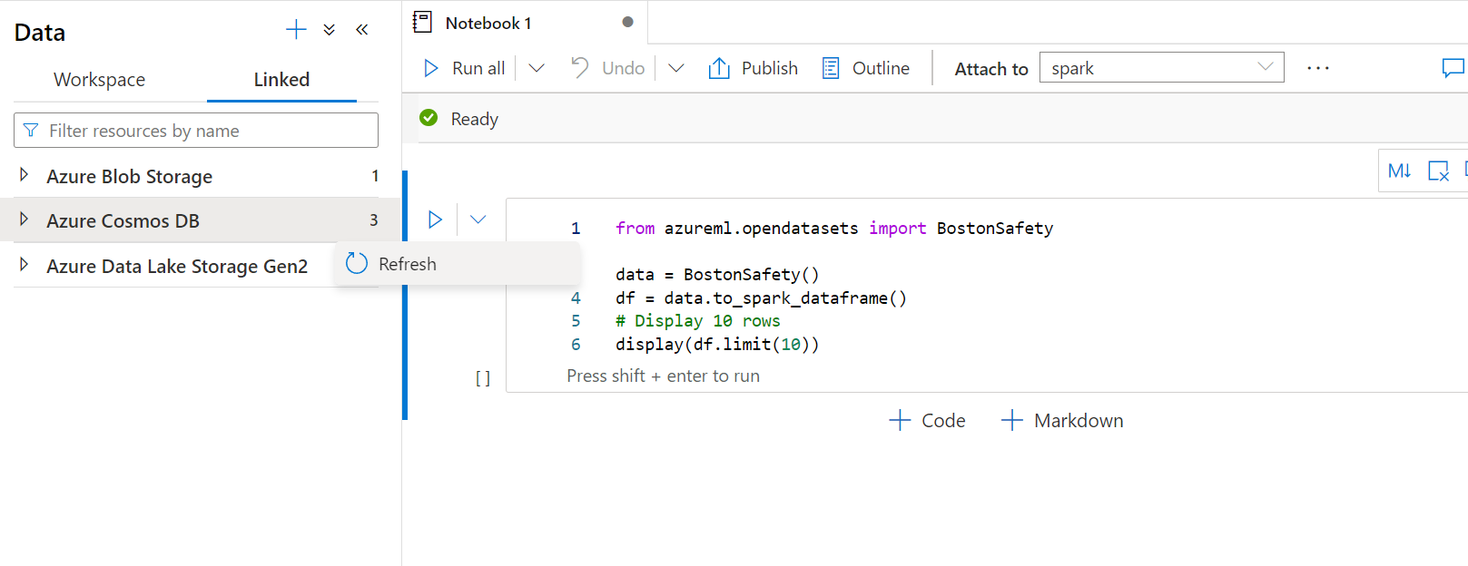

8)

Open the blob storage and fill all the required fields and click to create and deployment will be initiated. After completion of the deployment click on the go to resource. In the blob storage create container. Upload the files on container.

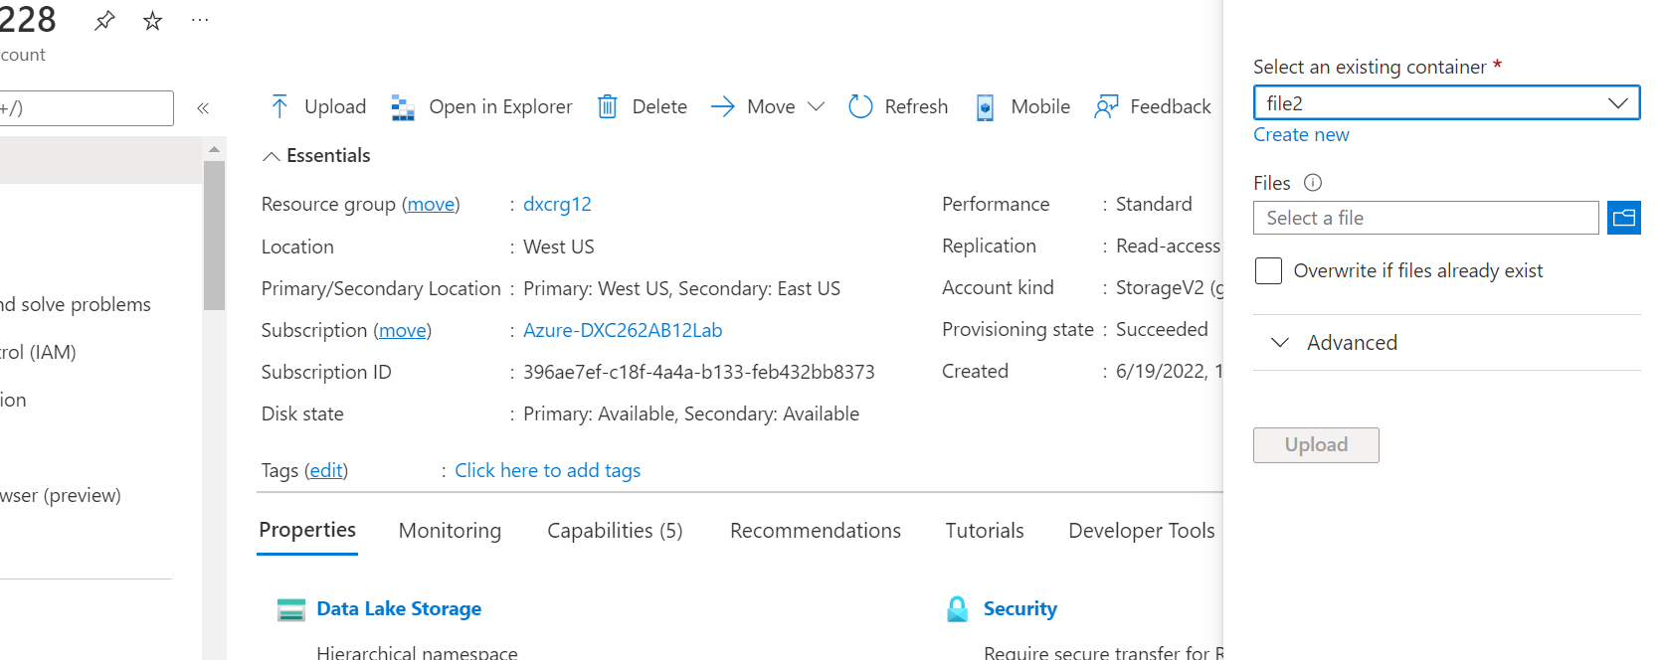

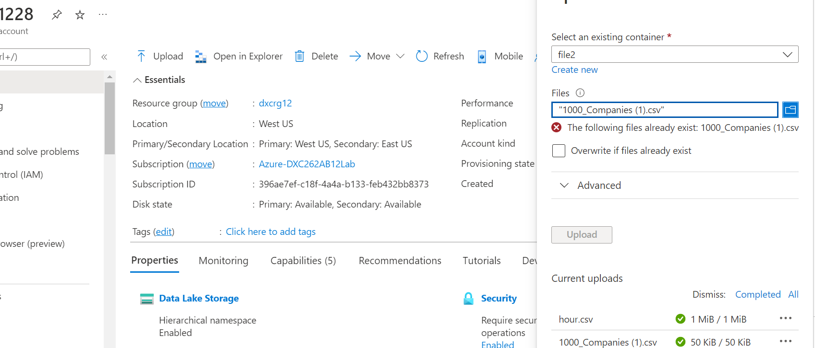

Create ADF account and give all the required fields. Create then deployment will be initiated.

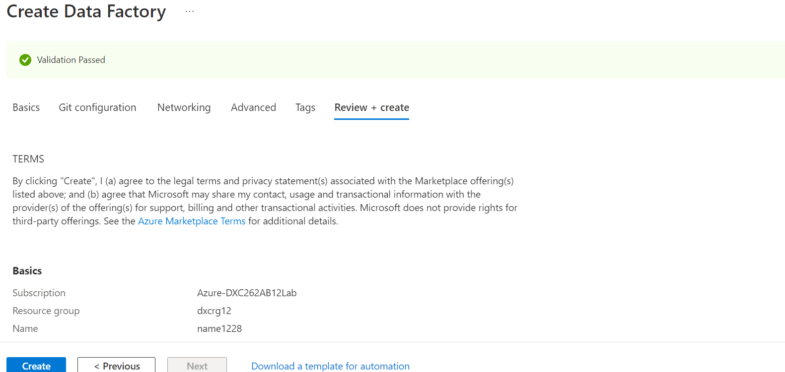

After completion of the deployment click on the go to resource group. Open ADF

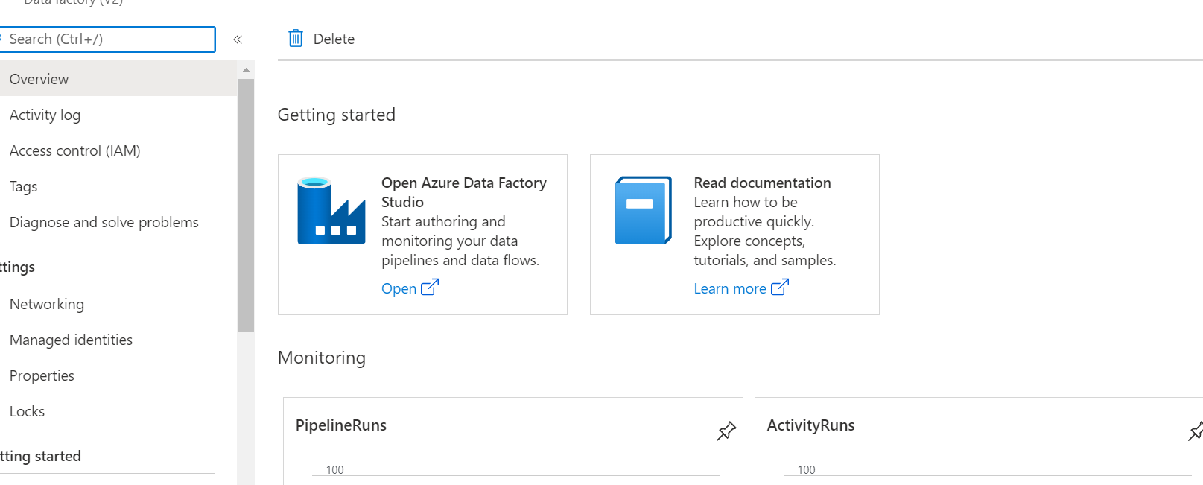

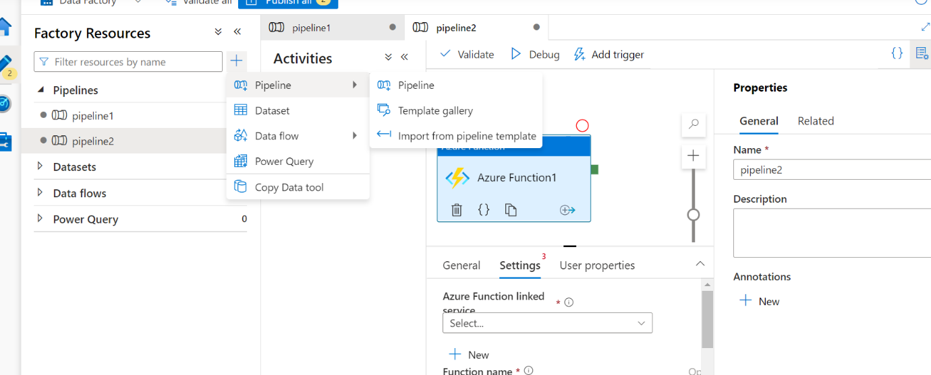Create pipe line in the ADF and drag and drop the files. After drag and dropping schedule the trigger.