CHAT-HIVE

CHATHIVE is a web-based chatbot application built using FastAPI, Google Gemini AI, and a frontend with HTML, CSS, and JavaScript. It allows users to engage in AI-driven conversations, storing chat history under unique chat IDs for continuity. The backend handles user queries, processes responses using the Gemini model, and returns formatted replies. The frontend provides a dark-themed, structured chat interface with dynamic updates, smooth interactions, and a sidebar for managing multiple chat sessions.

BACKEND:

- FastAPI-based chatbot integrating Google's Gemini AI for generating responses.
- Loads API key from .env file using dotenv for secure access.
- Configures genai library with the API key and fetches available Gemini models.
- Selects preferred model (gemini-2.0-flash-thinking-exp-01-21) if available; otherwise, uses the first available model.
- Initializes FastAPI app with Jinja2 templates for rendering an HTML-based frontend.
- Routes:
    - / → Renders index.html displaying stored chats.
    - /chat → Processes user messages and retrieves AI response
- Response Formatting:
    - Converts markdown-style bold text (**text**) to HTML <b> tags.
    - Replaces * bullet points with • for better readability.
- Handles errors:
    - Returns an error if no valid Gemini model is available.
    - Responds with a JSON error message if an exception occurs.

FRONTEND:

- Simple chatbot frontend built using HTML, CSS, and JavaScript, interacting with a FastAPI backend.
- Layout Components:
    - Sidebar with a "New Chat" button to start fresh conversations.
    - Chat container displaying user messages (right, purple) and bot responses (left, gray).
    - Input field for users to type messages.

- Message Handling:
    - Messages are submitted via an AJAX request to the /chat endpoint of the FastAPI server.
    - The "Send" button is temporarily disabled while fetching a response.
    - The chat history updates dynamically as messages arrive.
- CSS Styling Features:
    - Dark-themed interface with smooth transitions and structured spacing.
    - Responsive layout for a clean and modern chat experience.
- User Experience Enhancements:
    - Auto-scrolling ensures new messages are always visible.
    - Error Handling: Displays a message if the server is unavailable.

USERINTERFACE:


SAMPLE OUTPUT:

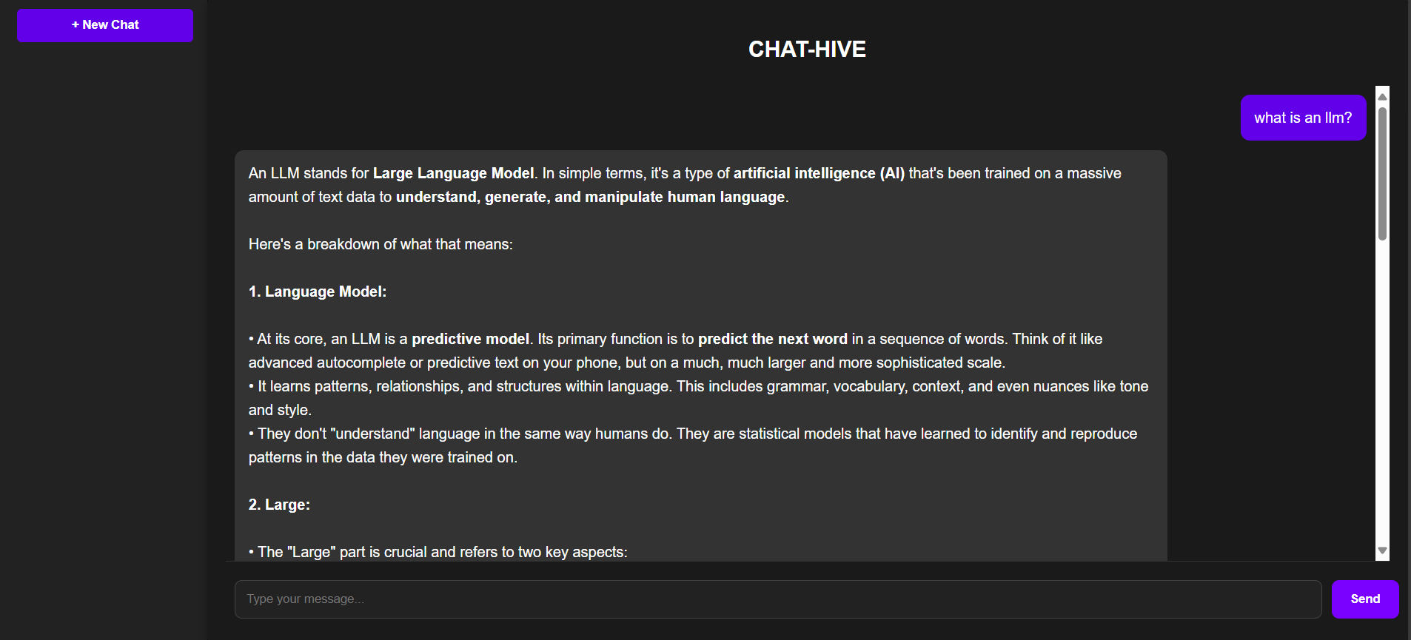

PROJECT STRUCTURE:

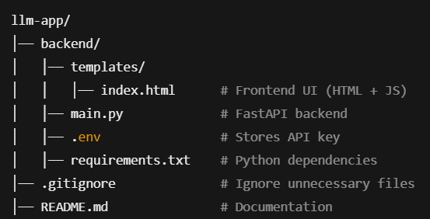

- backend/ - Contains the backend logic and API handling.
- templates/ - Stores frontend HTML files for rendering UI.
- Files:
- index.html - The main chatbot UI (HTML + JavaScript for interactions).
- main.py - FastAPI backend handling chat requests and AI responses.
- .env - Stores the Google Gemini API key (keep it secret).
- requirements.txt - Lists necessary Python dependencies.
- .gitignore - Prevents committing sensitive/unnecessary files to Git.
- README.md - Documentation explaining setup and usage.

