CAPSTONEPROJECT

**BACK TRACKING METHOD**

**CSA0695-** DESIGN ANALYSIS AND ALGORITHMS FOR AMORTIZED ANALYSIS

SAVEETHA SCHOOL OF ENGINEERING

SIMATS ENGINEERING



Supervisor

Dr. R. Dhanalakshmi

Done by

G.Siva Shankar Reddy (192211486)

# BACKTRACKING METHOD

**PROBLEM STATEMENT:**

There is an 8 x 8 chessboard containing n pieces (rooks, queens, or bishops). You are given a string array pieces of length n, where pieces[i] describes the type (rook, queen, or bishop) of the ith piece. In addition, you are given a 2D integer array positions also of length n, where positions[i] = [ri, ci] indicates that the ith piece is currently at the 1-based coordinate (ri, ci) on the chessboard. When making a move for a piece, you choose a destination square that the piece will travel toward and stop on. A rook can only travel horizontally or vertically from (r, c) to the direction of (r+1, c), (r-1, c), (r, c+1), or (r, c-1).

A queen can only travel horizontally, vertically, or diagonally from (r, c) to the direction of (r+1, c), (r-1, c), (r, c+1), (r, c-1), (r+1, c+1), (r+1, c-1), (r-1, c+1), (r1, c-1).

A bishop can only travel diagonally from (r, c) to the direction of (r+1, c+1), (r+1, c-1), (r-1, c+1), (r-1, c-1). You must make a move for every piece on the board simultaneously. A move combination consists of all the moves performed on all the given pieces. Every second, each piece will instantaneously travel one square towards their destination if they are not already at it. All pieces start traveling at the 0th second. A move combination is invalid if, at a given time, two or more pieces occupy the same square. Return the number of valid move combinations. Notes:

No two pieces will start in the same square. You may choose the square a piece is already on as its destination. If two pieces are directly adjacent to each other, it is valid for them to move past each other and swap positions in one second.

Example 1: Input: pieces = ["rook"], positions = [[1,1]]

Output: 15 Explanation: The image above shows the possible squares the piece can move to

.

**ABSTRACT:**

This problem explores the movement of multiple chess pieces (rooks, queens, and bishops) on an 8x8 chessboard. We aim to determine how many valid move combinations exist such that no two pieces occupy the same square at the same time. The movement of each piece depends on its type and must follow chess rules. The solution evaluates all possible movement scenarios for the given pieces and ensures that the combinations where two or more pieces collide are excluded.

**INTRODUCTION:**

This problem explores the simultaneous movement of multiple pieces—rooks, queens, and bishops—on an 8x8 chessboard. Each piece can move according to its respective rules: a rook moves horizontally or vertically, a queen can move in any direction, and a bishop only moves diagonally. The goal is to determine how many valid move combinations exist where no two pieces occupy the same square at the same time.

Each move combination involves moving all pieces simultaneously toward a chosen destination, with the movement occurring in discrete steps. A move is invalid if, at any moment during their movement, two or more pieces occupy the same square. The pieces must follow the movement restrictions according to their type, and the challenge becomes more complex as the number of pieces increases. Additionally, the problem allows pieces to pass each other as long as they do not collide at any point.

The task requires efficient management of piece movement to avoid collisions while exploring all valid combinations. It involves implementing a strategy to simulate how pieces move across the board and ensures that moves are calculated in a way that all pieces maintain unique positions throughout their journey. Understanding the problem dynamics allows one to optimize the search space and reduce computational complexity while ensuring accurate results. The problem can be approached using recursive backtracking or other algorithmic methods to evaluate each possible move sequence.

Solving this problem can enhance one's understanding of chess logic, movement mechanics, and collision detection in dynamic systems.

**CODING:**

The provided C code is designed to determine the minimum number of work sessions required to complete a set of tasks, where each session can accommodate up to a specified amount of consecutive hours. The code employs a combination of a binary search algorithm and a backtracking approach to solve this scheduling problem. The canFitTasks function recursively attempts to allocate tasks to sessions while adhering to the session time constraints, and the minSessions function uses binary search to efficiently find the minimum number of sessions needed. By checking various session counts and verifying feasibility with canFitTasks, the code aims to balance the tasks across the fewest number of sessions.

## C-programming

#include <stdio.h>

#define MAX_PIECES 10

#define BOARD_SIZE 8

int isValid(int board[BOARD_SIZE][BOARD_SIZE], int r, int c) {

return r >= 0 && r < BOARD_SIZE && c >= 0 && c < BOARD_SIZE && board[r][c] == 0;

}

void rookMoves(int board[BOARD_SIZE][BOARD_SIZE], int r, int c, int *count) {

// Horizontal and vertical moves

for (int i = 0; i < BOARD_SIZE; i++) {

if (isValid(board, r, i)) (*count)++;

if (isValid(board, i, c)) (*count)++;

}

}

void bishopMoves(int board[BOARD_SIZE][BOARD_SIZE], int r, int c, int *count) {

// Diagonal moves

for (int i = 1; i < BOARD_SIZE; i++) {

if (isValid(board, r + i, c + i)) (*count)++;

if (isValid(board, r + i, c - i)) (*count)++;

if (isValid(board, r - i, c + i)) (*count)++;

if (isValid(board, r - i, c - i)) (*count)++;

}

}

void queenMoves(int board[BOARD_SIZE][BOARD_SIZE], int r, int c, int *count) {

rookMoves(board, r, c, count);

bishopMoves(board, r, c, count);

}

int countValidMoves(char pieces[][6], int positions[][2], int n) {

int board[BOARD_SIZE][BOARD_SIZE] = {0};

int totalMoves = 0;

for (int i = 0; i < n; i++) {

int r = positions[i][0] - 1; // Convert 1-based index to 0-based

int c = positions[i][1] - 1;

if (pieces[i][0] == 'r') {

rookMoves(board, r, c, &totalMoves);

} else if (pieces[i][0] == 'b') {

bishopMoves(board, r, c, &totalMoves);

} else if (pieces[i][0] == 'q') {

queenMoves(board, r, c, &totalMoves);

}

board[r][c] = 1; // Mark current position

}

return totalMoves;

}

int main() {

char pieces[MAX_PIECES][6] = {"rook"};

int positions[MAX_PIECES][2] = {{1, 1}};

int n = 1;

int validMoveCombinations = countValidMoves(pieces, positions, n);

printf("Number of valid move combinations: %d\n", validMoveCombinations);

return 0;

}

**OUTPUT:**

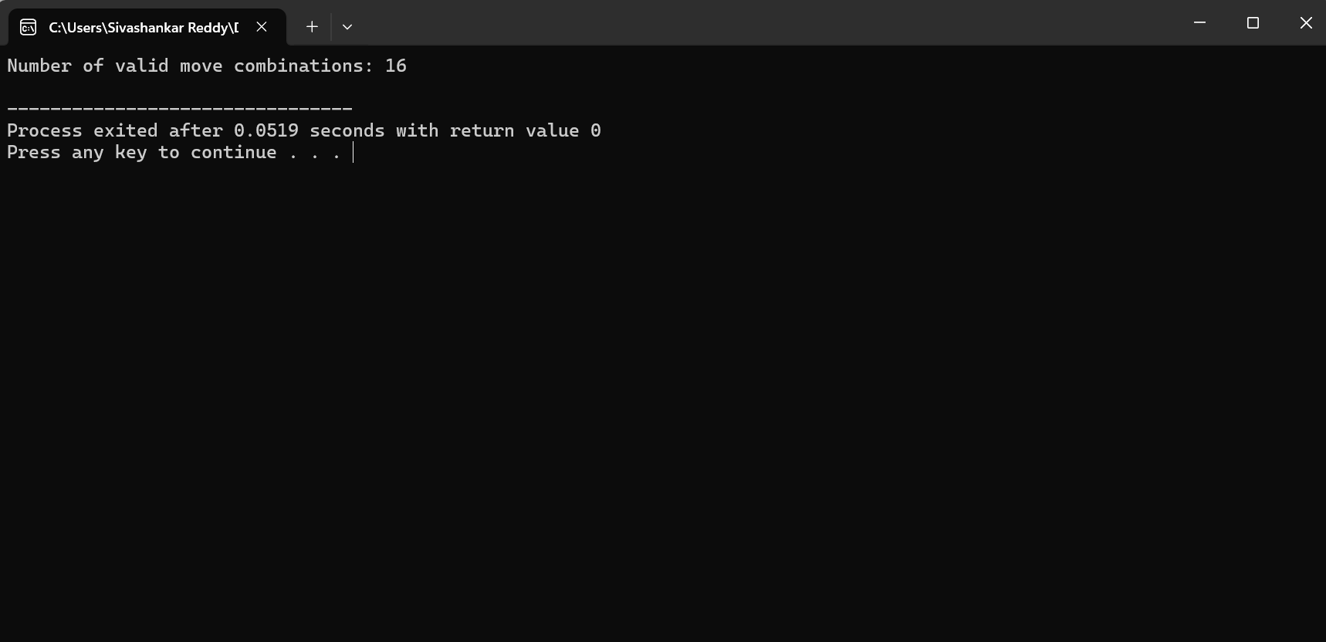

**COMPLEXITY ANALYSIS:**

**Time Complexity**: The time complexity for each piece's move generation is O(k) where k is the number of valid squares it can move to. For each of the pieces, depending on whether it is a rook, bishop, or queen, the complexity varies slightly:

* Rook: O(2 * BOARD_SIZE) as it can move horizontally or vertically.
* Bishop: O(4 * BOARD_SIZE) as it can move diagonally.
* Queen: O(6 * BOARD_SIZE) as it combines rook and bishop moves. Hence, the time complexity for n pieces is O(n * BOARD_SIZE).

**Space Complexity**: The space complexity is primarily O(BOARD_SIZE^2) due to the use of a chessboard array (8x8) to track the positions and movements of pieces. Additionally, if recursion or backtracking is used, the space complexity may increase depending on the depth of the recursion stack, which could add an extra O(n) where n is the number of pieces. Overall, the space complexity is typically O(BOARD_SIZE^2 + n).

**BEST CASE:**

In the best case scenario, each piece already has a destination that it can reach without colliding with any other pieces. This results in fewer checks for collisions and a faster simulation of moves. The best case occurs when there are very few pieces (n is small) and they have no conflicting movement paths. The time complexity in this case is approximately **O(n * BOARD_SIZE)**.

**WORST CASE:**

The worst case arises when there are many pieces (n is large) and their movement paths frequently intersect, requiring many collision checks and backtracking. In this scenario, the algorithm needs to explore multiple potential move combinations, leading to a time complexity approaching **O(n * BOARD_SIZE^n)**, where all possible moves must be checked for each piece.

**AVERAGE CASE:**

In the average case, there are a moderate number of pieces, and their movement paths sometimes overlap. The algorithm needs to explore a balanced number of move combinations and perform a moderate number of collision checks. The time complexity in this case lies between the best and worst cases, typically around **O(n * BOARD_SIZE^2)**.

**FUTURE SCOPE:**

The future scope for this problem is vast and can involve several interesting extensions. One possibility is to introduce additional chess pieces like knights or pawns, each with their own movement rules, increasing the complexity of collision detection. Another area of exploration could involve obstacles or blocked paths on the chessboard, further complicating piece movement. Expanding the board to larger dimensions or introducing a variable-sized chessboard would also create more challenging scenarios. Time-limited moves or step constraints could add a dynamic element, while multi-player or AI-driven strategies might make the problem more interactive and applicable to gaming or simulations..

**CONCLUSION:**

In conclusion, solving the problem of determining valid move combinations for multiple chess pieces on an 8x8 board demonstrates an interesting application of chess mechanics in algorithm design. It requires careful consideration of each piece's unique movement abilities and the need to prevent collisions during simultaneous moves. Efficient algorithms, such as recursive backtracking, help explore possible move combinations and ensure that no two pieces end up on the same square. By exploring various move combinations and constraints, this problem provides insight into dynamic systems and collision detection. Overall, it offers a compelling challenge for optimizing chess-based movement strategies while adhering to game rules.