**Step 1:**

**Services:**

1. Service Registry (8761),
2. User Service (9011),
3. Department Service (9012)

**GIT Commands:**

1. git checkout -b step-1-service-reistry main
2. git add department-service/ user-service/ service-registry/
3. git commit -m "Eureka Service Registry implementation with Dept and User Services" -n
4. git push --set-upstream origin step-1-service-reistry

**Step 2:**

**Services:**

1. Service Registry (8761),
2. cloud-gateway (9191),
3. User Service (9011),
4. Department Service (9012)

**GIT Commands:**

1. git checkout -b step-2-api-gateway step-1-service-reistry
2. git add department-service/ user-service/ service-registry/ cloud-gateway/ assets/
3. git commit -m "API GW implementation for Dept and User Services" -n
4. git push --set-upstream origin step-2-api-gateway

**Step 3:**

**Services:**

1. Service Registry (8761),
2. cloud-config-server (9020),
   1. https://github.com/SivasankarThalavai/config-server
3. cloud-gateway (9191),
4. User Service (9011),
5. Department Service (9012)

**GIT Commands:**

1. git checkout -b step-3-cloud-config-server step-2-api-gateway
2. git add department-service/ user-service/ service-registry/ cloud-gateway/ cloud-config-server/ assets/
3. git commit -m "Cloud Config Server implementation for Dept and User Services" -n
4. git push --set-upstream origin step-3-cloud-config-server

**Step 4:**

1. Service Registry (8761),
2. cloud-config-server (9020),
3. cloud-gateway (9191),
4. user Service (9011),
5. department Service (9012) with Slueth and Zipkin

**Zipkin Download and Run commands:**

1. curl -sSL <https://zipkin.io/quickstart.sh> | bash -s java -jar zipkin.jar
2. Zipkin URL: <http://127.0.0.1:9411/zipkin/>

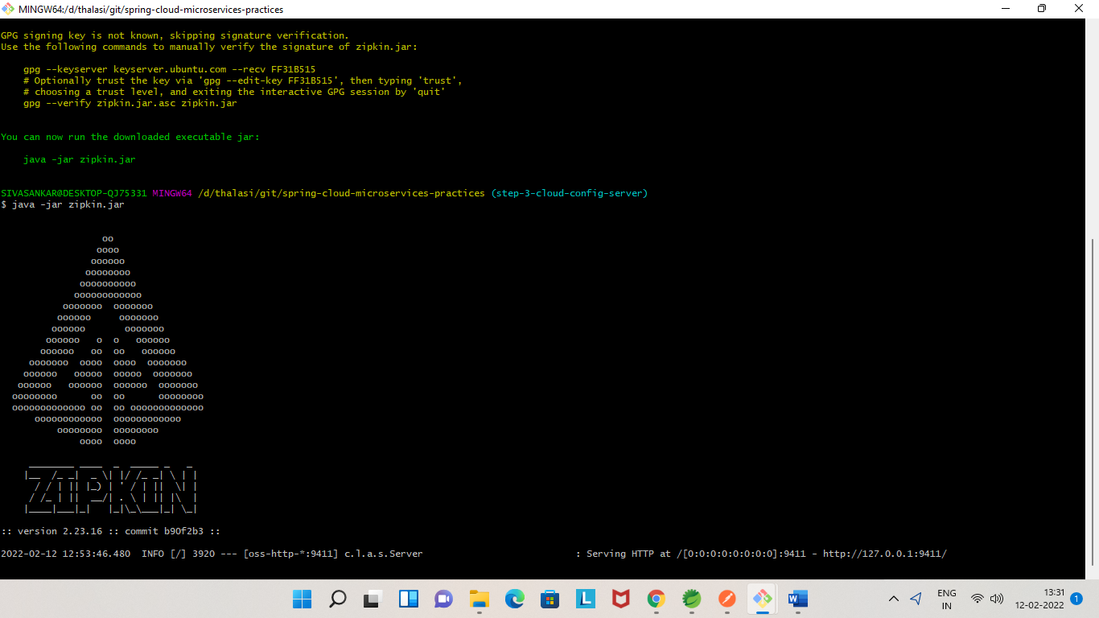

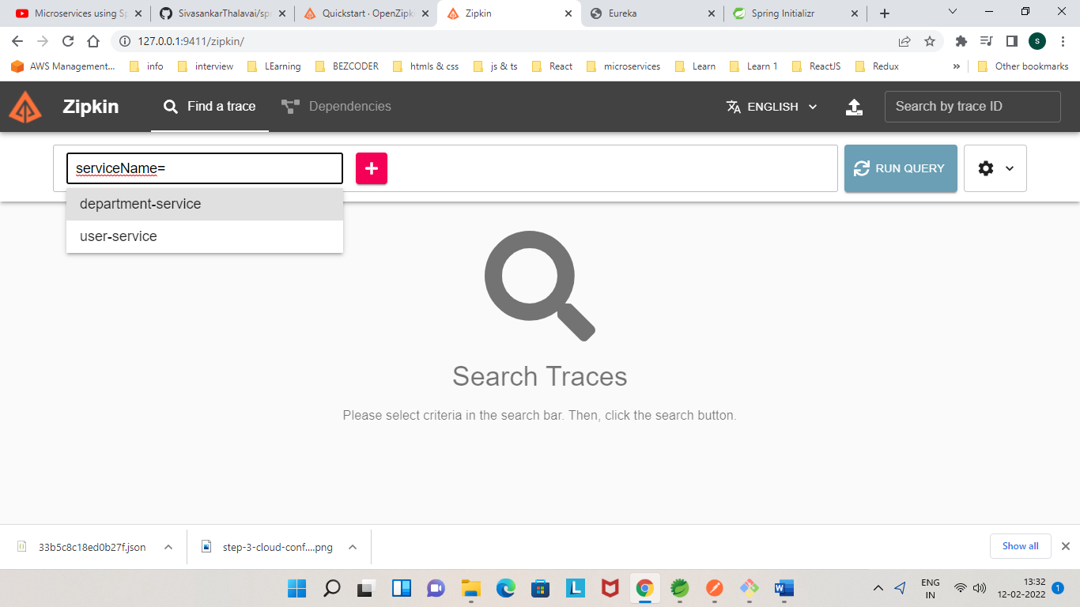

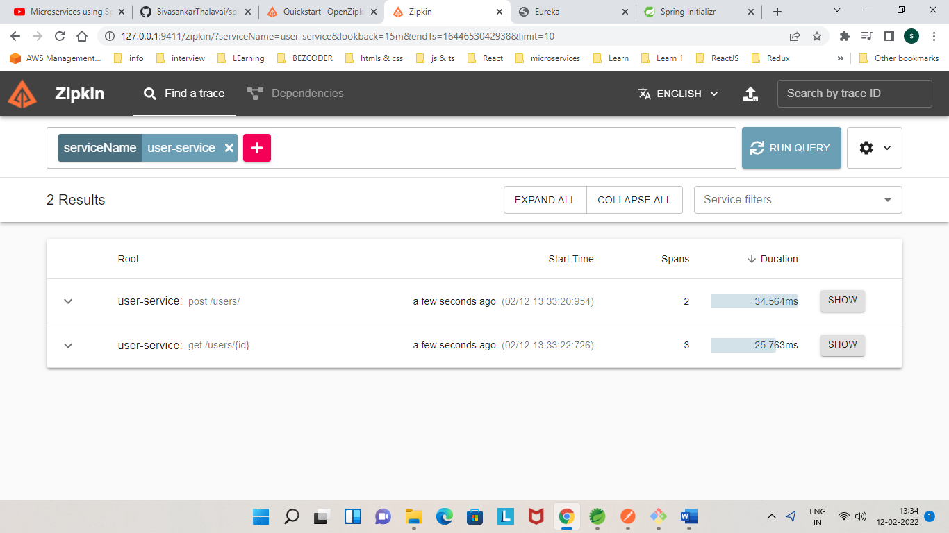

**User & Department Service Logs:**

2022-02-12 13:13:15.462 INFO [USER-SERVICE,**33b5c8c18ed0b27f, 33b5c8c18ed0b27f**] 3600 --- [nio-9012-exec-5] c.sivasankar.users.service.UserService : Inside getUserWithDepartment of UserService

2022-02-12 13:13:15.466 INFO [DEPARTMENT-SERVICE,**33b5c8c18ed0b27f, 442aa729e15c4ab9**] 17664 --- [nio-9011-exec-5] c.s.d.service.DepartmentService : Inside saveDepartment of DepartmentService

**TraceId:** 33b5c8c18ed0b27f

**SpanId** (for Department Service): 442aa729e15c4ab9

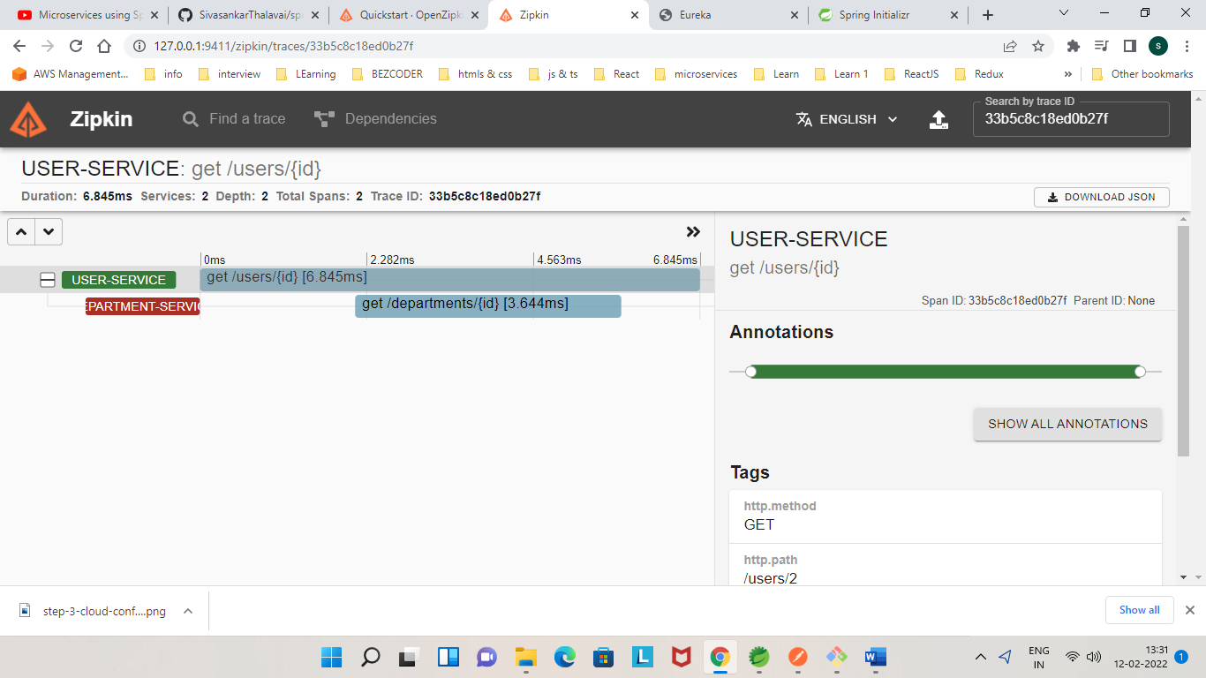

**Deploy Microservices in Docker and Kubernetes**:

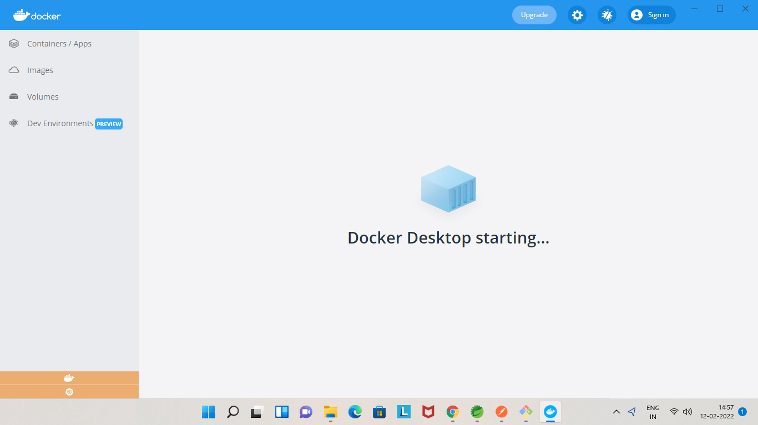

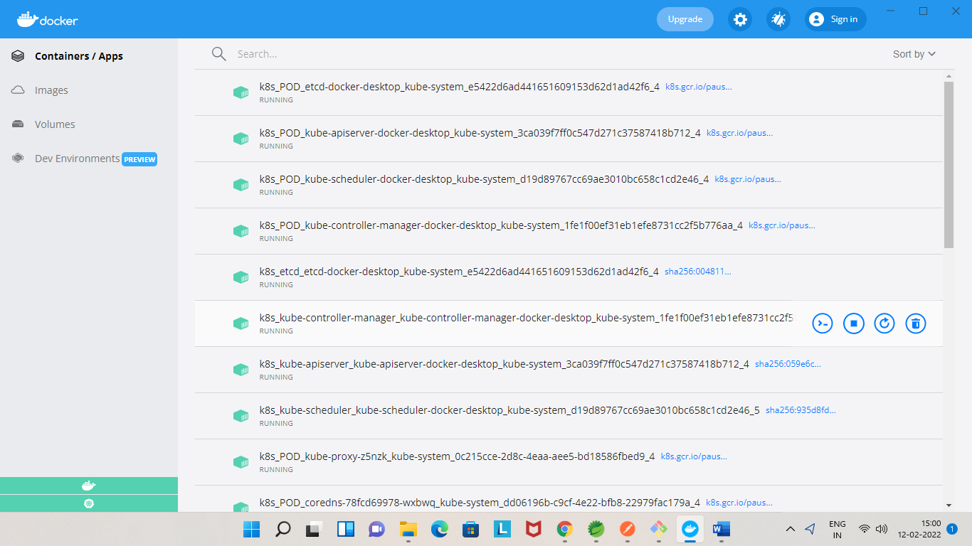

Add Docker hub Server details in **C:/users/.m2/settings.xml** file.

<server>

<id>docker.io</id>

<username> ******</username>

<password>****** </password>

</server>

**User Service (pom.xml)**

<plugin>

<groupId>com.spotify</groupId>

<artifactId>dockerfile-maven-plugin</artifactId>

<version>1.4.13</version>

<executions>

<execution>

<id>default</id>

<goals>

<goal>build</goal>

<goal>push</goal>

</goals>

</execution>

</executions>

<configuration>

<repository>thalasi1046/user-service</repository>

<tag>${project.version}</tag>

<useMavenSettingsForAuth>true</useMavenSettingsForAuth>

</configuration>

<dependencies>

<!-- To make this work on JDK 9+ -->

<dependency>

<groupId>javax.activation</groupId>

<artifactId>javax.activation-api</artifactId>

<version>1.2.0</version>

</dependency>

</dependencies>

</plugin>

</plugins>

**Build and Push command**

1. mvn clean package dockerfile:push

