**ProjectName : ContentNotifier**

**Objectives:**

| Objectives | Status |
| --- | --- |
| To provide a notification of upcoming data through an email. | Achieved |
| To reduce the time required for manual data checking. | Achieved |

**Results:**

1. Valid Inputs
   1. Valid inputs for gmail and web_source:

Web Source: <https://rguktsklm.ac.in/>

Required Data: Welcome

Reciepent Mail: sivasri.laveti@gmail.com

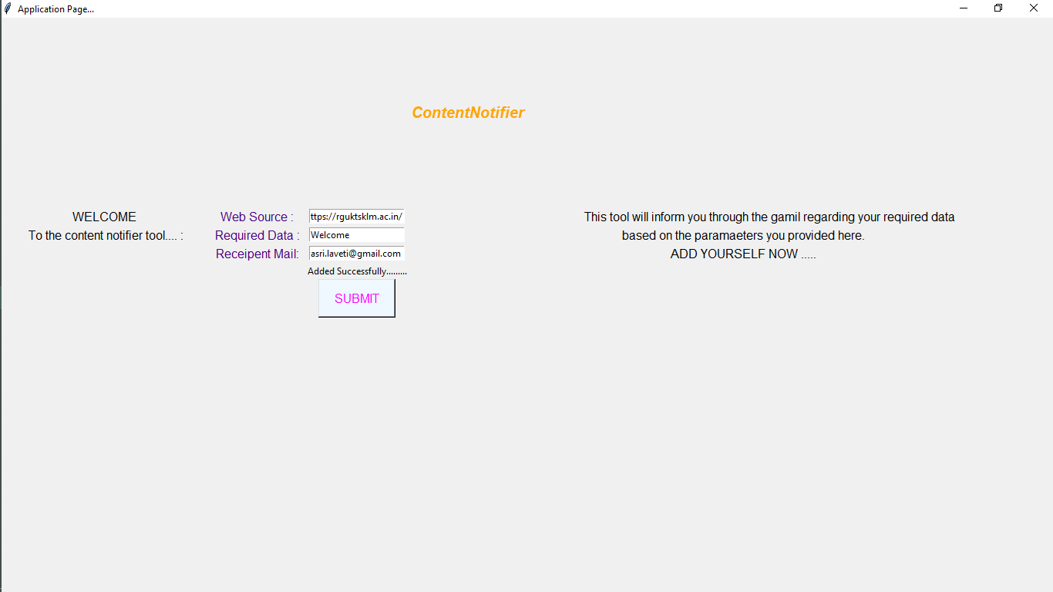

1. Invalid inputs
   1. Valid web_source and invalid gmail:

INPUT:

Web Source: <https://rguktsklm.ac.in/>

Required Data: Welcome

Reciepent Mail: random text

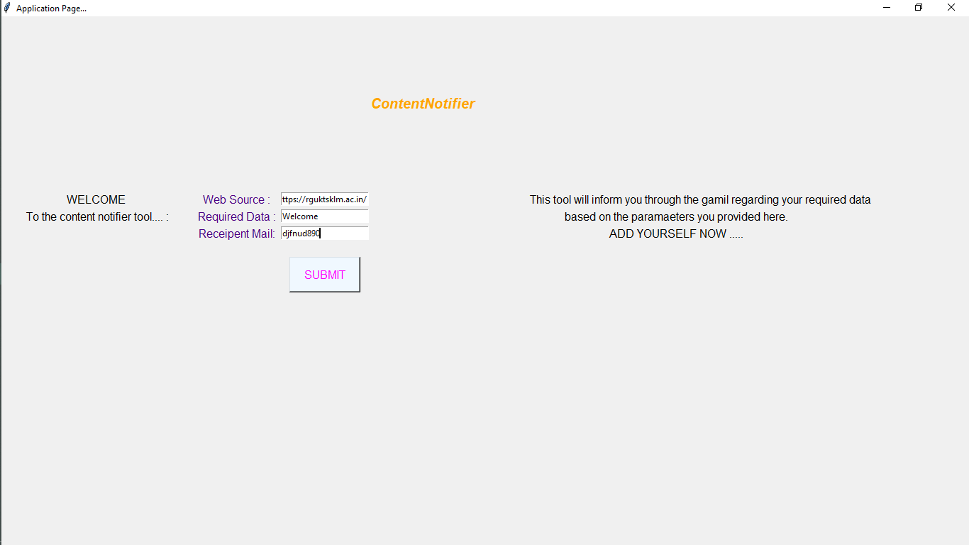

RESULT:

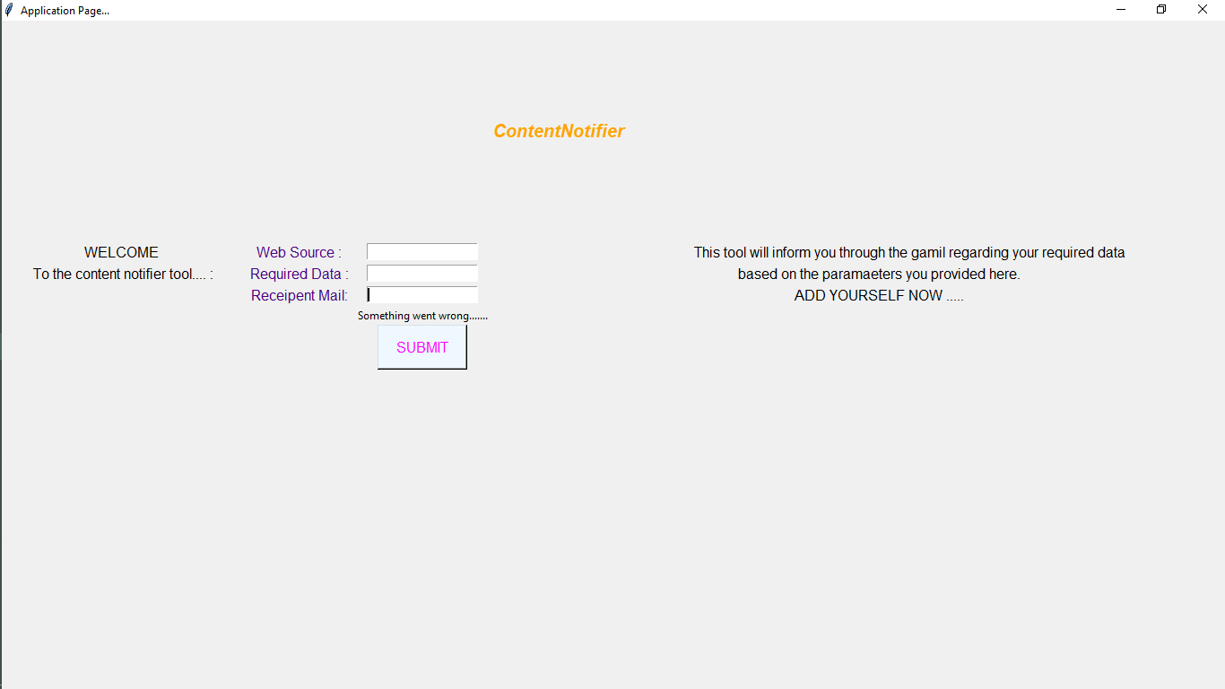

* 1. Valid gmail and invalid web_source:

INPUT:

Web Source: [https://rguktsklm](https://rguktsklm.ac.in/)

Required Data: Welcome

Reciepent Mail: sivasri.laveti@gmail.com

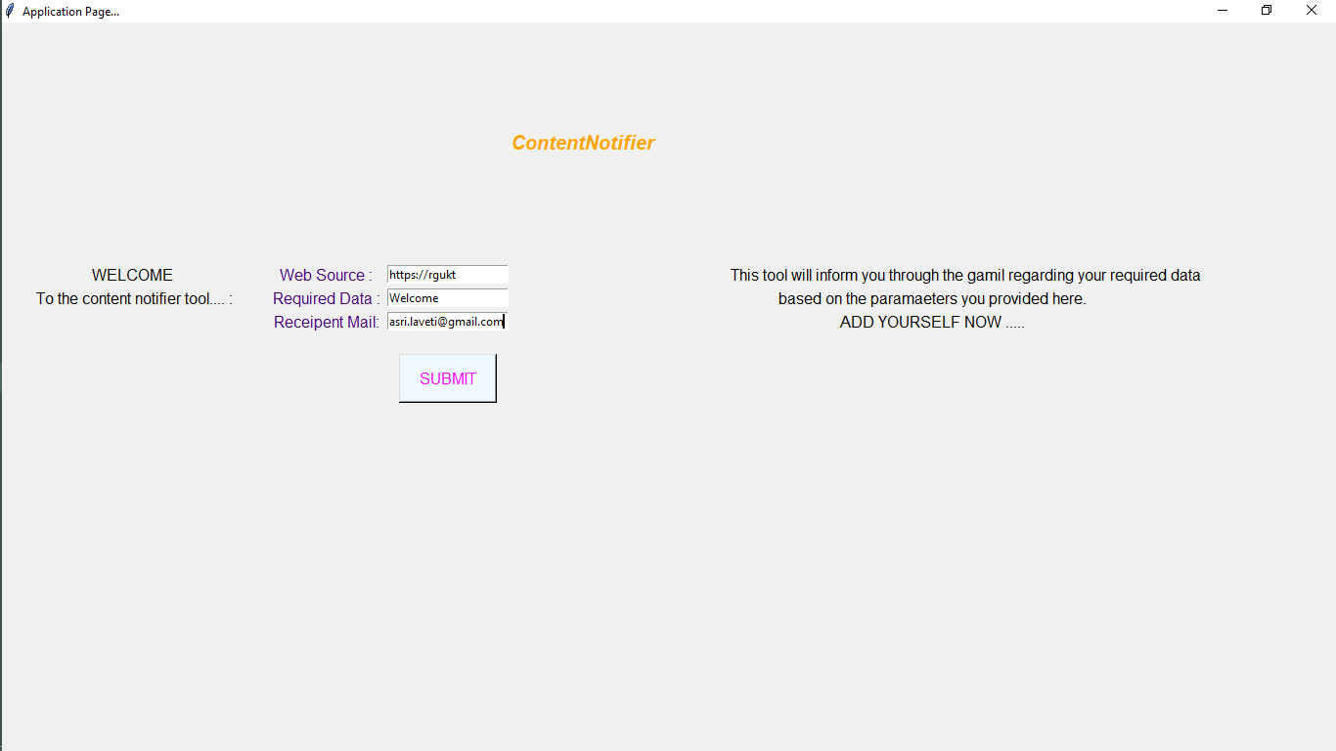

RESULT:

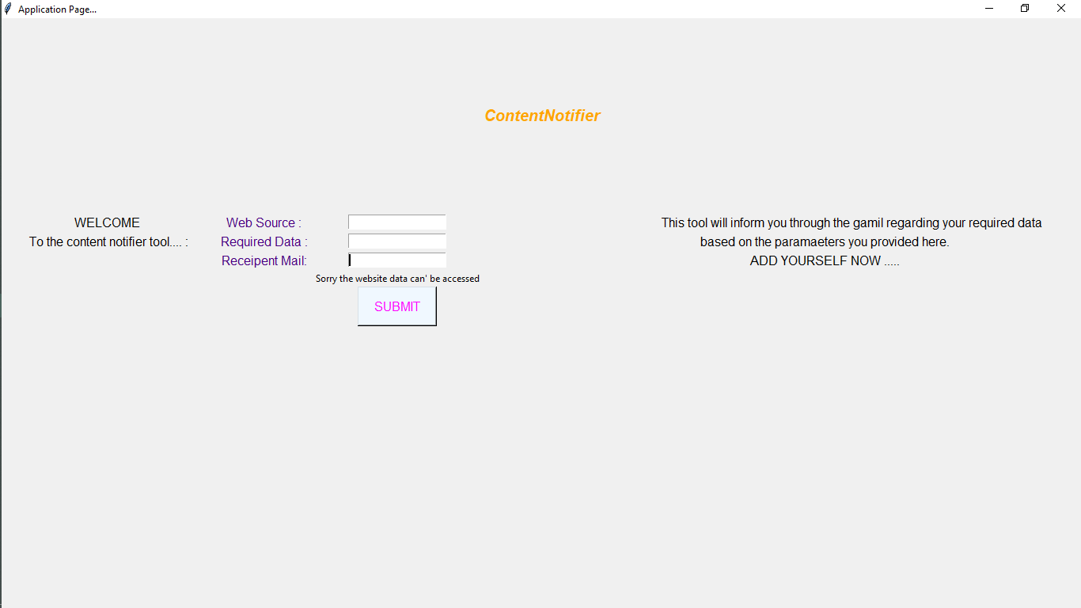

* 1. Invalid gmail and web_source:

INPUT:

Web Source: <https://rguktsklm.ac.in/>

Required Data: Welcome

Reciepent Mail: sivasri.laveti@gmail.com

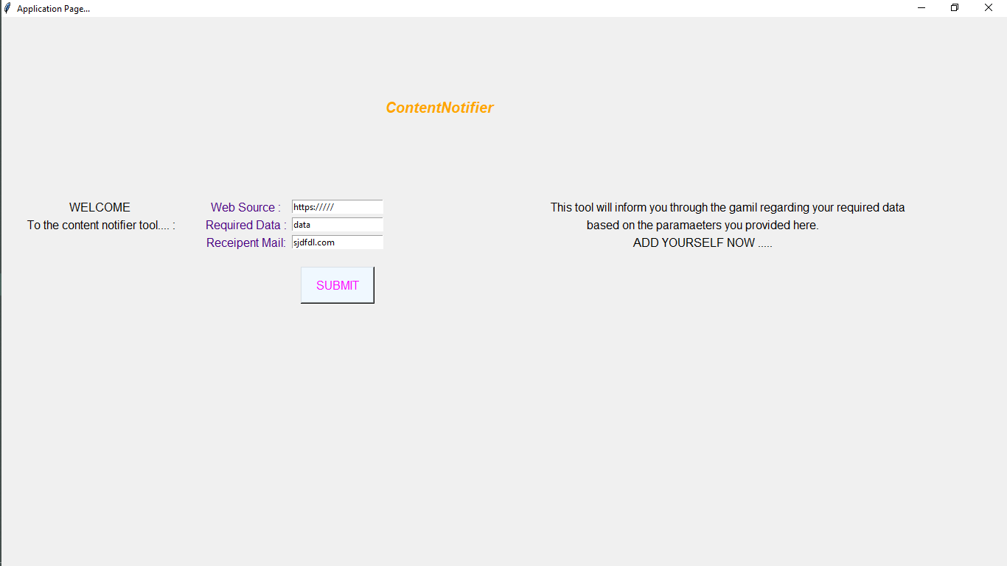

RESULT:

