**Docker-Task**

1. **Creating instance:**

* Creating one instance with amazon linux operating system, 1gb of RAM with 8gb volume.

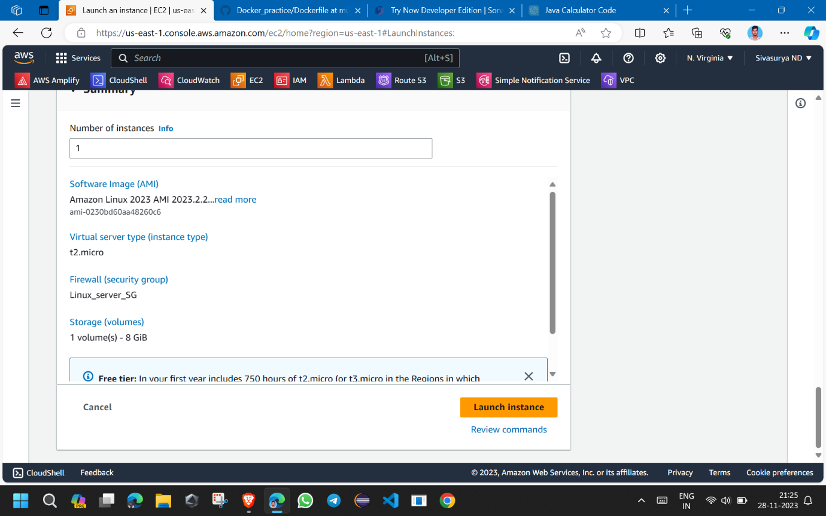

1. **Installing Docker:**

* Installing Git on the Instance by using command >>sudo yum install git –y
* Installing Docker and start that using commands
* sudo yum install docker –y
* systemctl enable docker
* systemctl start docker
* systemctl status docker

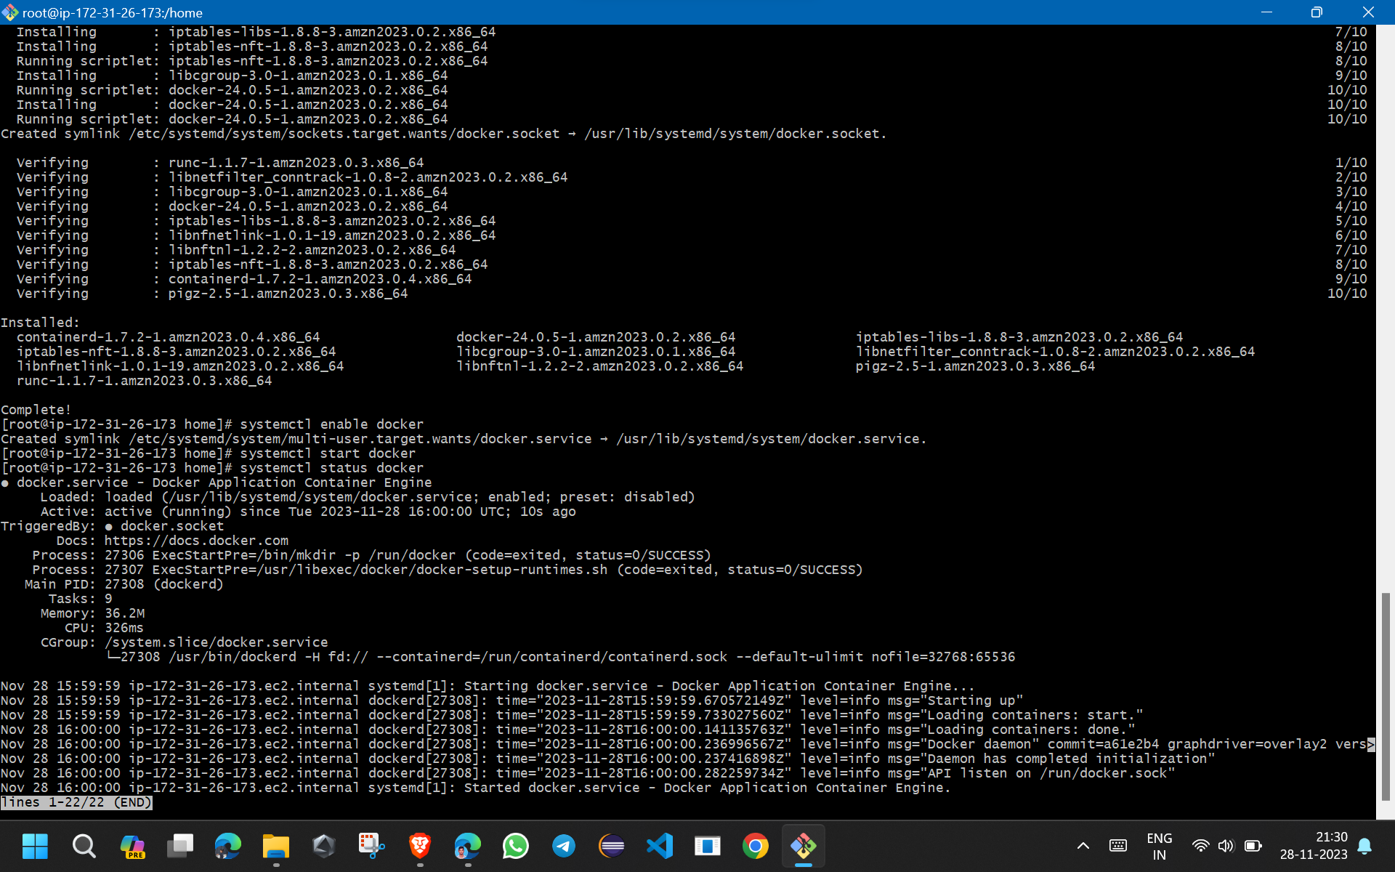

1. **Docker container for Go_lang_app:**

* Go language based calculator application.
* First I get the docker file from the git repository for application based on Go language which is shared to me.
* Then use that docker file I created image by cmd > docker build –t image-name
* After creation of image use that image I created container for run my application by using command > docker run –it --name cont-name image-name/id
* After creation of container my Go language based application running successfully on container which is based on Ubuntu operating system.

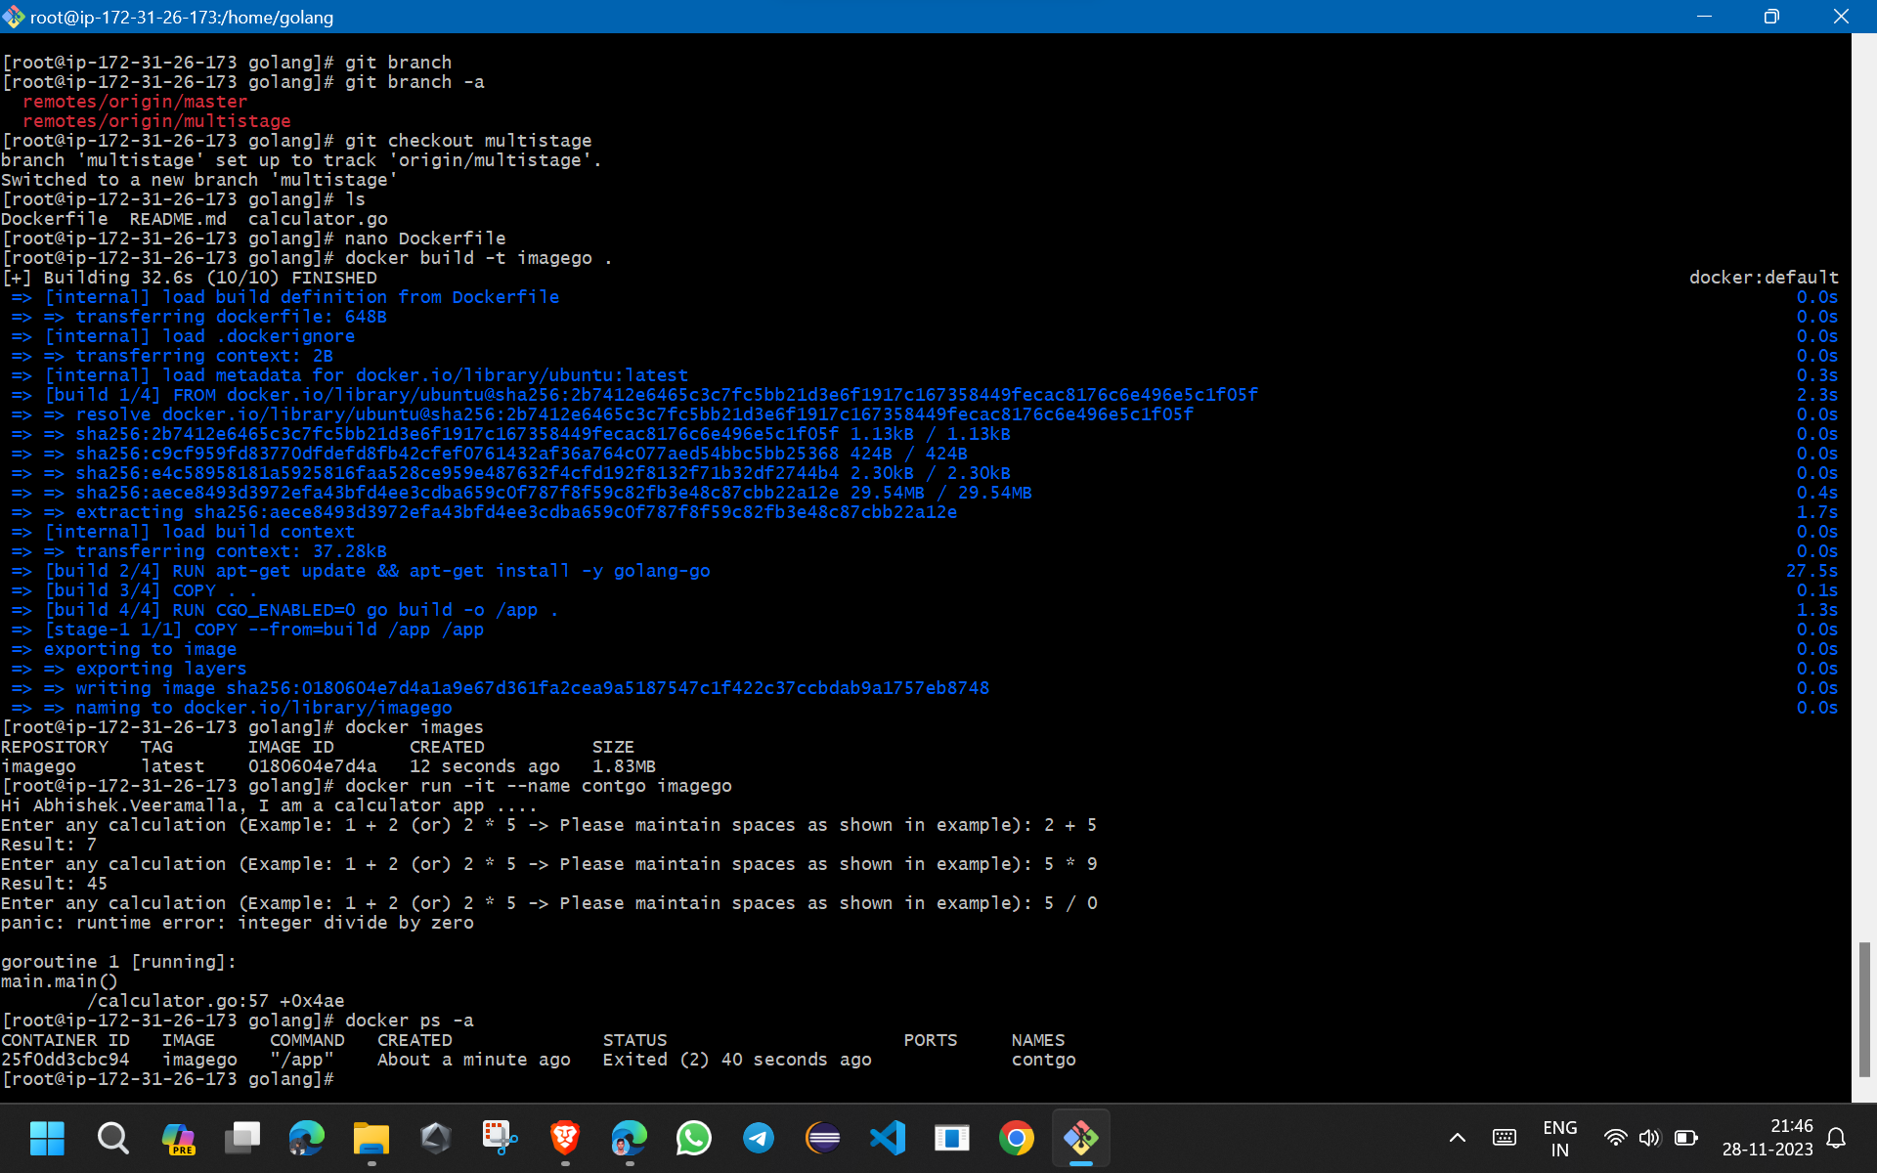

1. **Docker container for Python_lang_app:**

* Python based calculator application.
* First I get the docker file from the git repository for application based on Python language which is shared to me.
* Then use that docker file I created image by cmd > docker build –t image-name
* After creation of image use that image I created container for run my application by using command > docker run –it --name cont-name image-name/id
* After creation of container my Python language based application running successfully on container which is based on Ubuntu operating system.

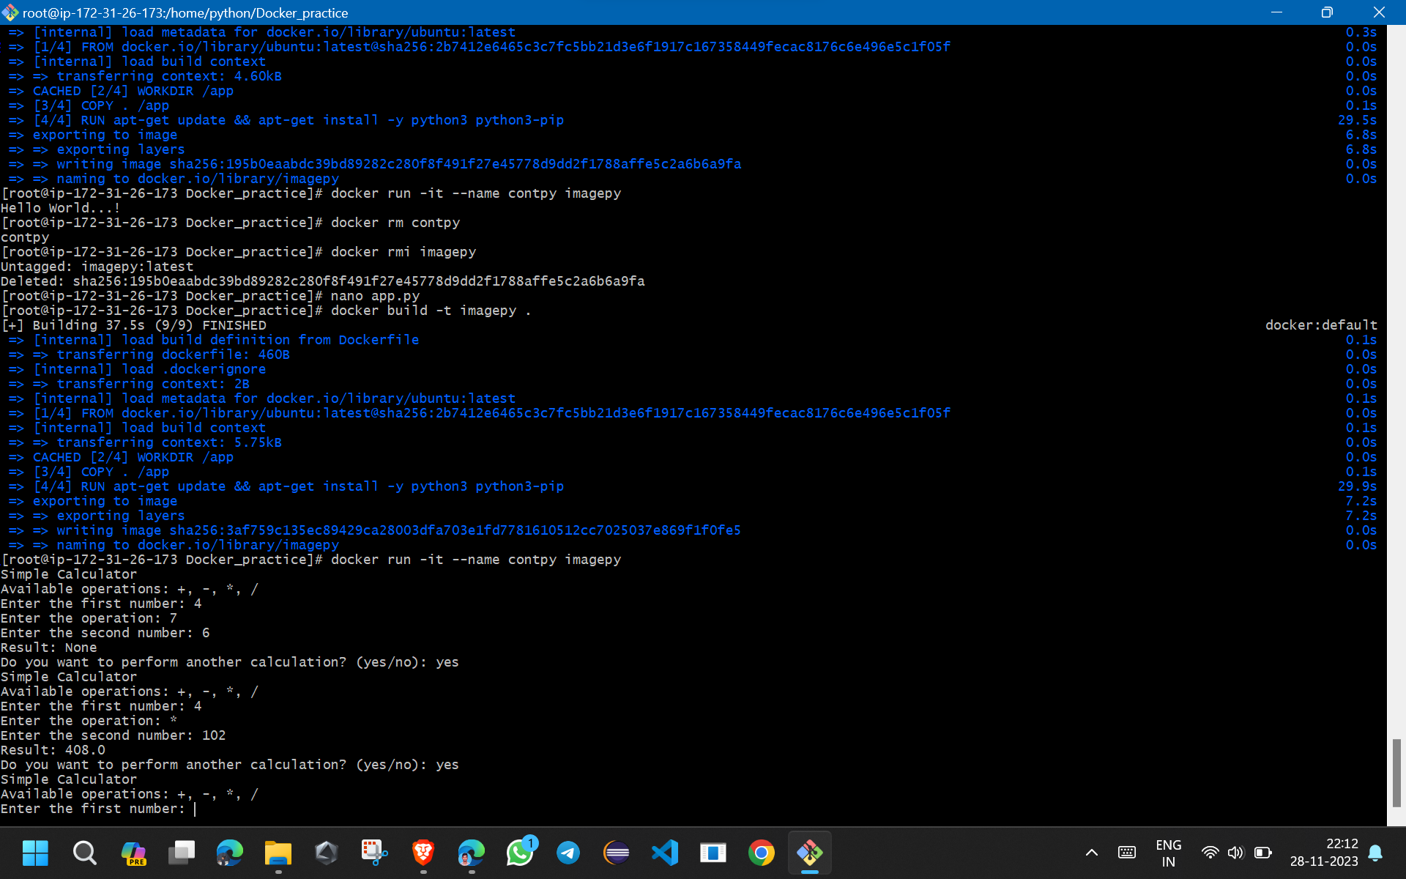

**5. Docker container for Java_lang_app:**

* Java based todo application for deploy in container.
* First I get the docker file from the git repository for application based on Java language which is shared to me.
* Then use that docker file I created image by cmd > docker build –t image-name
* After creation of image use that image I created container for run my application by using command > docker run –it --name cont-name image-name/id
* After creation of container my Java language based application running successfully on container which is based on Ubuntu operating system.

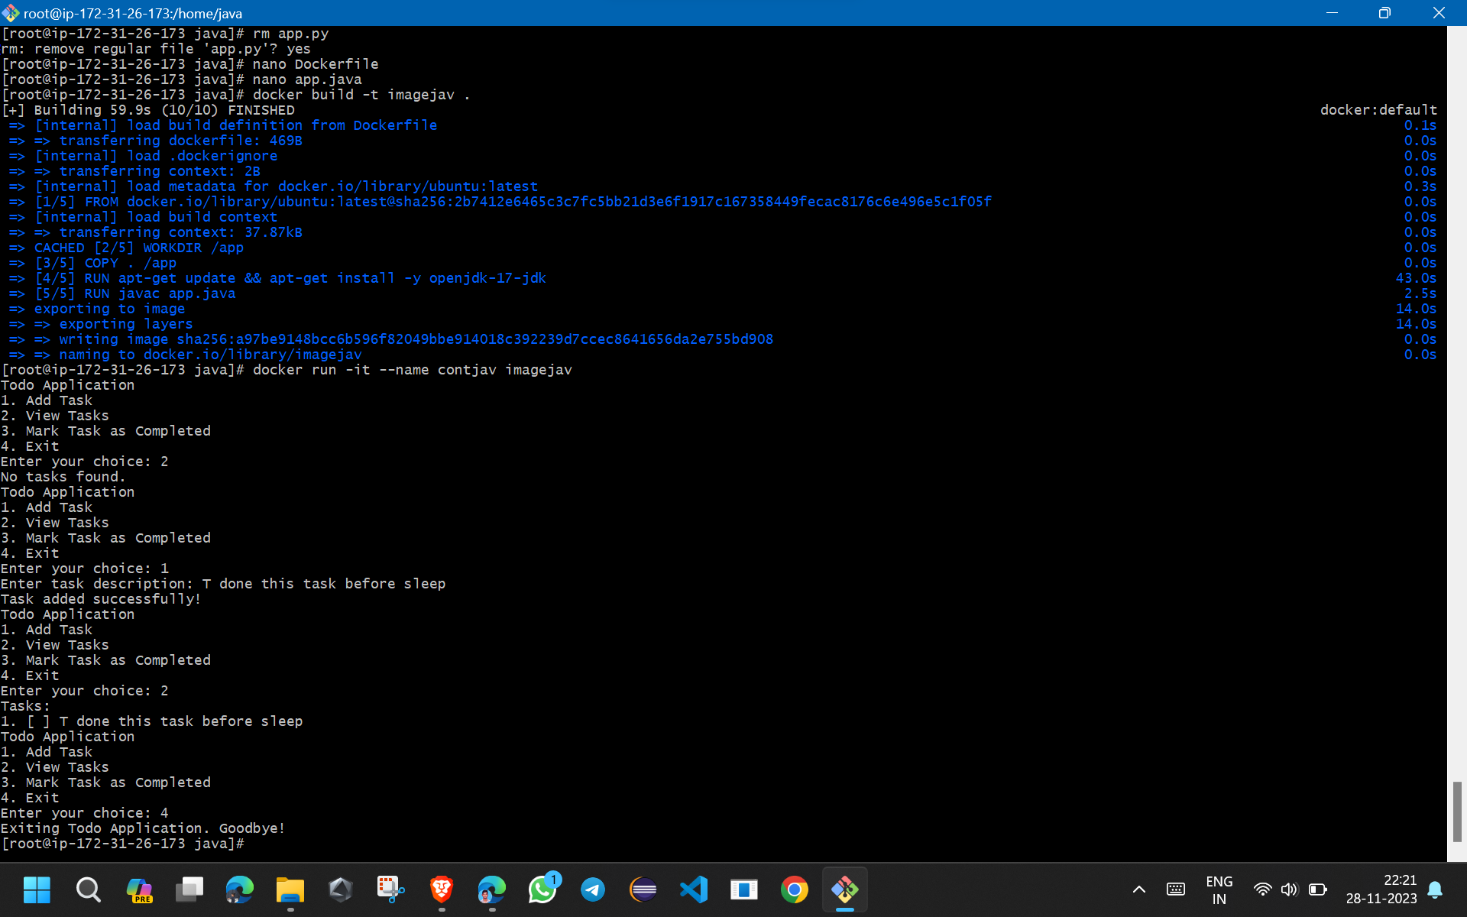

**6. List of containers:**

* In this one virtual machine (instance) I deployed three application which are based different programming languages in three different containers.
* In docker we can deploy multiple features of an application isolatedly.
* Below are the list of images and containers I created in this instance.

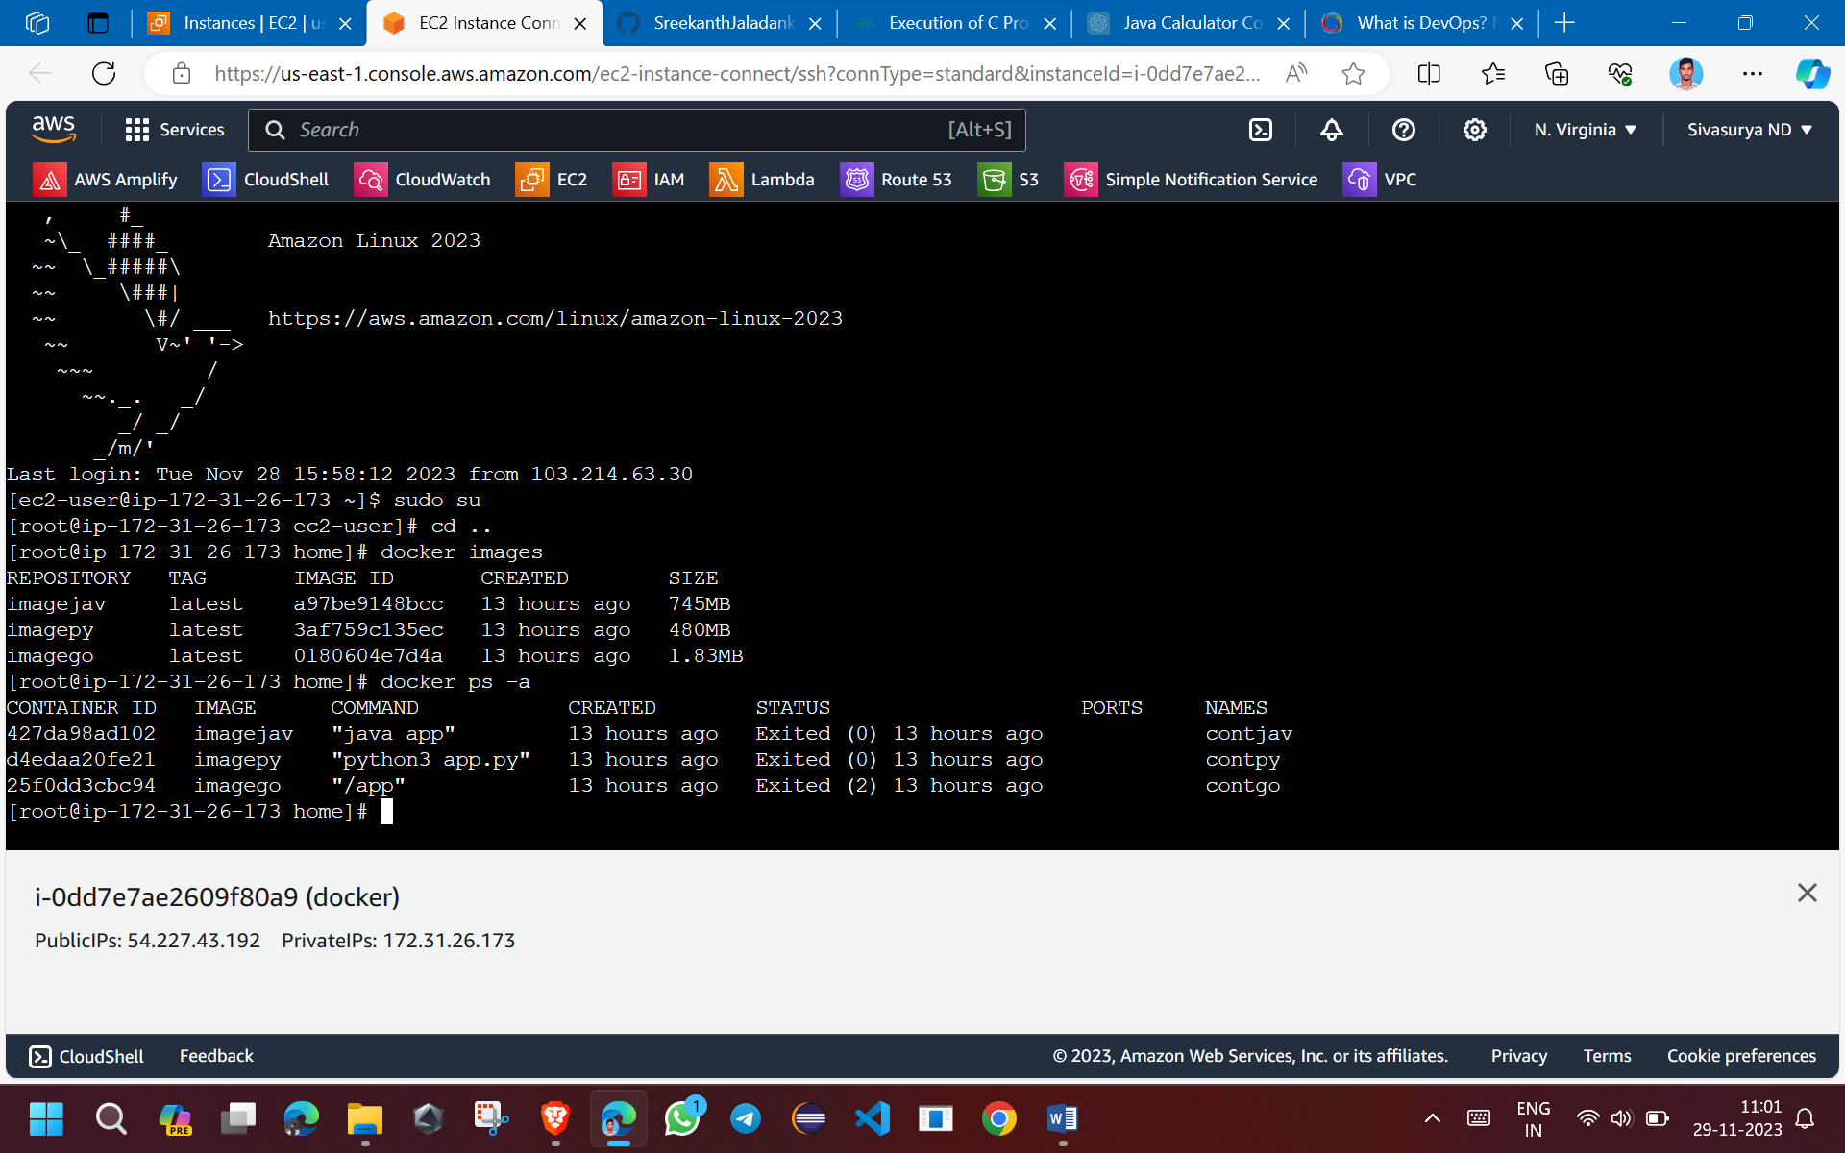

**7.Go_lang docker file:**

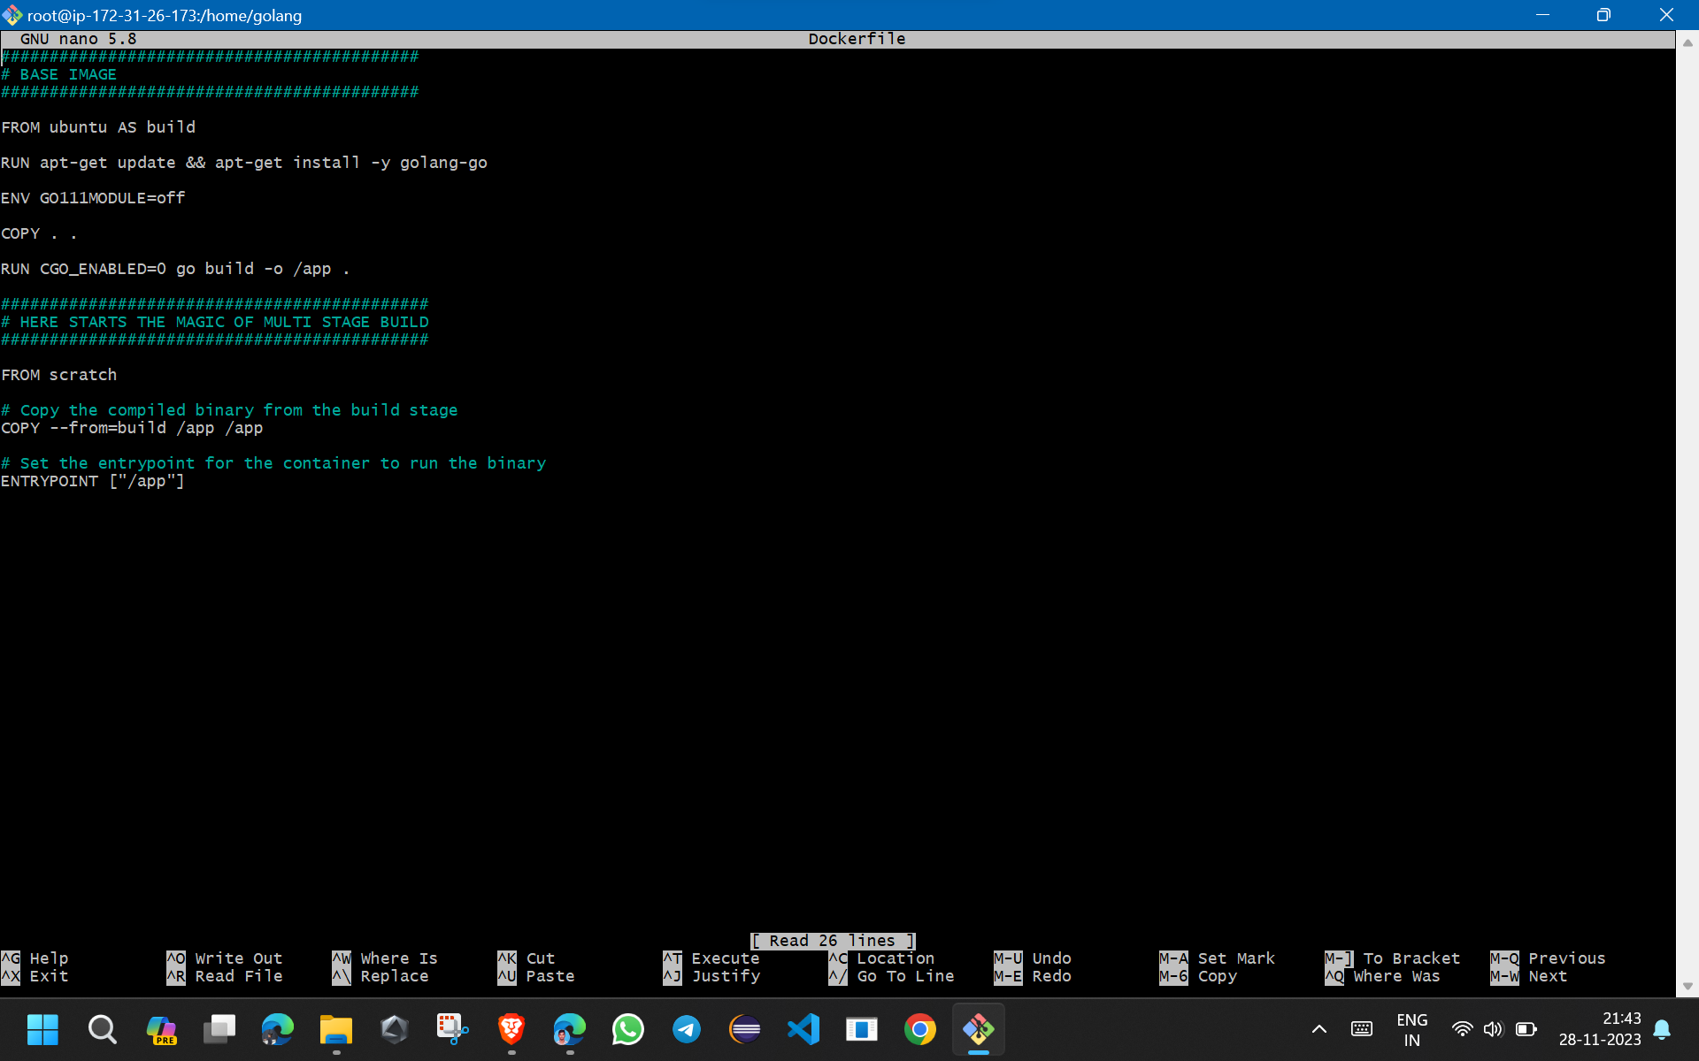

**8.Python_lang docker file:**

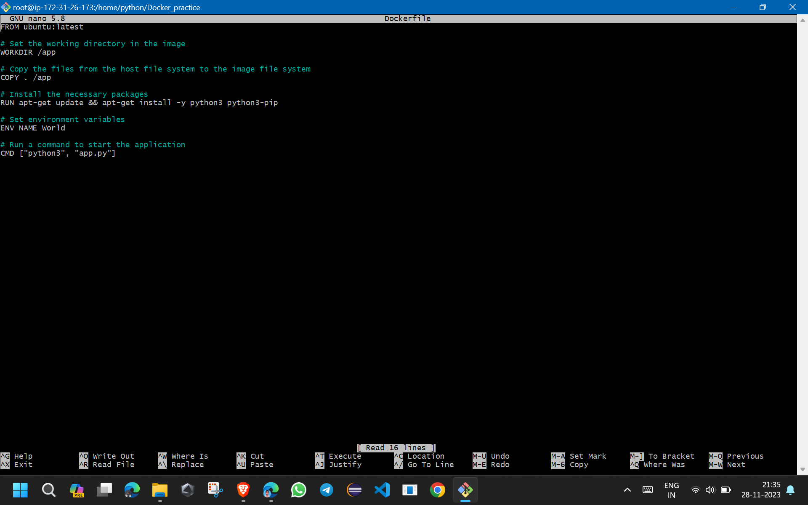

**9. Java_lang docker file:**

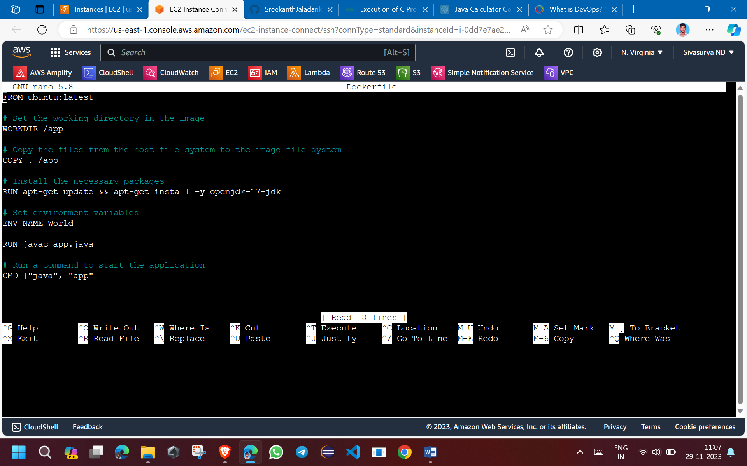

**10. Docker:**

* Docker is a containeraization tool to create containers on virtual machines to run our applications isolatedly.