Commissions Multilayer Automation Framework

Enterprise Multi-Layer Automation Testing Platform

Framework Type: Enterprise API, UI, Database and Integration Automation Platform
Document Type: Architecture Design Document

- Purpose
The Commissions Multilayer Automation Framework is designed to provide a scalable, reusable, maintainable and enterprise-grade automation platform capable of supporting
- API Automation Testing
- UI Automation Testing
- Database Automation Testing
- Integration Testing
- Smoke Testing
- Regression Testing
- Performance Testing
- Authentication and Authorization Testing
- CI/CD Pipeline Execution
- Mult-Environment Execution
This Framework separates business logic, API communication, validations, test data management, reporting and infrastructure concerns into independent layers.

- Architectural Principles
The framework is built on the following principles:
- Solid Principles
    - Single Responsibility Principle
    - Open Close Principle
    - Liskov Substitution Principle
    - Interface Segregation Principle
    - Dependency Inversion Principle
  - Design Patterns
    - Service Layer Pattern
    - Repository Pattern
    - Dependency Injection Pattern
    - Page Object Model Pattern
    - Strategy Pattern
    - Builder Pattern
    - Fluent Assertion Pattern

- High-Level Architecture
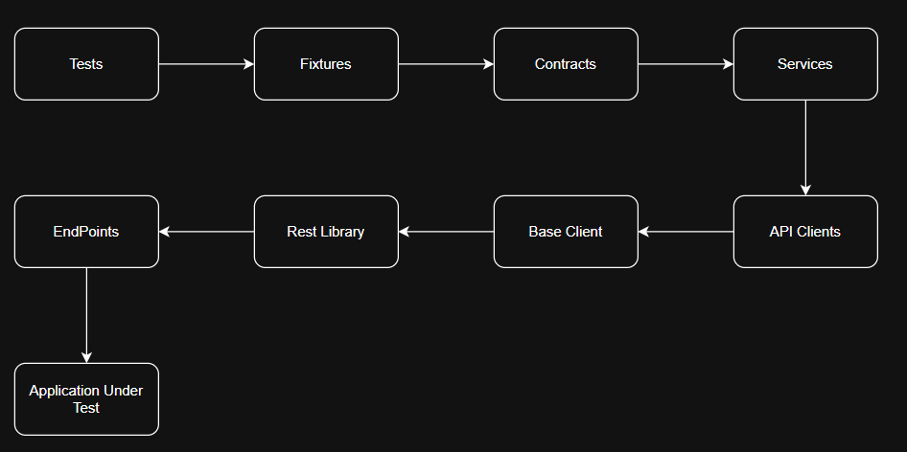

Framework structure
  - CommissionMultilayerAutomationFramework
    - src
      - Main
      - API
      - UI
      - Database
      - Reports
      - DevOps
      - TestData
      - Tests
      - Documentation

Main Layer
The Main layer provides reusable framework components used throughout the solution
  - Configuration
    - Responsible for environment configuration management
- Main
  - Configuration
    - BaseURL
    - EnvironmentSettings
    - AppSettings
      - appsettings.json
      - appsettings.dev.json
      - appsettings.qa.json
      - appsettings.uat.json
      - appsettings.prod.json
    - Responsibilities
      - Environment Selection
      - API Base URLs
      - Database Configurations
      - Authentication Settings
      - Reporting Settings
      - CI/CD Parameters
  - Contracts
    - Contracts define the services available to the framework. Outlines rules or protocol that needs to be followed when amending them in the services.
    - Only interfaces reside here.
- Main
  - Contracts
    - Benefits
      - Loose Coupling
      - Dependency Injection
      - Easier Maintenance
      - Simplified Unit Testing
  - Services
    - Contains business workflows and orchestration logic. The services will manage the package the requests logic for the services to consume, process information and produce outputs that are specific and align to the requirements
- Main
  - Services
    - Responsibilities
      - Business Logic
      - Service Orchestration
      - Workflow Management
      - Validation Execution
      - Client Coordination
  - Authentication
    - Centralized authentication framework
      - Authorization verifies what an authenticated user is granted rights to do. This verifies the identify of the user, assigns role base privilege. This also ensure that session established is secured and transaction cannot be intercepted.
- Authentication
  - TokenManager
  - OathProvider
  - JwtProvider
  - SessionManager
  - AuthenticationService
    - Supported Mechanisms
      - OAuth2.0
      - JWT
      - Azure AD
      - Token Refresh
      - Session Management
  - Validations
    - Centralized validation layer.
      - This will compose of validation check.
- Validation
  - RequestAndResponse
  - XML
  - Json
    - Purpose
      - Contract Validation
      - API Response Validation
      - Schema Validation
      - Business Rule Validation
  - Utils
    - Reusable Utilities
- Utils
  - Helpers
    - DisplayTest
    - HttpLogger
    - ReadDataFieldHander
    - RequestAndResponseHandler
    - RestLibraryCollectionSetup

API Layer
The API Handles all API communication.
- API
  - EndPoint
  - BaseClient
  - Clients
  - Models
    - Endpoint
      - Keep API routes centralized
- EndPoint
  - EndPointRegistry
  - ApprovalValidationTestEndPoints
  - BatchApprovalEndPoints
  - BatchTransactionEndPoints
  - ChannelSetupEndPoints
  - CommissionRunEndPoints
  - CommissionsEndPoints
  - DataImportEndPoints
  - EmailRecipientsEndPoints
  - EmailTestEndPoints
  - InspiratorEndPoints
  - PaymentAmendmentEndPoints
  - ScheduledTaskEndPoints
  - SignatoryEndPoints
  - UserBasketEndPoints
  - WorkFlowEndPoints

    - BaseClient
      - Providers reusable HTTP methods. This ensures maintainability of the framework that all HTTP methods reside a single location. All-consuming class will then pass (path parameters, query parameters and body) required test data to execute the HTTP method.
- API
  - BaseClient
    - Async Methods
      - (Get, Put, Patch, Post, Delete)
      - Common Headers
      - Authentication
      - HTTP communication
      - Retry Handling
      - Logging

    - Clients
      - Interacts directly with APIs. The client prepares request and response by means of provide the required schema in which the request, response are structure and data types are defined. This is to ensure that an API request and response is maps to API requirements.
- ApprovalValidationTest
  - Request
  - Response
- BatchApproval
  - Request
  - Response
- BatchTransaction
  - Request
  - Response
- ChannelSetup
  - Request
  - Response
- CommissionRun
  - Request
  - Response
- Commissions
  - Request
  - Response
- DataImport
  - Request
  - Response
- EmailRecipients
  - Request
  - Response
- EmailTest
  - Request
  - Response
- Inspirator
  - Request
  - Response
- PaymentAmendment
  - Request
  - Response
- ScheduledTask
  - Request
  - Response
- Signatory
  - Request
  - Response
- UserBasket
  - Request
  - Response
- WorkFlow
  - Request
  - Response
      - Responsibilities
        - API Calls
        - Request Mapping
        - Response Mapping

UI Layer
Built using the Page Object Model Design pattern.
- A design pattern that structures complex test suites by representing web application pages as classes. The approach provides a clean separation of concern and maintainability. Abstraction of components encapsulation
  - UI Structure
- UI
- Pages
- Components
- Locators
- Actions
    - Pages
      - Represent applications screens
- Pages
  - LoginPage
  - Name_Page
    - Components
      - Reusable UI Controls
- Components
  - HeadersAbstractComponents
  - NavigationsAbstractComponents
  - ModelAbstractComponents
    - Locators
      - Store selectors independently
- Locators
  - LoginPageLocators
  - Name_PageLocators
    - Actions
      - Encapsulates user interactions
- Actions
  - Async Login (username, password)
  - Async Register (fName, lName, Password, Address)

Database Layer
Provide backend validation capability.
  - Structure
- Database
  - Contracts
  - Repositories
  - Services
  - Queries
  - Contracts
    - Define data access operations
- Contracts
  - IDataAccess
  - Repositories
    - Contains business specific repositories
- Repositories

    - Responsibilities
      - SQL Execution
      - Data retrieval
      - Backend Validation
  - Services
    - Responsibilities
      - Database Connections
      - Transaction Management
      - Query Execution
  - Queries
    - Reusable SQL Scripts

Reports Layer
Provides centralized execution reporting, analytics, evidence management and result visualization. It serves as the frameworks single source of truth for automation execution outcome.
  - Purpose
    - Capture test execution results
    - Generate detailed automation reports
    - Provide Historical execution insights
    - Support audit and compliance requirements
    - Provide evidence for defect triage
  - Structure
- Reports
  - AllureReports
  - ExecutionSummary
  - Dashboard
  - Screenshots
      - Logs
      - Attachments
      - Evidence
    - Components
      - ReportManager
      - EvidenceManager

  - Components
    - Report Manager
      - Responsible for report initialization and lifecycle management
- ReportManager
  - ReportInitializer
  - ReportCofiguration
  - ReportPublisher
    - Evidence Manager
      - Responsible for collating execution evidence
- EvidenceManager
  - ScreenshotCapture
  - RequestLogger
  - ResponseLogger
  - SQLEvidence
  - ExceptionCapture
    - Responsibilities
      - Execution Reporting
      - Screenshot Management
      - API Request Logging
      - API Response Logging
      - Database Validation Evidence
      - Exception Tracking
      - Trend Analysis
      - Historical Reporting
      - Test Metric Generation
    - Report Outputs
      - HTML Reports
      - Allure Reports
      - PDF Reports
      - Azure DevOps Test Results
      - CSV Export Reports
    - Metrics
      - Total Test Executed
      - Passed Tests
      - Failed Tests
      - Skipped Tests
      - Execution Duration
      - Defect Density
      - Environment Information
      - Build Information

DevOps Layer
Integrates the automation framework with Continuous Integration and Continuous Delivery (CI/CD) pipelines
  - Purpose
    - Provide automation build validation, scheduled execution, deployment quality gates and reporting integration
  - Structure
- DevOps
  - Docker
  - Kubernetes
  - AzureDevOps
  - GitHubActions
  - Jenkins
  - PipelineTemplates
  - EnvironmentConfigs
  - Components
    - PipelineManager
  - Components
    - PipelineManager
      - BuildPipeline
      - ReleasePipeline
      - TestPipeline
      - DeploymentPipeline
  - Responsibilities
    - CI/CD Integration
    - Build Validation
    - Automated Regression Execution
    - Scheduled Testing
    - Environment Provisioning
    - Test Result Publishing
    - Quality Gate Enforcement
  - Execution Flow
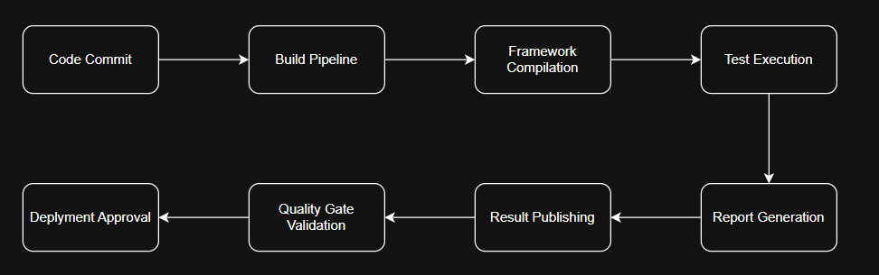

TestData Layer
Provides a centralized management, storage, generation and maintenance of test data.
- Purpose
  - Ensure all tests utilize controlled, reusable, environment-independent datasets
- Structure
- TestData
  - Json
  - XML
  - CSV
  - Excel
  - DynamicData
  - Environment
  - MockData
  - DataProviders
  - DataGenerators
- Components
  - Data Providers
- DataProviders
  - JsonProvider
  - XmlProvider
  - CsvProvider
  - ExcelProvider
  - DatabaseProvider
  - Data Generators
- DataGenerators
  - RandomAgentDetailsGenerator
  - TaskGenerator
  - TransactionGenerator
- Responsibilities
  - Test Data Provisioning
  - Dynamic Data Generation
  - Environmental Data Management
  - Data Cleanup
  - Data Masking
  - Data Transformation
  - Data Validation
- Benefits
  - Environment Independence
  - Data Reusability
  - Reduce Maintenance
  - Increased Test Reliability
- Supported Sources
  - Json files
  - XML Files
  - CSV Files
  - Excel Document
  - SQL Scripts
  - Database Records

Tests Layer
Contains all automated test suites executed by the framework
- Purpose
  - Provide executable test scenarios aligned to business requirements and application functionality.
- Structure
  - Tests
    - Smoke
    - Regression
    - Performance
    - UI
    - API
    - Database
    - Integration
    - Security
- Categories
Smoke Tests | Validates critical functionality after release deployment
Regression Tests | Verifies existing functionality remains functional after changes
Performance Tests | Measure scalability, throughput and response times
UI Tests | Validates frontend user journey and interaction with the application
API Tests | Validates service contracts, responses and business logic
Database Tests | Validate backend transactions and data integrity
Integration Tests | Validates interactions between multiple systems
Security Tests | Validate authentication, authorization and access control

- Execution Workflow
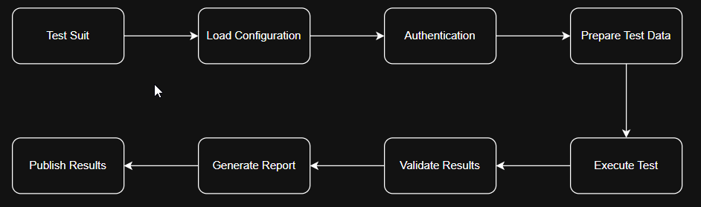
- Responsibilities
  - Test Execution
  - Assertion
  - Validation Orchestration
  - Defect Detection
  - Evidence Collating
  - Reporting

Documentation Layer
- Consists of all framework related technical, operational and governance documentation
- Purpose
  - Provides knowledge management, onboarding support, architecture guidance and framework governance.
- Structure
  - Documentation
    - Architecture
    - User Guide
    - Coding Standards
    - Design Patterns
    - API Reference
    - Troubleshooting
    - Release Notes
- Components
  - Architecture Documentation
    - Architecture
      - ArchitectureDesignDocument
      - ComponentDiagrams
      - SequenceDiagrams
      - DeploymentDiagrams
      - DataflowDiagrams
    - Operations
      - Installation Guide
      - User Guide
      - Execution Guide
      - Troubleshooting Guide
      - Support Guide
- Responsibilities
  - Framework Governance
  - Knowledge Sharing
  - Standardization
  - Onboarding Support
  - Change Management
  - Audit Compliance
- Documentation Deliverables
    - Architecture Design Document
    - Technical Specification
    - Framework User Guide
    - CI/CD Setup Guide
    - Coding standards
    - Troubleshooting Guide
    - Release Documentation
    - Best Practises
- Benefits
  - Fast adoption and onboarding
  - Consistent Development Standards
  - Improved Maintainability
  - Reduce keyman reliance
- Layer Interaction Summary
  - 