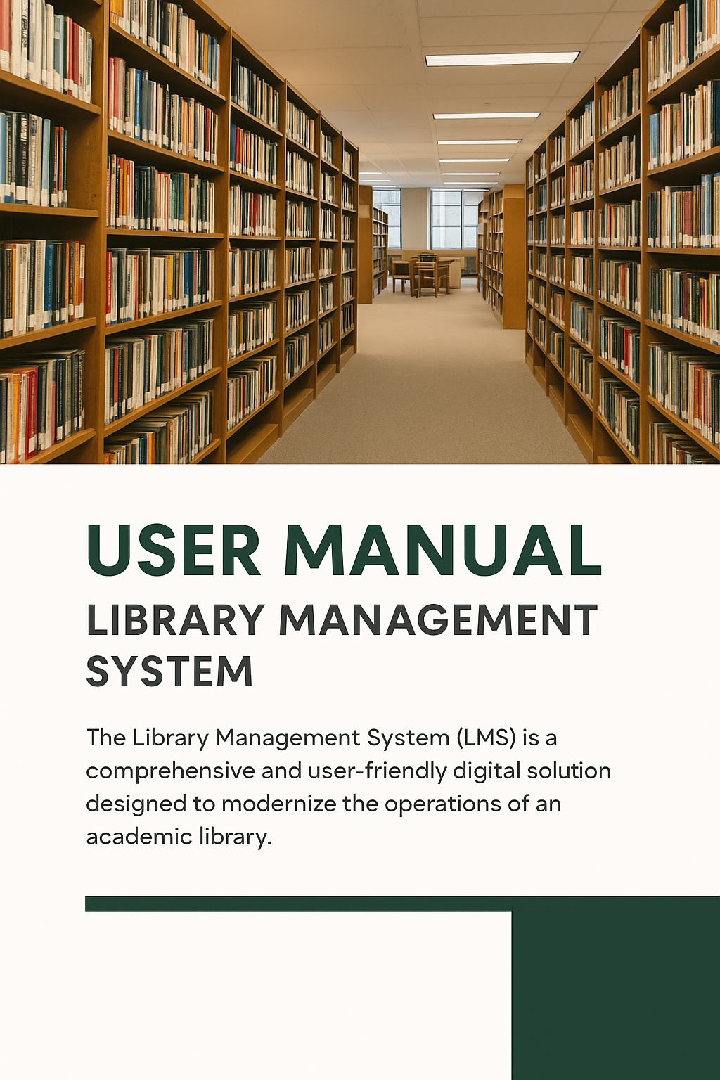
Contents
1. Introduction 4
2. Target Users 4
3. Modules Overview 5
3.1 Login Module 5
3.2 Librarian Dashboard 6
3.2.1 Catalogue Management………………………………………………………………………………… 9
Add Library Resource 9
Add Bulk Library Resource (Excel) 9
Manage Library Resources 10
Library Resource Copies 11
Add Library Resource Type 11
Add Author 12
3.2.2 Fine Management 13
3.2.3 Circulations ………………………………………………………………………………………………… 13
Issue Books ……………………………………………………………………………………………………….... 13
Return/Renew …………………………………………………………………………………………………… 14
Booking Lists ………………………………………………………………………………………………………. 15
3.2.4 New Book Requests ……………………………………………………………………………………… 16
3.2.5 Visitor Management …………………………………………………………………………………….. 16
3.2.6 Counter Management …………………………………………………………………………………… 17
3.2.7 Manual Circulation Entry ……………………………………………………………………………… 18
3.2.8 Reports……………………………………………………………………………………………………….. 18
Availability Report …………………………………………………………………………………………….. 19
Requested Report ………………………………………………………………………………………………. 19
Issued Report …………………………………………………………………………………………………….. 20
Overdue Report …………………………………………………………………………………………………. 20
Fine Report ……………………………………………………………………………………………………....... 21
3.3 Student / Faculty Dashboar 22
3.3.1 Borrow Resource …………………………………………………………………………………………. 23
3.3.2 My Reservations ………………………………………………………………………………………….. 23
3.3.3 My Booking List …………………………………………………………………………………………. 24
3.3.4 Borrowed History …….…………………………………………………………………………………. 24
3.3.5 Overdue List ……….………………………………………………………………………………………. 25
3.3.6 Terms & Conditions 25
4. System Workflow 26
5. Troubleshooting & Help 26
6. Security & Access Control 27
7. Future Enhancements 27
8. Conclusion 27

1. Introduction
The Library Management System (LMS) is a comprehensive and user-friendly digital solution designed to modernize the operations of an academic library. It replaces traditional manual record-keeping methods with an efficient, secure, and centralized online platform.
The system is developed to support the needs of students, faculty members, librarians, and administrative staff, ensuring smooth and transparent management of all library resources such as books, journals, e-resources, and other reference materials.
Through this system, librarians can easily manage book catalogues, track issues and returns, handle fines, and generate detailed reports — all from a single dashboard.
Students and faculty can view available books, reserve or borrow materials, track their borrowing history, and request new titles as per their academic requirements.
The LMS enhances productivity and accountability by providing:
- A centralized database to store all book and user records.
- Role-based access control, ensuring secure and personalized experiences.
- Automated fine calculation and real-time reporting.
- Seamless tracking of issue, renewal, and return processes.
- Easy scalability for future features like RFID integration and mobile app support.
In essence, the Library Management System aims to bridge the gap between traditional library management and modern digital access, fostering a smart, organized, and user-centred library experience for all.

2. Target Users
The system is designed for the following users:
- Librarian: Manages all library operations, including adding resources, handling circulation, reports, and fines.
- Assistant Librarian: Supports the librarian with daily tasks like issuing, returning, and managing reservations.
- Student: Can borrow, reserve, renew, and view their borrowing history and overdue items.
- Faculty: Has the same features as students to borrow and manage academic resources easily.

3. Modules Overview

3.1 Login Module
The Login Module is the first interface that appears to every user of the system. It serves as the main entry point for accessing the Library Management System.
Each user — whether Librarian, Assistant Librarian, Faculty, or Student — must log in using the credentials provided by the University. These credentials ensure that only authorized users can access the system and their respective dashboards.
After successfully logging in, users are redirected to their respective dashboards based on their roles:
- Librarian Dashboard – for managing library materials, issuing and returning books, and monitoring overall activity.
- Assistant Librarian Dashboard – for assisting in circulation, managing reservations, and maintaining records.
- Faculty Dashboard – for viewing, reserving, and requesting learning resources.
- Student Dashboard – for searching materials, placing reservations, and tracking their issued books.
The module also includes validation features to ensure secure access, such as:
- Input validation for username and password fields.
- Error messages for incorrect credentials.
- Session management for secure and consistent user access.
Overall, the Login Module provides a secure, user-friendly, and role-based gateway for accessing the Library Management System.
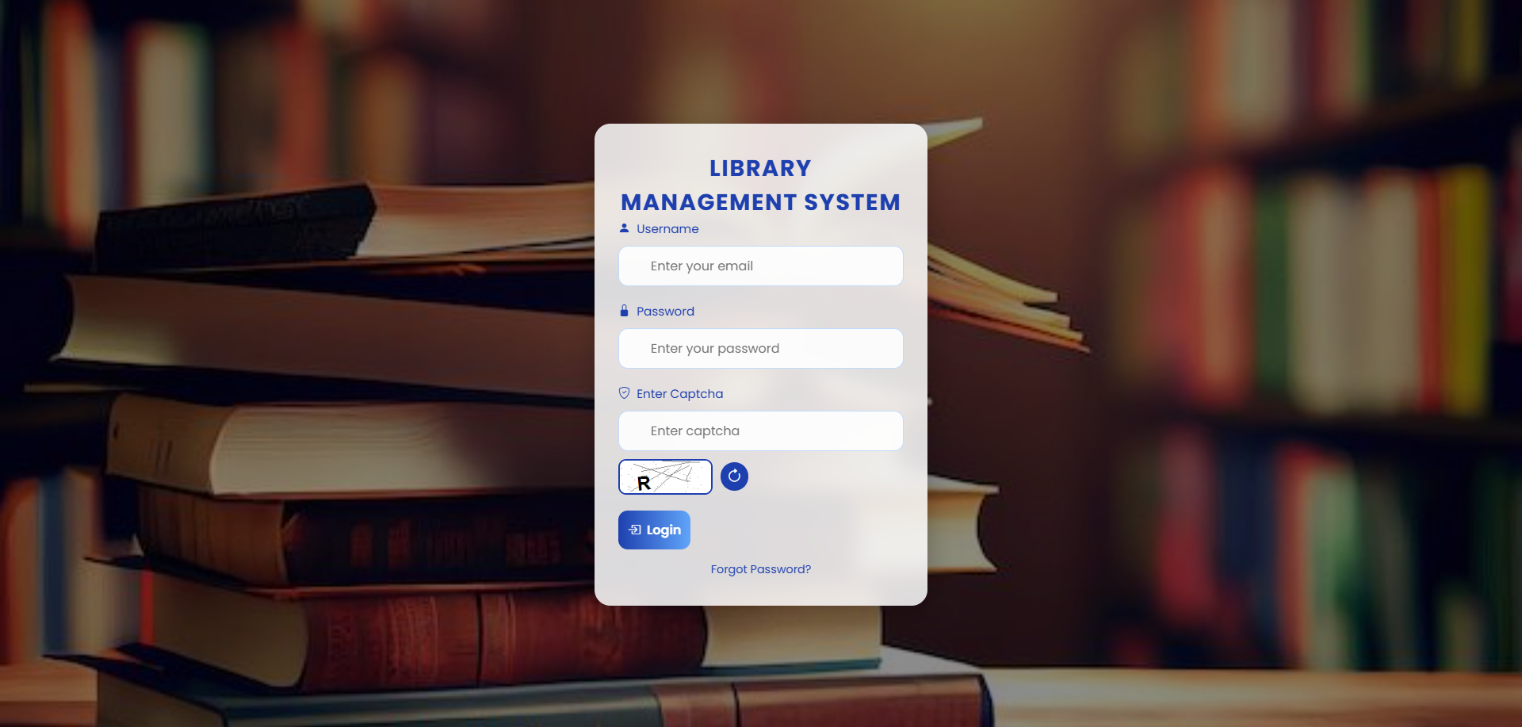

3.2 Librarian Dashboard
The Library Admin Dashboard is the main control panel that appears after a successful login by the Librarian or Admin. It provides a complete overview of library activities, resource availability, and pending operations — all in one place.
Once the librarian logs in with valid university credentials, they are redirected to this dashboard, which offers real-time insights and quick navigation through the library’s core modules.

Dashboard Overview
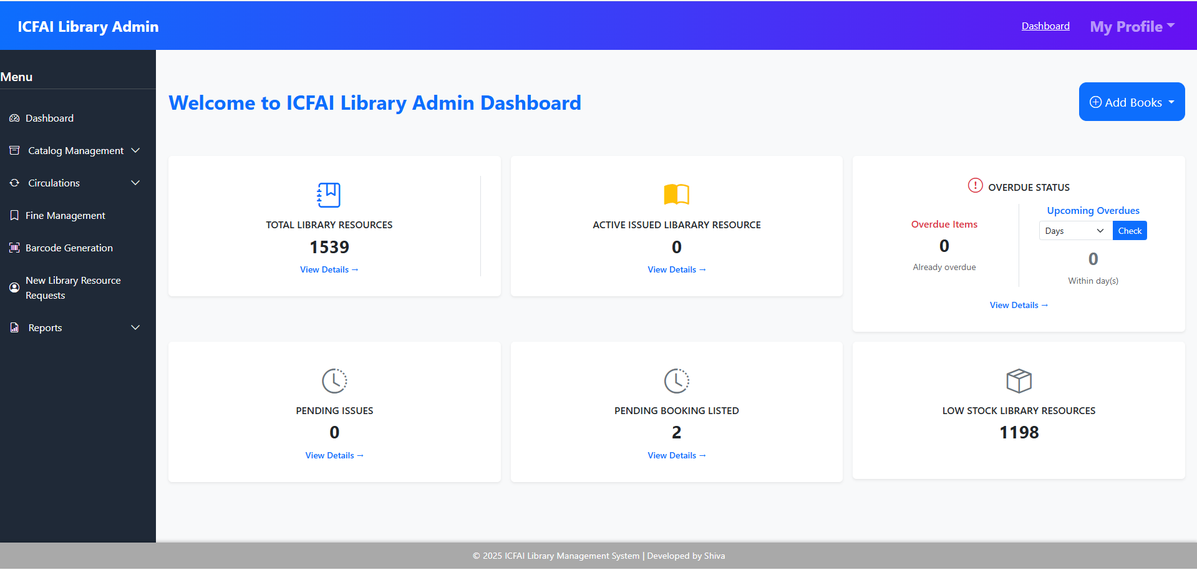
The dashboard contains multiple information cards and a side navigation menu, helping the librarian manage day-to-day library operations efficiently.

Key Components:
- Total Library Resources
Displays the total count of books and other library materials currently available in the system.
- Active Issued Library Resources
Shows the number of materials that are currently issued to patrons (students or faculty).
- Overdue Status
Provides details about books that are overdue or nearing their due date.
  - Overdue Items: Number of books already overdue.
  - Upcoming Overdue: Books that will be due soon within selected days.
- Pending Issues
Lists the total number of issue requests awaiting approval or processing by the librarian.
- Pending Booking Listed
Displays the count of materials booked by patrons that are yet to be approved or issued.
- Low Stock Library Resources
Alerts the librarian about materials that have reached the minimum stock limit, helping in timely replenishment.

Navigation Menu
The left sidebar provides quick access to key modules:
- Dashboard – Returns to the main overview page.
- Catalogue Management – Add, edit, and organize library resources.
- Circulations – Handle issue, return, and reservation of books.
- Fine Management – Manage overdue fines for patrons.
- Barcode Generation – Generate barcodes for new materials.
- New Library Resource Requests – View and approve material requests.
- Reports – Generate and view analytical or summary reports.

Additional Features
- Add Books Button: Allows quick addition of new library resources directly from the dashboard.
- Profile Section: Located at the top-right corner, providing access to profile settings and logout.
3.2.1 My Profile & Logout
The My Profile section allows all users to manage their personal account settings securely. This includes editing personal information and changing the account password.

Key Features:
- Edit Profile:
  - Users can update their name, email, contact details, and other personal information.
  - Changes are saved securely and reflected immediately across the system.
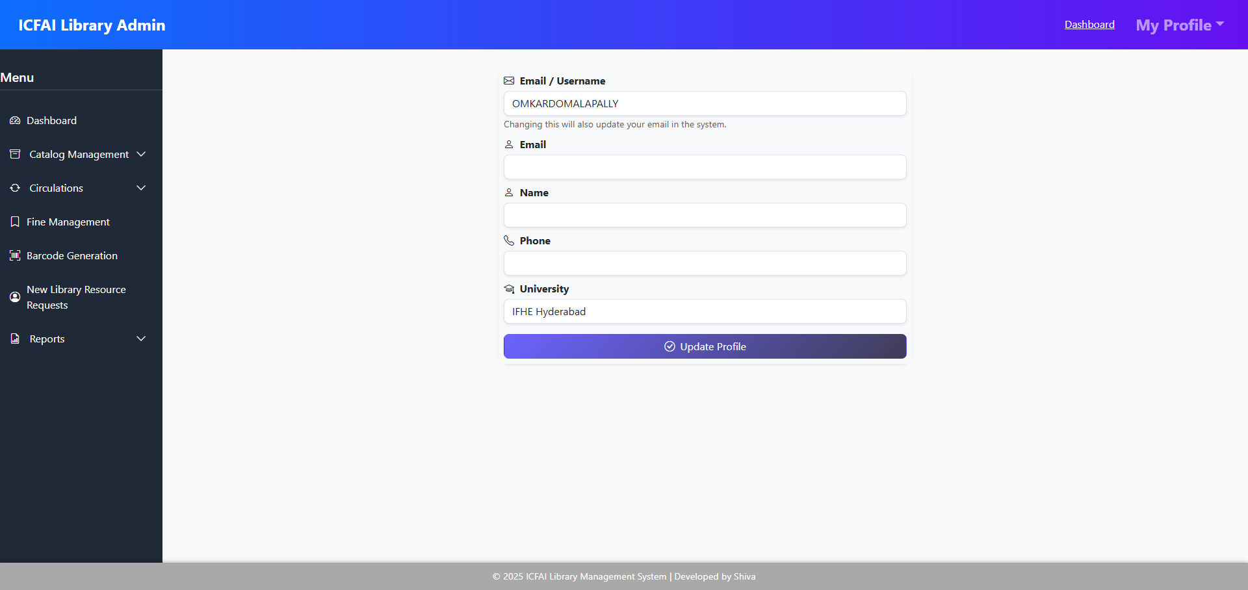
- Change Password:
  - Users can update their password at any time for security purposes.
  - The system ensures strong password validation and confirmation.
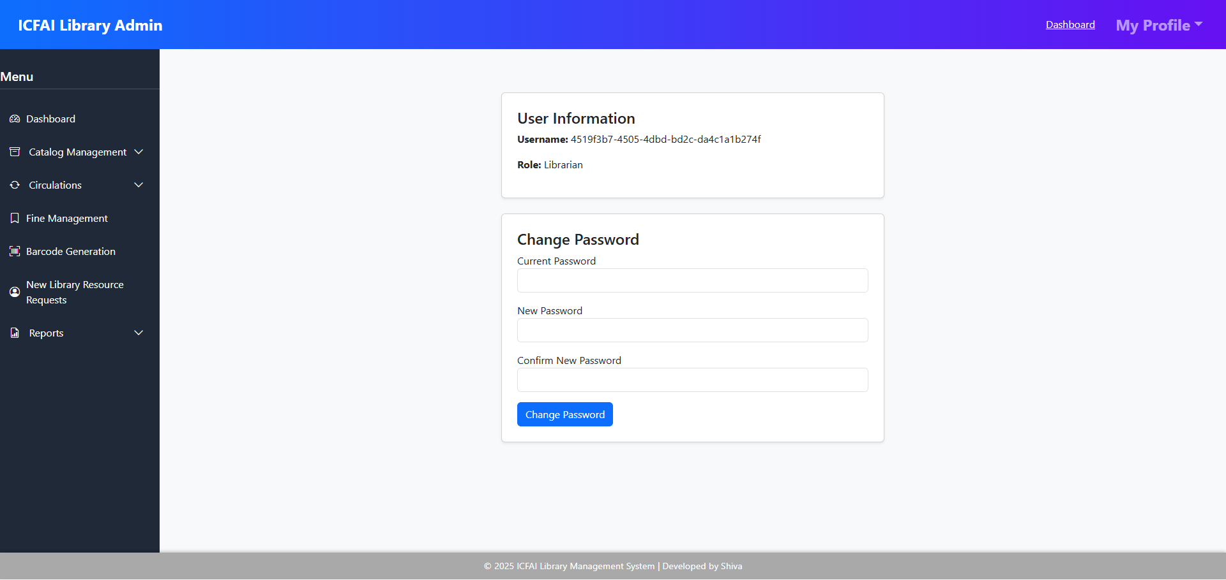
- Logout:
  - Users can safely log out from their account to ensure privacy and security.
  - Logout terminates the session, preventing unauthorized access.

3.2.1 Catalogue Management
The Catalogue Management module allows librarians to efficiently manage all library materials and related information. It ensures that every resource is properly recorded, categorized, and maintained for easy access and circulation.
This module provides several key options through dropdowns:

Add Library Resource
This feature allows librarians to add new books or materials to the library database.
It includes details like Title, Author, ISBN, Publisher, Edition, Year of Publication, and Resource Type. Once added, these materials become available for circulation and searching in the library catalogue.
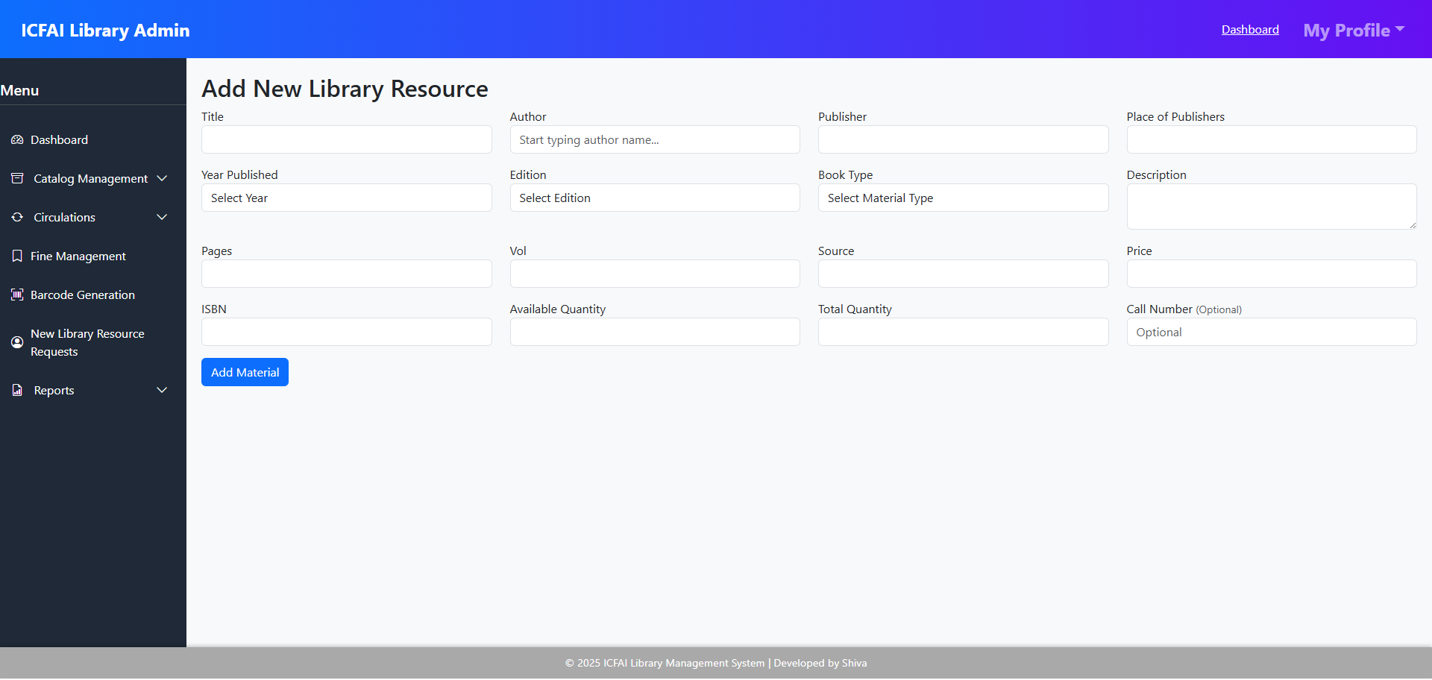

Add Bulk Library Resource (Excel)
This feature is designed for faster data entry and efficient catalogue management. It allows librarians to upload multiple library resources at once using an Excel file.
The system automatically reads and validates the uploaded file to ensure all required fields (like Title, Author, ISBN, Quantity, and Resource Type) are correctly filled.
All valid records are then added directly into the library database, saving significant time during large catalogue updates.
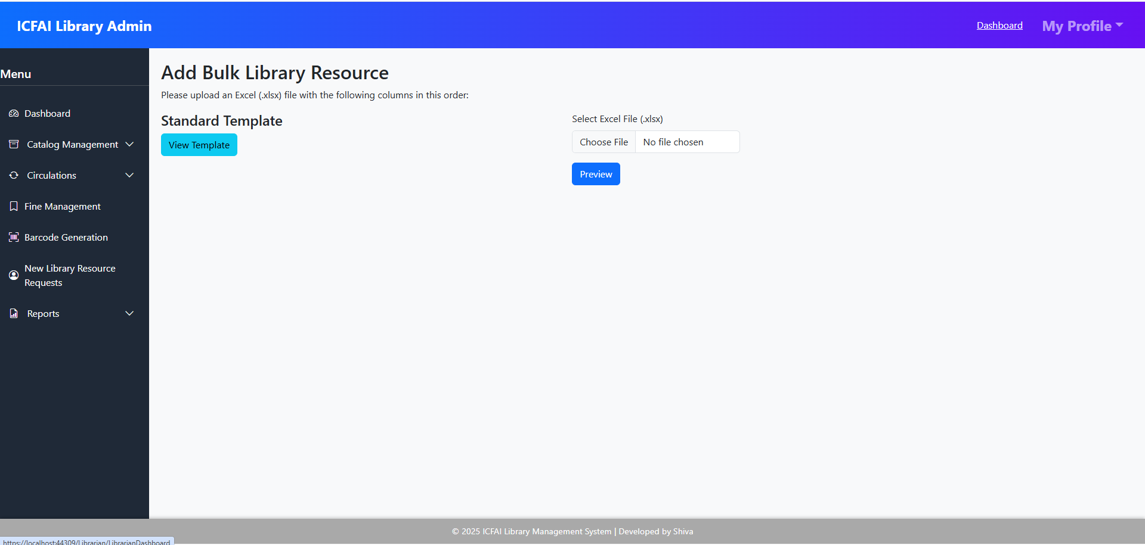
Librarians can click on the “Download Sample Template” button to get the required upload format. This helps them correctly prepare their data before uploading, ensuring smooth and error-free import.

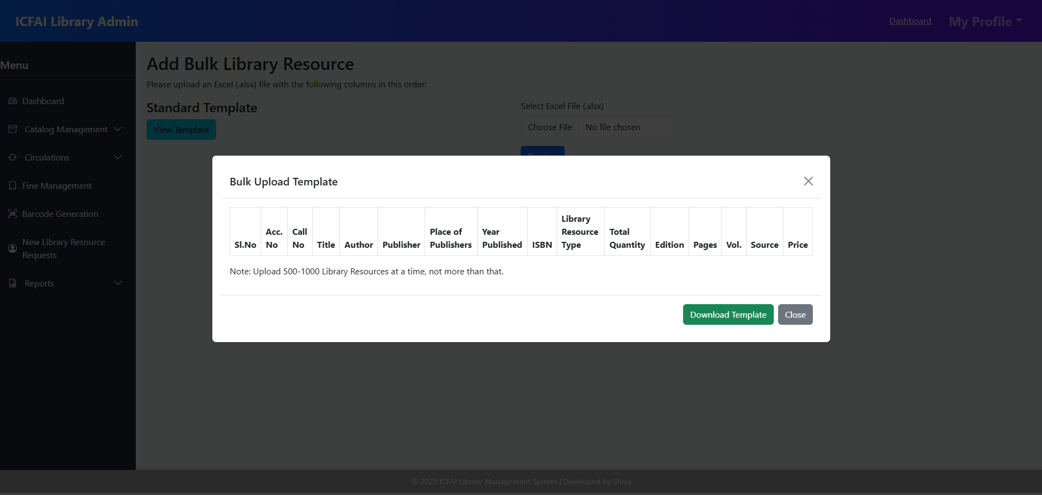
Manage Library Resources
This page displays a master list of all library materials currently available, along with their quantities.
Librarians can easily monitor how many copies are available for each resource, helping in tracking shortages or managing restocking needs.
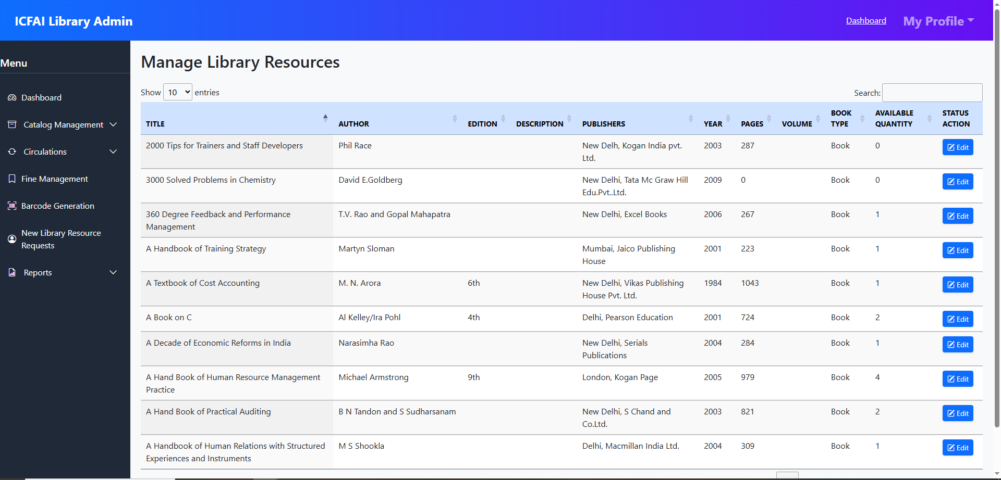

Library Resource Copies
This section is used to manage individual copies of a resource.
Librarians can view, add, or update copy details such as Copy Number, Accession Number, Shelf Location, and Availability Status. This ensures each physical item is properly tracked.
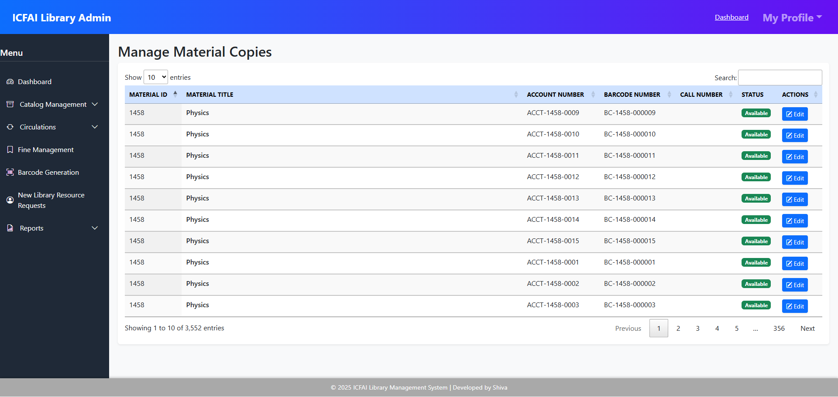

Add Library Resource Type
This option helps define and categorize different types of library resources, such as Books, Journals, Magazines, e-Resources, or Research Papers.
These types make it easier to classify and search resources efficiently in the system.
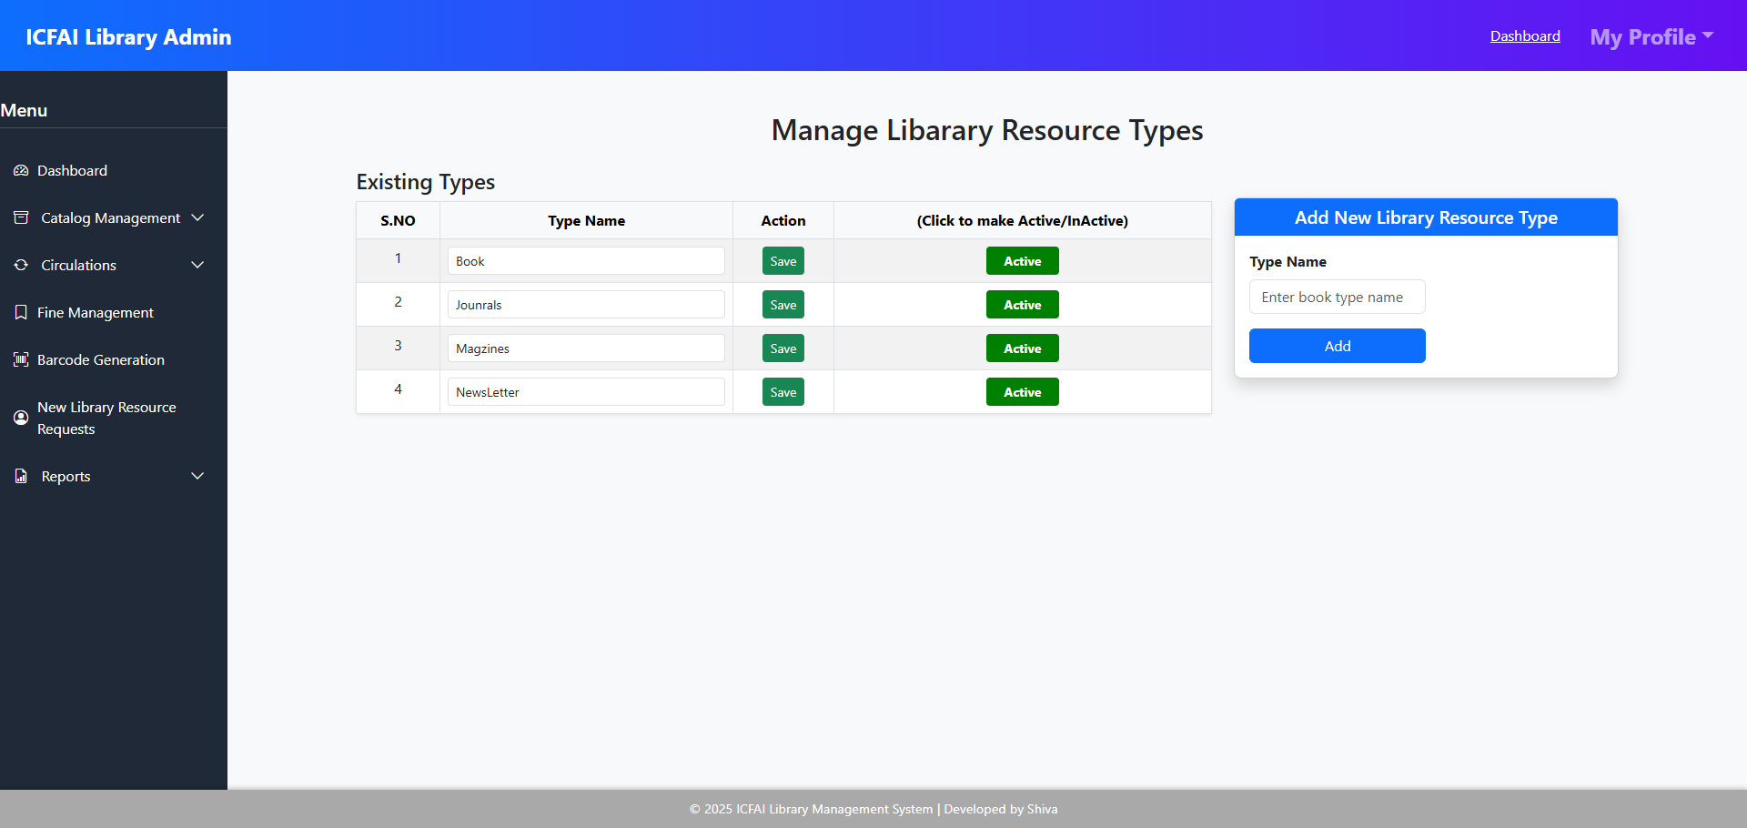

Add Author
The Add Author option allows the librarian to maintain a list of authors whose works are included in the library.
By registering authors separately, it becomes easier to associate multiple books or resources with the same author and improve search accuracy.
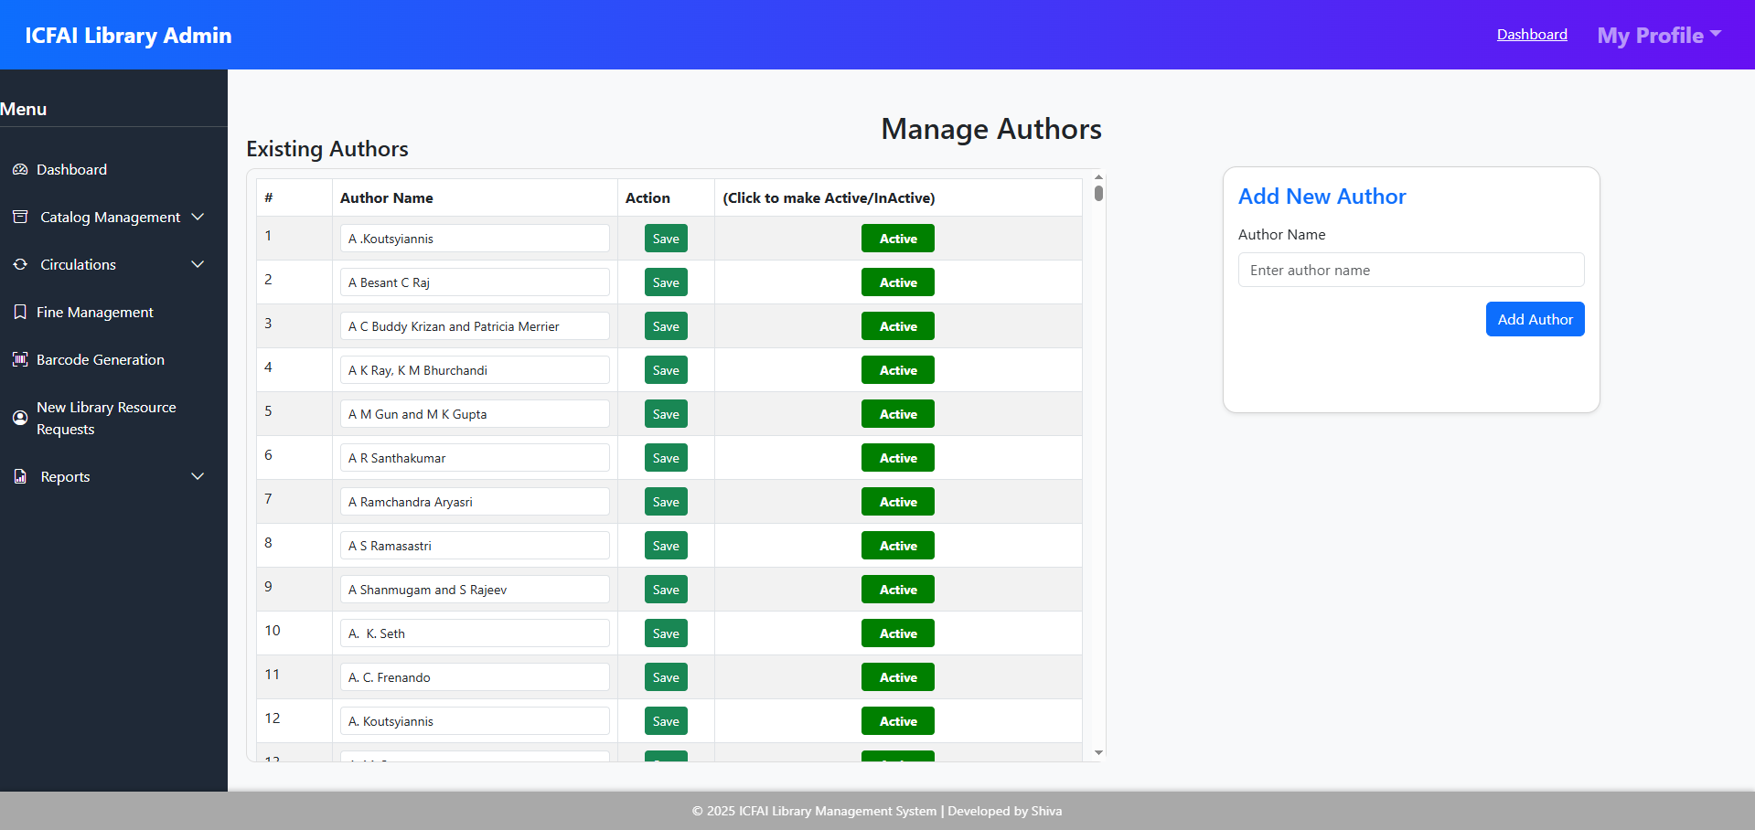

3.2.2 Fine Management
- Automates fine calculation for overdue items, with reporting for paid and pending fines.
- Automates fine calculation for overdue items, with reporting for paid and pending fines.
- Here you can add a new fine reason and define its amount of fine or you can update the existing fine.
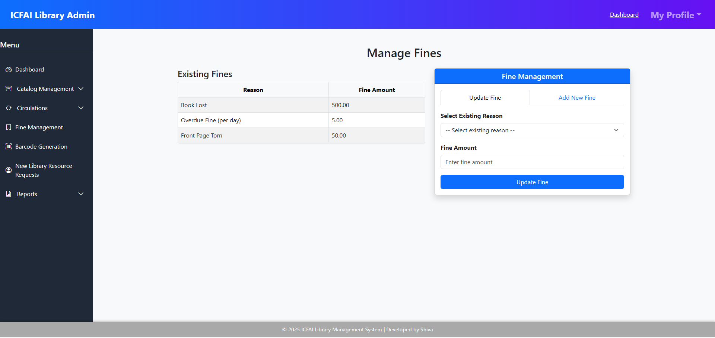

3.2.3 Circulations
The Circulations module enables librarians to efficiently manage the flow of library materials, including issuing, returning, renewing, and booking resources. All transactions are recorded securely, ensuring accurate tracking of materials and member activities. The module is divided into three main views:

Issue Library Resource with Barcode
This view allows the librarian to issue books or other resources to library members. The librarian can:
• Search for the user (Student/Faculty) using their ID or Name.
• Select the book/resource to be issued.
• Scan the barcode on the book using a barcode scanner.
- If the book does not have a barcode, the Librarian should:
  - Assign a new barcode number to the book copy.
  - Print and stick the barcode label onto the book.
  - From the next issue onward, the book can be easily issued by simply scanning the barcode.

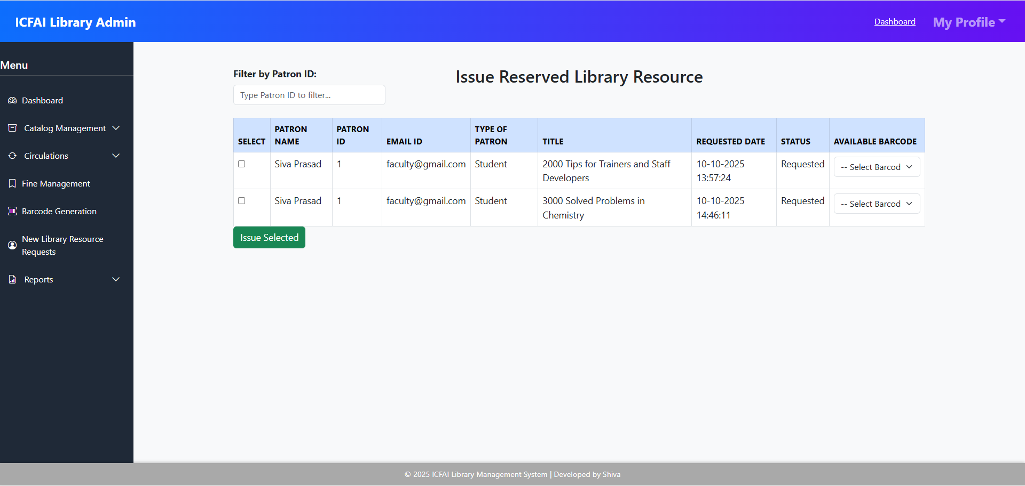

Return / Renew
This view helps the Librarian or Assistant Librarian manage the return or renewal of issued books.
Process:
- When a student or faculty member comes to return books, the Librarian scans the barcode on each returned book.
- Once scanned, the system automatically identifies the book and adds it to the return list.
- The Librarian can review the details and, if applicable,
  - Add or modify fines for late returns.
  - Mark fines as Paid or Unpaid.
- If the user wishes to keep the book longer, the Librarian can renew it for another issue period (as per library policy).

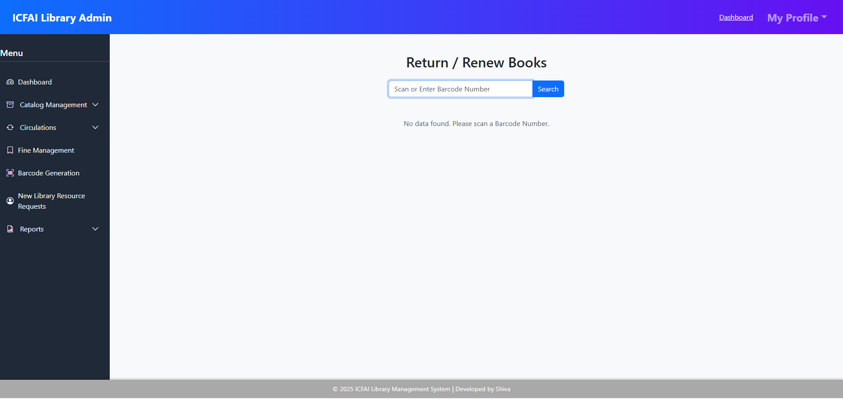

Booking List
The Booking List view allows librarians to manage reservations or bookings of materials by members. It enables:
- Automatically updating material availability once a booking is confirmed.
- Prioritizing bookings to ensure fair allocation of popular resources.
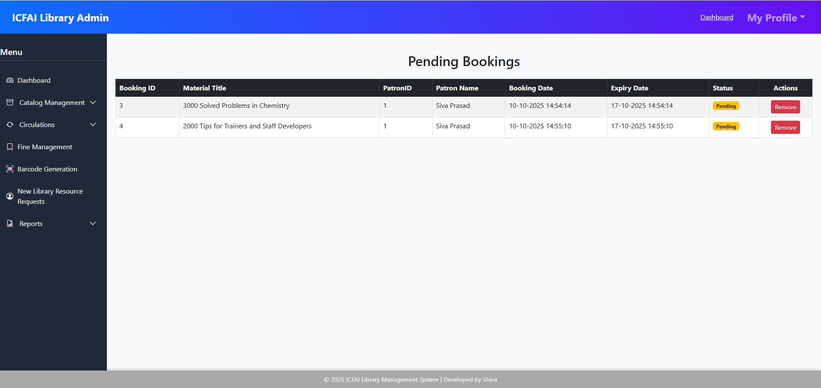

3.2.4 New Book Requests
Librarians can view all requests submitted by students or faculty for books not available in the library.
They can approve, reject, or mark requests as fulfilled once the book is acquired.
Users are notified automatically when their requested book becomes available.
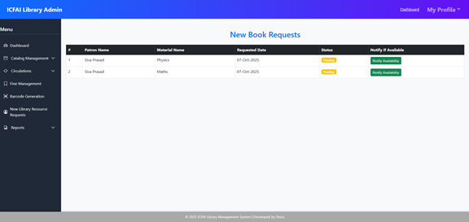

3.2.5 Visitor Management
The Visitor Management module allows the librarian to record details of individuals visiting the library who are not necessarily borrowing books. This helps maintain daily visitor statistics and track library footfall.
Key Features:
- Record visitor details such as name, purpose of visit, and time of entry/exit.
- View a summary of all visitors for the current day.
- Generate daily or periodic reports of total visitors.
- Helps monitor library usage by non-members or guests.
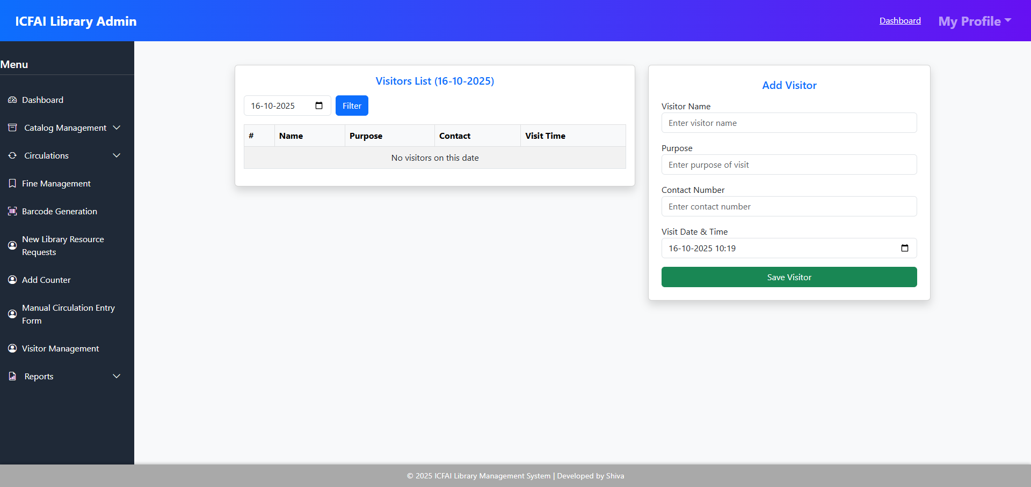

3.2.6 Counter Management
The Counter Management feature enables the librarian to efficiently organize and manage book-issuing counters within the library.
Key Features:
- Add, edit, or remove counters as required.
- Assign counters in sequence to students or staff for book collection.
- Helps distribute workload evenly among counters and reduces waiting time.
- Provides better control and tracking of circulation activities across multiple counters.
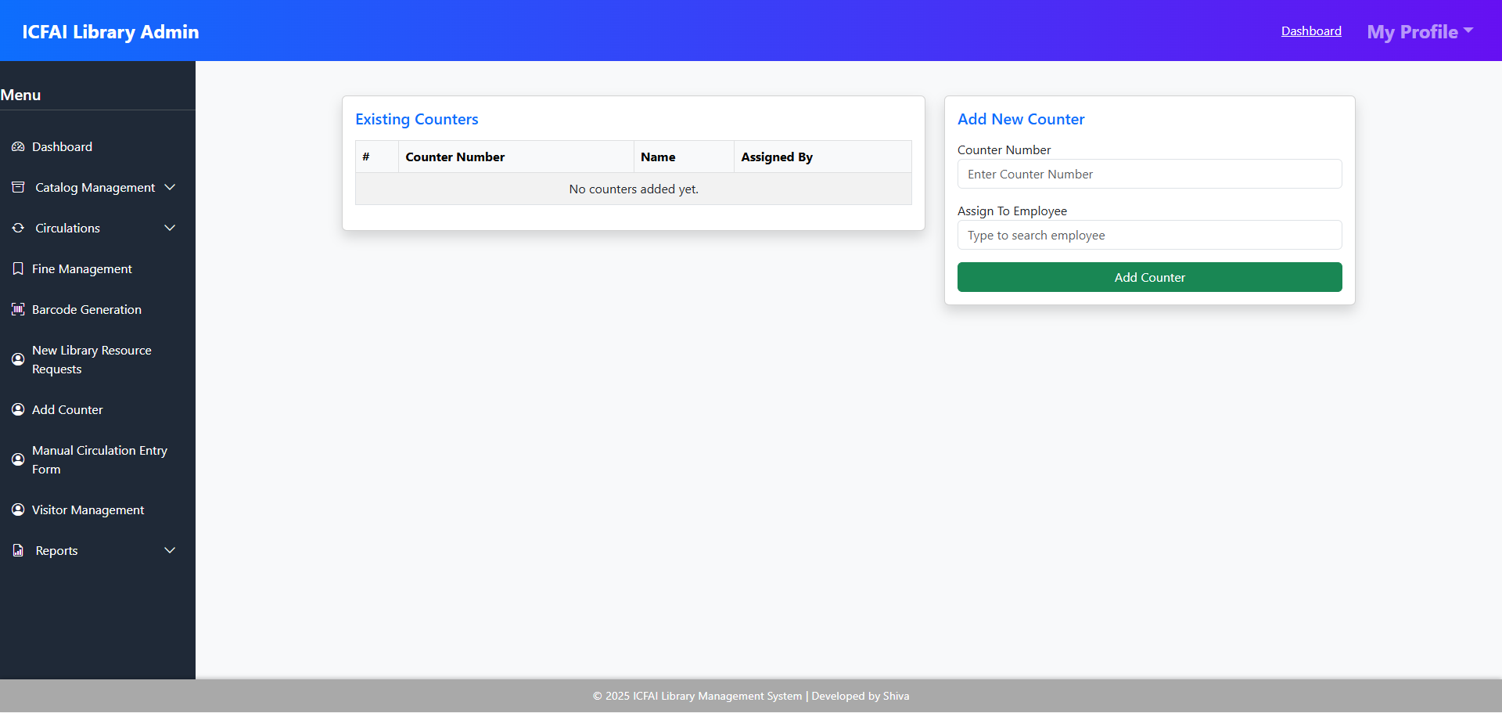

3.2.7 Manual Circulation Entry
The Manual Circulation Entry module is designed for entering records of books that were already in circulation before the library system was launched. This ensures that all historical data is included in the digital system.
Key Features:
- Manually record book issue and return details.
- Include borrower information, book ID, issue date, and due date.
- Useful for migrating pre-existing circulation records into the new system.
- Maintains a complete and accurate circulation history from both old and new data.
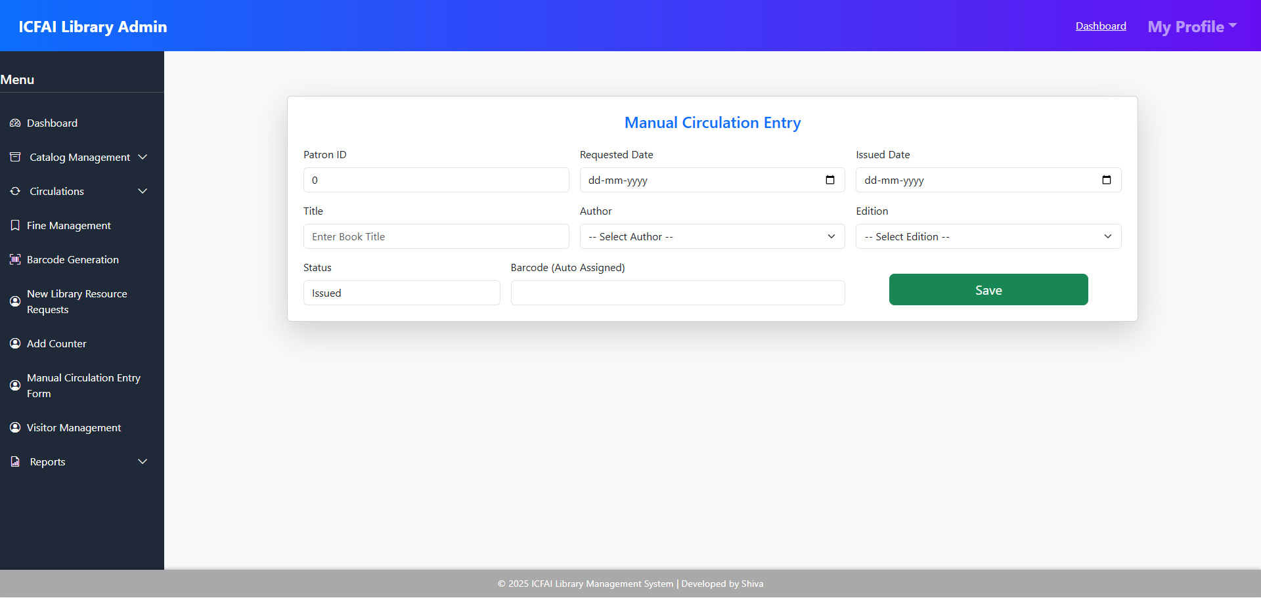

3.2.8 Reports
The Reports module provides librarians with detailed insights into library operations. It generates comprehensive reports on material availability, issued books, requests, overdue items, and fines. Each report is displayed in a dedicated view for easy access and management.

Availability Report
This report shows the current status of all library materials. Features include:
- Listing all available resources by category or type.
- Tracking quantities of each material.
- Highlighting materials that are low in stock or unavailable.
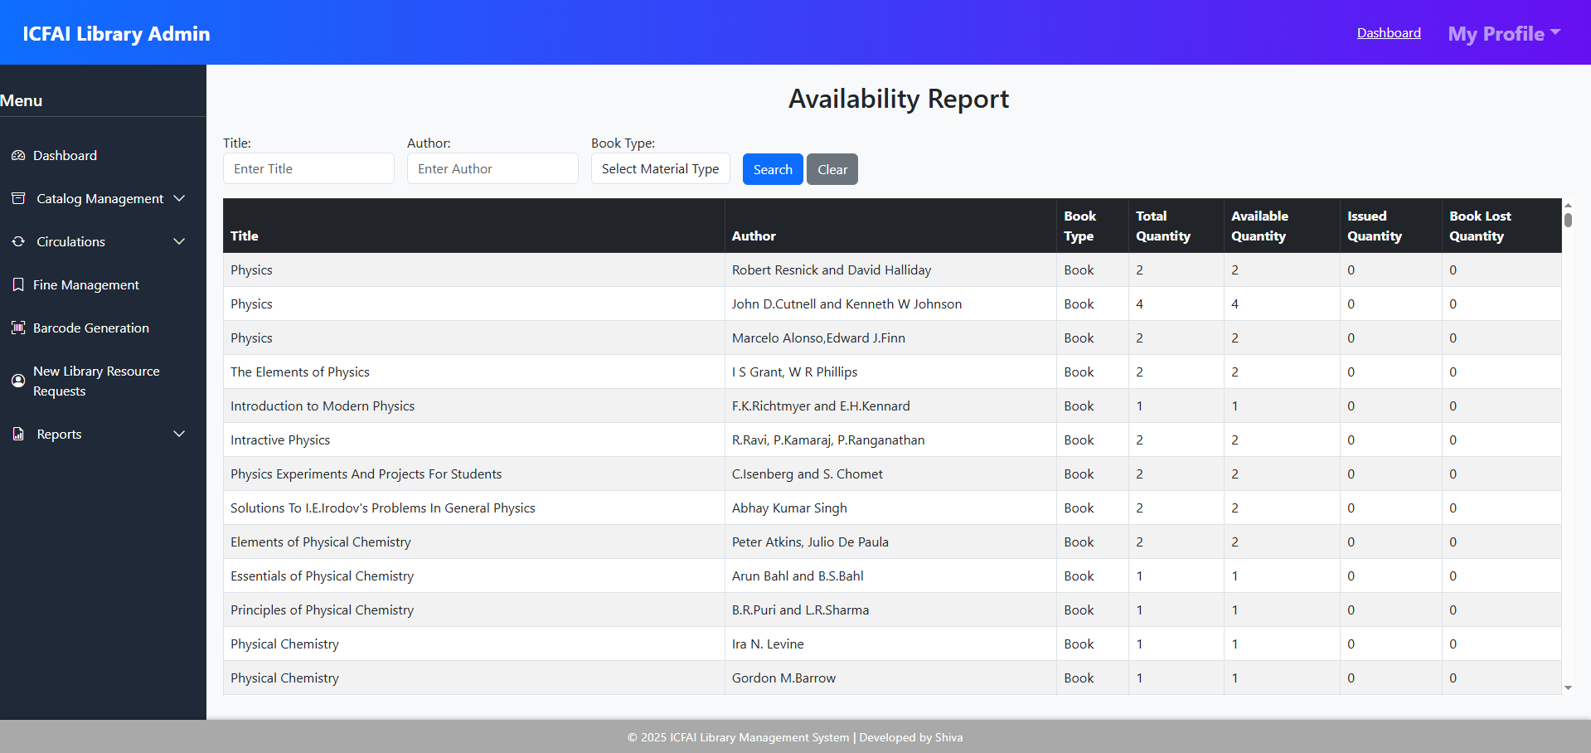

Requested Report
Displays all material requests made by members. Key features:
- Viewing pending, approved, and rejected requests.
- Tracking member-wise request history.
- Prioritizing requests to manage demand efficiently.
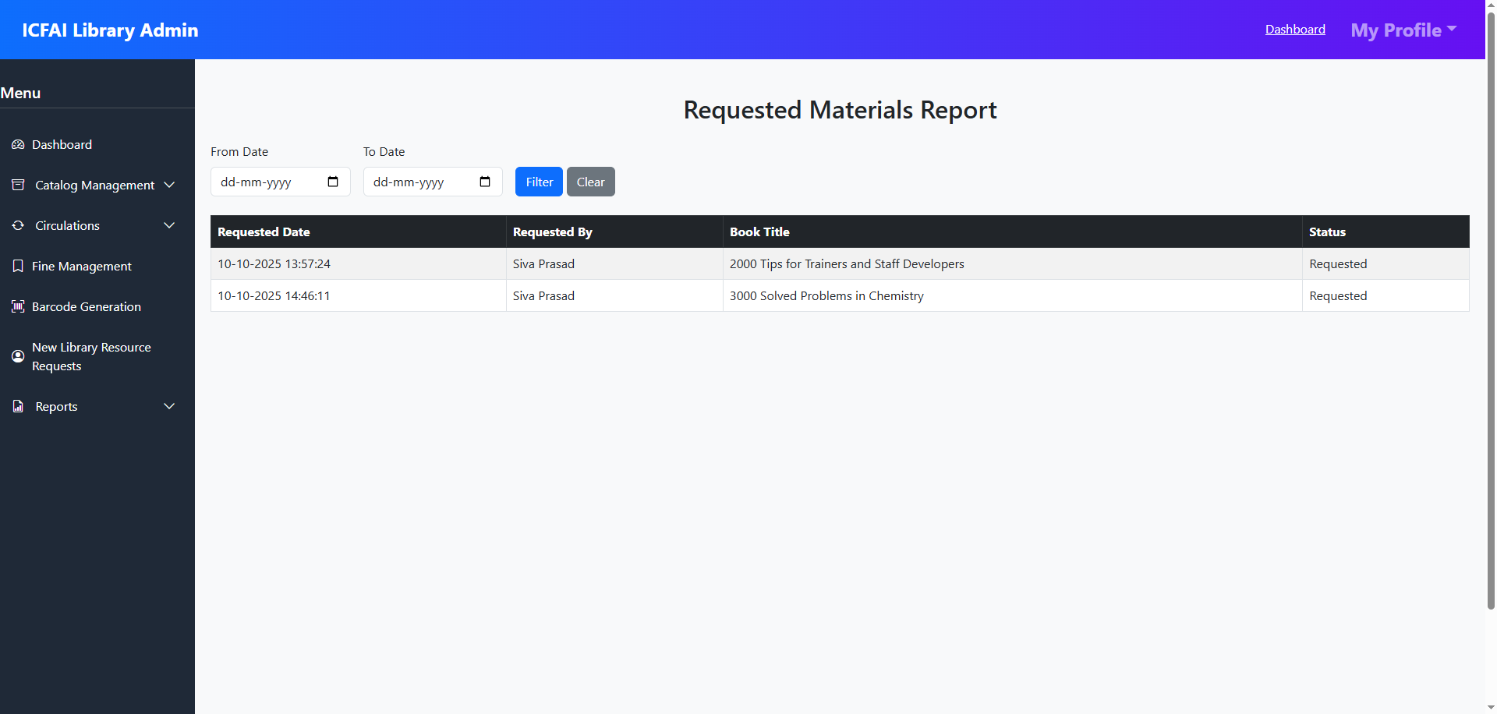

Issued Report
Shows details of all issued materials. Includes:
- Member-wise issue records.
- Material details with issue and due dates.
- Easy tracking of currently issued items and their status.
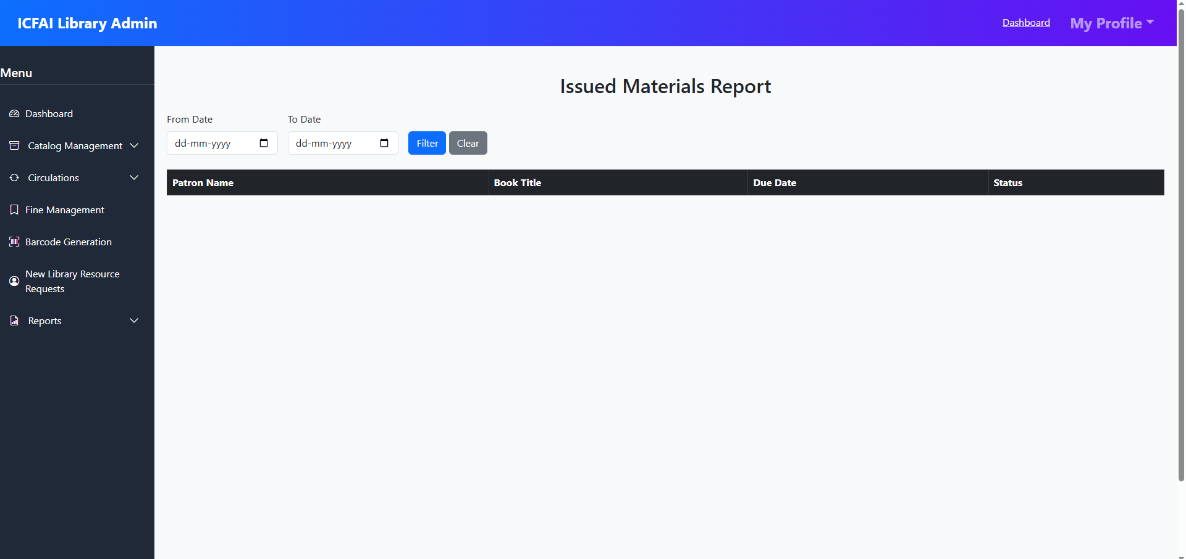

4. Overdue Report
Lists all materials that are overdue. Provides:
- Member and material details for overdue items.
- Number of days overdue.
- Option to trigger reminders or alerts to members.
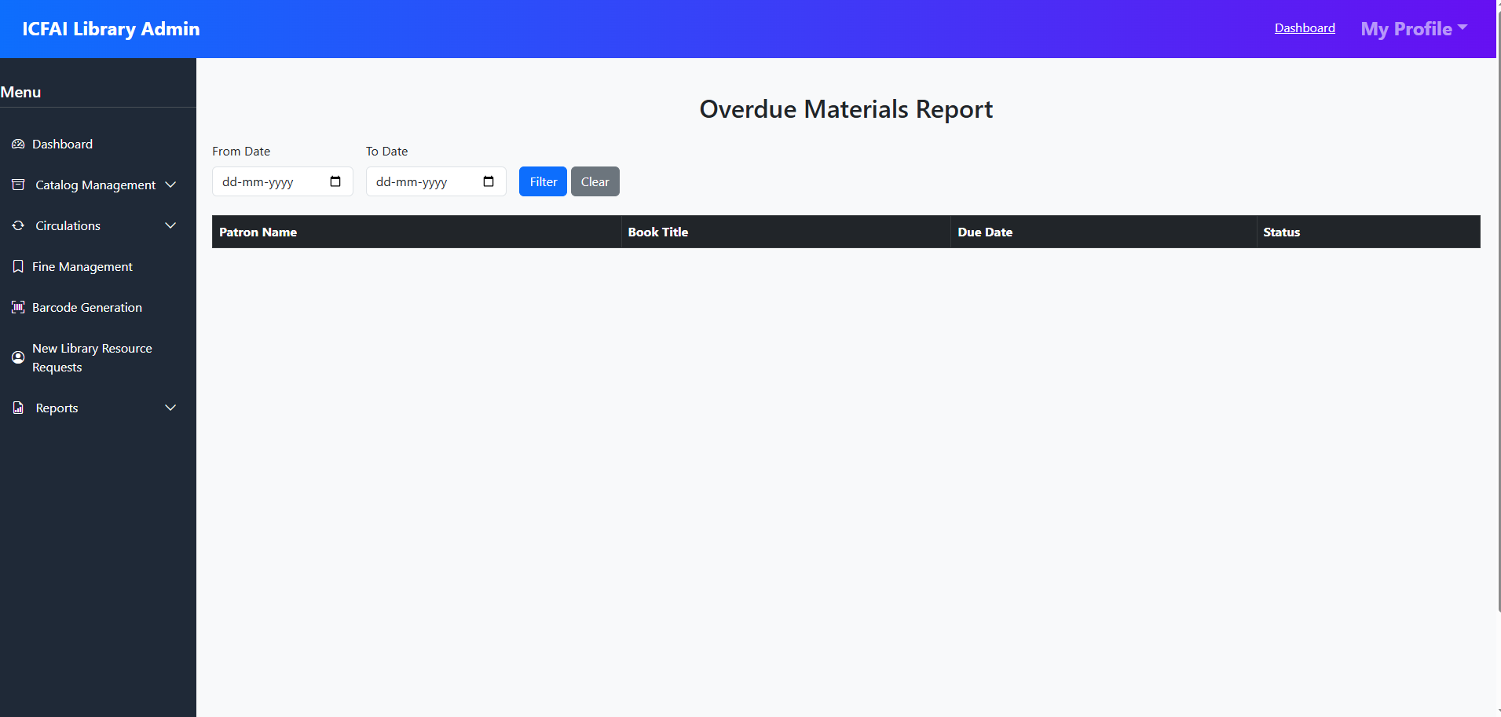

Fine Report
Generates a summary of fines collected or pending. Features include:
- Member-wise fine details.
- Total fines for a specific period.
- Tracking unpaid fines for follow-up.
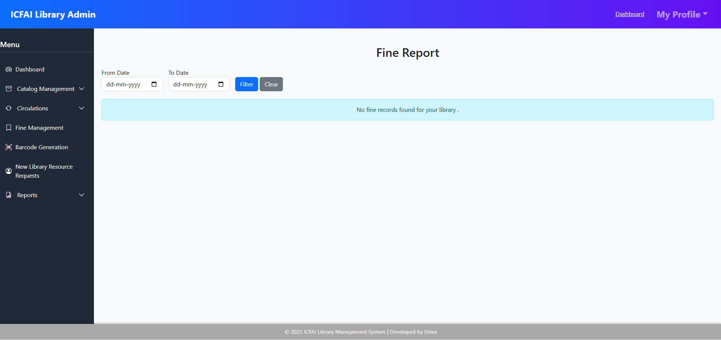

3.3 Student / Faculty Dashboard
The Dashboard provides students and faculty with a quick overview of their library activities and easy access to all related features. It is designed to be intuitive, informative, and interactive.

Dashboard Overview:
The main dashboard displays summary cards for quick insights:
- Active Issues: Shows the total number of books currently issued to the user. Clicking the card navigates to the Active Issues view with full details in a table format.
- Overdue Items: Displays the number of overdue materials. Clicking this card redirects to the Overdue List view.
- Pending Reservations: Shows requests made for materials that are awaiting approval or availability. Links to the My Reservations view.
- Pending Bookings: Displays materials booked but not yet issued. Clicking takes the user to the My Bookings view.

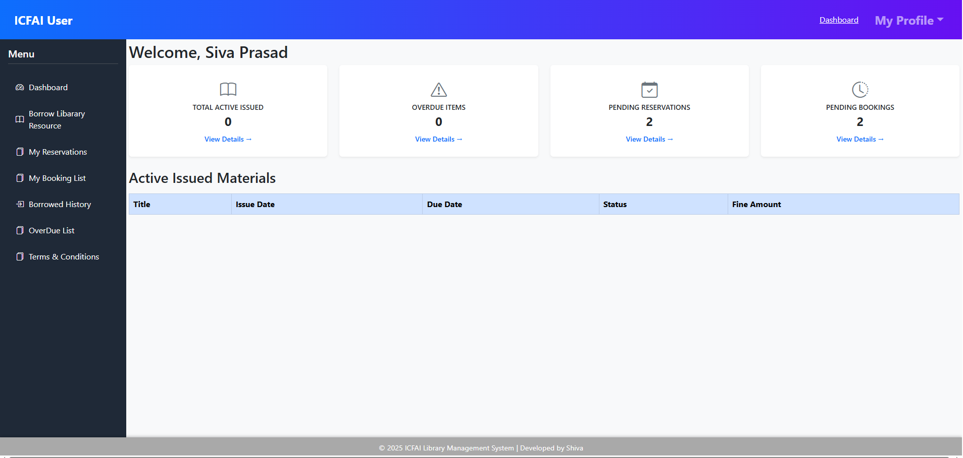

Menu Navigation:
The side menu provides easy access to all relevant sections:
- Dashboard – Main overview with activity cards.
- Borrow Library Resource – Search and borrow available materials.
- My Reservations – View and manage all pending and approved reservations.
- My Bookings – Track and manage all material bookings.
- Borrowed History – View history of all issued materials.
- Overdue List – Detailed list of overdue items and applicable fines.
Each menu item links to its dedicated view, providing a smooth and organized navigation experience.
3.3.1 Borrow Library Resource
- Allows users to search for available books or materials and initiate the borrowing process.
- Displays real-time availability and issue options.
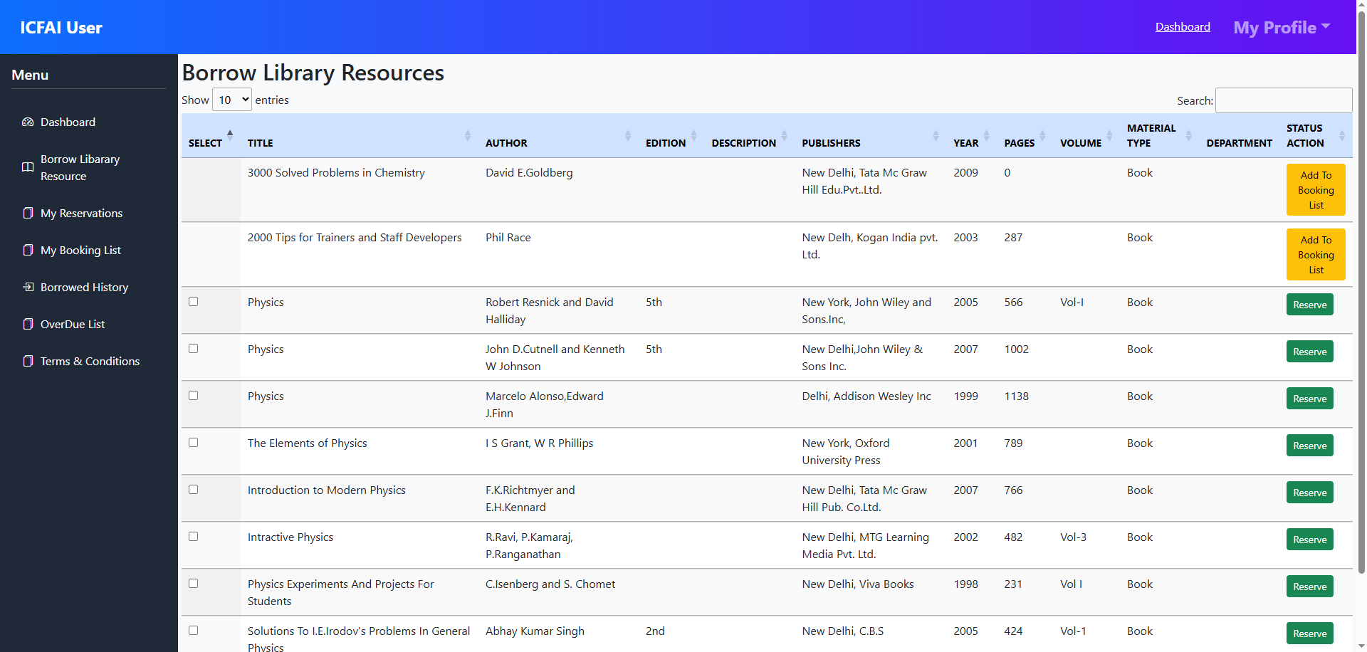
3.3.2 My Reservations
- Shows all materials reserved by the user, including pending and approved reservations.
- Allows users to manage or cancel reservations as needed.
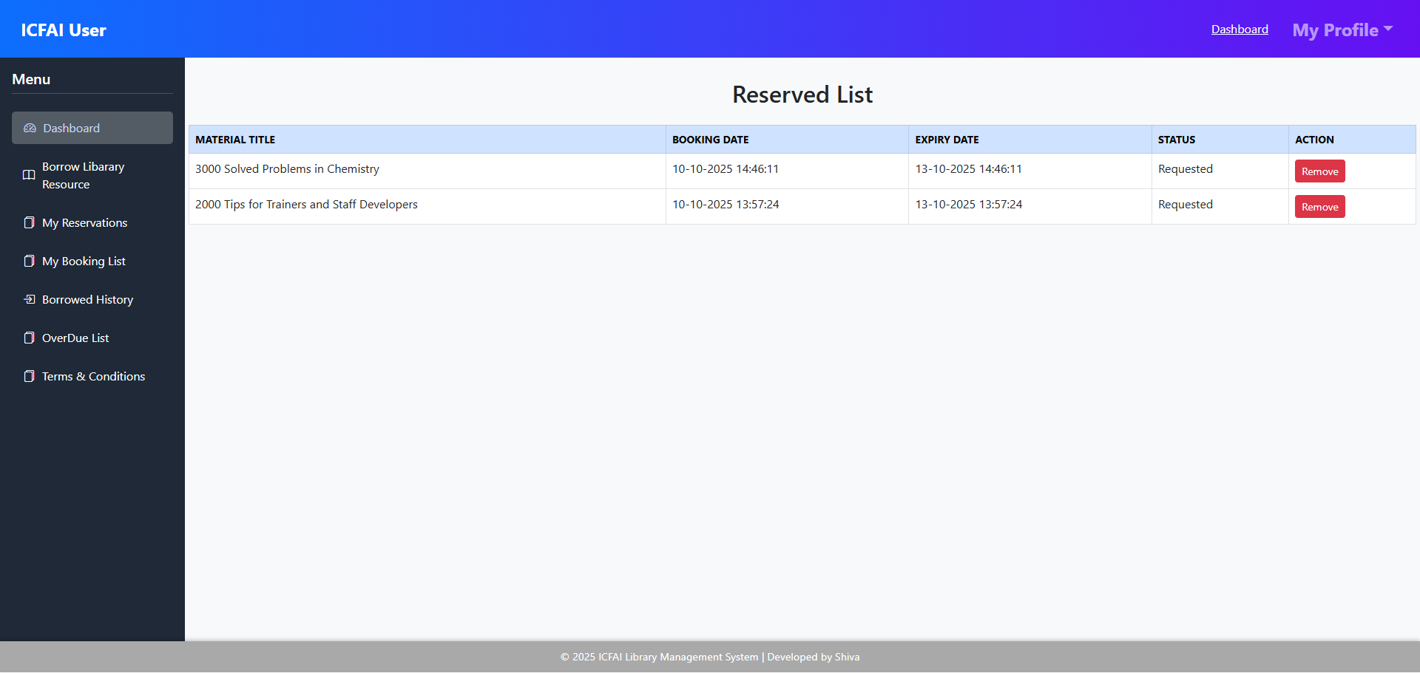

3.3.3 My Bookings
- Displays all booked materials that are yet to be issued.
- Users can track the status of each booking and take necessary actions.
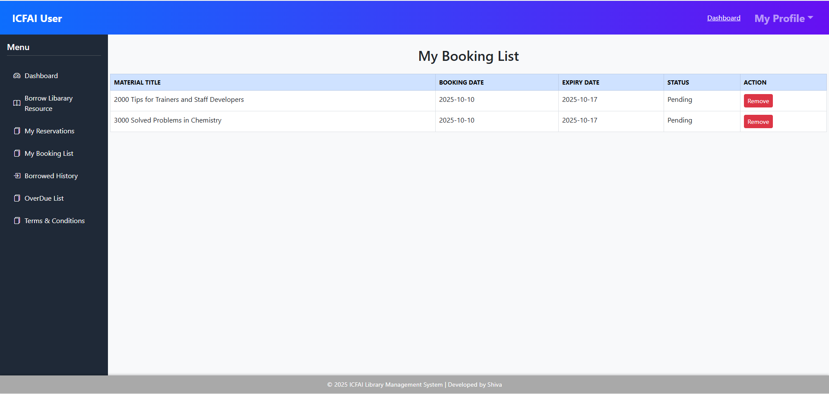
3.3.4 Borrowed History
- Provides a complete record of all previously issued materials.
- Helps users track their borrowing history for reference or review.
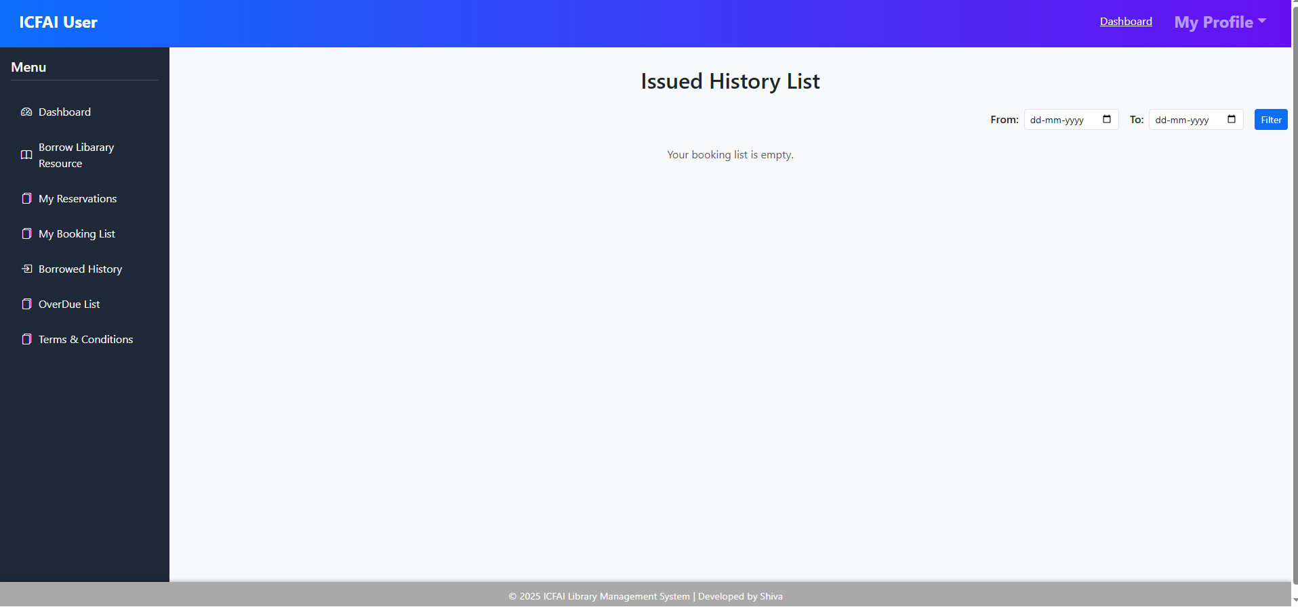

3.3.5 Overdue List
- Lists all materials that are overdue along with applicable fines.
- Enables users to take timely action to avoid penalties.
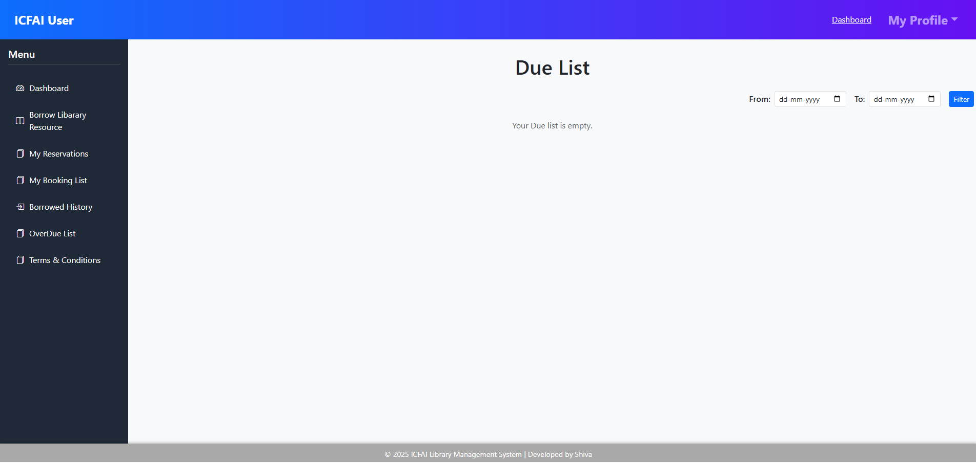

3.3.6 Terms & Conditions
Through this module, librarians can define, update, and display the library’s usage policies and rules to all users. It helps maintain transparency and ensures that every member is aware of the library’s operational guidelines.
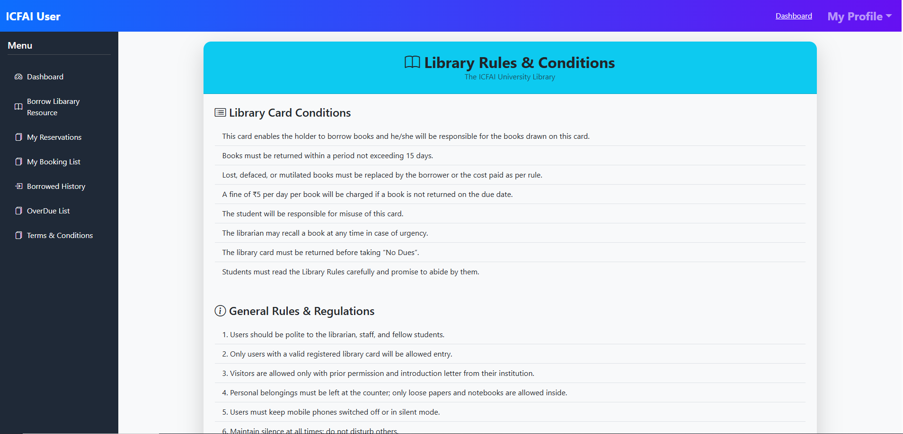

4. System Workflow
The system follows a role-based workflow where users log in, perform actions based on their permissions, and data is recorded in the central database for monitoring and reports.
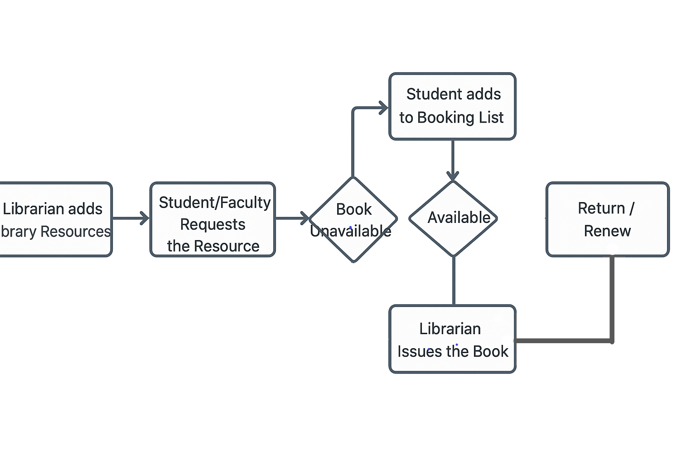

5. Troubleshooting & Help
This section provides guidance on resolving common issues users may encounter while using the library system. Quick reference solutions help ensure uninterrupted access and smooth operation.
Key Points:
- Login Issues: Check username/email and password; reset password if forgotten.
- Book Not Available: Verify catalogue search filters; request the book through the New Book Request option.
- Renewal/Return Errors: Ensure the book is issued to your account; contact the librarian if discrepancies persist.
- System Errors: Refresh the page or log out and log in again; contact support if the problem continues.
Tip: Contact the library support team for unresolved issues.

6. Security & Access Control
The system is designed with robust security measures to protect user data and library resources. Access is strictly controlled based on user roles.
Key Features:
- Secure Authentication: Users must log in with valid credentials to access the system.
- Encrypted Passwords: Passwords are stored securely using encryption techniques to prevent unauthorized access.
- Role-Based Access Control: Features and data are accessible only according to the user’s role (Librarian, Assistant, Student, or Faculty).
- Session Management: Active sessions are monitored, and automatic logout ensures protection against unauthorized use.

7. Future Enhancements
To make the library system even smarter and more convenient, several improvements are planned for future updates. These include:
- RFID Integration: For faster and contactless book issue and return.
- Mobile App Support: Allowing users to access library services anytime, anywhere.
- AI-Based Book Recommendations: Providing personalized reading suggestions based on user interests and borrowing history.

8. Conclusion
• Ensures efficient management of all library operations digitally.
• Provides transparent tracking of books, issues, returns, and reservations.
• Simplifies circulation and resource management for librarians and users.
• Enhances accessibility and user convenience for students and faculty.
• Serves as a reliable solution for modern educational institutions seeking organized and productive library management.

