DIFY AI PLATFORM
Comprehensive Reference Guide
From Fundamentals to Enterprise Production

With Real-Time Examples from Banking/BFSI & General Industries
Including Architecture Diagrams, Design Patterns & Best Practices
Version 2.0 | March 2026
Mixed Audience: Beginner to Advanced

Table of Contents
Table of Contents 2
Chapter 1: Introduction to Dify 5
1.1 What is Dify? 5
1.2 Why Dify? 5
1.3 Platform Architecture 5
1.4 Deployment Options 6
1.5 Dify Platform Resource Hierarchy 7
Chapter 2: Core Concepts 8
2.1 Application Types 8
2.1.1 Primary Types 8
2.2 Variables 8
2.2.1 Variable Referencing Methods 9
2.3 Execution Models 9
2.4 Triggers 9
2.5 Dify DSL (Domain-Specific Language) 10
Chapter 3: Workflow Nodes Deep Dive 11
3.1 Start Nodes 11
3.1.1 User Input Node 11
3.1.2 Schedule, Plugin, and Webhook Triggers 11
3.2 AI Nodes 11
3.2.1 LLM Node 11
3.2.2 Agent Node 12
3.2.3 Question Classifier Node 12
3.2.4 Parameter Extractor Node 13
3.3 Data Nodes 13
3.3.1 Knowledge Retrieval Node 13
3.3.2 Doc Extractor Node 13
3.3.3 Variable Aggregator & Variable Assigner 13
3.3.4 List Operator, Template, and Code Nodes 13
3.4 Control Nodes 13
3.4.1 If/Else Node 13
3.4.2 Iteration and Loop Nodes 13
3.4.3 Human Input Node 13
3.5 Integration and End Nodes 14
Chapter 4: Building Applications 15
4.1 Canvas Shortcuts 15
4.2 Error Handling 15
4.3 Workflow Design Patterns 16
4.3.1 Pattern: RAG Chatbot 16
4.3.2 Pattern: Branch and Merge 16
4.3.3 Pattern: Banking RM Workbench 16
4.3.4 Pattern: Approval Workflow 16
4.4 MCP Tools (Model Context Protocol) 16
4.5 Version Control 17
Chapter 5: Debugging 18
5.1 Debugging Tools Overview 18
5.2 Step Run and Variable Inspector 18
5.3 Common Error Types and Fixes 18
5.4 Pre-Publish Debugging Checklist 18
Chapter 6: Publishing & Deployment 20
6.1 Publishing Channels 20
6.2 Web Apps 20
6.3 Embedding in Websites 20
6.4 API Development 20
6.5 MCP Server Publishing 21
6.6 Access Control (Enterprise) 21
Chapter 7: Monitoring & Observability 22
7.1 Built-in Analytics Dashboard 22
7.2 Logs 22
7.3 Annotation Reply 22
7.4 External Monitoring Integrations 23
Chapter 8: Knowledge Base & RAG 24
8.1 How RAG Works 24
8.2 Creating a Knowledge Base 24
8.3 Data Sources 24
8.4 Chunking and Text Processing 24
8.4.1 Chunk Modes 25
8.5 Index Methods and Retrieval 25
8.6 Knowledge Pipeline (Advanced) 25
8.7 Best Practices for Chunk Quality 25
8.8 Knowledge Base API & Rate Limits 26
Chapter 9: Workspace Management 27
9.1 Roles and Permissions 27
9.2 Team Capacity 27
9.3 Model Providers 27
9.4 Plugins 27
9.5 App Management and DSL 28
9.6 API Extensions 28
Chapter 10: Tutorials & Hands-On Labs 29
10.1 Tutorial: Simple Geography Chatbot (Beginner, 15 min) 29
10.2 Tutorial: Twitter/X Account Analyzer (Intermediate, 30 min) 29
10.3 Tutorial: Customer Service Bot with KB (Intermediate, 45 min) 29
10.4 Tutorial: AI Image Generator (Beginner, 20 min) 29
10.5 Tutorial: Article Reader with Q&A Generation (Intermediate, 30 min) 29
10.6 Common Mistakes and Performance Tips 29
Chapter 11: Executive Summary & Decision Guide 31
11.1 Platform Summary 31
11.2 Edition Comparison 31
11.3 Dify vs Code-Based Frameworks 31
11.4 Decision-Maker Checklist 31
11.5 Risks and Mitigations 31
11.6 Recommended Next Steps 32
Appendix: Quick Reference 33
A.1 Node Quick Reference 33
A.2 Variable Referencing Quick Reference 33
A.3 Cron Expression Reference 34
A.4 System Constraints 34

Chapter 1: Introduction to Dify

1.1 What is Dify?
Dify is an open-source platform for building agentic AI workflows. It provides a visual drag-and-drop canvas that enables teams to design, test, and deploy AI applications without writing extensive backend code. The name Dify comes from Do It For You, reflecting its mission to simplify AI application development for both developers and business users.
At its core, Dify abstracts the complexity of connecting large language models (LLMs), knowledge bases, external APIs, and business logic into a unified visual interface. Whether you are building a simple FAQ chatbot or a complex multi-agent research system, Dify provides the building blocks to get from idea to production rapidly.
Example: Banking Context (Client Connect)
A Relationship Manager (RM) workbench like Client Connect, serving 11,000+ users across six Asian markets, could use Dify to build intelligent workflow apps that connect to core banking systems (Finacle, Avaloq) and provide RMs with automated KYC checks, product recommendations, and risk assessments — all orchestrated through visual workflows.
Example: E-Commerce Context
An online retailer could use Dify to build a customer support chatbot that classifies queries (returns, product info, order tracking), retrieves answers from product documentation, and escalates complex issues to human agents — all without writing a single line of backend code.

1.2 Why Dify?
Dify stands out in the crowded AI platform landscape for several compelling reasons:
Benefit | Description | Impact
Visual Workflow Builder | Drag-and-drop canvas to design AI pipelines | 80% reduction in development time for standard AI apps
Multi-Modal Support | Handle text, images, documents, and audio | Single platform for all content types
Production Ready | Deploy as web apps, APIs, MCP servers, or embedded widgets | Minutes from development to production
Open Source | Self-host on your infrastructure or use Dify Cloud | Full data control and compliance
Extensible | Connect to any LLM provider, knowledge base, or API | No vendor lock-in for AI models
Enterprise Grade | SSO, role-based access, audit logs | Meets BFSI compliance requirements

1.3 Platform Architecture
Understanding Dify's architecture helps you make informed deployment and scaling decisions. The platform consists of several interconnected components:
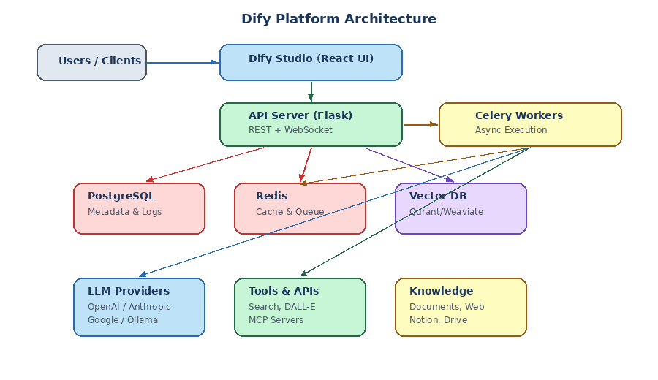
Figure: Dify Platform Architecture — showing the relationship between UI, API, workers, databases, and external services
The Dify Studio UI is a React/Next.js frontend where users design workflows visually. The API Server (Flask/Gunicorn) handles authentication, app definitions, and execution triggers. Celery Workers execute workflows asynchronously, especially LLM calls and tool invocations. PostgreSQL stores all metadata and execution logs, while Redis serves as the task queue and cache layer. External services include LLM providers (OpenAI, Anthropic, Google), vector databases (Qdrant, Weaviate) for knowledge retrieval, and various tool APIs.

1.4 Deployment Options
Option | Description | Best For
Dify Cloud | Managed SaaS; workspace created on first login | Quick start, prototyping, small teams
Community Edition | Self-hosted via Docker; free and open-source | Full data control, cost-sensitive deployments
Enterprise | Advanced access control, SSO, dedicated support | Banks, regulated industries, large organizations

Self-hosted Docker Setup:
git clone https://github.com/langgenius/dify.git
cd dify/docker
cp .env.example .env
docker compose up -d
TIP: For production deployments in BFSI environments, use Kubernetes with Helm charts for high availability. Dify provides community-maintained Helm charts and Terraform modules for AWS/Azure/GCP.

1.5 Dify Platform Resource Hierarchy
Every resource in Dify lives within a workspace. Understanding this hierarchy is essential for organizing your AI applications:
Workspace
├── Apps (Workflows, Chatflows, Agents, Chatbots)
├── Knowledge (Knowledge bases and pipelines)
├── Tools (Built-in, custom, MCP, workflow tools)
├── Members (Team roles and permissions)
├── Model Providers (AI model credentials)
├── Plugins (Workspace extensions)
└── Settings (Billing, API extensions, data sources)

Chapter 2: Core Concepts

2.1 Application Types
Dify offers two primary application types and three legacy types, all powered by the same underlying workflow engine:

2.1.1 Primary Types
Type | Description | Key Capability | Use Case Example
Workflow | Single-turn task applications | Batch execution; processes discrete inputs and returns outputs | Document processing, data pipelines, report generation
Chatflow | Multi-turn conversation applications | Persistent memory; conversation variables survive across turns | Customer support bots, RM assistants, Q&A systems

TIP: For new projects, always prefer Workflow or Chatflow over legacy types — they offer the most flexibility and the full node ecosystem.
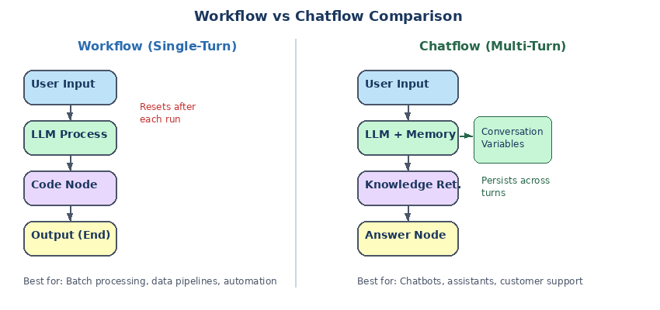
Figure: Workflow vs Chatflow — key architectural differences in execution model and memory management
Example: Banking: Workflow for Batch KYC Processing
A Workflow app accepts a CSV file of customer IDs, iterates through each, calls the core banking API (Finacle) to retrieve KYC status, and outputs a compliance report. Single-turn, no memory needed — each batch run is independent.
Example: Banking: Chatflow for RM Assistant
A Chatflow app lets an RM ask follow-up questions about a client's portfolio. The conversation variables remember the client context (name, account number, last query) across turns, so the RM doesn't need to repeat information.

2.2 Variables
Variables are how data flows between nodes in Dify. Understanding variable types and scoping is critical for building reliable workflows:
Variable Type | Scope | Description | Example
Input Variables | Workflow start | Custom variables provided by the user | customer_id, query_text, uploaded_file
System Variables | Runtime | Pre-defined metadata injected automatically | sys.user_id, sys.app_id, sys.timestamp
Output Variables | Per node | Generated by each node; available downstream | llm_1.text, code_1.result
Environment Variables | Workspace | Secure storage for API keys and secrets | FINACLE_API_KEY, CRAWLBASE_TOKEN
Conversation Variables | Chatflow session | Persist across turns; via Variable Assigner | client_name, session_context, preference_list

2.2.1 Variable Referencing Methods
Variables can be inserted into any node input through three methods: using the dropdown selector (click the variable picker in a node's input field), typing a slash command (type / in a text field to open the variable menu), or using Jinja2 syntax directly in prompts with {{ variable_name }}.
Example: Variable Referencing in a Prompt
System: You are a banking assistant for {{ env.BANK_NAME }}. User: The customer {{ userinput.customer_name }} is asking: {{ userinput.query }} Context from knowledge base: {{ knowledge_retrieval_1.result }}

2.3 Execution Models
Dify supports both serial and parallel execution. In serial execution, nodes execute one after another in sequence. In parallel execution, multiple nodes connected to the same source run simultaneously, with results merged by a Variable Aggregator node.
Constraint | Value
Parallel branches per node | 10 max
Nested parallel levels | 3 max
Parallel iterations | 10 max
File upload size | 15 MB per file
Max simultaneous file uploads | 10 files
Code node string output | 80,000 characters
Object/array nesting depth | 5 levels

2.4 Triggers
Triggers are a special type of Start node that runs workflows automatically without user interaction:
Trigger Type | Activation | Example
Schedule Trigger | Runs at predetermined times (cron or visual picker) | Daily 9 AM report generation: 0 9 * * 1-5
Plugin Trigger | Fires when an external system event occurs | GitHub PR opened → auto code review workflow
Webhook Trigger | Fires when HTTP request hits generated endpoint | Core banking transaction alert → fraud check workflow

Example: Banking: Scheduled Compliance Check
A Schedule Trigger runs at 6:00 AM every business day (cron: 0 6 * * 1-5). It queries the transaction database for unusual patterns, runs an LLM analysis on flagged transactions, and emails a compliance summary report to the risk team.

2.5 Dify DSL (Domain-Specific Language)
All Dify applications export to YAML format — the Dify DSL. This enables version control via Git, sharing workflows with the community, and programmatic app generation. The DSL includes app configuration, workflow settings, model parameters, and knowledge base connections. It excludes API keys, knowledge base content, and usage logs.

Chapter 3: Workflow Nodes Deep Dive
Nodes are the fundamental building blocks of Dify workflows. Each node performs a specific function, and they are connected on the canvas to form complete processing pipelines.
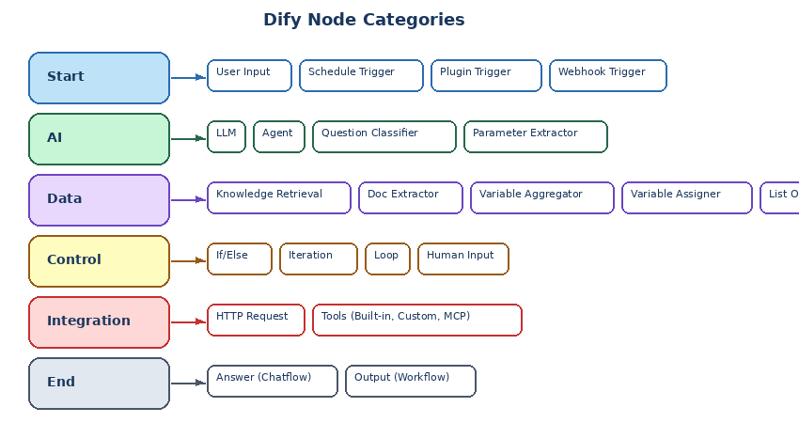
Figure: Dify Node Categories — organized by function with all available node types

3.1 Start Nodes

3.1.1 User Input Node
The User Input node initiates a workflow through direct user interaction or an API call. Each canvas supports only one User Input node. It defines the parameters users must provide, including text fields (short text up to 256 chars, or unlimited paragraph), structured data (select, number, checkbox, JSON), and file uploads (single or list).
WARNING: The User Input node collects files but does not parse them. Downstream nodes (Doc Extractor, vision LLM) must handle file content.
Example: Banking: RM Workbench Input
The User Input node collects: customer_id (Short Text, required), query (Paragraph), supporting_documents (File List — accepts PDF, DOCX for KYC documents), market (Select — options: Singapore, Hong Kong, India, Taiwan, China, Indonesia).

3.1.2 Schedule, Plugin, and Webhook Triggers
Schedule Triggers run workflows at specified times using cron expressions or a visual picker. Plugin Triggers fire when external system events occur (e.g., GitHub PR, Slack message). Webhook Triggers fire when an external system sends an HTTP request to a generated unique URL. All three are available only for Workflow apps.

3.2 AI Nodes

3.2.1 LLM Node
The core AI node. Sends prompts to a configured language model and captures its response. Supports text, images, documents, structured outputs, and streaming. Configure parameters like Temperature (0=deterministic, 1=creative), Top P, and penalty settings to control output behavior.
Feature | Description | Real-Time Example
Structured Output | Force JSON schema response | Extract {customer_name, loan_amount, tenure} from free-text loan application
RAG Context | Connect Knowledge Retrieval output | Product terms KB feeds verified policy information into RM responses
Vision | Process images directly | Analyze uploaded ID document photos for KYC verification
Memory (Chatflow) | Include prior conversation turns | RM assistant remembers client context across follow-up questions

3.2.2 Agent Node
Empowers an LLM with autonomous tool control. The agent dynamically reasons through a problem and invokes tools as needed. Two strategies are available: Function Calling (leverages native LLM tool-calling; best for GPT-4, Claude) and ReAct (structured Thought-Action-Observation loop; for models without native function calling). Set Max Iterations to 3–5 for simple tasks and 10–15 for complex research.
Example: Banking: Autonomous Research Agent
An Agent node configured with tools for Bloomberg API, internal research DB, and web search. When an RM asks 'What is the credit outlook for Company X?', the agent autonomously calls Bloomberg for financial data, searches the internal KB for prior assessments, and synthesizes a comprehensive credit report.

3.2.3 Question Classifier Node
Categorizes user input using an LLM and routes the workflow to the appropriate branch. Each category generates a distinct output branch, eliminating the need for complex conditional logic.
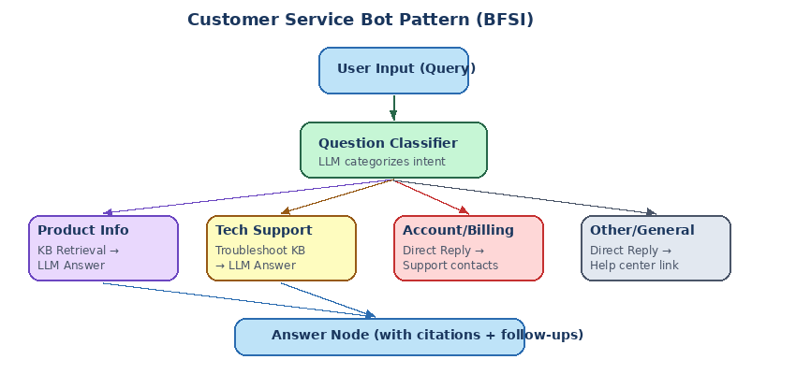
Figure: Customer Service Bot Pattern — Question Classifier routing to specialized branches

3.2.4 Parameter Extractor Node
Uses an LLM to convert unstructured text into structured, typed parameters. Outputs include extracted parameters (one per defined field), __is_success (1/0), and __reason for failures.
Example: E-Commerce: Order Intent Extraction
User says: 'I want to return the blue shoes I bought last Tuesday, order number 45892'. Parameter Extractor outputs: {action: 'return', product: 'blue shoes', order_id: '45892', date_reference: 'last Tuesday'}

3.3 Data Nodes

3.3.1 Knowledge Retrieval Node
Searches one or more knowledge bases and returns relevant document chunks as context for downstream LLM nodes. Configure query source, knowledge sources, retrieval options (Weighted Score, Rerank Model, Top K, Score Threshold), and metadata filtering.

3.3.2 Doc Extractor Node
Converts uploaded files into plain text. Supports TXT, Markdown, HTML, DOCX, XLS/XLSX, CSV, PDF, PPT/PPTX, EML, MSG, EPUB, VTT, JSON, and YAML. Spreadsheets are converted to Markdown tables. Single file input produces a text string; array input produces array[string].

3.3.3 Variable Aggregator & Variable Assigner
The Variable Aggregator merges outputs from multiple conditional branches into a single variable for downstream use (all aggregated variables must be the same type). The Variable Assigner (Chatflow only) writes values to conversation variables that persist across turns, with operations like overwrite, clear, append, add, subtract.

3.3.4 List Operator, Template, and Code Nodes
The List Operator filters, sorts, and selects elements from arrays. The Template node uses Jinja2 templating for formatting. The Code node executes custom Python or JavaScript in a strict sandbox (no file system, no network). Output limits: 80,000 chars for strings, 5 levels of nesting for objects.

3.4 Control Nodes

3.4.1 If/Else Node
Evaluates conditions and routes the workflow. Supports IF, ELIF (multiple), and ELSE branches. Conditions include text operators (contains, starts with, is/is not, empty check), numeric comparisons, and logical combinators (AND/OR).

3.4.2 Iteration and Loop Nodes
The Iteration node applies the same steps to every element in an array (sequential or parallel up to 10). Error handling options: Terminate, Continue on Error, or Remove Failed Results. The Loop node creates state-dependent repeated cycles where each iteration builds on the previous result, with termination conditions and maximum loop counts.
Example: Banking: Batch Portfolio Analysis (Iteration)
An Iteration node receives an array of 50 client portfolio IDs. In parallel mode (10 concurrent), each iteration calls the portfolio API, runs LLM analysis on holdings, and generates a risk summary. Failed items output null, and the template node formats all successful results into a consolidated report.

3.4.3 Human Input Node
Pauses the workflow and requests input or a decision from a human. Delivery via web app or email. The request closes after the first response. Configure action buttons (Approve/Reject/Regenerate) that route to different downstream paths, plus a timeout for fallback handling.
Example: Banking: Loan Approval Workflow
After the LLM generates a loan assessment, the Human Input node emails the credit committee. Buttons: Approve (proceeds to disbursement API), Reject (sends rejection notification), Request More Info (loops back to gather additional documents). Timeout: 48 hours → auto-escalate to senior manager.

3.5 Integration and End Nodes
The HTTP Request node connects to any external API (GET, POST, PUT, PATCH, DELETE) with variable substitution in URLs and bodies. The Tools node integrates pre-built services (Google Search, weather, custom OpenAPI tools, MCP tools). Answer (Chatflow) and Output (Workflow) nodes deliver final results.

Chapter 4: Building Applications

4.1 Canvas Shortcuts
Working efficiently on the Dify canvas requires knowing the shortcuts:
Action | Windows/Linux | macOS
Go to Anything | Ctrl + K | Cmd + K
Undo / Redo | Ctrl + Z / Ctrl + Y | Cmd + Z / Cmd + Y
Zoom In / Out | Ctrl + = / Ctrl + - | Cmd + = / Cmd + -
Run Workflow | Alt + R | Option + R
Copy / Paste Node | Ctrl + C / Ctrl + V | Cmd + C / Cmd + V
Duplicate Node | Ctrl + D | Cmd + D
Auto-arrange | Ctrl + O | Cmd + O

4.2 Error Handling
Four node types support built-in error handling: LLM, HTTP Request, Code, and Tools. This is critical for production applications.
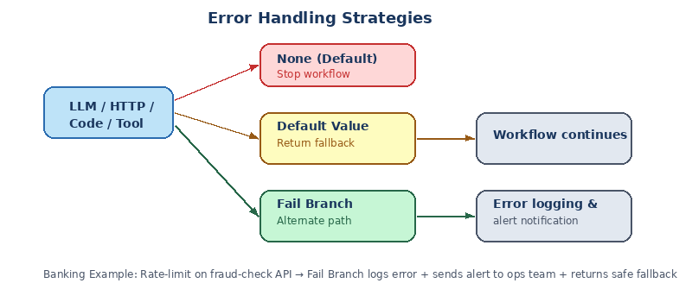
Figure: Error Handling Strategies — None, Default Value, and Fail Branch approaches
Strategy | Behavior | Best Used When
None (default) | Stops the entire workflow; shows original error | Testing, or when failure must halt processing
Default Value | Substitutes a fallback value; workflow continues | Graceful degradation acceptable
Fail Branch | Activates a separate error-handling sub-workflow | Production apps needing logging, alerts, or recovery

Example: Banking: Rate-Limit Handling for Core Banking API
When the HTTP Request node calling Finacle hits a rate limit (429 error), the Fail Branch strategy activates: (1) Log the error with timestamp and request details to an audit table via another HTTP node, (2) Send a Slack alert to the ops team, (3) Return a safe fallback: 'The system is temporarily busy. Your request has been queued and will be processed within 5 minutes.'

4.3 Workflow Design Patterns
Dify supports several proven design patterns for common use cases:

4.3.1 Pattern: RAG Chatbot
[User Input: query] → [Knowledge Retrieval: search KB] → [LLM: answer using context] → [Answer]
Example: Banking: Product FAQ Bot
Customer asks about fixed deposit rates. Knowledge Retrieval searches the product terms KB. LLM generates a grounded answer with current rates and tenure options. Citation display shows which product brochure section the answer came from.

4.3.2 Pattern: Branch and Merge
[User Input] → [Question Classifier]
Branch A → [KB Retrieval] Branch B → [HTTP: external API] Branch C → [Direct reply]
└───────────────────┴───────────────────────┘
[Variable Aggregator] → [LLM: respond] → [Answer]

4.3.3 Pattern: Banking RM Workbench
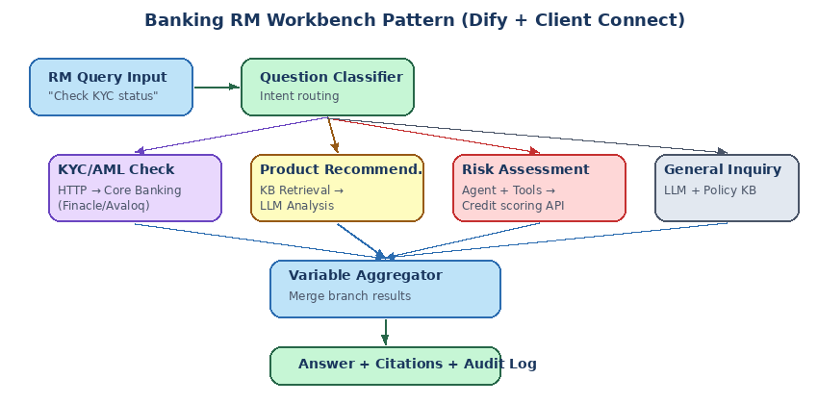
Figure: Banking RM Workbench Pattern — Question Classifier routing to KYC, product, risk, and general branches

4.3.4 Pattern: Approval Workflow
[Trigger/Input] → [LLM: generate draft] → [Human Input: Approve/Reject/Regenerate]
Approve → [Publish Tool] | Regenerate → [Loop back to LLM] | Reject → [Notify]

4.4 MCP Tools (Model Context Protocol)
Connect your workflow to external tools served by MCP servers. Dify currently supports HTTP transport. When adding an MCP server, provide the Server URL, Name, and a unique Server ID (max 24 chars, lowercase + numbers + _ + -).
WARNING: Never change the Server ID after apps start using it — doing so breaks all dependent applications.
TIP: When writing tool descriptions for MCP, be specific: instead of 'processes user data', write 'accepts a JSON object with required fields: name (string), email (string), preferences (array of strings)'.

4.5 Version Control
Dify supports version states: Current Draft (your working copy, editable), Latest Version (active version users see, not editable), and Previous Versions (archived, can be restored to draft). Publishing immediately replaces the live app. Always test in draft before publishing, use descriptive version names, and export DSL before major changes.

Chapter 5: Debugging

5.1 Debugging Tools Overview
Tool | Purpose | When to Use
Step Run | Test individual nodes in isolation | Validating node logic before connecting
Variable Inspector | Inspect and modify live variable values | What-if testing without re-running expensive LLM calls
Run History | View full execution traces with timing | Post-deployment investigation and optimization
Error Reference | Understand and resolve specific error codes | Diagnosing failures in production

5.2 Step Run and Variable Inspector
Test any single node independently by selecting it, entering test input data, and clicking Run. The 'Last Run' section shows exact input, output, duration, and any errors. Importantly, the Variable Inspector captures each node's output and caches it, allowing you to edit cached values and re-run downstream nodes without re-executing expensive upstream operations.
Example: Banking: Debugging a SQL Query Node
The LLM node generates SQL: SELECT * FROM customers WHERE region = 'SG'. Using the Variable Inspector, you edit this to SELECT * FROM customers WHERE region = 'HK' and re-run the database HTTP Request node to observe different results — without waiting for another LLM call.

5.3 Common Error Types and Fixes
Error Category | Common Error | Root Cause | Fix
Code Node | OutputValidationError | Return type doesn't match declared output | Ensure dict keys match declared outputs
LLM Node | VariableNotFoundError | Prompt references non-existent variable | Check variable names match upstream outputs
LLM Node | InvalidContextStructureError | Array passed to Context field | Convert to string before passing
HTTP Request | ResponseSizeError | API response exceeds 10 MB | Add query params to reduce size
Tool Node | ToolProviderNotFoundError | Tool not installed or misconfigured | Install from Marketplace; verify credentials
System | InvokeRateLimitError | API rate limit exceeded | Add retry logic with exponential backoff

5.4 Pre-Publish Debugging Checklist
Before publishing, verify: all nodes are connected with no orphans, Output/Answer node is present, parallel branches merge correctly, all LLM nodes have models selected and non-empty prompts, API keys are configured, HTTP Request nodes use valid URLs, all variable references use correct names, error handling is configured on LLM/HTTP/Code/Tool nodes, edge cases are tested (empty input, wrong file type, API timeout), and a full Test Run completes successfully.

Chapter 6: Publishing & Deployment
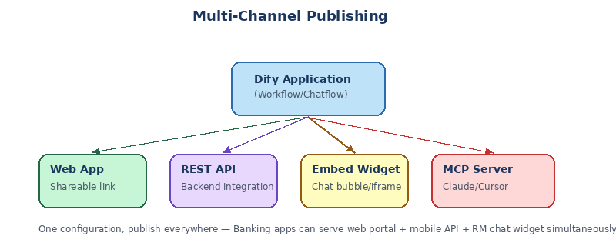
Figure: Multi-Channel Publishing — one configuration, deploy everywhere

6.1 Publishing Channels
Every Dify application is available through multiple channels when you click Publish: Web App (instant shareable link), REST API (backend integration), Embed Widget (chat bubble or iframe on your website), and MCP Server (connect to Claude Desktop, Cursor).

6.2 Web Apps
Workflow Web Apps present a form-based interface supporting single execution and batch processing via CSV (each row = one execution). Chatflow Web Apps present a conversational interface with persistent memory, pre-conversation forms, follow-up suggestions, voice input, and source citations.
Example: Banking: Batch Compliance Processing
The compliance team downloads the CSV template, fills 200 rows (one per transaction to review), uploads it, and monitors parallel processing. Each row triggers the full fraud-detection workflow. Results are exported when complete. Unicode encoding prevents import failures with multilingual transaction descriptions.

6.3 Embedding in Websites
Two embedding methods are available: Chat Bubble Widget (floating button that opens chat, ideal for support) and Iframe Integration (always-visible inline embed, ideal for forms and demos).

6.4 API Development
Use the Dify API to integrate AI into your own products. Key concepts include conversation_id (empty string for new, reuse for follow-up), response_mode (blocking or streaming), and user (your system's user identifier). API conversations are separate from Web App conversations.
Python API Example:
import requests
response = requests.post(
'https://api.dify.ai/v1/chat-messages',
headers={'Authorization': 'Bearer YOUR_API_KEY'},
json={
'inputs': {}, 'query': 'Check KYC for customer C-12345',
'conversation_id': '', 'response_mode': 'streaming',
'user': 'rm-user-789'
}, stream=True)
WARNING: Never expose API keys in frontend code. Always call Dify APIs from your backend server.

6.5 MCP Server Publishing
Publish your Dify app as an MCP server so AI tools like Claude Desktop and Cursor can use it as a native extension. The MCP Server URL contains authentication credentials — treat it like an API key. Connect to Claude Desktop via Settings > Integrations, or to Cursor via .cursor/mcp.json.

6.6 Access Control (Enterprise)
Access Level | Description
All Members Within Platform | Any workspace member; requires authentication
Specific Members | Default; selected groups or individuals only
Authenticated External Users | Non-workspace users via third-party SSO
Anyone | Public; no authentication required

Chapter 7: Monitoring & Observability
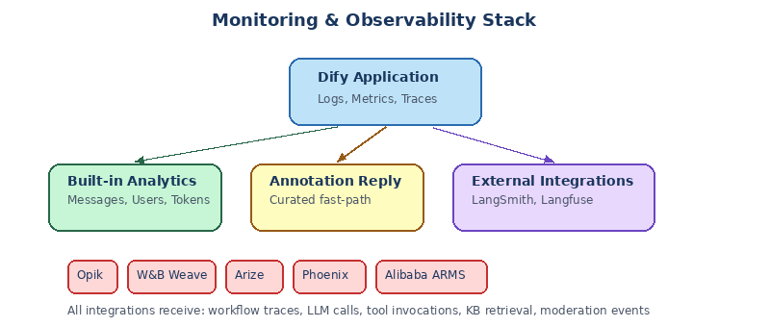
Figure: Monitoring and Observability Stack — built-in analytics plus external integrations

7.1 Built-in Analytics Dashboard
Key metrics include Total Messages (conversation volume), Active Users (meaningful interactions), Average User Interactions (exchanges per session), and Token Usage (proxy for cost). Use the time selector to view trends across day, week, month, or custom ranges.

7.2 Logs
The Logs section records every real-world conversation through your published application. Logged: all web app/API conversations, input/output history, user feedback, model selection, token usage, response times. Not logged: debug/test sessions, prompt testing.
Plan | Data Retention
Sandbox | 30 days
Professional | Unlimited (active subscription)
Team | Unlimited (active subscription)
Self-hosted | Unlimited (configurable via env vars)

WARNING: Logs contain complete user conversations including potentially sensitive data. Establish appropriate access controls and comply with GDPR, CCPA, and other data protection regulations.

7.3 Annotation Reply
Build a curated response library that bypasses LLM generation for known questions. When enabled, the system performs semantic search over your annotation library before calling the LLM. If a match is found above the similarity threshold, the pre-written answer is returned immediately — improving consistency and eliminating hallucinations.
Example: Banking: Compliance-Approved Answers
For regulated questions like 'What is the minimum balance for a savings account?', the Annotation Reply system ensures customers always receive the exact, compliance-approved answer: 'The minimum balance for a DBS Savings Account is SGD 500.' — no LLM generation involved, no risk of hallucination.

7.4 External Monitoring Integrations
Platform | Type | Best For
LangSmith | Commercial | Deep evaluation + experiment tracking
Langfuse | Open-source | Self-hostable observability + prompt management
Opik (Comet) | Open-source | Comet ecosystem integration
W&B Weave | Commercial | ML experiment tracking + LLM monitoring
Arize | Enterprise | Enterprise-grade OpenTelemetry
Phoenix (Arize) | Open-source | Self-hosted OTel-based observability
Alibaba ARMS | Enterprise | Alibaba Cloud ecosystem (Dify 1.6.0+)

All integrations receive the same trace data: workflow execution details, LLM conversation details, moderation events, suggested questions, knowledge base retrieval queries, and tool invocations.

Chapter 8: Knowledge Base & RAG

8.1 How RAG Works
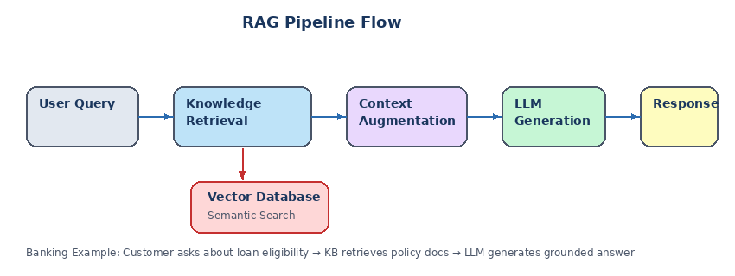
Figure: RAG Pipeline Flow — from user query through retrieval and augmentation to grounded generation
Retrieval-Augmented Generation (RAG) is Dify's approach to grounding AI responses in your own data. The process follows four steps: the user submits a query, the system performs semantic search over your knowledge base for relevant chunks, the retrieved chunks are combined with the query as context, and the LLM generates an answer grounded in verified content.
Benefit | Description
Accuracy | Answers drawn from verified, current content
Reduced Hallucination | LLM references real documents instead of guessing
Updatable | Add or update documents without retraining
Source Attribution | Users see exactly where information came from

8.2 Creating a Knowledge Base
Three options: Quick Create (upload files, configure chunks, set index method), Knowledge Pipeline (visual workflow for advanced processing), or External Knowledge Base API (connect to independently managed systems like AWS Bedrock or custom RAG).

8.3 Data Sources
Dify supports multiple data sources: upload local files (PDF, TXT, Markdown, HTML, DOCX, XLSX, CSV, PPTX, EML, EPUB, JSON, YAML — up to 15 MB per file), sync from Notion (pages and databases, note: images are not imported), and sync from websites via Firecrawl or Jina Reader crawling services.

8.4 Chunking and Text Processing
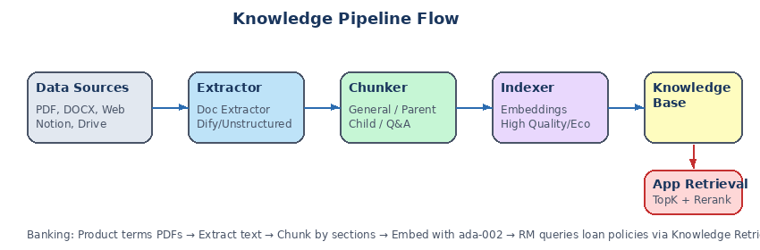
Figure: Knowledge Pipeline Flow — from data sources through extraction, chunking, indexing, and retrieval

8.4.1 Chunk Modes
Dimension | General Mode | Parent-Child Mode
Chunking | Single-tier | Two-tier (child for matching, parent for context)
Retrieval | Matched chunk returned directly | Child matches → parent chunk returned
Index Methods | High Quality + Economical | High Quality only
Best For | FAQs, glossaries, simple content | Dense technical/research documents

Example: Banking: Product Terms Knowledge Base
For a bank's product terms and conditions documents (dense, multi-section PDFs), use Parent-Child mode. Child chunks match specific clauses ('early redemption penalty'), while parent chunks provide the full section context. Settings: Parent delimiter \n\n, child max 300 chars. This ensures the LLM gets enough context to provide accurate, nuanced answers about specific terms.

8.5 Index Methods and Retrieval
Strategy | Description | Cost
Vector Search | Query converted to vector; nearest chunks returned | Requires embedding model
Full-Text Search | Traditional keyword indexing | No extra cost
Hybrid Search | Both simultaneously; configurable weighting | Best accuracy, embedding cost
Economical Index | 10 keywords per chunk, inverted indexing only | No embedding cost, lower accuracy

8.6 Knowledge Pipeline (Advanced)
Knowledge pipelines provide a visual workflow builder for sophisticated document processing. The core flow is: Data Source → Extractor → Chunker → Knowledge Base. Built-in templates include General Mode-ECO, Parent-child-HQ, Simple Q&A, LLM Generated Q&A, and Convert to Markdown.

8.7 Best Practices for Chunk Quality
After processing, review each chunk: chunks that are too short lack context, too long include irrelevant content, and semantically incomplete chunks are cut mid-thought. For Parent-Child mode, rewrite child chunks as semantic anchors (e.g., transform 'The LED indicator light blinks red when...' into 'blinking red light, power error, connection failure, LED status indicator'). Use summaries to bridge query-content gaps, especially when users use different terminology than the documents.

8.8 Knowledge Base API & Rate Limits
Plan | Requests per Minute
Sandbox | 10
Professional | 100
Team | 1,000

Chapter 9: Workspace Management
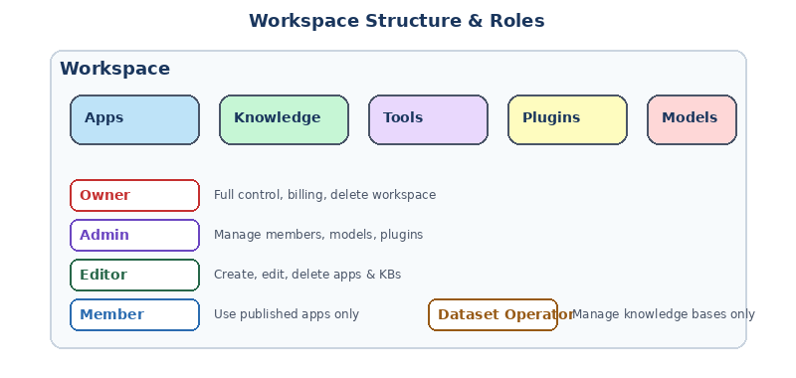
Figure: Workspace Structure and Roles — resources and permissions hierarchy

9.1 Roles and Permissions
Role | Key Capabilities | Cannot Do
Owner | Everything; billing; delete workspace | N/A (one per workspace)
Admin | Manage members, configure models and plugins | Adjust roles; manage billing
Editor | Create, edit, delete apps and knowledge bases | Manage team
Member | Use published apps and accessible tools | Create or edit apps
Dataset Operator | Manage knowledge bases only | Create apps

9.2 Team Capacity
Plan | Max Members | Max Apps | Daily API Calls
Free (Sandbox) | 1 | 5 | 5,000
Professional | 3 | 50 | Unlimited
Team | 50 | 200 | Unlimited

9.3 Model Providers
Model providers are the AI models powering your applications. System Providers are Dify-managed with subscription billing (best for prototyping). Custom Providers use your own API credentials with direct provider billing (best for production). Both can coexist. Supported categories include LLMs, Embeddings, Image Generation, Speech, Reranking, and Moderation. Load balancing (paid feature) distributes requests across multiple API keys using round-robin.

9.4 Plugins
Plugins extend Dify via model providers, external APIs, and custom tools. Install from the Dify Marketplace, GitHub URL + version, or local .zip upload. Build custom plugins using the Dify Plugin SDK. Owner/Admin can install and configure; Editor/Member can use installed plugins.

9.5 App Management and DSL
Key operations include Edit Info, Duplicate (for A/B testing), Export DSL (YAML backup), Import DSL, and Delete (permanent, cannot be undone). The DSL exports app configuration, workflow settings, model parameters, and KB connections. It does not export API keys, KB content, or usage logs.
WARNING: App deletion is permanent and cannot be undone. Always export DSL as a backup before deleting.

9.6 API Extensions
Extend Dify's capabilities with custom external services. Two extension types: external_data_tool (inject external data into prompts at runtime, e.g., real-time stock prices) and moderation (filter or override user input and LLM output). All endpoints must accept POST requests with JSON and Bearer token authentication. Deploy easily with Cloudflare Workers.
Example: Banking: External Data Extension for Market Data
An external_data_tool extension endpoint receives the tool_variable 'market_data_retrieve' with inputs {symbol: 'DBS', date: 'today'}. The endpoint queries Bloomberg/Reuters API and returns: 'DBS Group Holdings: SGD 38.45, +1.2%, Volume: 5.2M, P/E: 10.8'. This data is injected into the LLM prompt so the RM assistant provides real-time market context.

Chapter 10: Tutorials & Hands-On Labs

10.1 Tutorial: Simple Geography Chatbot (Beginner, 15 min)
Build a chatbot that accepts country questions, uses an LLM with structured JSON output to extract country/question/answer, runs Python code for fun facts, and returns a formatted response. Covers Chatflow basics, LLM node, Code node, Answer node, and structured output.

10.2 Tutorial: Twitter/X Account Analyzer (Intermediate, 30 min)
Build a chatflow that accepts a Twitter username, uses a Code node to construct the profile URL, an HTTP Request node to scrape via Crawlbase, and an LLM node to analyze topics, tone, and engagement. Covers environment variables for API key security, HTTP Request nodes, and multi-node pipelines.

10.3 Tutorial: Customer Service Bot with KB (Intermediate, 45 min)
Build a chatbot that classifies incoming questions into categories (product, technical, billing, other), routes product questions to a knowledge base for RAG answers with citations, and handles other categories with direct replies. Covers Knowledge Base creation, Question Classifier, multi-path routing, and features like Citation Display and Follow-up Suggestions.
Example: Banking Adaptation: RM Knowledge Assistant
Adapt Tutorial 3 for banking by creating four categories: Product Inquiry (search product terms KB), Regulatory/Compliance (search compliance KB), Client Portfolio (HTTP Request to portfolio API + LLM analysis), and General (direct reply with help desk contacts). Enable Citation Display so RMs can verify which policy document backs each answer.

10.4 Tutorial: AI Image Generator (Beginner, 20 min)
Build an Agent app with Stability AI tool integration. Covers Agent app type, tool authorization, prompt engineering, and content moderation constraints.

10.5 Tutorial: Article Reader with Q&A Generation (Intermediate, 30 min)
Build an article reading assistant that accepts document uploads, extracts text via Doc Extractor, uses an Iteration node to process each file (structure analysis + question generation), and formats output with a Template node. Covers File Upload, Doc Extractor, Iteration with continue-on-error, and multi-LLM pipelines.

10.6 Common Mistakes and Performance Tips
Mistake | Fix
LLM returns unstructured text when you need data | Enable Structured Output with a JSON Schema
Iteration fails when one item errors | Set error handling to Continue on Error
Context field receives array instead of string | Use Template node to convert KB result to string
API key exposed in node configuration | Store in Environment Variables; reference as {{ env.VAR_NAME }}
File variable not parsed by LLM | Always use Doc Extractor before passing files to LLM

Performance Tip | When to Apply
Enable Iteration parallel mode | When items are independent and order doesn't matter
Use cheaper models for classification | Question Classifier doesn't need GPT-4
Set Score Threshold in Knowledge Retrieval | Prevents low-quality chunks from polluting context
Cache frequent patterns with Annotation Reply | Repeated questions needing the same answer
Use Variable Inspector for debugging | Instead of re-running full workflow for every tweak

Chapter 11: Executive Summary & Decision Guide

11.1 Platform Summary
Dify is an open-source AI workflow platform that combines a visual low-code interface with enterprise-grade capabilities. With support for 100+ LLM models, built-in RAG pipelines, agent frameworks with 50+ tools, and one-click API/web publishing, it serves as a one-stop environment for building and operating AI applications. Organizations like Kakaku.com have demonstrated 75% employee adoption building 950 AI apps internally using Dify Enterprise.

11.2 Edition Comparison
Edition | Deployment | SSO/Security | Support | Pricing
Dify Cloud | Hosted SaaS | Standard (no SSO) | Community | Free sandbox + paid ($59-$159/mo)
Community (CE) | Self-host Docker/K8s | User manages | Community | Free (open-source)
Enterprise | Cloud or On-Prem | SSO (SAML/OIDC), audit logs | Priority SLAs | Custom license fee

11.3 Dify vs Code-Based Frameworks
Aspect | Dify Platform | DIY (e.g., LangChain)
Development Model | Visual, low-code workflows | Code-centric Python SDK
Multi-Model Support | 100+ providers built-in | Manual integration per provider
RAG Pipeline | Integrated (ingestion + vector store) | Assemble separate components
Deployment | SaaS or Docker/K8s | Self-managed containers
Monitoring | Built-in analytics and logs | External setup required
Learning Curve | Low (no-code) | High (code + framework)

11.4 Decision-Maker Checklist
When evaluating Dify: assess use case alignment (excels at rapid prototyping and employee-led AI apps), team skills (empowers non-developers via visual UI), security and compliance (Enterprise provides SSO, audit logs, isolation for regulated environments), cost (Cloud subscription vs. self-hosted infrastructure + LLM API costs), and vendor support (Enterprise includes SLA-backed support; Community relies on forums).

11.5 Risks and Mitigations
Risk | Mitigation
Platform Maturity | Start with pilot project; engage community/consultants
Operational Complexity | Use managed services (RDS, Elasticache) or Dify Cloud
Cost Overruns | Set quotas; switch to local/open models when possible
Security Vulnerabilities | Apply HTTPS, firewalls; enforce SSO and private VPC
Data Privacy | Use Community/Enterprise on-prem for confidential data

11.6 Recommended Next Steps
1. Pilot a Proof-of-Concept: Build a simple Dify app (e.g., FAQ bot using a knowledge base). 2. Prototype Comparison: Compare development time with a code-centric approach. 3. Cost Modeling: Estimate API calls and workspace needs against subscription fees. 4. Security Assessment: Test SSO integration and ensure compliance. 5. Scaling Plan: Prepare for Kubernetes with external vector DB and auto-scaling workers. 6. Team Enablement: Provide training on Dify concepts, establish best practices for version control and prompt testing.

Appendix: Quick Reference

A.1 Node Quick Reference
Node | Category | App Support
User Input | Start | Workflow + Chatflow
Schedule Trigger | Start | Workflow only
Plugin Trigger | Start | Workflow only
Webhook Trigger | Start | Workflow only
LLM | AI | Both
Agent | AI | Both
Question Classifier | AI | Both
Parameter Extractor | AI | Both
Knowledge Retrieval | Data | Both
Doc Extractor | Data | Both
Variable Aggregator | Data | Both
Variable Assigner | Data | Chatflow only
List Operator | Data | Both
Template | Data | Both
Code | Data | Both
If/Else | Control | Both
Iteration | Control | Both
Loop | Control | Both
Human Input | Control | Both
HTTP Request | Integration | Both
Tools | Integration | Both
Answer | End | Chatflow only
Output | End | Workflow only

A.2 Variable Referencing Quick Reference
Context | Syntax
In LLM prompts | {{ node_id.output_variable }}
In Template nodes | {{ variable }} with full Jinja2 support
In Code node inputs | Declared in input variable list, accessed by name
In If/Else conditions | Via the variable selector dropdown

A.3 Cron Expression Reference
Expression | Meaning
0 9 * * 1-5 | 9:00 AM every weekday
*/15 9-17 * * 1-5 | Every 15 min, 9 AM–5 PM, weekdays
0 0 1 * * | Midnight on the 1st of every month
@daily | Once a day at midnight
@hourly | Once an hour at minute 0

A.4 System Constraints
Constraint | Value
User Input nodes per canvas | 1
Parallel branches per node | 10 max
Nested parallel levels | 3 max
Parallel iterations | 10 max
MCP server subscriptions per plugin | 10 per workspace
File upload size | 15 MB per file
Max simultaneous file uploads | 10 files
Code/Template node string output | 80,000 characters
Object/array nesting depth | 5 levels
HTTP Response max size | 10 MB

