

1. Physiological Phenomena Predicted by a Non-Invasive Medical Test, Its Advantages, and Relevance in Cardiovascular/Circulatory Health
Non-invasive medical tests allow clinicians to observe internal physiological processes without penetrating the body. Common examples include electrocardiography (ECG), photoplethysmography (PPG), echocardiography, Doppler ultrasound, and blood pressure monitoring.
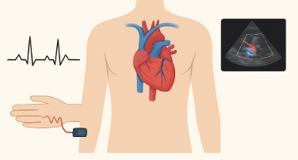
Physiological Phenomena Predicted
Non-invasive tests can predict or assess:
- Cardiac electrical activity – arrhythmias, conduction blocks, ischemia
(via ECG)
- Blood flow patterns & vascular resistance
(via Doppler ultrasound)
- Oxygen saturation and pulse waveform characteristics
(via PPG, pulse oximetry)
- Heart chamber structure & valvular pathology
(via echocardiography)
- Hemodynamic parameters – stroke volume, cardiac output, preload/afterload
(computed via echocardiography / impedance cardiography)
Advantages over Invasive Techniques
- No tissue penetration → lower infection risk
- Reduced cost and complexity
- Repeatability for long-term monitoring
- Immediate results at point-of-care
- Patient comfort and compliance
- Useful in critical or unstable patients where invasive procedures are risky
Relevance to Cardiovascular & Circulatory Monitoring
- Continuous assessment of arrhythmia burden, ischemia, heart rate variability
- Trend monitoring of blood pressure and perfusion in chronic disease
- Rapid detection of heart failure exacerbations through echo markers
- Evaluation of vascular integrity, such as peripheral arterial disease
- Tracking oxygenation in patients with circulatory compromise (shock, sepsis)

2. Interpretation of Modern MRI Reconstruction Techniques Through a Neuroimaging Case Study for Early Stroke Detection
Modern MRI reconstruction aims to make scans faster, clearer, and more sensitive to early pathological changes—critical for stroke diagnosis.
Key Reconstruction Techniques
Technique | Purpose | Benefit
Compressed Sensing (CS) | Under-sampled k-space + sparsity-based reconstruction | Faster scans without major image quality loss
Parallel Imaging (SENSE/GRAPPA) | Multiple coil data reconstructed jointly | Reduces scan time; improves resolution
Deep-learning reconstruction | Neural networks denoise and fill missing k-space | Superior detail, lower artifacts
Diffusion-weighted MRI (DWI) advanced reconstruction | Evaluates water movement in tissue | High sensitivity for acute ischemia
Case Study Example: Early Stroke Detection
A 58-year-old presents with sudden unilateral weakness.
Modern techniques enable:
- Rapid DWI acquisition (using CS + parallel imaging)
→ Detects restricted diffusion in minutes.
- Deep-learning reconstruction
→ Enhances contrast between healthy and ischemic tissue, revealing subtle infarcts.
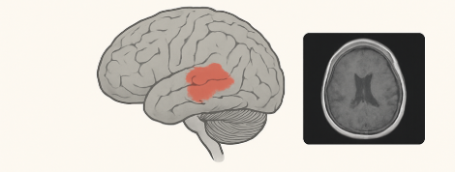
- Perfusion MRI maps
→ Identify penumbra (salvageable tissue), critical for treatment decisions.
- Artifact reduction
→ Motion correction aids patients who cannot cooperate (common in stroke).
Outcome:
Early identification of ischemic lesions enables rapid thrombolysis or thrombectomy, drastically improving prognosis.
3. Incorporation of Relevant Medical Devices, Potential Hazards, and Implications of Neglecting Safety Measures
Common Medical Devices
- ECG monitor
- Defibrillator
- Infusion pumps
- Ventilators
- MRI scanners
- Ultrasound machines
- Pulse oximeters
- Blood pressure monitors
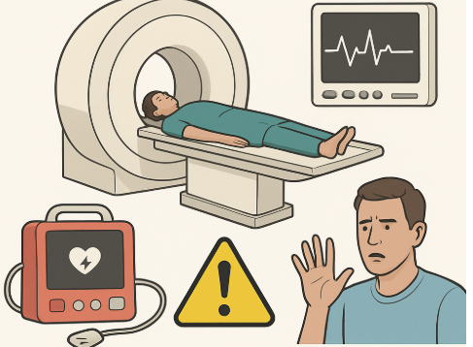
Potential Hazards
Device | Possible Hazard
MRI Scanner | Projectile accidents (ferromagnetic objects), RF burns, heating of implants
Defibrillator | Accidental shock delivery, improper pad placement
Infusion Pumps | Overdose/underdose due to programming errors
Ventilators | Barotrauma, incorrect oxygen concentration
ECG leads | Electrical shock risk if cables are damaged
Pulse oximeter | False readings in low perfusion/skin pigmentation issues
Ultrasound | Thermal effects at high exposure (rare)
Implications of Neglecting Safety Measures
- Patient injury or fatality (e.g., MRI projectile accidents)
- Misdiagnosis due to faulty sensors or improper calibration
- Equipment damage leading to downtime and increased costs
- Electrical hazards from poorly maintained cables
- Legal and ethical implications due to negligence
- Compromised critical care management (wrong infusion rates, wrong ventilation settings)
Healthcare providers must follow:
- Regular device calibration
- Strict MRI safety zones
- Routine inspection of cables and electrodes
- Training on defibrillator and infusion pump use
- Adherence to international standards (IEC, FDA, WHO)

