A-data: (BDTI TD3: 265,000mt, Middle East Gulf to Japan -- BDTI TD4: 260,000mt, West Africa to US Gulf)

B-data: (BDTI TD4: 260,000mt, West Africa to US Gulf -- BDTI TD5: 130,000mt, West Africa to USAC)

C-data: (BDTI TD3: 265,000mt, Middle East Gulf to Japan -- BDTI TD5: 130,000mt, West Africa to USAC)

Window size: 10—N/4, step 10

DCCA:

|  |  |  |  |
| --- | --- | --- | --- |
| Hurst Exponent | A-data | B-data | C-data |
| Period 1 | 0.629164172724 | 0.582080516556 | 0.584845054399 |
| Period 2 | 0.657615552802 | 0.625168149506 | 0.644580555957 |

DPXA:

|  |  |  |  |
| --- | --- | --- | --- |
| Hurst Exponent | A-data | B-data | C-data |
| Period 1 | 0.64642052322 | 0.605461409439 | 0.605239876561 |
| Period 2 | 0.719606428059 | 0.696333540565 | 0.6917151399 |

Hurst exponent:

1. DCCA, DPXA: 第二段hurst exponent都大于第一段。DPXA的增幅更大一些。说明油价是影响因素，但金融危机前后的核心因素可能综合/复杂无法分析定论。
2. DCCA: A>C>B; DPXA: A>B>C

从经验上来说，A-data有相同船型，B-data航线有相同的起点，C-data表面上没很大关系 -> hurst exponent A>B>C. DCCA得到了一个违背经验的结果。

1. DCCA, DPXA中从Period 1到Period 2，B-data和C-data之间hurst exponent的差异变大，//可能是金融危机过后失去了一种共因，有待检验。

**有新的因素加入，或者油价以外的因素加强，DXPA的差异比较小一点。油价还是存在的，但不会是单独的油价外因变化。**

1. DCCA, DPXA的general hurst exponent 在同一时段都是极为相似的，说明DPXA是在DCCA基础上一个有效的改进。
2. DCCA, DPXA的图都是非线性的，证明是多分形的。第二段比第一段H_q跨度更大，分形维度增加。原因是金融危机增强的价格波动。

左：DPXA第一段；右：DCCA第一段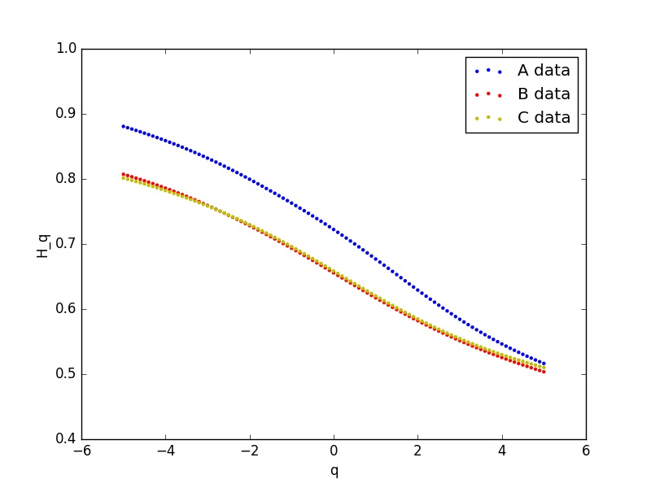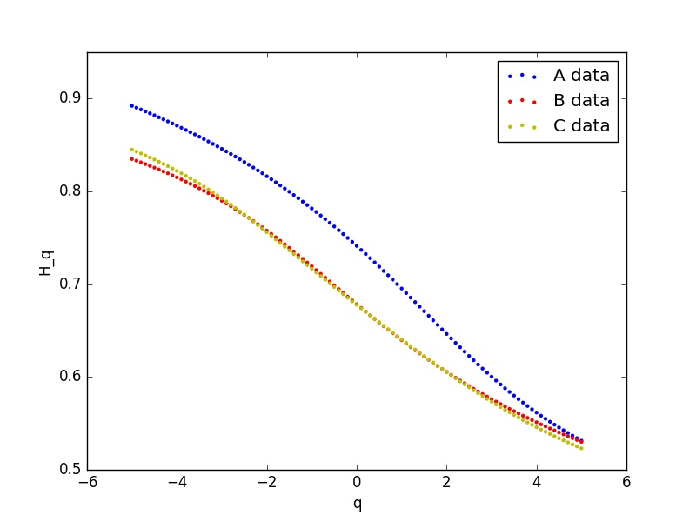

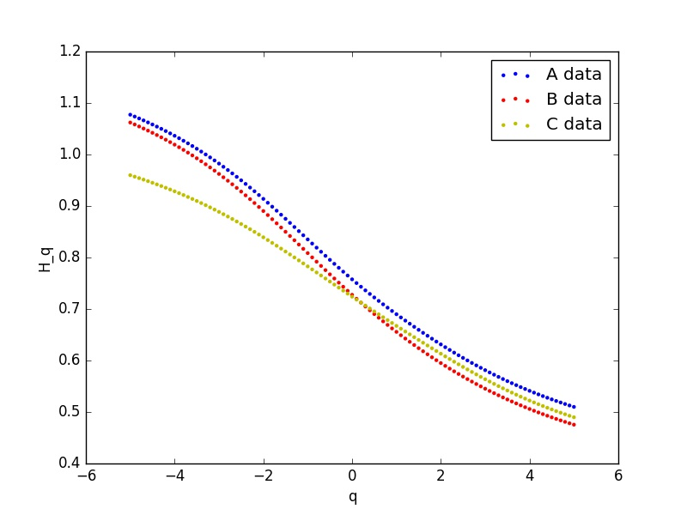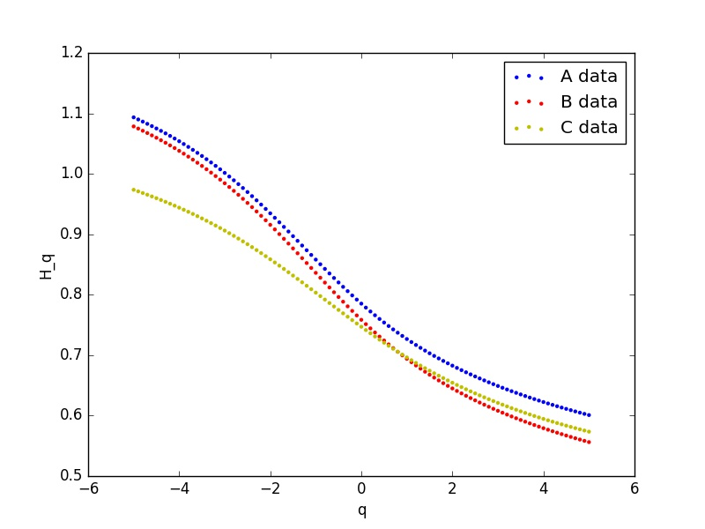左：DPXA第二段；右：DCCA第二段

τ直接反映分形维度，与上述结论契合。

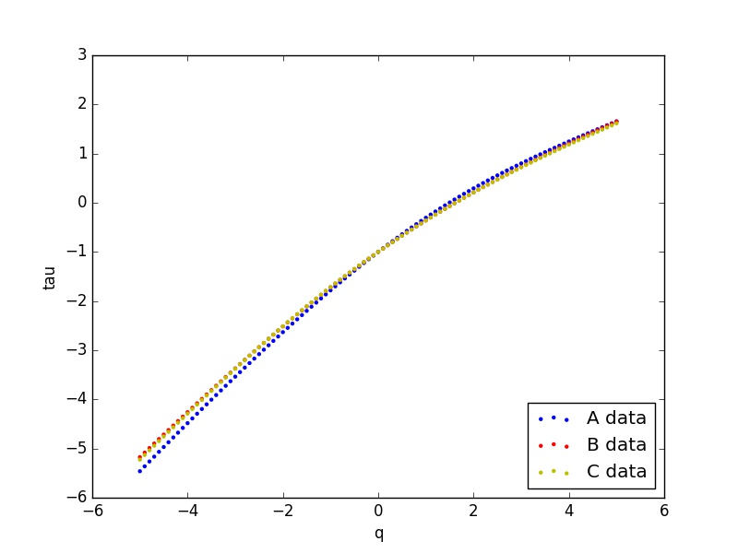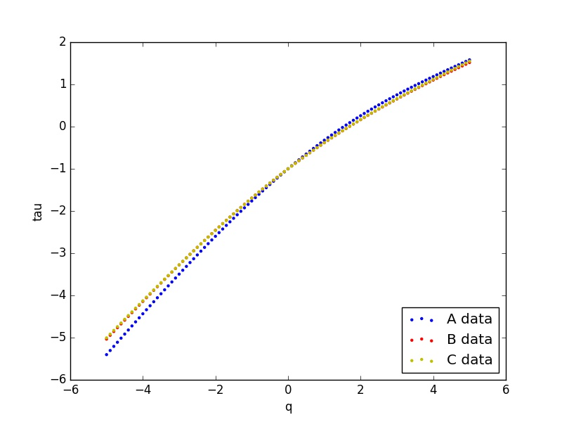左：DPXA第一段；右：DCCA第一段

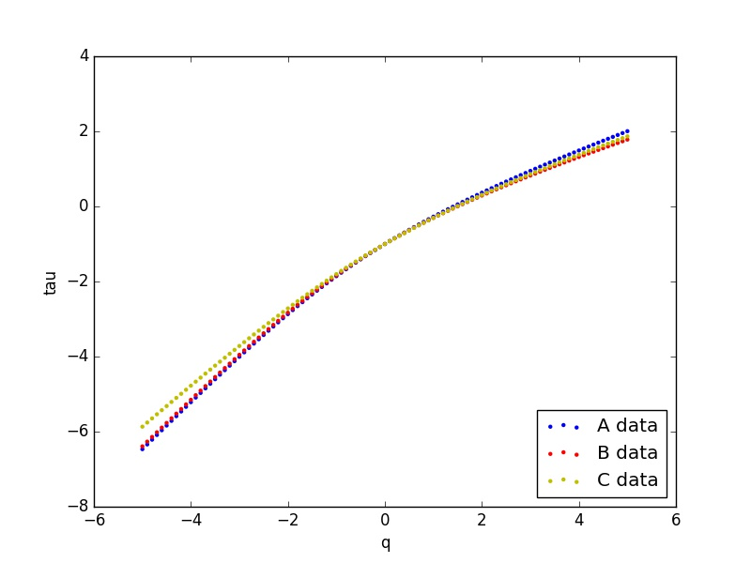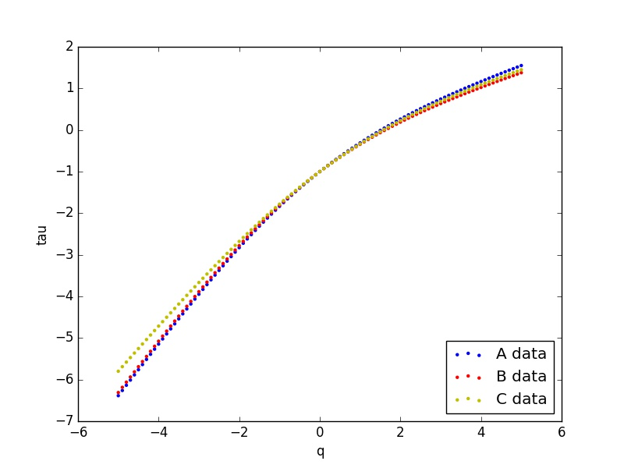左：DPXA第二段；右：DCCA第二段

|  |  |  |  |  |  |  |  |  |  |
| --- | --- | --- | --- | --- | --- | --- | --- | --- | --- |
| DCCA: | |  | | |  | | |  | |
| A-data delta_alfa | | origin | | | random | | | surrogated | |
| Period 1 | | 0.464473763 | | | 0.056267675 | | | 0.203790363 | |
| Period 2 | | 0.778346468 | | | 0.086360434 | | | 0.119842361 | |
|  | |  | | |  | | |  | |
| B-data delta_alfa | | origin | | | random | | | surrogated | |
| Period 1 | | 0.340799995 | | | 0.033431963 | | | 0.153220063 | |
| Period 2 | | 0.826557 | | | 0.082667096 | | | 0.1536731 | |
|  | |  | | |  | | |  | |
| C-data delta_alfa | | origin | | | random | | | surrogated | |
| Period 1 | | 0.30167057 | | | 0.049644233 | | | 0.134659825 | |
| Period 2 | | 0.636876493 | | | 0.108077358 | | | 0.204101138 | |
|  | |  | | |  | | |  | |
| DPXA: | |  | | |  | | |  | |
| A-data delta_alfa | | origin | | | random | | | surrogated | |
| Period 1 | | 0.470588203 | | | 0.071429751 | | | 0.195238833 | |
| Period 2 | | 0.734403604 | | | 0.102735036 | | | 0.108792081 | |
|  | |  | | |  | | |  | |
| B-data delta_alfa | | origin | | | random | | | surrogated | |
| Period 1 | | 0.32204555 | | | 0.08096191 | | | 0.201501728 | |
| Period 2 | | 0.790431184 | | | 0.112843252 | | | 0.172846623 | |
|  | |  | | |  | | |  | |
| C-data delta_alfa | | origin | | | random | | | surrogated | |
| Period 1 | | 0.303446676 | | | 0.080081168 | | | 0.174042519 | |
| Period 2 | | 0.596614849 | | | 0.122533735 | | | 0.18169771 | |
| DCCA: |  | |  |  | |  |  | |  | |
| A-data | total | | LM | NL | | PDF | eff | | eff percent(%) | |
| Period 1 | 0.4644738 | | 0.1475227 | 0.2606834 | | 0.0562677 | 0.3169511 | | 68.238747 | |
| Period 2 | 0.7783465 | | 0.0334819 | 0.6585041 | | 0.0863604 | 0.7448645 | | 95.698326 | |
|  |  | |  |  | |  |  | |  | |
| B-data | total | | LM | NL | | PDF | eff | | eff percent(%) | |
| Period 1 | 0.3408 | | 0.1197881 | 0.1875799 | | 0.033432 | 0.2210119 | | 64.850909 | |
| Period 2 | 0.826557 | | 0.071006 | 0.6728839 | | 0.0826671 | 0.755551 | | 91.409424 | |
|  |  | |  |  | |  |  | |  | |
| C-data | total | | LM | NL | | PDF | eff | | eff percent(%) | |
| Period 1 | 0.3016706 | | 0.0850156 | 0.1670107 | | 0.0496442 | 0.216655 | | 71.818401 | |
| Period 2 | 0.6368765 | | 0.0960238 | 0.4327754 | | 0.1080774 | 0.5408527 | | 84.9227 | |
|  |  | |  |  | |  |  | |  | |
| DPXA: |  | |  |  | |  |  | |  | |
| A-data | total | | LM | NL | | PDF | eff | | eff percent(%) | |
| Period 1 | 0.4705882 | | 0.1238091 | 0.2753494 | | 0.0714298 | 0.3467791 | | 73.690568 | |
| Period 2 | 0.7344036 | | 0.006057 | 0.6256115 | | 0.102735 | 0.7283466 | | 99.175243 | |
|  |  | |  |  | |  |  | |  | |
| B-data | total | | LM | NL | | PDF | eff | | eff percent(%) | |
| Period 1 | 0.3220456 | | 0.1205398 | 0.1205438 | | 0.0809619 | 0.2015057 | | 62.570569 | |
| Period 2 | 0.7904312 | | 0.0600034 | 0.6175846 | | 0.1128433 | 0.7304278 | | 92.40878 | |
|  |  | |  |  | |  |  | |  | |
| C-data | total | | LM | NL | | PDF | eff | | eff percent(%) | |
| Period 1 | 0.3034467 | | 0.0939614 | 0.1294042 | | 0.0800812 | 0.2094853 | | 69.0353 | |
| Period 2 | 0.5966148 | | 0.059164 | 0.4149171 | | 0.1225337 | 0.5374509 | | 90.083389 | |

1. DCCA, DPXA的有效成分主要是non-linear part（NL），DPXA的non-linear part（NL）更少一些，突出了趋势
2. DPXA的PDF part总是大于DCCA -> 去除油价影响之后更加偏离fat-tailed distribution
3. 从第一段到第二段，effective part的占比都是增加的，说明金融危机之 linear correlation（LM）的占比大幅减小。
4. DPXA里的有效成分占比大体与DCCA相近但都略高出一些，说明DPXA是一个相对更有效的分析方法
5. 如果两个序列的关联越强，则数据越趋向于特定分布-> PDF part 相对固定。根据中心极限定理，随机数据的PDF part= total->波动越随机PDF part越大。外因消除越多越体现市场的随机波动。金融危机之后PDF part总是变大的，随机波动的特点加强。
6. 对于non-linear part（NL）的值，关系较强的序列（A,B），金融危机之后增涨比关系较强的序列（C）大。强相关序列中A的增涨比B小（原因未知）
7. Period 1的时候DCCA/DPXA 中linear correlation part（LM）基本一致Common external force 主要的影响在于non-linear part（NL）和PDF。Period 2的时候LM/PDF/NL三个成分都有比较大的影响。**common external factor影响较大in period 2**
8. Period 1到Period 2的effective part占比变大符合金融危机后波动更剧烈的现象（non-linear part（NL）显著增加）。

对于金融危机前后，虽然波动性和多重分形的特性都增加，但是long-term persistent cross-correlation增强，总体趋势增强，并不矛盾。

For the two different fluctuation analysis method, we both take multifractality into consideration, so that " Multifractal detrended cross-correlation analysis " will be DCCA in short and " Detrended partial cross-correlation analysis " DPXA in short in the latter sections.

------------------------Hurst exponent--------------------------------------

Here we applied two different fluctuation analysis method to calculate generalized Hurst exponents. The Hurst exponents decrease with the order q with a non-linear relation, which indicates the fractal characteristic in the cross-correlation of the three pair of time series. We can also observe that the Hurst exponents of B-data and C-data exchange their relative magnitude at some point, where q-order is smaller(negative) in period 1 and larger(positive) in period 2, meanwhile the Hurst exponents of A-data hold their relative position. We can also observe a stronger non-linear characteristic in period 2 than in period 1, this phenomena can be explained as the expansion of fractal characteristic, which may be attributed to the economic fluctuation after financial crisis.

For normal prospect of time series analysis, we consider the Hurst exponent at order q=2, which reveals the long-term cross-correlation of the time series. In both DCCA and DPXA method, we observe an increase of Hurst exponents in three pairs of data from period 1 to period 2. However, Hurst exponents calculated by DPXA has a greater increment. Since DPXA removes the common external force from time series that analyzed, it may infer that crude oil is the common external force. But a nucleus common factor might still exist before and after the financial crisis, which still does not have an accurate data set to describe or too complicated to be stated. This type of common external force may also be the reason for the enlarged difference of Hurst exponent between period 1 and period 2.

We admit at $H_{2, \cdot}$ is the measuring point for long-term cross-correlation of the return series.(cite) For both period 1 and period 2, the Hurst exponents are larger than 0.5, indicating a strong persistent long-term correlation in the three pair of time series. Also, with the common external force subtracted in DPXA, we obtained a stronger long-term correlation, implying the existence of nucleus common factors, which confirm our suggestion for a complicated and not measurable common external force.

In empirical point of view, dominant factor always plays an important role in cross-correlation. Since A-data has the same size of bulk carrier, the shipping line of B-data has the same starting point and C-data does not show a dominant factor, we expected that $H_A>H_B>H_C$. We observed that Hurst exponents from DPXA fit the empirical prediction, however, that from DCCA have $H_A>H_C>H_B$ which contradicts with empirical prediction. Under this circumstance, DCCA may not produce a empirically correct answer for Hurst exponents, so that DPXA appears to be a more advanced way of analysis. Despite the measuring point at q=2, the curves of general Hurst exponents generated by DPXA and DCCA are quiet similar during the same period, hence DPXA is an effective way of improving DCCA

----------------------tau------------------------------

From Eq.X, we calculate and obtain the Renyi exponent $\tau(q)$ for three pairs of data that varies with q varying from -5 to 5. The Renyi exponent $\tau(q)$ shows the the shape of nonlinear curves both in period 1I and period 2 , which can also confirm the multifractal cross-correlation between BDTI return series. We did not observe a great difference of the Renyi exponent between DCCA and DPXA in the same period, so that both methods gives out similar multifractality.

--------------------FSE---------------------------

Based on Eq.X, we can conclude that if the multifractal spectrum appears as a point, it is monofractal. As a result, The width of the multifractal spectrum can be employed to estimate the strength of multifractality(cite), with which we can quantitatively analyze the origin of multifractality. Apparently, in each multifractal spectrum, the curve is not a point which is a proof of the character of multifractality. Due to the limited size of data, we have to consider finite size effect to precisely analyze the effect part of the strength of multifractality.

It has been clearly stated that two diﬀerent types of multifractality may exist in a time series data, namely multifractality due to long-term cross-correlations of the ﬂuctuations which is composed of the $\d\a_{LM}$ (linear) and $\d\a_{NL}$(nonlinear) correlation parts and multifractality due to a fat-tailed probability distribution function of the values in the series($\d\a_{PDF}$).(cite)

As we calculate every part of $\d\a$ of DCCA and DPXA, we conclude that the $\d\a_{EFF}$(effective part) of $\d\a$ mainly consists of $\d\a_{NL}$(non-linear part), and $\d\a_{NL}$ in DPXA is less than that in DCCA, which reveals a clearer trend after common external forces are wiped off. The increment of $\d\a_{NL}$ of time series with strong dominant common factors(A-data, B-data) is larger than that of a relatively weak pair of time series(C-data) after financial crisis. In addition, B-data has the greater increment than A-data. Comprehensive causation behind this result can be length of the shipping line, type of harbor, or even the random choice of surrogating.

Another segment of $\d\a_{EFF}$ is $\d\a_{PDF}$, resulting from the probability distribution of cross-correlation function. As for data produced by random walk, central limit theorem states that the probability distribution is normal distribution if given large size of sample. Since we take log returns for all data, we get a log-normal distribution for original data which is a fat-tailed distribution. Obviously, none of those return data are random, which satisfies the result of Hurst exponents. As $\d\a_{PDF}$ increases after financial crisis, the trend of global trend of the cross-correlation function is enhanced, which explains the increase of Hurst exponent. With the common external force subtracted in DPXA, the randomness caused by crude oil price is also reduced. Therefore, $\d\a_{PDF}$ in DPXA is larger than that in DCCA.

The ratio of $\d\a_{EFF}$ is an import criterion for estimating multifractality. From period 1 to period 2, the great increment of $\d\a_{EFF}$ relies on the decrease of $\d\a_{LM}$ and the increase of $\d\a_{NL}$. Furthermore, we observe that percentage of $\d\a_{EFF}$ in DPXA is larger of that in DCCA, persuading the effectiveness of DPXA. Also, $\d\a_{LM}$ calculated by DCCA and DPXA is close in period 1, however, distinguishable in period, so that in period 1 common external forces mainly have impact on $\d\a_{NL}$ and $\d\a_{PDF}$, and in period 2 $\d\a_{LM}$ is also infected.