UI/UX PROJECT ASSIGNMENT REPORT
Track It — Mobile Expense & Budget Tracker App

Presented By:
Sivikelwe Gwebu
Class: SY BSc Computer Science
Thakur College of Science and Commerce
University of Mumbai

Figma Design Project Link:
https://www.figma.com/design/leIME6tJ1KOkrYCha4frQ5/Expense-Tracking-App?node-id=0-1&t=MSiTNeqGGBinZ8Jt-1
1. Problem Statement
Many individuals struggle with managing their personal finances because existing financial tracking applications are often overly complex, cluttered with advanced investment tools, or intimidating for first-time users. Users need a streamlined, intuitive, and visually clear mobile tool that allows them to quickly record expenses, check their total balance, monitor monthly budgets, and analyze spending habits without a steep learning curve.
2. User Flow & Navigation Structure
The application's user flow is optimized for speed and minimal friction, allowing users to complete key daily financial tasks in just a few taps:
- Splash Screen (Track It): Initial app launch displaying the brand logo and the primary 'Get Started' CTA button.
- Login / Sign-Up: Secure authentication screen allowing users to input their credentials or register a new account.
- Home Dashboard: The central hub displaying Total Balance, Income/Expense summaries, budget progress bar, and recent transactions.
- Add Expense Workflow: Quick entry form where users input amounts, select categories, and instantly update their financial records.
- Monthly Analytics: Interactive visual charts showing spending breakdowns across weekly, monthly, and yearly timeframes.
- Profile / Settings: Dedicated section for managing account preferences, spending categories, and notification settings.

3. Vertical User Flow Diagram (A4 Optimized)
The diagram below outlines the vertical user flow architecture, formatted in portrait layout to fit seamlessly within A4 document boundaries:
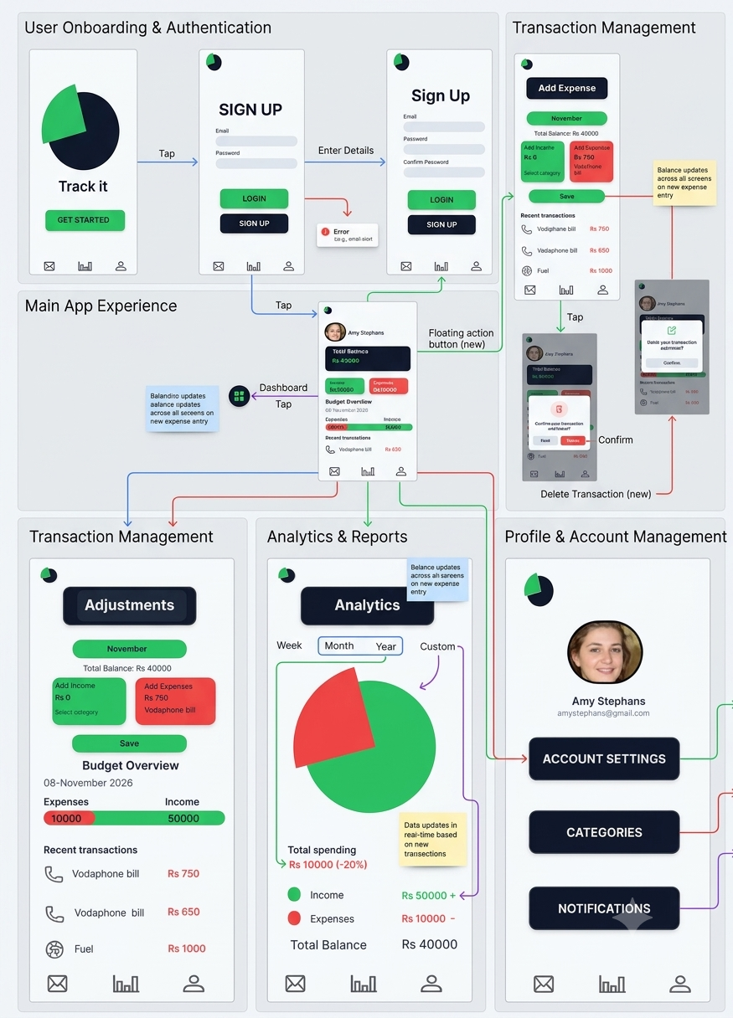
Figure 1: Vertical portrait user navigation flow diagram

4. Key Design Decisions
Several strategic UX and UI decisions were implemented in the Figma design to ensure optimal usability and visual appeal:
- Dark Mode Theme Base: A sophisticated dark navy background (#10141D) reduces eye strain in low-light environments and gives the application a modern fintech aesthetic.
- Intentional Color Coding: Emerald green is utilized for positive metrics (Total Balance, Income, 'Get Started' action buttons) to symbolize financial growth, while coral/red is reserved for expenses and negative indicators.
- Hierarchical Dashboard Layout: Essential metrics—such as total balance and immediate monthly budget status—are anchored at the top of the Home Dashboard for immediate visual parsing.
- Persistent Bottom Navigation: A standardized 3-icon bottom navigation bar provides instant, thumb-friendly access to core app sections from anywhere within the application.



