

SUBJECT
Academic Year 2026 – 2027
Optimising Last-Mile Pickup Routes with Machine Learning
COURSE: OPTIMISATION FOR MACHINE LEARNING
MASTER AIDA — DAUPHINE-PSL
Prepared by: BEN MUSTAPHA Siwar Supervised by: Mr. Ayadi Slim
Contents
1. Introduction and problem statement 3
Context 3
Business problem 3
Project objectives 3
Why Machine Learning 3
KPIs tracked and strategies compared 3
2. Dataset and preprocessing 4
Key variables 4
Data quality and processing carried out 4
3. Exploratory Data Analysis 5
4. Machine Learning 6
5. Optimisation and conclusion 7
References 7
Machine Learning & Logistics Optimisation project
Optimising last-mile pickup routes with Machine Learning
Dynamic routes with time windows — LaDe-P dataset (Cainiao), city of Yantai
Professor: Mr Slim Ayedi

1. Introduction and problem statement

Context
The last mile accounts for a major share of logistics cost. Every day, a courier collects parcels from customers who have been given a 2-hour time window. Requests arrive throughout the day: the courier does not know all of their tasks in the morning.

Business problem
Every time they finish a pickup, the courier has to decide where to go next. A bad visiting order lengthens the distance, uses up working time and misses deadlines. This is a dynamic version of the travelling salesman problem with time windows (TSPTW), an NP-hard combinatorial optimisation problem.

Project objectives
- Prepare and analyse the real data of 1,146,781 parcels collected by 2,593 couriers over 184 days.
- Learn with Machine Learning the time required between two visits (travel + service).
- Use these predictions in an optimisation model that chooses the visiting order at each stop.
- Measure the gain honestly compared with the real courier and with optimisation without ML.

Why Machine Learning
An optimiser needs a time matrix between all points. This time does not exist in the data: it depends on distance, neighbourhood, hour or type of place. ML estimates it from nearly one million observed trips. ML predicts, optimisation decides.

KPIs tracked and strategies compared
KPI | Definition | Unit
Distance travelled | Sum of distances between successive visits (exact calculation, no model) | km / day
Travel time | Sum of travel and service times | min / day
Route duration | From the first to the last pickup (including waiting for new tasks) | min / day
Late pickups | Visits made after the end of their window | visits / day

Strategy | Who decides the order? | Times used to decide
Real (courier) | The courier, as recorded in the data | Their experience
Scenario 1 — Optimised without ML | Optimisation heuristic at each stop | Formula: median service + distance ÷ median speed
Scenario 2 — Optimised with ML | The same heuristic, at each stop | Hourly matrix predicted by Gradient Boosting

Comparing scenarios 1 and 2 isolates the added value of ML; comparing them with the real order measures the added value of optimisation.

2. Dataset and preprocessing
Source: LaDe (Last-mile Delivery), the first large public last-mile delivery dataset, published by Cainiao, Alibaba's logistics arm (Wu et al., 2023; Apache-2.0 licence). We use the pickup subset for the city of Yantai (file pickup_yt.csv).
Feature | Value | Feature | Value
Rows (parcels) | 1,146,781 | Columns | 19
Couriers | 2,593 | Courier days | 71,521
Regions / AOIs | 30 / 6,024 | Period | May → October (184 days)
Median window | 120 min | Late pickups (real) | 0.47%

Key variables
Coordinates of the pickup point (lng, lat), region and area of interest (region_id, aoi_id, aoi_type), courier, time window (time_window_start / end), moment the task becomes known (accept_time) and actual pickup moment (pickup_time).

Data quality and processing carried out
Step | Rows | Justification
Duplicates / repeated identifiers | 0 / 0 | No duplicates: nothing to remove
Time inconsistencies | 0 | No pickup before acceptance, no reversed window
Points outside the area | 0 | All coordinates plausible
Missing GPS columns | 21% and 36% | Not used: the declared coordinates are complete
Grouping into visits | 1,135,167 | Consecutive parcels at the same place = a single visit
Pairs visit → next | 1,063,646 | ML learning unit
Causality filter | 976,050 | The next visit had to be known at departure (otherwise we measure a wait, not a trip)
Breaks excluded from training | 16,547 | Gaps > 120 min (1.7%): breaks or other activities; kept in the real routes
Final training base | 959,503 | 9 explanatory variables known before departure

Dates: the year is not provided; a dummy year is used only for calculations, so the day of the week is not used. Split without data leakage: training on May–August, test on September–October. Couriers are randomly drawn into two disjoint groups: group A trains the planner model, group B trains an independent evaluator model that is only used to score the routes.
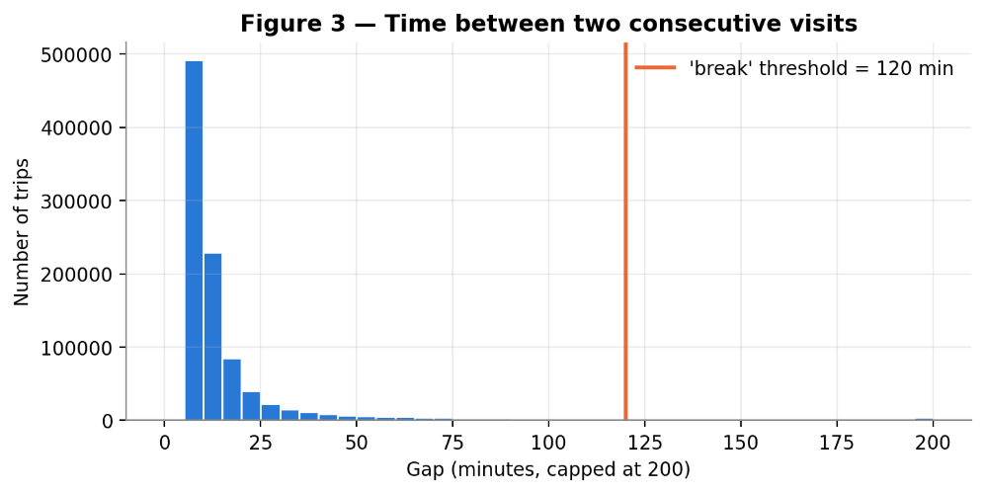
Figure 3 — Distribution of the time between two consecutive visits: median of 9 min, long tail beyond the break threshold (120 min).

3. Exploratory Data Analysis
The figures use the same numbering as in the Notebook. The EDA answers three questions that directly guide the modelling: what does time depend on?, are the windows binding? and when are the tasks known?
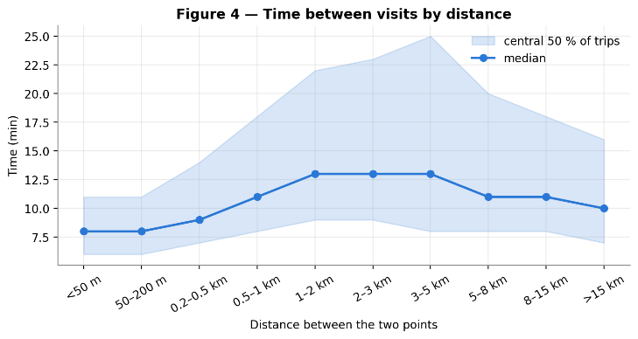  Figure 4 — Time between visits by distance (median and central 50%). | 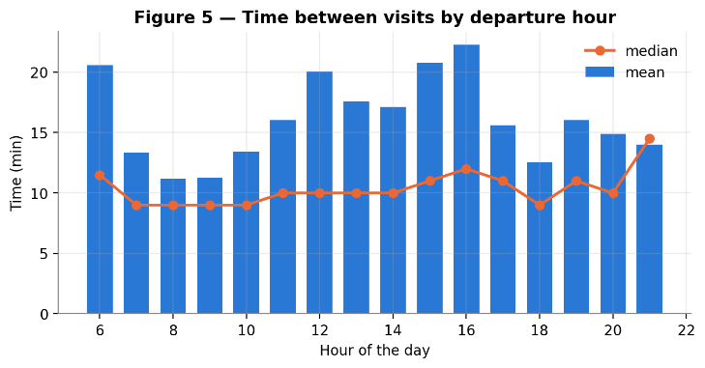  Figure 5 — Time between visits by departure hour.
Time is not proportional to distance. It goes from 8 min (under 50 m) to 13 min (1 to 5 km), then drops for long trips, probably made by vehicle. For the same distance, the dispersion is very large. The hour matters: the average time is about 11 to 13 min in the morning and rises to about 20 min in the afternoon. The time matrix must therefore depend on the hour, which a fixed formula cannot do.
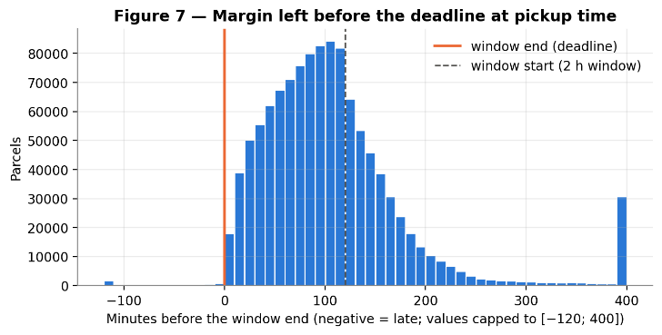  Figure 7 — Margin left before the deadline at pickup time. | 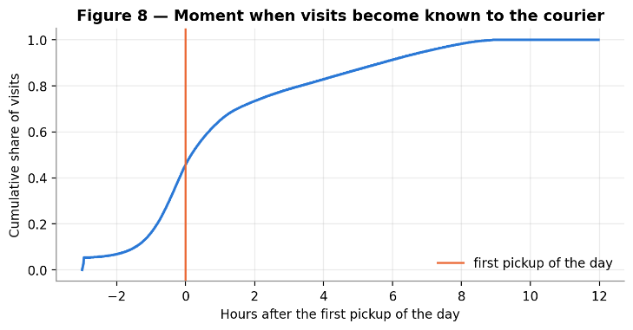  Figure 8 — Moment when visits become known to the courier.
Couriers already almost always meet deadlines: only 0.47% lateness, and 32% of parcels are collected before the window start. The window end is therefore a deadline; the start is not binding. The expected gain concerns time and distance, without degrading the service.
Only 46% of visits are known before the first pickup. Planning the whole day in the morning would be unrealistic, as it would use future information. We therefore optimise dynamically: at each stop, among the tasks already known only.
Correlations (Spearman): distance (0.27) and hour (0.17) are the variables most related to time, but all correlations remain weak. No single variable is enough: this argues for a non-linear model, and signals that prediction will be difficult.

4. Machine Learning
Target: time (min) between the end of one visit and the start of the next. Variables: distance, same AOI, departure and arrival AOI types, departure hour, parcels on arrival, region, arrival latitude and longitude. All are known before leaving. Training: 327,693 pairs (couriers A, May–Aug.); test: 153,772 pairs (couriers A, Sept.–Oct.).
Models compared, from the simplest to the most flexible: a baseline based on historical averages (median service of 8 min + distance ÷ 16.7 km/h), a linear regression (explainable), a decision tree, a Random Forest and a Gradient Boosting (scikit-learn).
Model | MAE (min) | Mean bias (min) | RMSE (min) | R²
Baseline (historical averages) | 7.98 | −5.07 | 17.78 | -0.104
Linear regression | 9.39 | −0.13 | 16.55 | 0.043
Decision tree | 9.24 | −0.07 | 16.25 | 0.078
Random Forest | 9.11 | −0.06 | 16.04 | 0.101
Gradient Boosting (selected) | 9.01 | −0.04 | 15.92 | 0.115
Table — Performance on the test set (Sept.–Oct.). Bias = mean (prediction − actual).
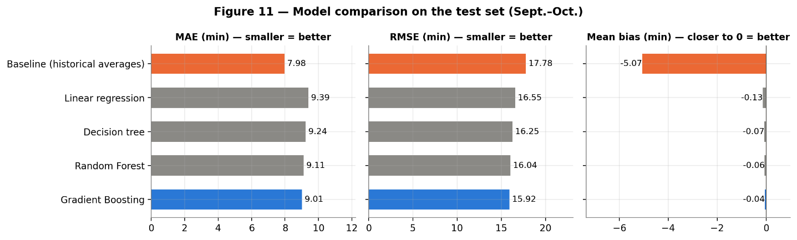
Figure 11 — Model comparison: MAE, RMSE and mean bias.
A counter-intuitive and instructive result. The baseline has the smallest MAE (7.98 min) because it predicts the “typical” trip. But it underestimates each trip by 5.1 min on average, which amounts to more than an hour of error over a 20-trip route. Gradient Boosting has a slightly higher MAE (9.01 min) but the best RMSE (15.92), the best R² (0.11) and an almost zero bias (-0.04 min). Above all, it avoids large errors on long trips (Figure 12).
Model choice: a route adds up the times of its trips. For planning, we therefore need times that are right on average, and not only “often close”. We keep Gradient Boosting, best in RMSE and unbiased, and fast to train (6 s). R² remains modest: a large part of the time depends on elements absent from the data (customer waiting, phone call, deliveries in between).
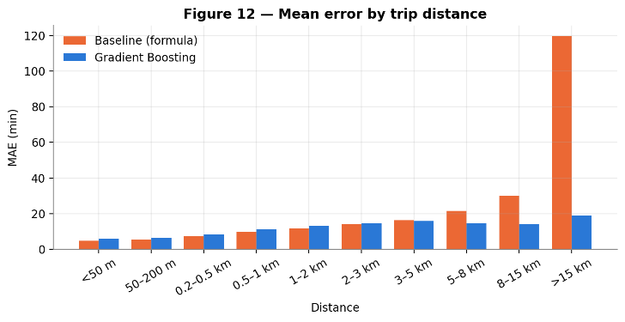  Figure 12 — Mean error by trip distance. | 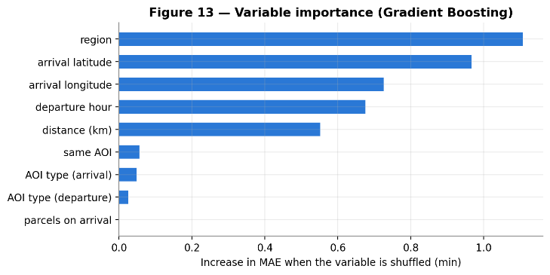  Figure 13 — Variable importance (permutation).
What the model learned: location (region, coordinates) and hour weigh more than distance. Some neighbourhoods and the afternoon are slower. The AOI type matters little.

5. Optimisation and conclusion
Mathematical model. At instant τ, the courier knows N pending visits. We minimise Σ t(i,j)·x(i,j) + λ·Σ L(j), where x(i,j) ∈ {0,1} equals 1 if we go from i to j, t(i,j) is the time predicted by ML for the departure hour, and L(j) ≥ a(j) − l(j) is the lateness with respect to the deadline l(j). The constraints impose one entry and one exit per visit, as well as time propagation a(j) ≥ a(i) + t(i,j) − M·(1 − x(i,j)), which also eliminates subtours. This is a TSPTW-type MILP, with λ = 5.
Dynamic solution. At each stop, a heuristic (greedy construction + 2-opt + or-opt) reorders the known visits; the courier heads to the first one. Validated against the exact optimum (HiGHS solver) on 30 instances of 8 visits, it finds the optimum in 83% of cases, with a mean gap of 0.17%, in 1.0 ms versus 0.40 s for the MILP. Evaluation: 150 test days; the times actually experienced are given by the independent evaluator, whose simulated durations are correlated at 0.61 with real durations (median error 9%). The distance is computed exactly.
Mean KPI per day | Real (courier) | Optimised without ML | Optimised with ML | With ML vs real | With ML vs without ML
Distance (km) | 10.45 | 8.23 | 8.93 | −14.6% | +8.5%
Travel time (min) | 318.5 | 295.7 | 298.6 | −6.2% | +1.0%
Route duration (min) | 462.9 | 430.4 | 431.4 | −6.8% | +0.3%
Late pickups | 1.05 | 1.39 | 0.92 | −12% | −34%
Minutes late | 45.2 | 42.4 | 30.7 | −32% | −28%

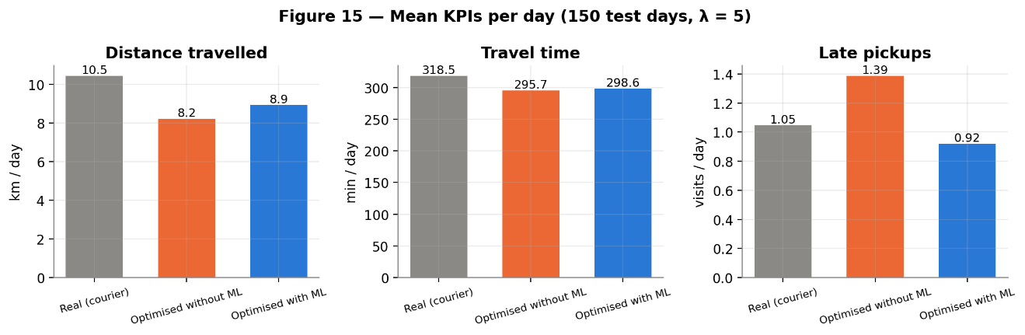
Figure 15 — Mean KPIs per day for the three strategies (150 test days, λ = 5).
Simulated gains. Optimisation clearly shortens routes compared with the field: −14.6% distance and −6.2% travel time with ML. It beats the real courier on 82% of days (Wilcoxon, p < 0.001). Without ML, the kilometre gain is stronger (−21.3%) but is paid for with more lateness than the real order, because the formula underestimates times. With ML, lateness drops by 34% compared with the scenario without ML, for +1.0% travel time. The sensitivity analysis (λ from 0 to 20, see Notebook) shows that the formula does not fix its lateness even with a heavy penalty: a good penalty does not compensate for a bad prediction.
Limitations. Time and lateness gains are simulated (a route that was never driven cannot be observed); the evaluator overestimates lateness in absolute terms (1.05 simulated versus 0.08 observed per day), so only comparisons between strategies can be interpreted. Distances are straight-line, the real courier has information absent from the data, and the model's R² remains low.
Conclusion. The project links an ML prediction to a measured operational decision. Optimisation shortens routes; ML makes the plan reliable by preserving deadline compliance. Next steps: road distances (roads.csv), multi-courier version (VRPTW), forecasting of future requests.

References
Wu, L. et al. (2023). LaDe: The First Comprehensive Last-mile Delivery Dataset from Industry. arXiv:2306.10675.
Pedregosa, F. et al. (2011). Scikit-learn: Machine Learning in Python. Journal of Machine Learning Research, 12, 2825–2830.
Huangfu, Q. & Hall, J. A. J. (2018). Parallelizing the dual revised simplex method. Mathematical Programming Computation, 10, 119–142 (solveur HiGHS).
Solomon, M. M. (1987). Algorithms for the vehicle routing and scheduling problems with time window constraints. Operations Research, 35(2), 254–265.
Pillac, V., Gendreau, M., Guéret, C. & Medaglia, A. L. (2013). A review of dynamic vehicle routing problems. European Journal of Operational Research, 225(1), 1–11.

