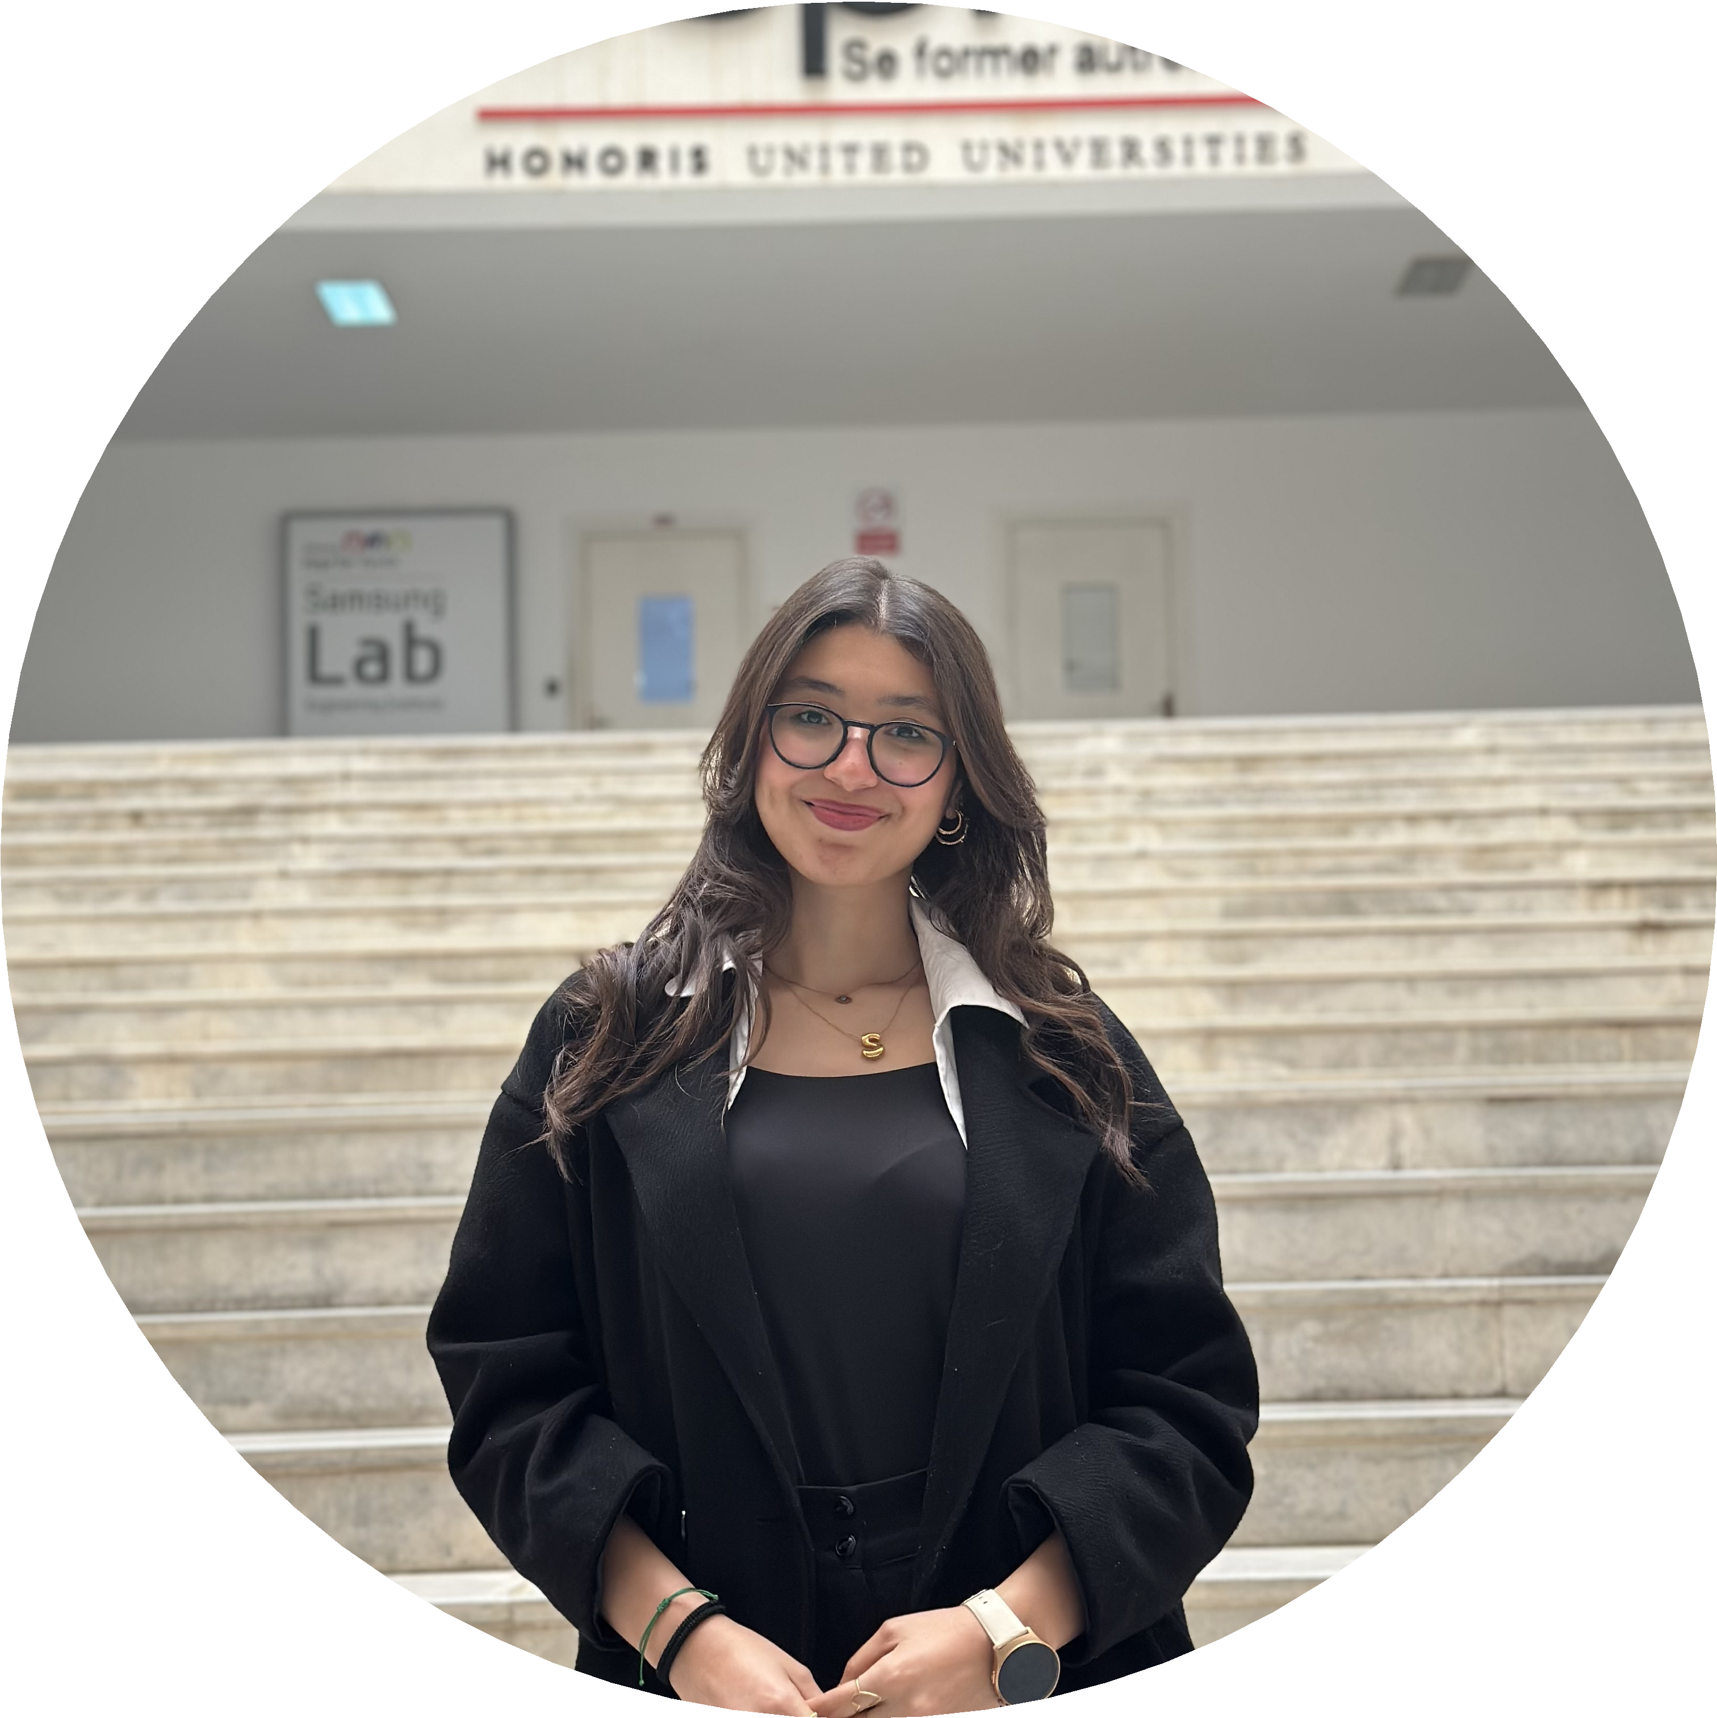
Siwar Taktak
M.Sc. Data Science Student

siwar.taktak@esprit.tn  +49 1757483676 Ederstrasse 4, 35390 Giessen LinkedIn  Portfolio  GitHub

Profile
I am a 3rd-year Data Science Engineering student (International Class) at ESPRIT (Higher School of Engineering and Technology) and an exchange student currently enrolled at Philipps-Universität Marburg. I have built a solid foundation in machine learning and data engineering, through academic projects and hands-on work with Large Language Models and AI agents. Now I am looking for an internship where I can move from theory to practice, solving real challenges and learning what it takes to deploy AI systems that actually work.

Professional Experience
Summer Internship (Engineering Internship) 06/2025 – 08/2025 ESPRIT Tunisia
- Developed and implemented clustering algorithms in Python to form balanced and heterogeneous student groups based on GPA, skills, learning styles, and interests.
- Created and maintained backend workflows and Jupyter notebooks for data processing, algorithm testing, and perfor- mance evaluation.
- Integrated machine learning outputs with the web application, supporting gamification features to enhance student engagement and learning outcomes.
Summer Internship (Company Immersion) 07/2024 – 09/2024 Prologic Tunisia
- Analyzed and visualized data to support strategic decision-making across departments.
- Gained hands-on experience in data management, reporting, and the use of BI tools.
- Assisted in the centralization of data from multiple applications (GLPI and PMA) and helped design a dashboard to monitor key performance indicators.
Summer Internship (Observation) 07/2022 – 08/2022
Bank of Tunisia Tunisia
- Prepared branch backup servers and automated the reinstallation of operating systems.
- Installed and configured essential software, including Microsoft Deployment Toolkit (MDT) and System Center Config- uration Manager 2012 SCCM 2012.
- Performed BIOS configuration to enable operating system installation via network (PXE boot).

Education
Exchange Student (M.Sc. Data Science) 10/2025 – Present
Philipps-Universität Marburg Marburg, Germany
Final Year Data Science Student 09/2021 – Present
ESPRIT - Private Higher School of Engineering and Technology Tunisia
Baccalaureate in Mathematics 01/2017 – 07/2021
L’Aouina High School Tunisia

Skills
Soft Skills Creativity & Motivation • Problem Solving & Critical Thinking • Communication & Team Collaboration • Time Management & Multitasking
Hard Skills Python Programming • Machine Learning & AI (Scikit-learn, PyTorch, TensorFlow) • Data Analysis & Feature Engineering (Pandas, Matplotlib) • LLM & AI Agents (RAG, LangChain, Hugging Face, OpenAI APIs) • Con- tainerization & CI/CD (Docker, Git, GitHub, Kubernetes) • Databases & BI Tools (MySQL, Power BI)

Languages
Languages Arabic (Native) • French (B2) • English (Advanced C2)

Certificates & Training
- Nvidia: Building Transformer-Based Natural Language Processing Applications Course & Fundamentals of Deep Learning
- DataScientist.fr: Introduction to Docker, Introduction to RAG with LangChain, Fundamentals of Kubernetes
- AWS Academy: Certificate of Completion for AWS Academy Graduate - Cloud Foundations Training Badge
- National Microsoft Technologies Camp (NMTC) 4th edition 2023: Certificate of participation, AI and Mi- crosoft Technologies conference certificate (Mariem Kharrat), MLOPS and Autonomous Telecommunications by Orange Tunisia
- Coursera: Emotional and Social Intelligence

