# 说明

1.上传参数中，以 *标注为必传参数，以 –标注为可选参数

2.返回报文中statusCode为200表示请求成功，statusCode为400表示请求错误

## 创建会议

URL: <http://127.0.0.1:18011/createMeet>

请求类型：POST

参数：

{

"content":"测试的内容", *

"header":"测试的标题", *

"organizer":{

"name":"冉鹏峰", -

"id":"1" *

},

"members":[{"name":"老胡"},{"name":"胡老师"}] *

}

返回报文：

{

"statusCode": "200",

"data": "创建成功"

}

PostMan实例：

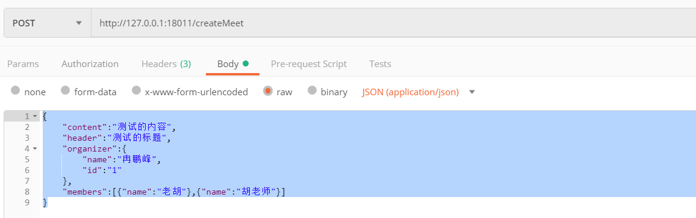

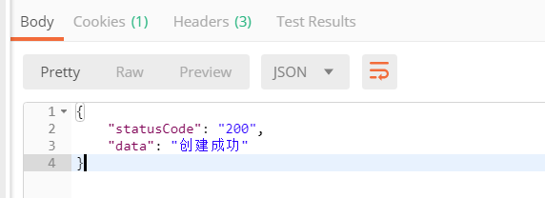

## 删除会议记录

URL: <http://127.0.0.1:18011/deleteMeet>

请求类型:GET

参数:会议记录的id *

返回报文：

{

"statusCode": "200",

"data": "删除成功"

}

示例：

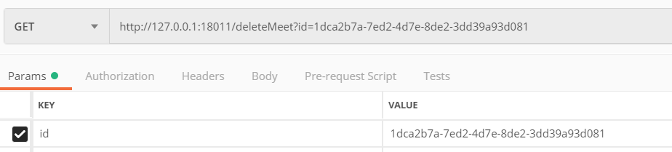

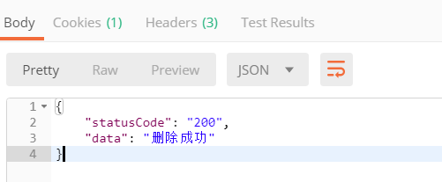

## 修改会议记录

URL: <http://127.0.0.1:18011/updateMeet>

请求类型：POST

请求参数：{

"id":" 3607c6cf-8190-405e-8391-9dea31148379 ", *

"content":"要修改测试的内容", -

"header":"要修改测试的标题", -

"members":[{"name":"老王"},{"name":"胡老师"}] -

}

可以修改会议content header members，修改什么传什么

返回报文：

{

"statusCode": "200",

"data": "修改成功"

}

示例：

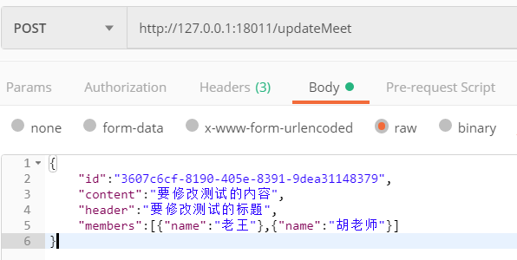

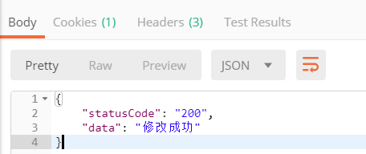

## 会议记录查询

URL: <http://127.0.0.1:18011/searchMeet>

请求类型：POST

参数：

{

"content":"测试", -

"header":"测试", -

"organizer":{"name":"鹏"}, -

"members":[{"name":"老王"}] -

}

需要什么条件就提交什么字段其中content header organizer 支持模糊查询

返回报文：

{

"statusCode": "200",

"data": [

{

"id": "1",

"content": "测试",

"header": "测试",

"members": [

{

"id": "1",

"name": "冉鹏峰",

"nickName": "siwash",

"avatarUrl": ""

},

{

"id": "3",

"name": "老王",

"nickName": "king",

"avatarUrl": null

}

],

"picture": null,

"date": null,

"updateTime": "2019-01-17T16:48:08.000+0000",

"organizer": {

"id": "1",

"name": "冉鹏峰",

"nickName": "siwash",

"avatarUrl": ""

}

},

{

"id": "3607c6cf-8190-405e-8391-9dea31148379",

"content": "要修改测试的内容",

"header": "要修改测试的标题",

"members": [

{

"id": "1",

"name": "冉鹏峰",

"nickName": "siwash",

"avatarUrl": ""

},

{

"id": "13457d48-3469-4d57-a776-31dff55ef167",

"name": "胡老师",

"nickName": null,

"avatarUrl": null

},

{

"id": "3",

"name": "老王",

"nickName": "king",

"avatarUrl": null

}

],

"picture": null,

"date": "2019-01-18T06:47:27.000+0000",

"updateTime": "2019-01-18T06:47:27.000+0000",

"organizer": {

"id": "1",

"name": "冉鹏峰",

"nickName": "siwash",

"avatarUrl": ""

}

}

]

}

示例：

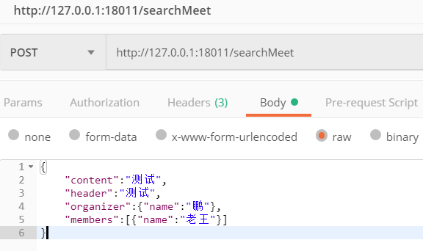

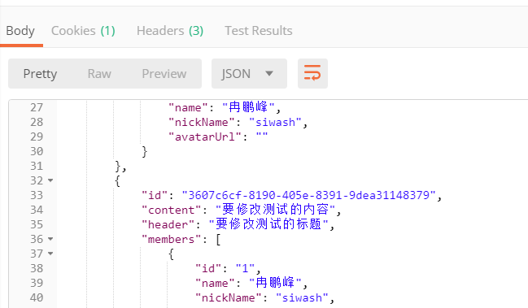

## 查询与用户有关的会议记录

URL：<http://127.0.0.1:18011/searchMeetByUser>

请求类型：POST

参数：

{

"id":"1", -

"name":"冉鹏峰" -

}

以上参数二选一

返回报文：

{

"statusCode": "200",

"data": [

{

"id": "1",

"content": "测试",

"header": "测试",

"members": [

{

"id": "1",

"name": "冉鹏峰",

"nickName": "siwash",

"avatarUrl": ""

},

{

"id": "3",

"name": "老王",

"nickName": "king",

"avatarUrl": null

}

],

"picture": null,

"date": null,

"updateTime": "2019-01-17T16:48:08.000+0000",

"organizer": {

"id": "1",

"name": "冉鹏峰",

"nickName": "siwash",

"avatarUrl": ""

}

}

],

"picture": null,

"date": "2019-01-18T06:47:27.000+0000",

"updateTime": "2019-01-18T06:47:27.000+0000",

"organizer": {

"id": "1",

"name": "冉鹏峰",

"nickName": "siwash",

"avatarUrl": ""

}

}

]

}

示例：

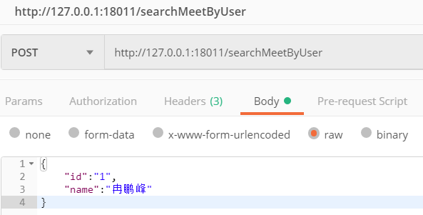

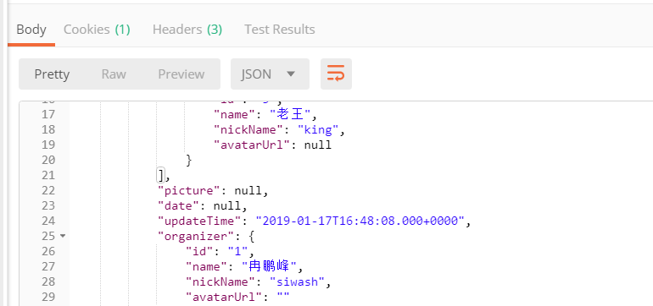

## 录入用户

URL: <http://127.0.0.1:18011/registerUser>

请求方式：POST

参数：

{

"name":"冉鹏峰", *

"avatarUrl":"https://wx.qlogo.cn/mmopen/vi_32/NibcydITBWLLWmTm5MmfkJ8T8xxBDsicBG9ODeKKsMjO2yG9hUoxbldfXhQoXIr8F2kc5ue7ZG9QibOic8ncwdfALQ/132", *

"nickName":"siwash" *

}

说明：avatarUrl和nickName在小程序中通过getuserinfo方式获取

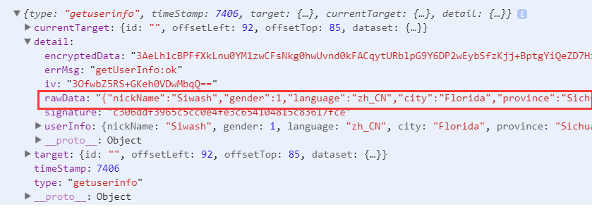

返回报文：

{

"statusCode": "200",

"data": {

"id": "62291ab6-2ac3-45ad-8a4f-1ffc9711c5ea",

"name": "冉鹏峰",

"nickName": "siwash",

"avatarUrl": "https://wx.qlogo.cn/mmopen/vi_32/NibcydITBWLLWmTm5MmfkJ8T8xxBDsicBG9ODeKKsMjO2yG9hUoxbldfXhQoXIr8F2kc5ue7ZG9QibOic8ncwdfALQ/132"

}

}

示例：

