# Dev_Setup

Setup Development Environment

#Assignment: Setting Up Your Developer Environment

#Objective: This assignment aims to familiarize you with the tools and configurations necessary to set up an efficient developer environment for software engineering projects. Completing this assignment will give you the skills required to set up a robust and productive workspace conducive to coding, debugging, version control, and collaboration.

#Tasks:

1. Select Your Operating System (OS): Choose an operating system that best suits your preferences and project requirements. Download and Install Windows 11. <https://www.microsoft.com/software-download/windows11>

**Downloading Windows 11**

Visit the [Windows 11 download page.](https://www.microsoft.com/software-download/windows11)

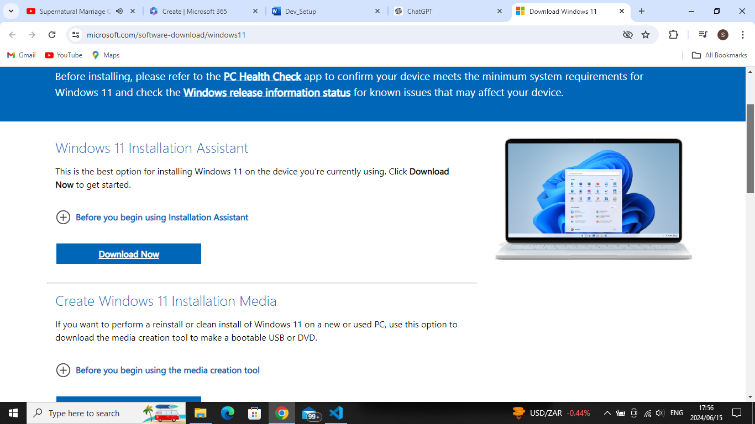

The file will download in your downloaded files. Got to it and double click

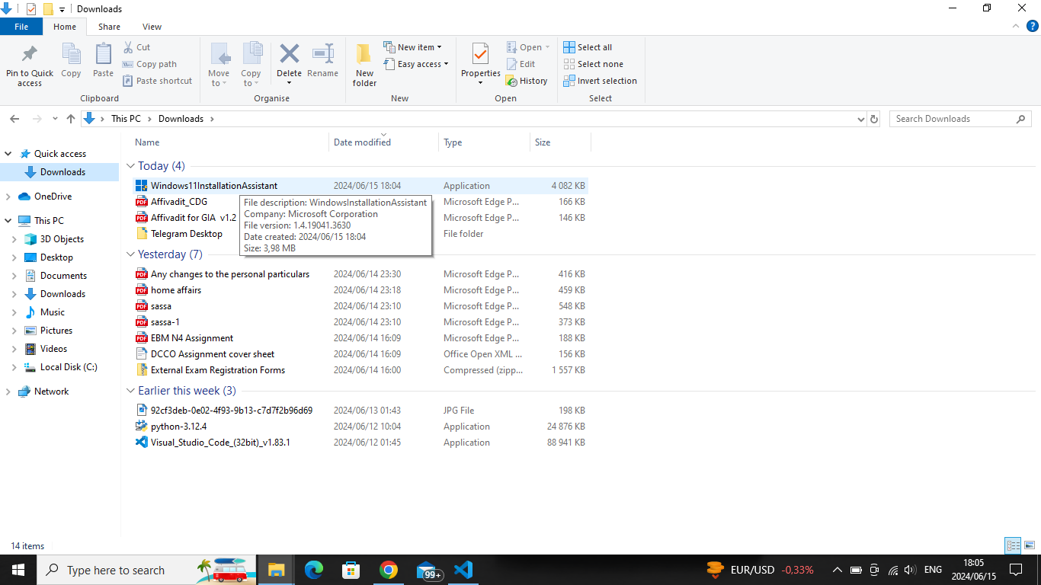

The Pc will prompt that “do you want this app to make changes to this pc” click **YES**

Applicable notice and license terms clicks **ACCEPT, click next**

Select language and edition, click use the recommended options for this PC**, click next**

Chose which media to use**, click next**

Select **USB flash drive**

Note : the USB may not show immediately , if you also face this issue click refresh drive list

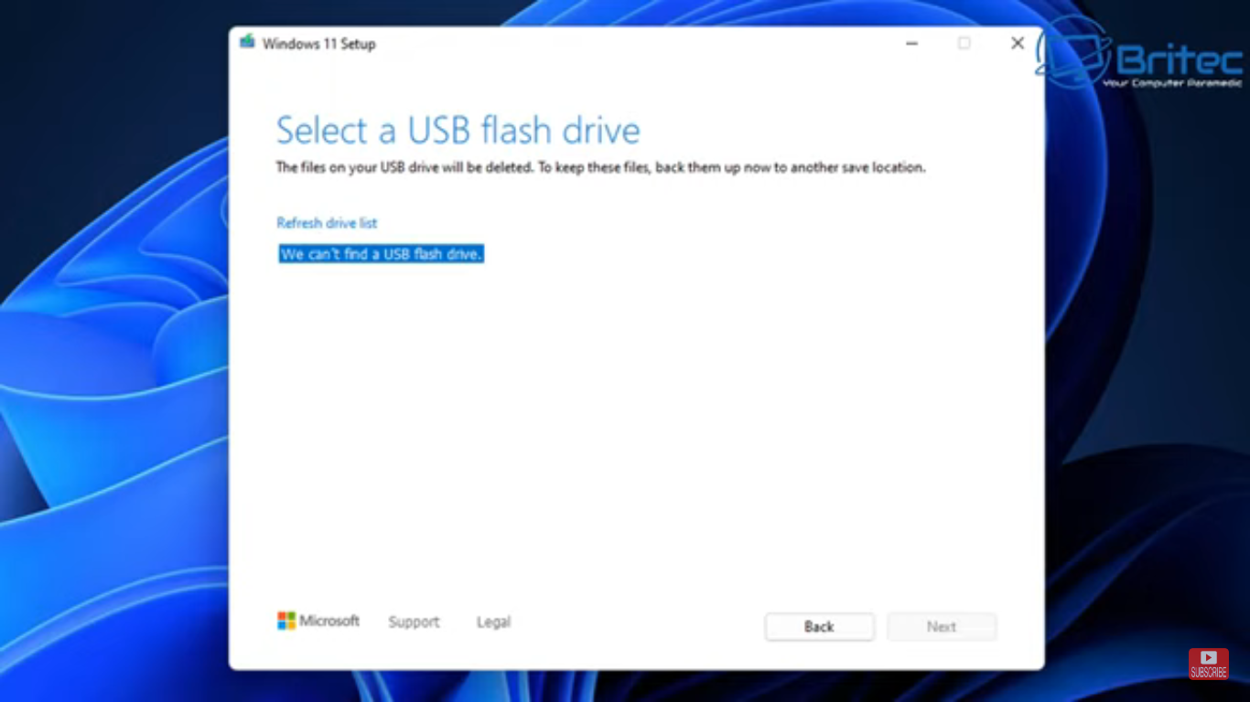 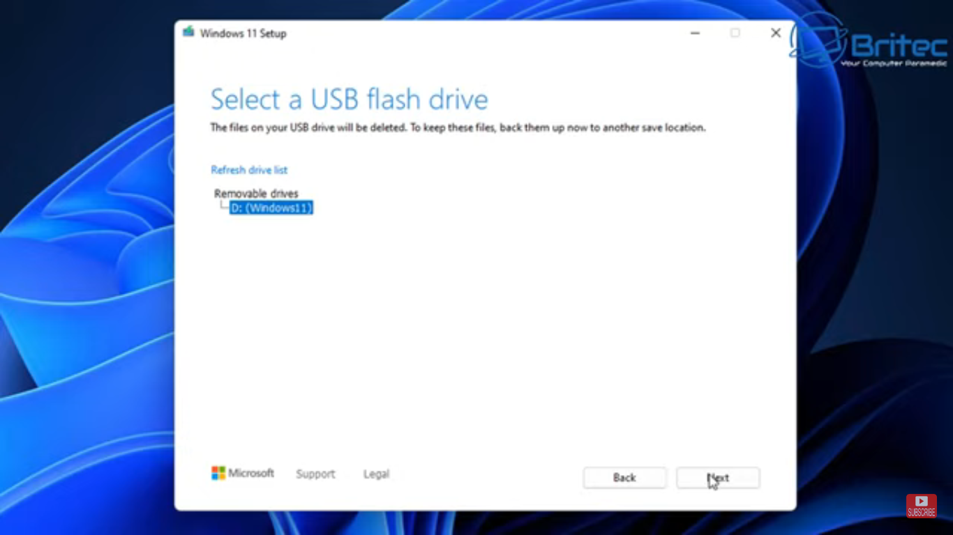

Select the USB D:/ windows 11 prompt

You will see, Downloading Windows 11...., Verifying your download, Creating Windows 11 media

Your USB flash drive is ready, **click FINISH**.

You will need to boot the USB system, once booted click F10 and its ready to be installed

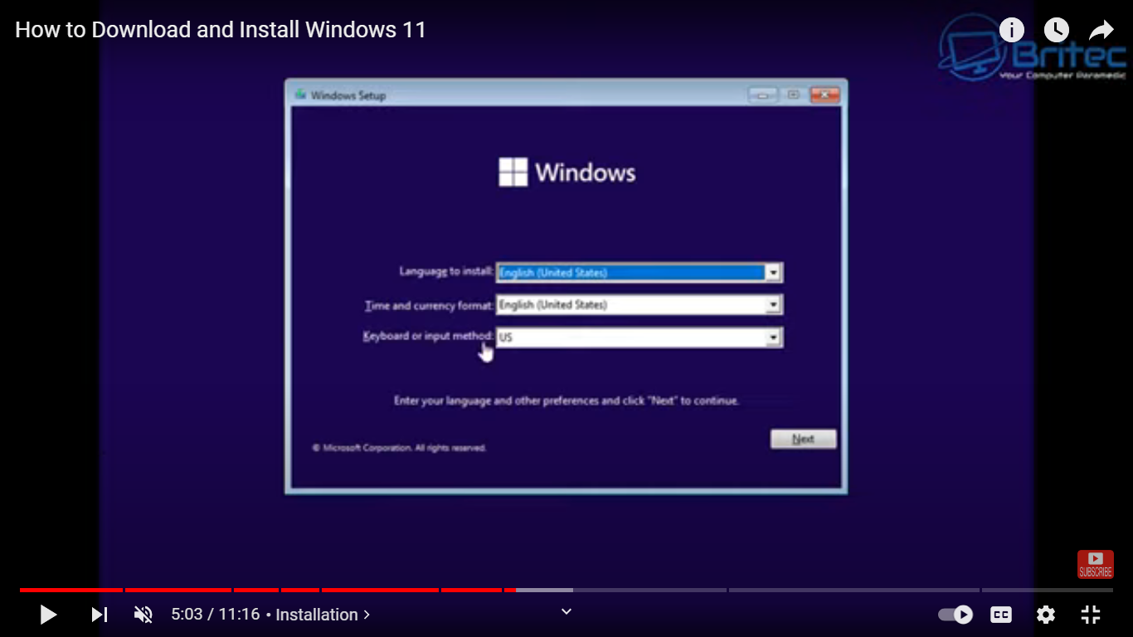

**Installing Windows 11**

A windows page will show **click Next**

And the click **install now** .

You will see Activate windows, type to select the windows version you want to download then, **click next**

**Note :** if it does not run. Cancel and do a windows health check first and redo the steps till now

You will then see the Applicable notice and license terms, C**heck the I accept box, click next**

**Select custom install windows only (advanced)**

You will se Where so you want to install windows , **select the location, click next.**

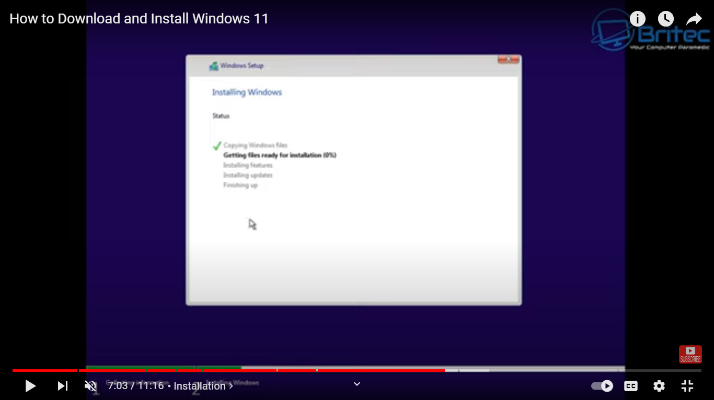

When it’s done you will then be moved to setting up your windows 11

1. Install a Text Editor or Integrated Development Environment (IDE): Select and install a text editor or IDE suitable for your programming languages and workflow. Download and Install Visual Studio Code. <https://code.visualstudio.com/Download>

On the download page, there is options for different operating systems. Click on the download link for your operating system (Windows, macOS, or Linux). I’m using windows as my operating system so i selected Windows

The download starts automatically, then **double-click the installer file.**

The licensing prompt will appear, **click on I agree.** **Then next**

You will land on the select destination page, **just click next**

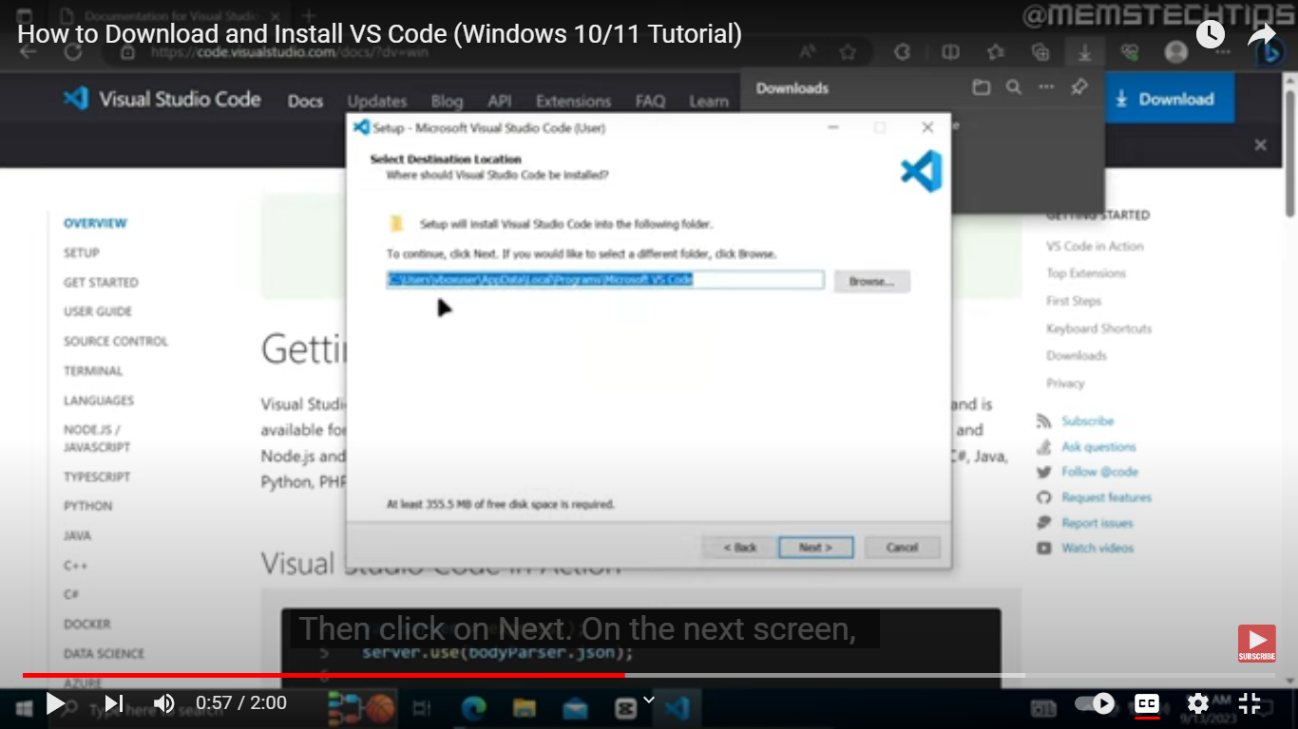

You will land on the start menu folder page, click next

The you will land on the select additional tools. Check all the boxes and click nex

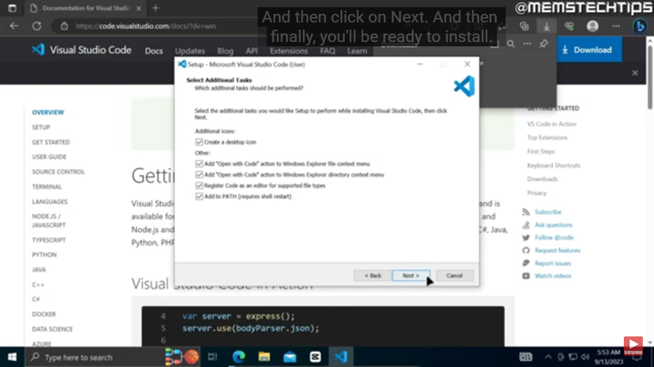

Finally, it will be ready to install. **Click install.** Then **finished**

1. Set Up Version Control System: Install Git and configure it on your local machine. Create a GitHub account for hosting your repositories. Initialize a Git repository for your project and make your first commit. <https://github.comll>

### **Configure Git**

Open a terminal Git Bash, run as administrator

Set Git username by running: git config --global user.name "Name"

Set Git email by running: git config --global user.email “[email@example.com”](mailto:your.email@example.com)

### **Create a GitHub Account**

Go to [GitHub](https://github.com/).com

Click on "Sign up" and fill in the required information to create your account.

Verify your email address by clicking on the link sent to your email.

### **Create a Repository on GitHub**

Log in to your GitHub account.

Click the "+" icon in the top right corner and select "New repository".

Fill in the repository name, description (optional), and choose between public or private.

Click "Create repository".

**Initialize a Git Repository**

Open a terminal.

Create directory : mkdir my_project

Go into the directory: cd my_project

Initialize a new Git repository: git init

git add .

git commit –m “add massage here”

git remote add origin (copy and paste repository link here

git push-u origin master

1. Install Necessary Programming Languages and Runtimes: Instal Python from [http://wwww.python.org](http://wwww.python.org/) programming language required for your project and install their respective compilers, interpreters, or runtimes. Ensure you have the necessary tools to build and execute your code.

### Download Python, Open the web browser and go to the [Python download page](https://www.python.org/downloads/).

### Click on the download link for the latest stable version of Python suitable for your operating system.

### **install Python**

Run the downloaded Python installer.

**Important:** Check the box that says, "Add Python to PATH" before clicking "Install Now".

Click "Install Now" to begin the installation process.

Optional features, **check all boxes, then next**

Advanced option**, click on install python**

**Click on install now**

1. Install Package Managers: If applicable, install package managers like pip (Python).

Open git bash and insert the following command prompts

python get-pip.py

Verify that pip is installed by running

pip –version

python –m pip install virtualenv

1. Configure a Database (MySQL): Download and install MySQL database. <https://dev.mysql.com/downloads/windows/installer/5.7.html>

Select and download your preferred version.

fter selecting a version, you are provided with the option of signing up for a MySQL Community account. If you are not interested, select the ***No thanks, just start my download***

accepting the Oracle license agreement terms

the first screen you encounter allows you to define which MySQL products are going to be installed. select the **Server Only** option and click **Next**.

Ready to start the installation process in earnest. Click **Execute** to begin the installation process.

The MySQL Server 8.0.19 is now ready to be configured. Initiate the process by clicking **Next**.

**1. High Availability** selected the classic, single server option.

**2. Type and Networking** *Development Computer*

he default setting is port number 3306 and can be changed to suit your needs. By checking the *Show Advanced and Logging Option* box, you can set additional logging options at a later stage. Click **Next** once you’ve selected the options you feel meet your requirements.

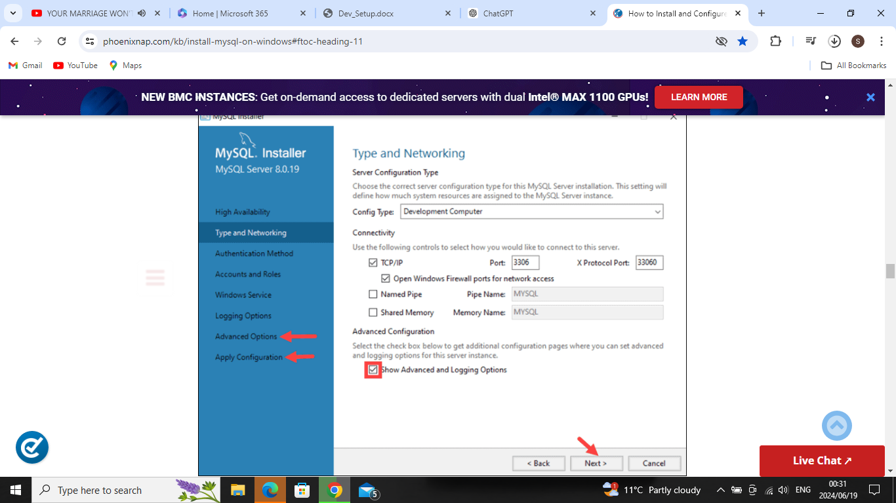

**3. Authentication Method Use Strong Password Authentication** option

### **4. Accounts and Roles** You are now prompted to enter a password for your MySQL root user.

### **5. Windows Service** check all boxes and standard system account must be selected.

### **6. Logging Options (Optional)**If you have selected the *Show Advanced Logging* option in the **Type and Networking** tabClick **Next** to reach the **Advanced Options** section

**7. Apply Configuration** An overview of the configurations steps appears on the screen. Click **Execute** to apply the configuration.

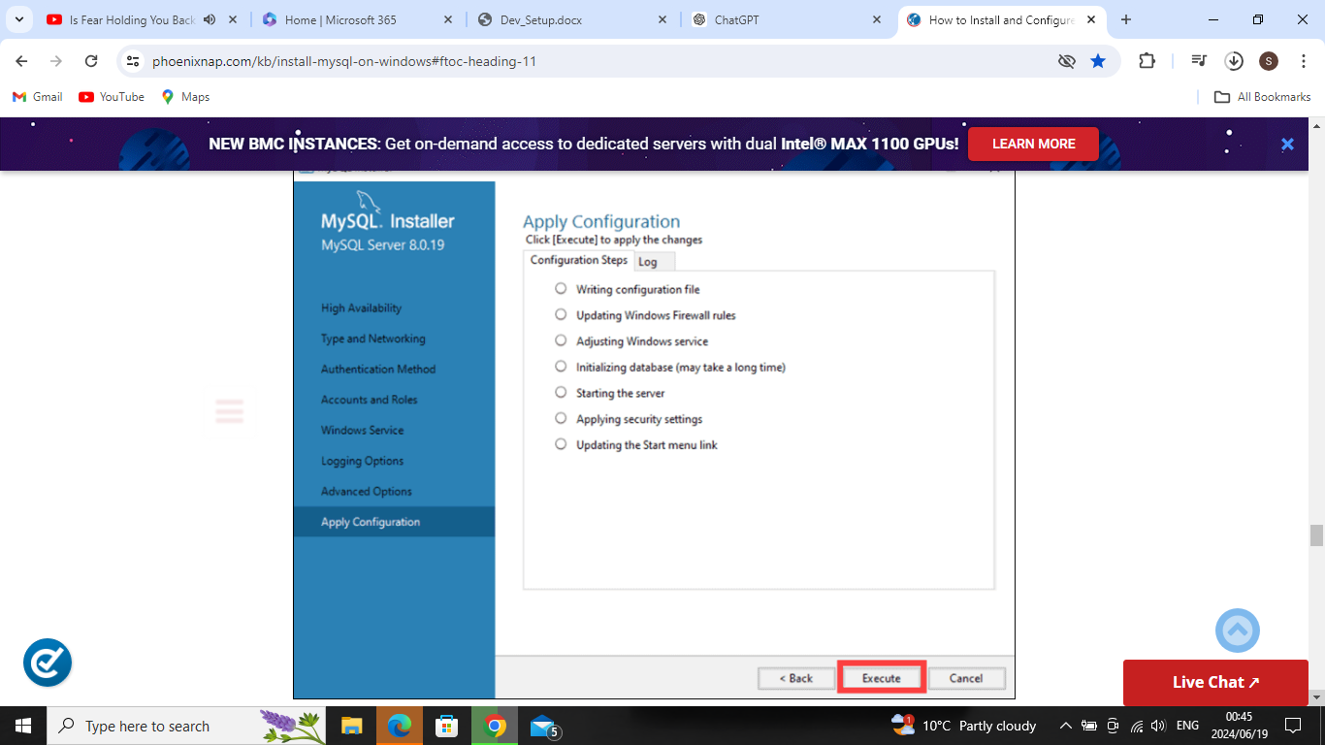

The system informs once the configuration process is completed. Select **Next** to continue the installation process.

After clicking **Next*,*** you are given the option to copy the installation process log to the Windows Clipboard.

Click **Finish** to complete the MySQL server installation

start the MySQL Server on Windows for the first time enter the following command in the Windows Command Prompt: "C:\Program Files\MySQL\MySQL Server 8.0\bin\mysqld" --console

1. Set Up Development Environments and Virtualization (Optional): Consider using virtualization tools like Docker or virtual machines to isolate project dependencies and ensure consistent environments across different machines.
2. Explore Extensions and Plugins: Explore available extensions, plugins, and add-ons for your chosen text editor or IDE to enhance functionality, such as syntax highlighting, linting, code formatting, and version control integration.
3. Document Your Setup: Create a comprehensive document outlining the steps you've taken to set up your developer environment. Include any configurations, customizations, or troubleshooting steps encountered during the process.

#Deliverables:

* Document detailing the setup process with step-by-step instructions and screenshots where necessary.
* A GitHub repository containing a sample project initialized with Git and any necessary configuration files (e.g., .gitignore).
* A reflection on the challenges faced during setup and strategies employed to overcome them.

#Submission: Submit your document and GitHub repository link through the designated platform or email to the instructor by the specified deadline.

#Evaluation Criteria:**

* Completeness and accuracy of setup documentation.
* Effectiveness of version control implementation.
* Appropriateness of tools selected for the project requirements.
* Clarity of reflection on challenges and solutions encountered.
* Adherence to submission guidelines and deadlines.

# SE-Assignment-5

Installation and Navigation of Visual Studio Code (VS Code) Instructions: Answer the following questions based on your understanding of the installation and navigation of Visual Studio Code (VS Code). Provide detailed explanations and examples where appropriate.

Questions:

1. Installation of VS Code:
   * Describe the steps to download and install Visual Studio Code on Windows 11 operating system. Include any prerequisites that might be needed.
2. First-time Setup:
   * After installing VS Code, what initial configurations and settings should be adjusted for an optimal coding environment? Mention any important settings or extensions.
3. User Interface Overview:
   * Explain the main components of the VS Code user interface. Identify and describe the purpose of the Activity Bar, Side Bar, Editor Group, and Status Bar.
4. Command Palette:
   * What is the Command Palette in VS Code, and how can it be accessed? Provide examples of common tasks that can be performed using the Command Palette.
5. Extensions in VS Code:
   * Discuss the role of extensions in VS Code. How can users find, install, and manage extensions? Provide examples of essential extensions for web development.
6. Integrated Terminal:
   * Describe how to open and use the integrated terminal in VS Code. What are the advantages of using the integrated terminal compared to an external terminal?
7. File and Folder Management:
   * Explain how to create, open, and manage files and folders in VS Code. How can users navigate between different files and directories efficiently?
8. Settings and Preferences:
   * Where can users find and customize settings in VS Code? Provide examples of how to change the theme, font size, and keybindings.
9. Debugging in VS Code:
   * Outline the steps to set up and start debugging a simple program in VS Code. What are some key debugging features available in VS Code?
10. Using Source Control:
    * How can users integrate Git with VS Code for version control? Describe the process of initializing a repository, making commits, and pushing changes to GitHub.

Submission Guidelines:

* Your answers should be well-structured, concise, and to the point.
* Provide screenshots or step-by-step instructions where applicable.
* Cite any references or sources you use in your answers.
* Submit your completed assignment by 1st July