SKATE Stream Deck Neo icons
A hand-designed icon set for SKATE and the Spotter voice agent. Each key has a unique, color-coded glyph. Files live in SKATE/streamdeck-neo-icons as both .svg (vector) and .png (288×288).

How a macro works
Each stance key pre-prompts Spotter into a coaching stance and opens the microphone in one press. You talk, Spotter listens in that stance, then responds. The two touch points just start and stop the mic. Every key is a Stream Deck Hotkey action using the modifier stack Ctrl + Alt + Shift plus the listed key. The Spotter page must be open and focused for the stance keys to fire.

Design system
- Format: SVG (vector) for crisp scaling, plus matching 288×288 PNGs.
- Look: white glyph on a color-coded rounded square, with a short label baked in.
- Color: each macro family has its own hue so keys are distinct at a glance.
- Brand: skate-mark and spotter reproduce the SKATE logo (A-frame on a skateboard).

Talk controls (Neo touch points)
Icon | Macro | What it does | Hotkey
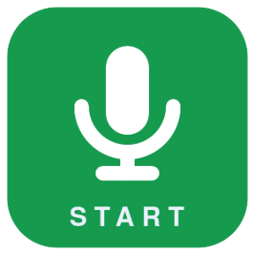 | Start talking | Open the mic in the current stance | Ctrl+Alt+Shift+Space
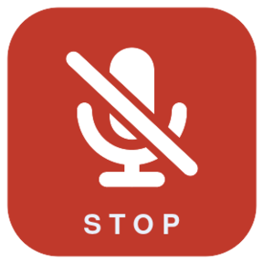 | Stop talking | Close the mic and send to Spotter | Ctrl+Alt+Shift+X

Spotter stances (Neo keys)
Icon | Macro | What it does | Hotkey
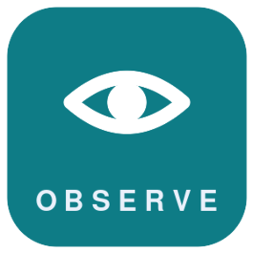 | Observe | Capture what people do, say, feel, and work around | Ctrl+Alt+Shift+O
 | Find Waste | Listen for delay, rework, handoffs, motion, waiting | Ctrl+Alt+Shift+W
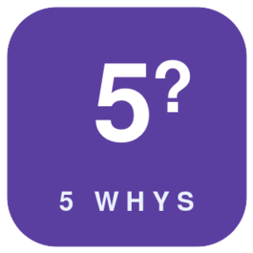 | 5 Whys | Drive a root-cause chain from the symptom | Ctrl+Alt+Shift+Y
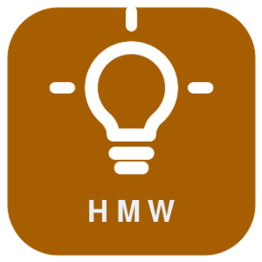 | How Might We | Reframe the pain into strong HMW prompts | Ctrl+Alt+Shift+H
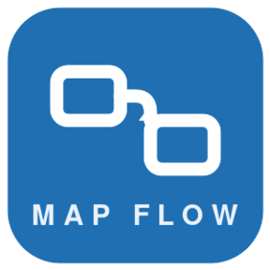 | Map Flow | Turn the spoken flow into trigger, handoffs, queues | Ctrl+Alt+Shift+M
 | Frame Challenge | Sharpen a raw pain into a clear problem statement | Ctrl+Alt+Shift+F
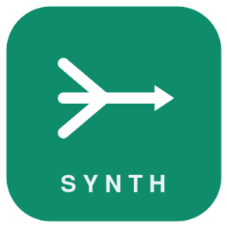 | Synthesize | Connect patterns across the session's notes | Ctrl+Alt+Shift+Z
 | Executive Readout | Turn the moment into an exec-ready insight + next step | Ctrl+Alt+Shift+R
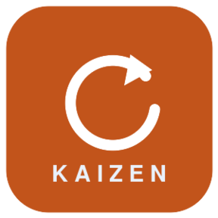 | Kaizen | Current state, waste, quick wins, next experiment | Ctrl+Alt+Shift+K
 | Next Experiment | Smallest useful test, owner, metric, learning goal | Ctrl+Alt+Shift+T
 | Ask Spotter | Free question to the coach | Ctrl+Alt+Shift+Q

Navigation / brand
Icon | Macro | What it does | Hotkey
 | Open Spotter | Jump to the Spotter page | Ctrl+Alt+Shift+P
 | About SKATE | Brand mark / open About | Ctrl+Alt+Shift+A
 | Library | Open the note library | Ctrl+Alt+Shift+L
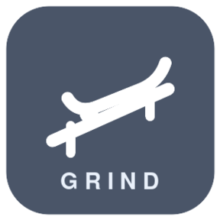 | GRIND | Open the GRIND synthesis view | Ctrl+Alt+Shift+G
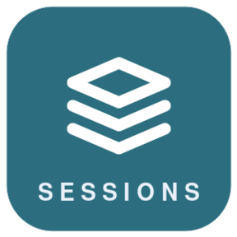 | Sessions | Open Sessions | Ctrl+Alt+Shift+S
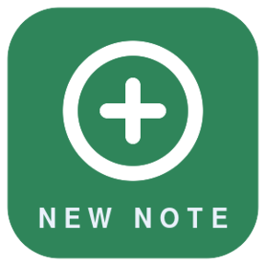 | New Note | Create a new note | Ctrl+Alt+Shift+N

Setup in Stream Deck
- Add a Hotkey action to each key and record its combination (Ctrl + Alt + Shift + the key).
- Set the key image to the matching .png (or .svg) in this folder.
- Open SKATE → Spotter (Ctrl+Alt+Shift+P) and keep that window focused during the workshop.
- Select a Session in the Session memory field so Synthesize and Readout can use its notes.
- In the room: tap a stance key (mic opens) → talk → tap Stop talking → Spotter responds.

Editing
The icons are plain SVG text files — open one and tweak paths, colors, or labels directly. To re-export PNGs, run tools/svg_to_png.py. No build step or Python dependency is required to use the SVGs themselves.

Stance pre-prompts — what each key tells Spotter
Two layers shape every Spotter answer. First, a fixed base persona that is always on: Spotter, Aberdeen Advisors’ facilitation co-pilot, fluent in Lean Six Sigma (DMAIC, the DOWNTIME wastes, 5 Whys, VA/NVA), Kaizen events, Design Thinking / HCD, DFSS, and AI & automation — operator-grade, bottom line first. Second, the stance pre-prompt below, injected the instant you press the key, which points that persona at one specific job. You then talk, and Spotter responds in that stance.
The “Pre-prompt” column is the exact text each button sends (verbatim from the app). “Captures” is the object type the stance tags its note with. Stances marked with session use read the active Session’s notes when one is selected.
Stance | Hotkey | Captures | Pre-prompt (verbatim)
Observe | Ctrl+Alt+Shift+O | observation | Wake up as an IDEO-style workshop observer. Listen for what people do, say, feel, avoid, repeat, and work around. Use session notes when available.
Find Waste | Ctrl+Alt+Shift+W | pain | Wake up as a Lean coach. Listen for process waste, delay, defects, overprocessing, motion, inventory, waiting, handoff friction, and avoidable cognitive load.
5 Whys | Ctrl+Alt+Shift+Y | insight | Wake up as a root-cause coach. Facilitate a concise 5 Whys chain using the capture and session notes. Separate observed symptoms from plausible root causes.
How Might We | Ctrl+Alt+Shift+H | question | Wake up as a design thinking facilitator. Convert the capture and relevant session notes into strong How Might We prompts that are broad enough for ideation and specific enough for action.
Map Flow (Process Map) | Ctrl+Alt+Shift+M | process | Wake up as a process improvement coach. Map the flow implied by the capture and session notes: trigger, handoffs, queues, rework loops, systems, decisions, and outputs.
Frame Challenge | Ctrl+Alt+Shift+F | pain | Wake up as a design thinking problem-framing coach. Turn the capture and relevant session notes into a clear challenge, affected users, constraints, evidence, and assumptions.
Synthesize Notes | Ctrl+Alt+Shift+Z | insight | Wake up as a workshop synthesis partner. Read the applicable session notes, connect patterns, identify tensions, and summarize what the team should notice now.
Executive Readout | Ctrl+Alt+Shift+R | insight | Wake up as an executive synthesis coach. Turn the capture and applicable session notes into executive-ready insight, recommendation, decision needed, and action path.
Kaizen Event | Ctrl+Alt+Shift+K | process | Wake up as a Kaizen event coach. Look for current state, waste, standard work gaps, quick wins, owners, daily management signals, and the next experiment.
Next Experiment | Ctrl+Alt+Shift+T | recommendation | Wake up as a practical experimentation coach. Turn the capture and notes into the smallest useful test, owner, metric, learning goal, and next decision.
Ask Spotter | Ctrl+Alt+Shift+Q | observation | Wake up as Spotter, a workshop coach using IDEO-style design thinking, Kaizen events, Lean process improvement, HFE, and transformation consulting. Use notes if a session is active.
Keys without a pre-prompt (action only). The remaining eight keys carry no pre-prompt — they perform an action rather than set a coaching stance:
- Start talking (Ctrl+Alt+Shift+Space) and Stop talking (Ctrl+Alt+Shift+X) — open and close the mic in the current stance; they do not change the stance.
- Library (L), New Note (N), GRIND (G), Spotter (P), Sessions (S), and About (A) — navigation only; each just opens that page (all with the Ctrl+Alt+Shift modifier).

