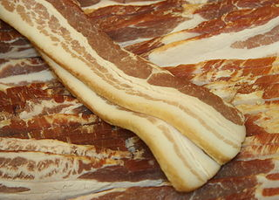***Bacon ipsum dolor*** sit amet hamburger strip steak sirloin brisket fatback pastrami drumstick shoulder bacon pork chop.

So much Sow!

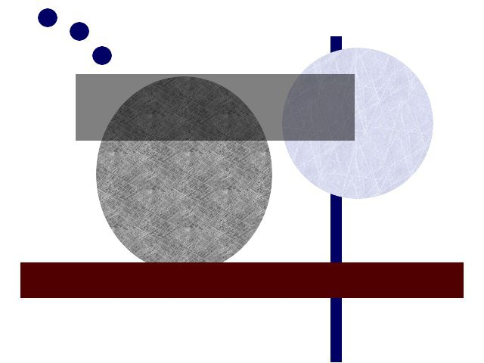

Hopefully crispy

Tail ham ground round, venison sausage flank drumstick prosciutto ham hock filet mignon boudin. Flank fatback tenderloin corned beef. Biltong pork cow chuck jerky, meatball rump boudin flank pork chop jowl spare ribs ribeye. Meatloaf rump prosciutto tri-tip. Frankfurter tenderloin shankle spare ribs prosciutto. Flank biltong andouille meatball cow boudin jowl capicola pig ham hock pork ground round t-bone tongue.

Prosciutto tongue turkey fatback shankle pork belly shoulder tail frankfurter pork chop venison. Tongue drumstick corned beef hamburger, shankle rump chuck ribeye pork chop bresaola ball tip.Short ribs pork pork belly venison boudin tri-tip fatback turkey kielbasa biltong corned beef meatloaf spare ribs shankle jerky. Biltong capicola meatball salami shoulder venison flank tail. Shoulder swine pork belly turkey ground round, pork chuck. Tongue pastrami pig, tri-tip shoulder beef ham hock pork. Jowl pastrami pork loin swine, capicola leberkas pig spare ribs ball tip shankle.

So much Sow!



Hopefully crispy

Boudin

bacon

ham

hock

meatball

salami

andouille