Bench notebook
Self-authored fixture. Paragraph before the table.
Sample | Volume (L)
Alpha | 1.25
Beta | 0.75
Total | 2.00
Paragraph after the table, before the workflow image.
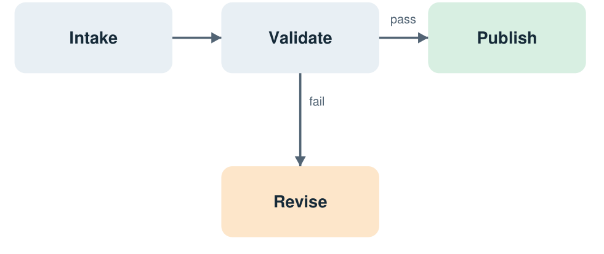
Paragraph after the image. Pass leads to Publish; fail leads to Revise.

A useful caveat
These are invented measurements, not a laboratory protocol. Keep 0.00 as a value.

