**DOCKER**

Docker is a platform for developing, shipping, and running applications in containers. Containers are lightweight, portable, and self-sufficient units that can run applications and their dependencies isolated from the host system.

**Steps to create docker container for nginx web server:**

**Step 1**(Connect EC2 Instances):

**Step 2**(Update EC2 Instances):

apt update -y

**Step 3**(Install Docker):

apt install docker.io -y

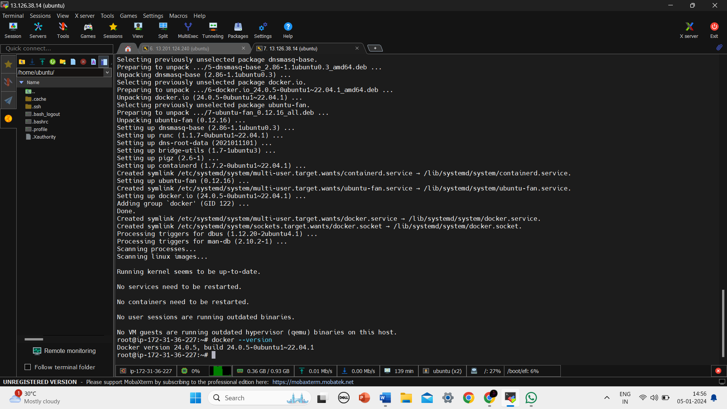

**Step 4**(Pull image from docker hub):

docker pull saravana2431/nginx:latest

docker images

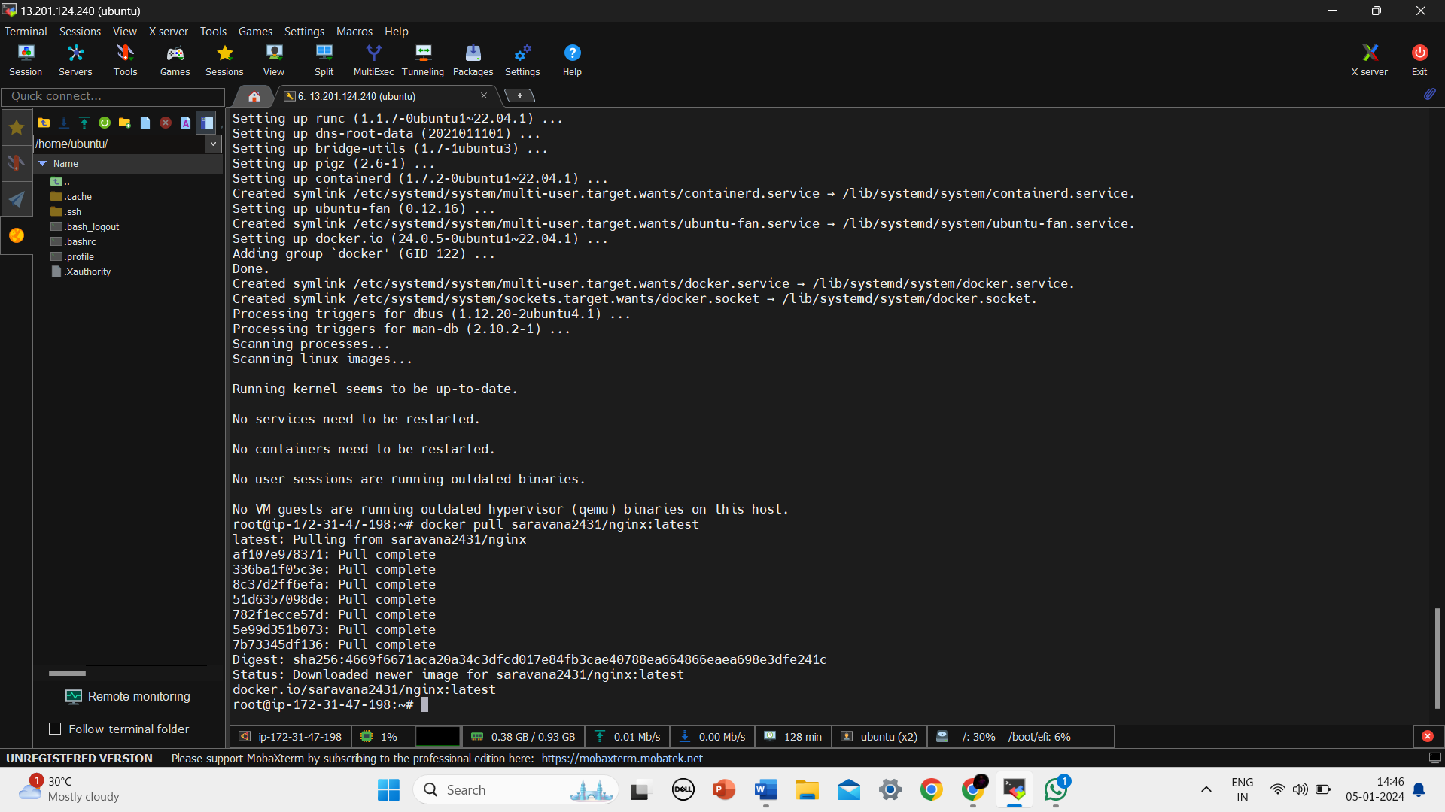

**Step 5**(Build docker Container):

docker run -itd --name container -p "8080:80" d453

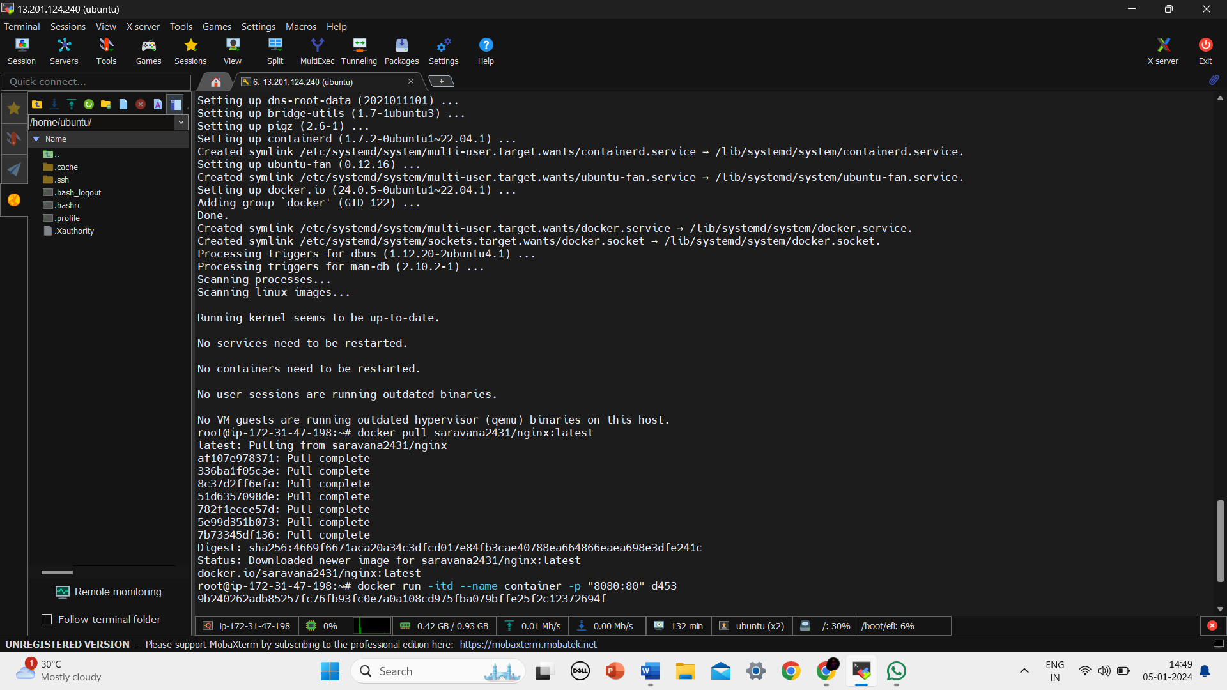

**Step 6**(Update Container):

docker exec -it container apt-get update

docker exec -it container apt-get install -y vim

**Step 7**(Change content):

docker exec -it 5b32 /bin/bash

vi usr/share/nginx/html/index.html

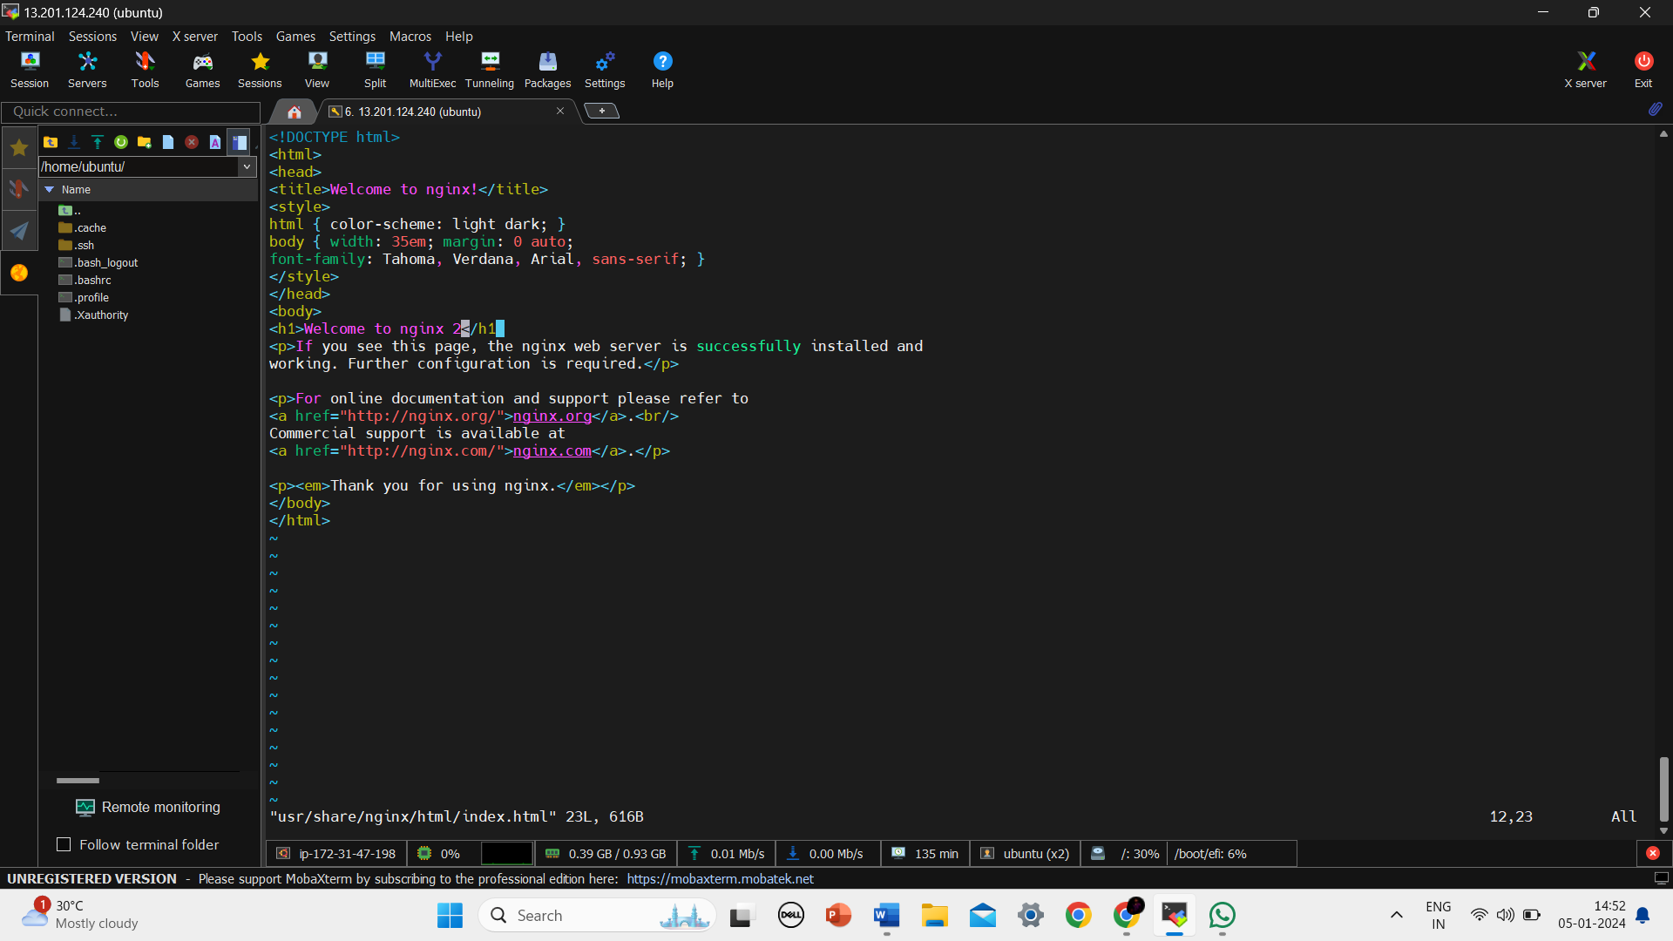

**Docker Hub:**

Docker Hub is a cloud-based registry service provided by Docker that allows you to store and share Docker images. It serves as a central repository for Docker users to publish and access container images.

