Agent: Vacuum Cleaner

Environment: Room

Sensor: Location sensor, Status sensor

Actuator: Wheels, Rotor pipe, Suction pipe

Action: Left, Right, Suck, No operation

Goal test: Both the rooms are clean

Path cost: 1 per action

Percepts: location and dirt: e.g. [B, Dirty]

There are eight possible states possible in vacuum cleaner problem:

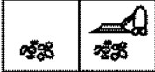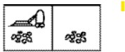[A, dirty] & [B, dirty] location: A [A, dirty] & [B, dirty] location: B

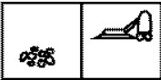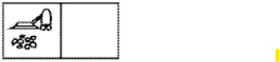[A, dirty] & [B, clean] location: A [A, dirty] & [B, clean] location: B

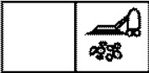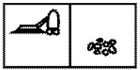[A, clean] & [B, dirty] location: A [A, clean] & [B, dirty] location: B

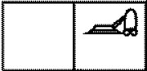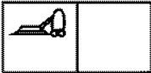[A, clean] & [B, clean] location: A [A, clean] & [B, clean] location: B

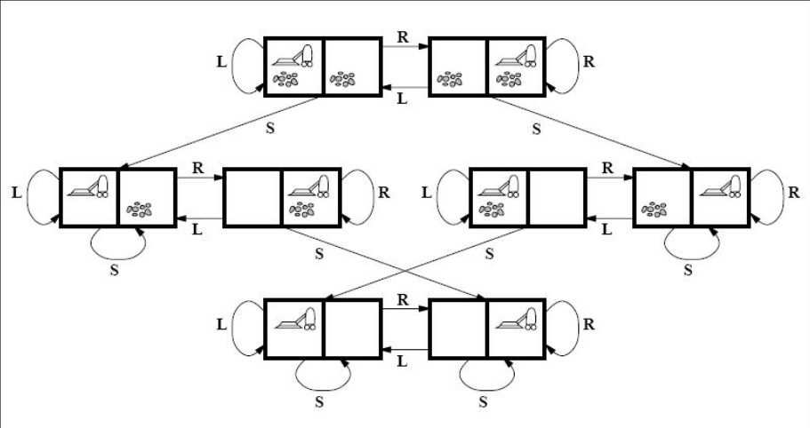State Space Graph: