Name: Siya Dhokane

Mis: 111903106

**Water jug problem**

You are given two jugs, a ‘j1’ litre one and a ‘j2’ litre one, a pump which has unlimited water which you can use to fill the jug, and the ground on which water may be poured. Neither jug has any measuring markings on it. How can you get exactly z litres of water?

X => amount of water in the j1-litre jug 0 ≤ x ≤ j1

y => amount of water in the j2-litre jug 0≤ y ≤ j2

initially x = 0, y = 0;

**Agent Function:**

|  |  |  |  |
| --- | --- | --- | --- |
| **Sr.No** | **Description of action taken** | **Condition** | **Final state** |
| 1. | Fill the j1-litre jug completely | If x<j1 | (j1,j2) |
| 2. | Fill the j2-litre jug completely | if y<j2 | (x,j2) |
| 3. | Empty the j1-litre jug | If x>0 | (0,y) |
| 4. | Empty the j2-litre jug | If y>0 | (x,0) |
| 5. | Pour some water from the j2-litre jug to fill the j1-litre jug | If (x+y)<j1+j2 | (j1, y-[j1-x]) |
| 6. | Pour some water from the j1-litre jug to fill the j2-litre jug | If (x+y)<j1+j2 | (x-[j2-y],j2) |
| 7. | Pour all water from j2-litre jug to the j1-litre jug | If (x+y)<j1 | (x+y,0) |
| 8. | Pour all water from the j1-litre jug to the j2-litre jug | if (x+y)<j2 | (0, x+y) |

Agent: Water-Jug Agent

Action: fill jug, empty jug, transfer from one jug to other

Goal test: z litres water in either of jugs

Path cost: 1 per action

Environment Type: single agent, partially observable, deterministic, static, Discrete,

PEAS Description:

1.Performance measure:

Correctness i.e. successfully reach goal state

Cost : +1 for each action i.e. fil jug, transfer water or empty jug

2.Environment:

Two jugs and a tap with unlimited water

3.Actuators:

The Pump, the robotics arm

4.Sensors:

Sensor to detect Water level

The agent has sensors to judge when when jug is empty and full.

Ex: If j1 = 4, j2 = 3 and z = 2

|  |  |  |
| --- | --- | --- |
| **4 litres jug** | **3 litres jug** | **Rule Applied(to get 2 litres)** |
| 0 | 0 | Initial State |
| 4 | 0 | 1.Fill 4 |
| 1 | 3 | 6. Pour 4 into 3 to fill |
| 1 | 0 | 4. Empty 3 |
| 0 | 1 | 8. Pour all of 4 into 3 |
| 4 | 1 | 1. Fill 4 |
| 2 | 3 | 6.Pour into 3 |

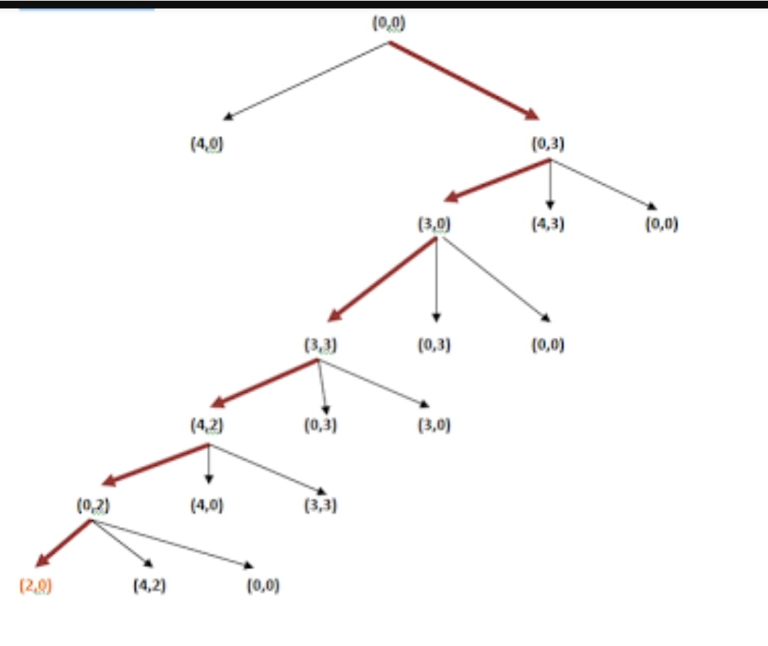State Space graph for this example: