BLOOD BANK MANAGEMENT SYSTEM

1. INTRODUCTION

Blood bank is a place where blood bag that is collected from blood donation events is stored in one place. The term “blood bank” refers to a division of a hospital laboratory where the storage of blood product occurs and where proper testing is performed to reduce the risk of transfusion related events.

1. PROBLEM STATEMENT

The percentage of people donating blood is increasing day by day due to awareness to donate blood for those needed. The blood received have to be managed thoroughly so that there will be no negative effect to the blood receiver once they received blood.

1. OBJECTIVE

The main objective of this application is to automate the complete operations of the blood bank. They need to manage the details of Blood Bank, Blood Group, Donor, Blood Stock. The purpose of the project is to build an application program to reduce the manual work for managing the Blood Bank, Blood Group, Record, Donor. This application helps to register all the donors, Blood collection details, blood issued details etc.

1. FUNCTIONAL REQUIREMENTS

* Receptionist registers donor
* Allows administrator to transact blood to hospitals
* Editing, adding, updating of Records of donors
* Checker tests the blood sample and validates it whether it is transfusable.
* View donor’s and statistics about no of female , male donors and also donations in a particular month
* Blood is checked and transfusable blood is stored in blood bank from where it is delivered to hospitals via the permission of administrator.
* Checker, receptionist, administrator are the staff that works at blood bank.
* Provides the searching facilities based on donor id

1. 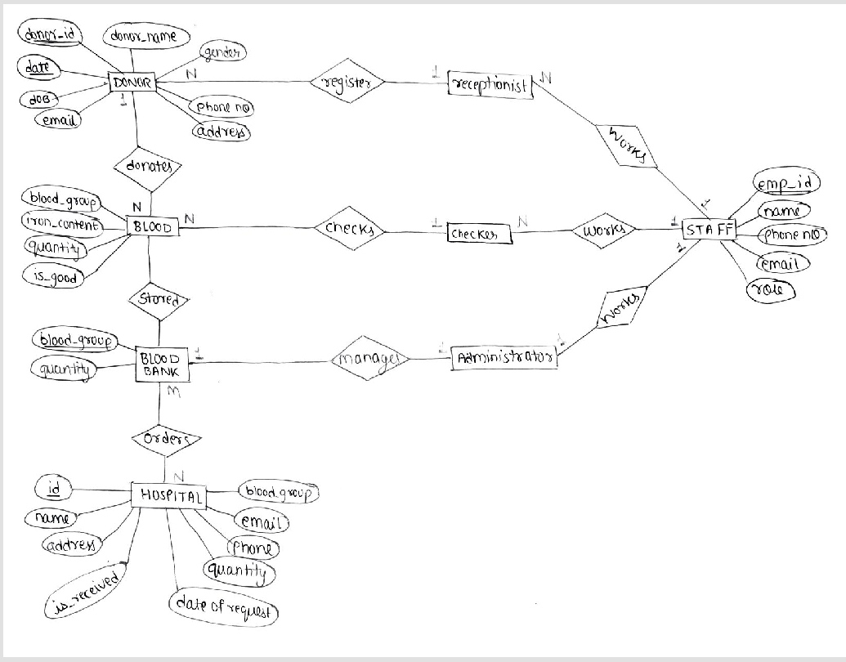ER DIAGRAM
2. 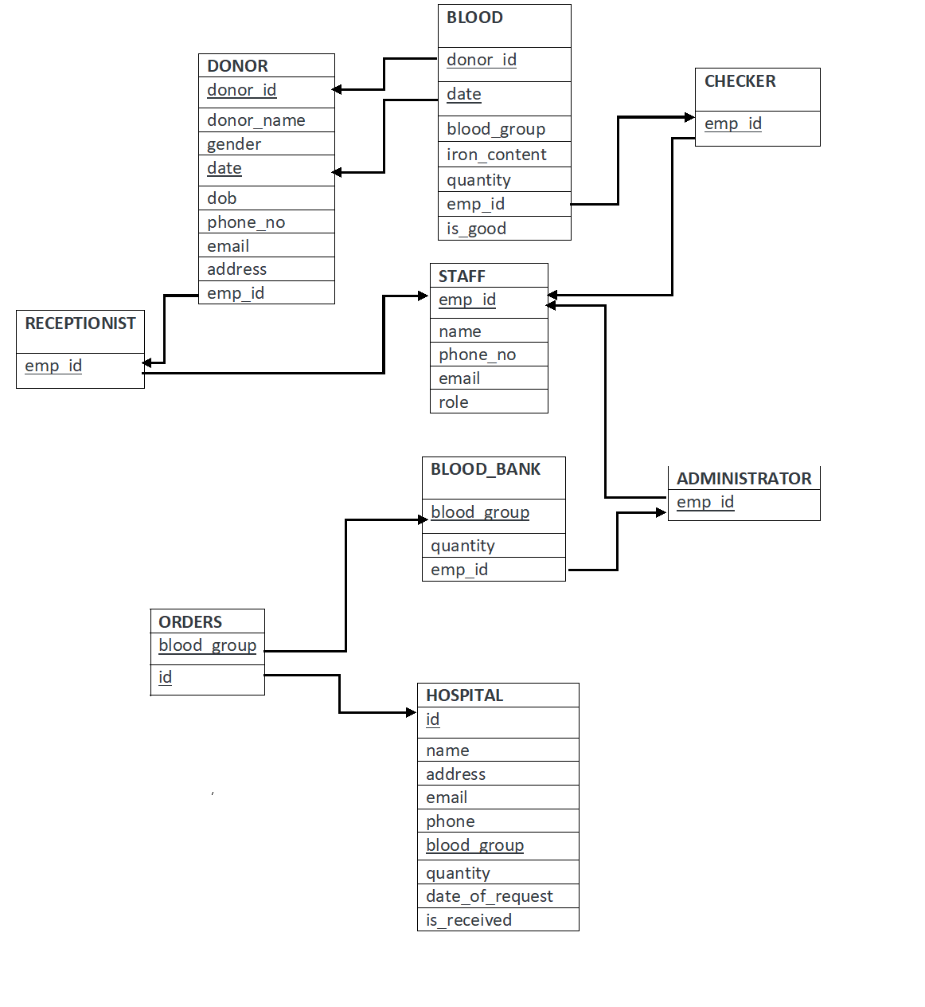RELATIONAL SCHEMAS
3. FUNCTIONAL DEPENDENCIES

Table: DONOR

{donor_id, date} → {donor_name,gender,dob,phone_no, email, address}

Table: BLOOD

donor_id → blood_group

{donor_id, date} → {iron_content, quantity, is_good}

Table: STAFF

emp_id → {name, phone_no, email, role}

table: BLOOD_BANK

blood_goup→quantity

table: HOSPITAL

id → {name, address, email, phone}

{id, blood_group}->{quantity, date_of_request, is_received}