Siyabonga Nemutavhanani

ST10495241
Rosebank International
Polokwane Campus
PRogramming 2B
POE Part 1

1. System Description
RaceDay is a REST-based event management system for organising and participating in running events. The system stores users, events, categories, event enrolments and race results in a SQL Server database.

2. User Roles

Participant
- Register and log in.
- View and update their profile.
- Browse events and categories.
- Enrol in an event.
- Cancel their own enrolment.
- View their results.

Organizer
- Register and log in.
- View and update their profile.
- Create, update and delete events.
- Create, update and delete categories.
- Assign categories to events.
- View event enrolments.
- Record and view race results.

3. Entity Relationship Diagram (ERD)
The ERD contains six entities: Users, Events, Categories, EventCategories, Enrolments and Results. Primary keys, foreign keys and relationships are shown.

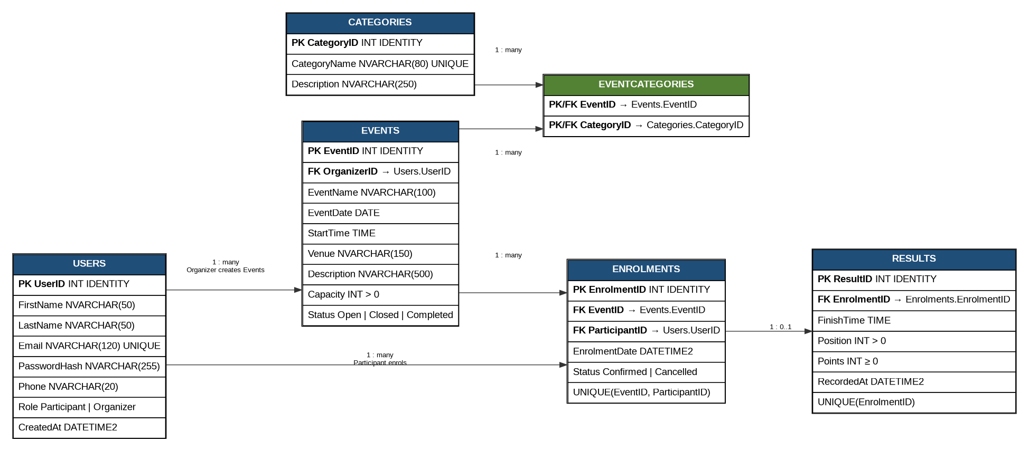

4. REST API Endpoint Plan
The API uses simple REST rules: GET reads data, POST creates data, PUT updates data and DELETE removes data. Participant and Organizer permissions are included.
HTTP Method | Route | Description | Role Required | Request / Response
POST | `/api/auth/register` | Creates a new RaceDay account. | Public | Request: `{ firstName, lastName, email, password, phone, role }`  Response: **201 Created** user created; **400** validation error; **409** email exists
POST | `/api/auth/login` | Authenticates a user and returns an access token. | Public | Request: `{ email, password }`  Response: **200 OK** token + user; **401** invalid credentials
GET | `/api/users/me` | Returns the logged-in user's profile. | Any logged-in user | Request: None  Response: **200 OK** profile; **401** unauthenticated
PUT | `/api/users/me` | Updates the logged-in user's profile. | Any logged-in user | Request: `{ firstName, lastName, phone }`  Response: **200 OK** updated profile; **400** invalid data; **401** unauthenticated
GET | `/api/events` | Lists available RaceDay events, optionally filtered by date/category. | Public | Request: None  Response: **200 OK** event list
POST | `/api/events` | Creates a new event. | Organizer | Request: `{ eventName, eventDate, startTime, venue, description, capacity, categoryIds }`  Response: **201 Created** event; **400** validation error; **403** forbidden
GET | `/api/events/{eventId}` | Gets details for one event, including categories. | Public | Request: None  Response: **200 OK** event; **404** event not found
PUT | `/api/events/{eventId}` | Updates an event owned by the organizer. | Organizer | Request: `{ eventName, eventDate, startTime, venue, description, capacity, status, categoryIds }`  Response: **200 OK** updated event; **403** forbidden; **404** not found
DELETE | `/api/events/{eventId}` | Removes an event. | Organizer | Request: None  Response: **204 No Content**; **403** forbidden; **404** not found
GET | `/api/categories` | Lists all event categories. | Public | Request: None  Response: **200 OK** category list
POST | `/api/categories` | Creates a category. | Organizer | Request: `{ categoryName, description }`  Response: **201 Created**; **400** validation error; **409** duplicate
PUT | `/api/categories/{categoryId}` | Updates a category. | Organizer | Request: `{ categoryName, description }`  Response: **200 OK**; **404** not found; **409** duplicate
DELETE | `/api/categories/{categoryId}` | Deletes a category not in use. | Organizer | Request: None  Response: **204 No Content**; **404** not found; **409** category in use
POST | `/api/events/{eventId}/categories` | Adds a category to an event. | Organizer | Request: `{ categoryId }`  Response: **201 Created** link; **404** event/category not found; **409** already linked
DELETE | `/api/events/{eventId}/categories/{categoryId}` | Removes a category from an event. | Organizer | Request: None  Response: **204 No Content**; **404** link not found
POST | `/api/events/{eventId}/enrolments` | Enrols the logged-in participant in an event. | Participant | Request: None or `{}`  Response: **201 Created** enrolment; **404** event not found; **409** already enrolled/full
GET | `/api/enrolments/me` | Lists the logged-in participant's enrolments. | Participant | Request: None  Response: **200 OK** enrolment list; **401** unauthenticated
DELETE | `/api/events/{eventId}/enrolments/me` | Cancels the participant's own enrolment. | Participant | Request: None  Response: **204 No Content**; **404** enrolment not found
GET | `/api/events/{eventId}/enrolments` | Views all participants enrolled in an event. | Organizer | Request: None  Response: **200 OK** enrolment list; **403** forbidden; **404** event not found
POST | `/api/events/{eventId}/results` | Records a result for an enrolled participant. | Organizer | Request: `{ enrolmentId, finishTime, position, points }`  Response: **201 Created** result; **400** invalid data; **404** enrolment not found; **409** result exists
GET | `/api/events/{eventId}/results` | Returns results for an event. | Participant / Organizer | Request: None  Response: **200 OK** results; **404** event not found
GET | `/api/results/me` | Returns results belonging to the logged-in participant. | Participant | Request: None  Response: **200 OK** result list; **401** unauthenticated

5. SQL Server Database Script
The SQL below is deliberately written in a simple beginner-friendly style. It creates six tables and adds the required sample data.
-- RaceDay Database
-- Beginner-friendly SQL Server script
-- Run this script once on a clean SQL Server instance.

CREATE DATABASE RaceDayDB;

USE RaceDayDB;

-- 1. Users
CREATE TABLE Users
(
UserID INT IDENTITY(1,1) PRIMARY KEY,
FirstName VARCHAR(50) NOT NULL,
LastName VARCHAR(50) NOT NULL,
Email VARCHAR(100) NOT NULL UNIQUE,
PasswordHash VARCHAR(255) NOT NULL,
Phone VARCHAR(20),
Role VARCHAR(20) NOT NULL,
CreatedAt DATETIME DEFAULT GETDATE(),

CHECK (Role = 'Participant' OR Role = 'Organizer')
);

-- 2. Events
CREATE TABLE Events
(
EventID INT IDENTITY(1,1) PRIMARY KEY,
OrganizerID INT NOT NULL,
EventName VARCHAR(100) NOT NULL,
EventDate DATE NOT NULL,
StartTime TIME NOT NULL,
Venue VARCHAR(150) NOT NULL,
Description VARCHAR(500),
Capacity INT NOT NULL,
Status VARCHAR(20) DEFAULT 'Open',
CreatedAt DATETIME DEFAULT GETDATE(),

FOREIGN KEY (OrganizerID) REFERENCES Users(UserID),
CHECK (Capacity > 0),
CHECK (Status = 'Open' OR Status = 'Closed' OR Status = 'Completed')
);

-- 3. Categories
CREATE TABLE Categories
(
CategoryID INT IDENTITY(1,1) PRIMARY KEY,
CategoryName VARCHAR(80) NOT NULL UNIQUE,
Description VARCHAR(250)
);

-- 4. EventCategories
-- This table connects Events and Categories.
CREATE TABLE EventCategories
(
EventID INT NOT NULL,
CategoryID INT NOT NULL,

PRIMARY KEY (EventID, CategoryID),
FOREIGN KEY (EventID) REFERENCES Events(EventID),
FOREIGN KEY (CategoryID) REFERENCES Categories(CategoryID)
);

-- 5. Enrolments
CREATE TABLE Enrolments
(
EnrolmentID INT IDENTITY(1,1) PRIMARY KEY,
EventID INT NOT NULL,
ParticipantID INT NOT NULL,
EnrolmentDate DATETIME DEFAULT GETDATE(),
Status VARCHAR(20) DEFAULT 'Confirmed',

FOREIGN KEY (EventID) REFERENCES Events(EventID),
FOREIGN KEY (ParticipantID) REFERENCES Users(UserID),
UNIQUE (EventID, ParticipantID),
CHECK (Status = 'Confirmed' OR Status = 'Cancelled')
);

-- 6. Results
CREATE TABLE Results
(
ResultID INT IDENTITY(1,1) PRIMARY KEY,
EnrolmentID INT NOT NULL,
FinishTime TIME,
Position INT,
Points INT,
RecordedAt DATETIME DEFAULT GETDATE(),

FOREIGN KEY (EnrolmentID) REFERENCES Enrolments(EnrolmentID),
UNIQUE (EnrolmentID),
CHECK (Position IS NULL OR Position > 0),
CHECK (Points IS NULL OR Points >= 0)
);

-- Sample Users
-- The password values below are example hashes/text for database seed data.
INSERT INTO Users
(FirstName, LastName, Email, PasswordHash, Phone, Role)
VALUES
('Amanda', 'Mokoena', 'amanda@raceday.co.za', 'hash_amanda_123', '0712345678', 'Organizer'),
('Brian', 'Nkosi', 'brian@raceday.co.za', 'hash_brian_123', '0723456789', 'Organizer'),
('Siyabonga', 'Madiba', 'siya@example.com', 'hash_siya_123', '0734567890', 'Participant'),
('Lerato', 'Khumalo', 'lerato@example.com', 'hash_lerato_123', '0745678901', 'Participant');

-- Sample Categories
INSERT INTO Categories (CategoryName, Description)
VALUES
('5 km Fun Run', 'Short community running event'),
('10 km Road Race', 'Competitive 10 km race'),
('21 km Half Marathon', 'Long distance half marathon');

-- Sample Events
INSERT INTO Events
(OrganizerID, EventName, EventDate, StartTime, Venue, Description, Capacity, Status)
VALUES
(1, 'Kgapane Community Run', '2026-10-10', '07:00', 'Kgapane Stadium',
'Community fun run', 500, 'Open'),

(2, 'Polokwane Spring 10K', '2026-10-24', '06:30', 'Peter Mokaba Stadium',
'10 km road race', 750, 'Open'),

(1, 'Limpopo Half Marathon', '2026-11-15', '06:00', 'Polokwane Civic Centre',
'21 km half marathon', 1000, 'Open');

-- Connect events to categories
INSERT INTO EventCategories (EventID, CategoryID)
VALUES
(1, 1),
(2, 1),
(2, 2),
(3, 2),
(3, 3);

-- Sample Enrolments
INSERT INTO Enrolments (EventID, ParticipantID, Status)
VALUES
(1, 3, 'Confirmed'),
(2, 3, 'Confirmed'),
(2, 4, 'Confirmed'),
(3, 4, 'Confirmed');

-- Sample Results
INSERT INTO Results (EnrolmentID, FinishTime, Position, Points)
VALUES
(1, '00:28:42', 4, 80),
(2, '00:49:31', 8, 70);

-- Check that the data was added
SELECT * FROM Users;
SELECT * FROM Categories;
SELECT * FROM Events;
SELECT * FROM EventCategories;
SELECT * FROM Enrolments;
SELECT * FROM Results;

