Web development POEPART1

Website Project Proposal

WEDE5020

Siyamthanda Mkhatshwa

ST10495640

Group 2

# Table of contents:

Table of contents: 1

Organisation Overview (about us): 2

Website Goals and Objectives: 3

Current Analysis 4

Proposed Website Features and Functionality: 5

Design and User Experience: 7

Technical Requirements: 9

Timeline & Milestones: 10

Budget: 11

References: 12

# Organisation Overview (about us):

**Name:** BRIGHT FOUNDATION

**Slogan:** “Lighting the path to brighter futures.”

**History:** The BRIGHT FOUNDATION was established in South Africa to address the challenges faced by children from underprivileged families who show impressive academic ability but lack the resources and support to reach their full potential. The founder recognized that many learners, despite their potential, are held back by poverty, limited access to quality education resources and lack of mentorship.

Since its establishment, the foundation has partnered with schools, communities and local organisations to identify promising learners and provide them with scholarships, mentorship, educational resources, and holistic development programs , The foundation empowers young people to thrive academically, build confidence, and unlock opportunities for a brighter future.

**Mission Statement:** To provide educational opportunities, mentorship and holistic support to talented learners from disadvantaged backgrounds, enabling them to excel academically and build a brighter future for themselves and their communities.

**Vision Statement:** A South Africa where every children with the ability to excel has equal access to education, resources, and opportunities- regardless of their socio-economic background.

**Target Audience:**

Primary Beneficiaries: Learners from disadvantaged families in South Africa (underprivileged, living in low-income or rural communities) who demonstrate academic excellence or potential but lack financial or educational support.

Secondary Stakeholders:

* Schools and educators seeking to empower learners.
* Families who need support systems for their children’s education.
* Donors, Sponsors, and partners passionate about education and social improvement.
* Communities that benefit from empowered, educated youth.

# Website Goals and Objectives:

Specific Goals for the Website:

1. Increase Awareness of the foundation: educate the public about the mission, vision and programs of Bright Foundation. Share success stories to inspire support and build trust.

2. Attract and Engage potential Donors & Sponsors: provide clear donation options (once-off, monthly giving, corporate sponsorships). Encourage sponsorships of learners or programs.

3. Support Beneficiaries & Communities: provide easy access to scholarship application forms, mentorship sign-ups, and program information. Offer resources for learners (study tips, career guidance, bursary information…).

4. Build a Strong Volunteer & Partner Network: showcase opportunities for volunteers (mentorship, tutoring, events). Create a platform for collaboration with schools, NGOs and businesses.

5. Enhance Transparency & Credibility: share reports, updates, and impact statistics to show accountability. Highlight partnerships, achievements and testimonials.

Key Performance Indicators (KPIs):

**1. Website Awareness & Reach**

* Traffic growth: monthly website visitors.
* Number of returning visitors vs. new visitors.
* Engagement: average time spent on site.
* Bounce rate (are the visitors leaving quickly?)

**2. Donor & Sponsor Engagement**

* Number of donations made through the website.
* Amount of funds raised online.
* Number of corporate sponsors contacting via the website.

**3. Beneficiary Impact**

* Number of scholarship applications submitted online.
* Number of learners/ parents downloading resources.
* Engagement with mentorship/ tutoring sign-up forms.

**4. Community & Volunteer Growth**

* Number of volunteer sign-ups via website.
* Partnerships or collaborations initiated online.
* Newsletter/email list sign-ups.

**5. Transparency & Trust**

* Number of downloads/ views of reports (annual reports, impact reports).
* Social shares/ mentions of success stories.
* Visitor feedback through contact forms or surveys.

# Current Analysis

At present, the Bright Foundation has a limited online presence, which cause several challenges:

**1. Lack of Centralized Information**

* + Supporters, beneficiaries, and potential partners do not have a single hub where they can learn about the foundation’s mission, programs, and impact.
  + Information is often shared via word-of-mouth or basic flyers, limiting reach.

**2. Low Visibility and Awareness**

* + Without an active website, the foundation relies heavily on social media posts, which may not appear credible to all audiences (e.g., potential donors, schools, or community leaders).
  + This reduces opportunities for partnerships and sponsorships.

**3. Inefficient Communication**

* + Interested individuals must rely on email or phone for inquiries, which can be slow and discouraging.
  + There is no structured platform for FAQs, resources, or program details.

**4. No Showcasing of Impact**

* + Success stories, testimonials, and program highlights are not properly documented online.
  + As a result, it is harder to demonstrate the foundation’s value and attract new supporters.

**5. Limited Engagement Opportunities**

* + Without dedicated sections for volunteering, donations, or resources, it is difficult to encourage community participation.
  + Engagement is inconsistent and not strategically guided.

# Proposed Website Features and Functionality:

**HOMEPAGE:**

Brief introduction of the foundations, highlighting the mission & vision.

Buttons to donate now, apply for support, volunteer.

Footer with social media, newsletter signup.

**ABOUT US:**

About bright foundation.

Mission, vision and core values.

Teams and partners.

**PRODUCTS/SERVICES:**

***PROGRAMS & IMPACT:***

Scholarship program details.

Community outreach projects.

Impact stories (learner success/ testimonials).

*RESOURCES (for learners & families):*

Scholarship application forms (download/ submit online).

Study tips and career guidance.

Links to external bursaries or opportunities.

*NEWS & UPDATES:*

Blog Posts (education topics, foundation updates).

Events (fundraisers, workshops).

Media coverage.

**ENQUIRY:**

**GET INVOLVED:**

For Donors: easy donation options (once-off, monthly, corporate).

For Volunteers: sign-up form, mentorship / tutoring opportunities.

For Partners: collaboration opportunities (schools, NGOs, companies).

**CONTACT US:**

Contact form (general inquiries, support requests).

Email, phone, physical office.

Social media links.

# Design and User Experience:

**Colour Scheme:**

Denim/Stone Blue Palette

Primary: Denim Blue (#305F72) trust, reliability, professionalism.

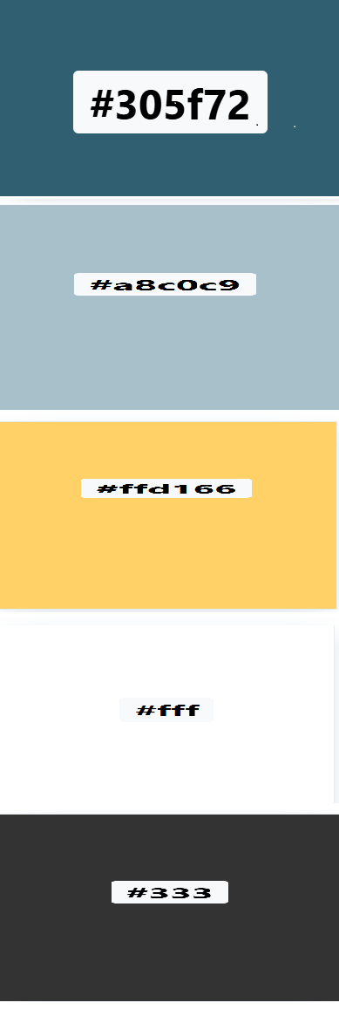Secondary: Light Stone Blue (#A8C0C9) calm, supportive tone.

Accent: Warm Yellow (#FFD166) ties into the “bright future” idea.

Neutral: White (#FFFFFF) and Charcoal (#333333) for text and background balance.

Giving a calm, professional yet uplifting feel.

**Typography (Font Choices & Hierarchy):**

Headings (H1, H2, H3):

* Font: Montserrat (Bold/Semi-Bold).
* Colour: Denim Blue (#305F72).
* Size hierarchy:
* H1: 36-40px
* H2: 28-32px
* H3:20-24px

Body Text (Paragraphs):

* Font: Open Sans (Regular/Light).
* Colour: Charcoal Grey (#333333).
* Size: 16-18px for readability.

Buttons & CTAs:

* Font: Montserrat Bold, all caps.
* Background: Warm Yellow (#ffd116).
* Text: Charcoal (#333333).

**Layout & Design:**

* Clean, simple and minimal.
* Plenty of whitespace for readability.
* Use full width hero images (kids learning, mentoring scenes).
* Consistent card/ grid layouts for programs, resources, and stories.
* Footer: simple with contact info, newsletter sign-ups, and social icons.

**User Experience Guidelines:**

**Navigation:** Simple top menu with 7 pages (home, about, programs, get involved, resources, news, contact).

**Mobile-friendly:** responsive design for smartphones &tablets.

**CTA (Call to Action) Placement:** “Get Involved ” button always visible (header + homepage hero section).

# Technical Requirements:

**Hosting & Domain**

Domain name: brightfoundation.org.za (non-profit identity, localised to South Africa).

Alt: brigthfoundation.org or .ngo if available.

Annual cost: +-R150-R300/year.

Hosting:

Shared Hosting (e.g Afrihost or HostAfrica).

Includes SSL certificate (important for security, donor trust).

Estimated cost: R100-R2500/month.

Email Setup:

[info@brightfoundation.org.za](mailto:info@brightfoundation.org.za)

included with most hosting packages.

**Programming Language &Frameworks**

Frontend:

HTML for the structure. CSS for styling and responsive design. JavaScript for interactivity and dynamic elements.

Backend:

Recommended for Non-Profits: WordPress CMS (open-source, easy content updates, plugins for donations and newsletters).

# Timeline & Milestones:

4-5 weeks

|  |  |  |
| --- | --- | --- |
| week | milestone | deliverables |
| Week 1 | Planning & design | Style guide (colours and typography). |
| Week 2 | Frontend development | Build homepage + core pages in html/css. |
| Week 3 | Content upload | Add mission, programs, images, stories, donations/volunteer forms. |
| Week 4 | testing | Cross-browser and mobile testing, fix bugs. |
| Week 5 | presentation | Make submission |

# Budget:

| **Item** | **Cost Estimate** |
| --- | --- |
| Domain Registration (.org.za) | R200 / year |
| Web Hosting (with SSL) | R2000 – R3000 / year |
| Design & Development. | R7,000 – R10,000 once-off |
| WordPress Plugins (donations, security, SEO) | R1,000 – R2,000 |
| Content Creation (basic graphics, copywriting) | R2,000 – R3,500 |
| Maintenance & Updates | R500 – R1000 / month |
| **Total First-Year Budget** | +- R12,000 – R17,000 |

# References: