WEB DEVELOPMENT (INTRODUCTION)
WEDE5020

Website Project Proposal
Sithole Agriculture & LiveStocks

Full Name: Njabulo Sithole
Student Number: [Student Number]
Group: Individual

The Independent Institute of Education (IIE)

Table of Contents

1. Organisation Overview
- Name: Sithole Agriculture & LiveStocks
Sithole Agriculture & LiveStocks is a livestock and crop-farming enterprise being established in KwaZulu-Natal, inspired by a childhood spent watching a grandfather's cattle and a grandmother's chickens and crops. It begins on one hectare with two cows, four goats and ten chickens, with plans to grow toward twenty hectares over time.
- Mission: To raise healthy, well-cared-for livestock and grow quality crops, combining traditional farming knowledge with modern best practice.
- Vision: To grow into a respected supplier of livestock and produce to the local community and other organisations across the region, creating local jobs as the farm expands.
Target Audience
- Local community members buying livestock and fresh produce directly.
- Other agricultural organisations and wholesalers seeking livestock and crops in larger volumes.

2. Website Goals and Objectives
Goals
- Introduce the farm and its story to the wider community as a new venture.
- Showcase the livestock breeds and crops on offer, and generate enquiries from buyers.
- Build early trust and credibility as the operation grows.
Key Performance Indicators (KPIs)
- Number of enquiries received through the contact form.
- Website visits and unique visitors.
- Click-through rate from the livestock and crops page to the enquiry form.

3. Current Website Analysis (if applicable)
Not applicable — Sithole Agriculture & LiveStocks is a new venture with no existing website. This proposal establishes the organisation's first web presence from the ground up, so there is no existing site to analyse.

4. Proposed Website Features and Functionality
- Homepage: a hero image of the land and livestock, a brief introduction and a clear call to action.
- About Us: the farm's founding story, mission and vision.
- Livestock & Crops: Nguni and Brahman cattle, goats, and traditional Zulu chickens alongside corn, potatoes and tomatoes.
- Enquiry Page: a form for individual and wholesale buyers to request livestock or produce.
- Contact Page: general farm location, phone number and email address.

5. Design and User Experience
- Colour Scheme: Earthy green with warm terracotta-brown accents on a cream background, reflecting the land and livestock at the heart of the business.
- Typography: A sturdy, grounded heading font paired with a clean, easy-to-read body font.
- Layout and Design: A warm, photography-led layout that puts the animals and land front and centre, fully responsive across devices.
User Experience Considerations
- Simple navigation with a prominent enquiry call to action for buyers and wholesalers.
- Fast-loading imagery optimised for mobile data.
Low-fidelity wireframe of the homepage layout and information hierarchy:
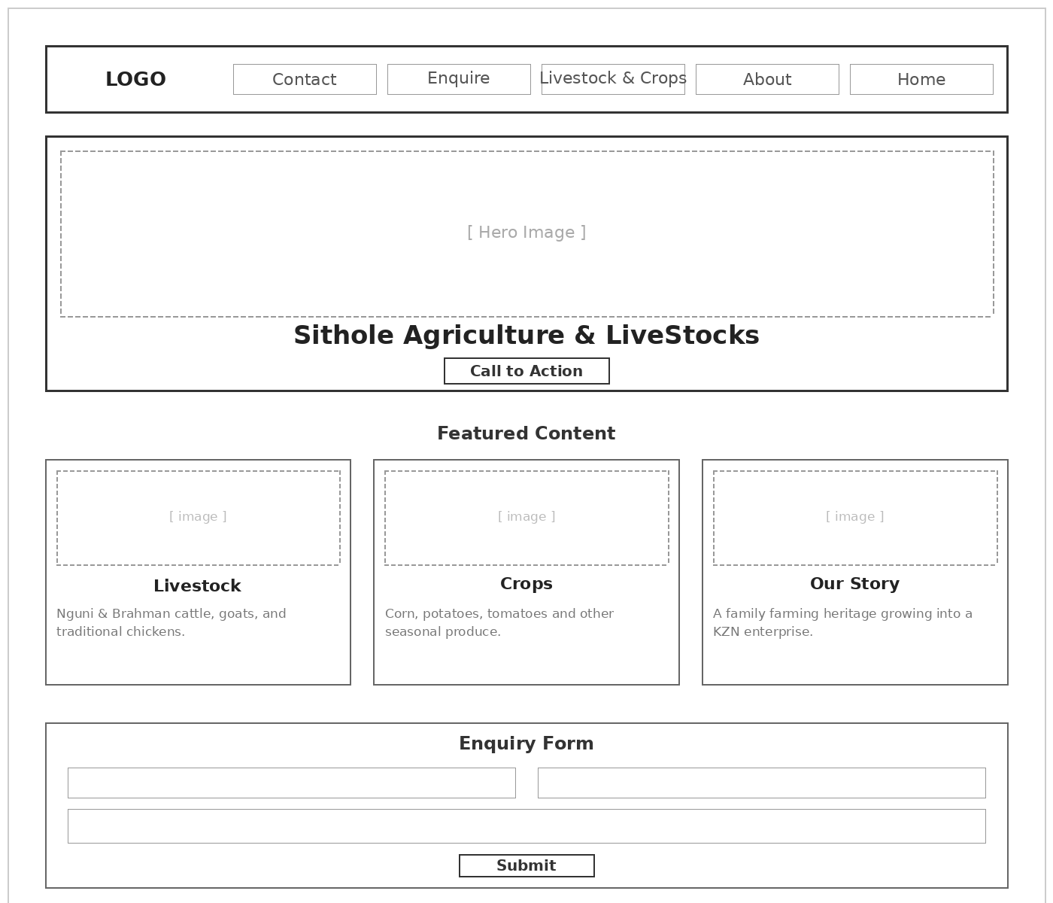
Figure 1: Low-fidelity homepage wireframe for Sithole Agriculture & LiveStocks.

6. Technical Requirements
- Built using HTML, CSS and JavaScript, in line with the module's Part 1–3 structure.
- A .co.za domain (e.g., sitholeagriculture.co.za) registered through a ZADNA-accredited registrar (ZADNA, n.d.).
- Free-tier or low-cost hosting appropriate for a start-up farming venture.

7. Timeline and Milestones
The timeline below follows the module's own three-part structure, aligning each phase with the subject's submission dates.
Phase | Milestone
Part 1 | Proposal approval, project planning and HTML structure for all five pages.
Part 2 | CSS styling applied — colour scheme, typography, layout and responsive design.
Part 3 | JavaScript functionality (enquiry form validation) added and the site tested and refined.

8. Budget
As this is a student project for a start-up venture rather than a live commercial build, the estimates below reflect realistic, low-cost options appropriate at this stage.
Item | Estimated Cost
Domain registration (.co.za) | R150 – R200 per year
Hosting | Free tier to start
Photography and content | Own time and effort — no direct cash cost
Placeholder / stock imagery | Free / Creative Commons resources

9. References
Van Eeden, Z., 2025. Nguni: the legacy of the land. Farmer's Weekly. [Online] Available at: https://www.farmersweekly.co.za/animals/cattle/nguni-the-legacy-of-the-land/ [Accessed 12 August 2026].
South Africa Online, n.d. Nguni Cattle Beef Production in South Africa. [Online] Available at: https://southafrica.co.za/nguni-cattle.html [Accessed 12 August 2026].
ZADNA, n.d. .za Domain Name Authority. [Online] Available at: https://www.zadna.org.za [Accessed 12 August 2026].

