

**National School of Business Management**

# CS107.3 Object-Oriented Programming with C#

Group Assignment 19.2

**Declaration**

|  |  |
| --- | --- |
| **Student ID** | **Student Name** |
| 18199 | A S D Silva |
| 18153 | J M D R H Wishwakeerthi |
| 18588 | K A G O A Perera |
| 18207 | G P S A Kriyanji |
| 10026478 | W K N S Vishvanath |

Date of Submission: ……........................................

**Table of Contents**

1. INTRODUCTION 3
2. ACKNOWLEDGEMENT 4
3. ER DIAGRAM 5
4. USE CASE DIAGRAM 6
5. SCREENSHOTS OF ALL PAGES 7
6. DISCUSSION 25
7. CONCLUSION 25
8. REFERENCES 26

# 01. INTRODUCTION

Our task is to build Develop software for a manual system using .Net framework (C#). So, we created software for our BIT CODE Company. According to their requirements, we developed software for their manuals recording. Company can use this software after storing the C # web application software on their machines. After storing Software firstly need to register to the Application, to do that we gave login and registration facilities to this software. It gives high-security defense for the data & record on application. An employee of the company can access the application after creating an account.

Our Employee Management System is crucial for smooth running of any organization having substantial number of employees. It’s a useful tool for human resource department that allows them to view details of any employee working in the organization. Employee management system is made with C#.NET using Visual Studio 2019. That system helps to add, edit record and delete any employee details of an organization. User can register and login to view all entries of the employee.

# 02.ACKNOWLEDGEMENT

The system analyst stops shortly to thank all those who devoted their energy, resources, and time to the success of this project. The foremost ultimate thank you goes to our determined and ever encouraging computer studies teacher **MR. Pramudya Tilakaratne.** No words can explain our gratitude for yourever-helping hand through this process. However, We can’t forget the support that both ourschool administrations and our families have granted us through this process. In conclusion, the system analyst will ever treasure the help from both mentioned and non-mentioned well-wishers deeply in his heart

# 03. ER DIAGRAM

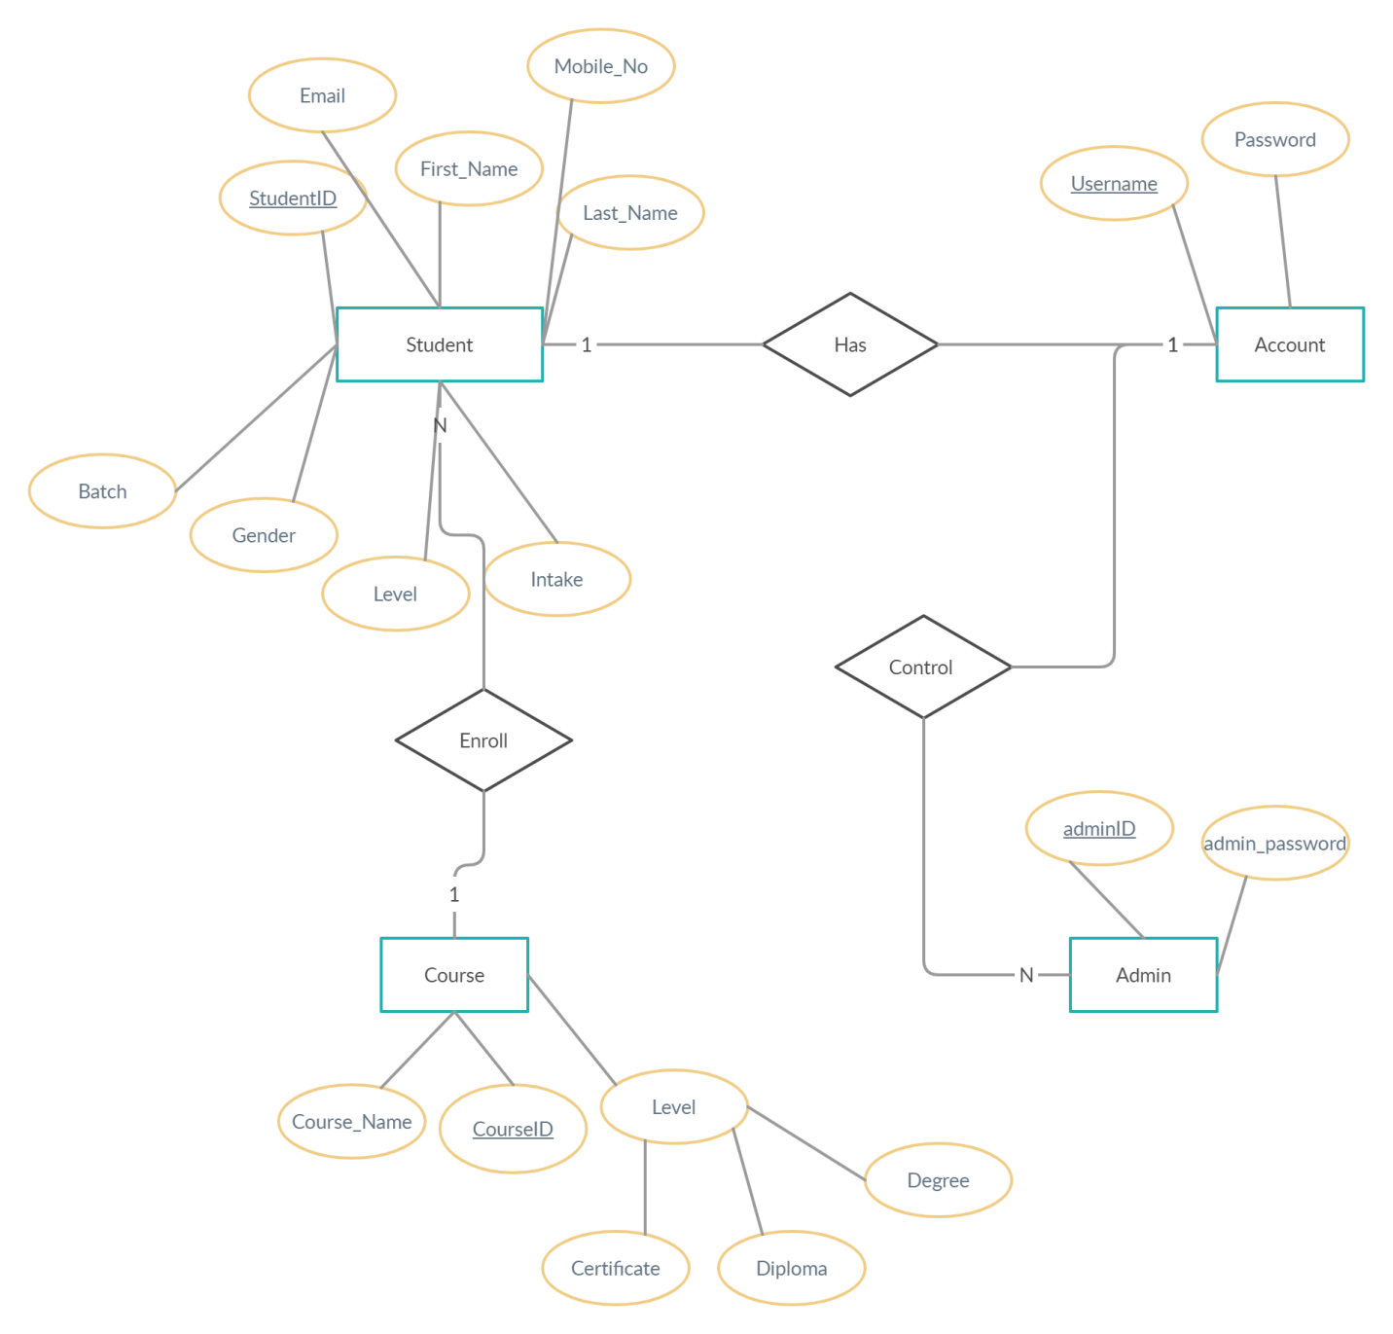

# 04. CLASS DIAGRAM

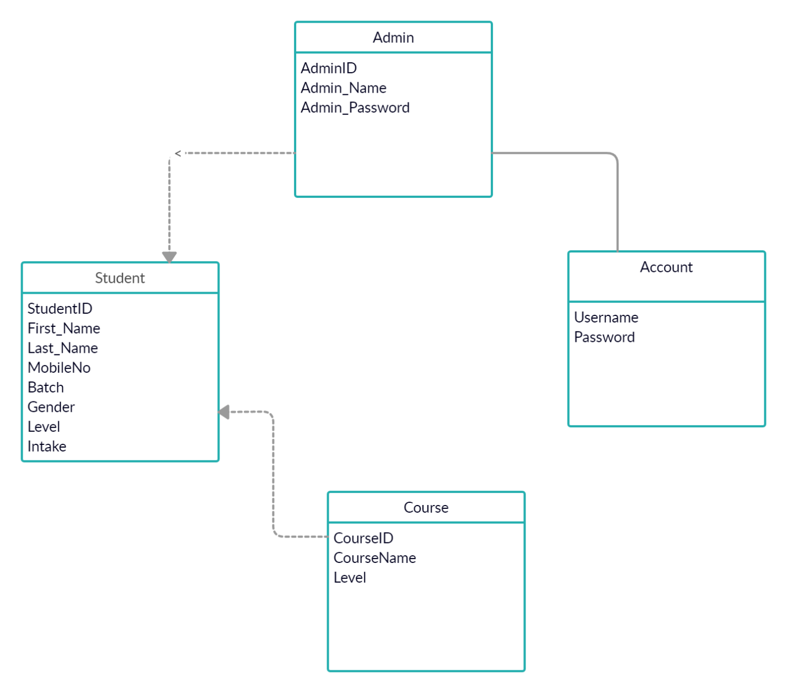

**05. USE CASE DIAGRAM**

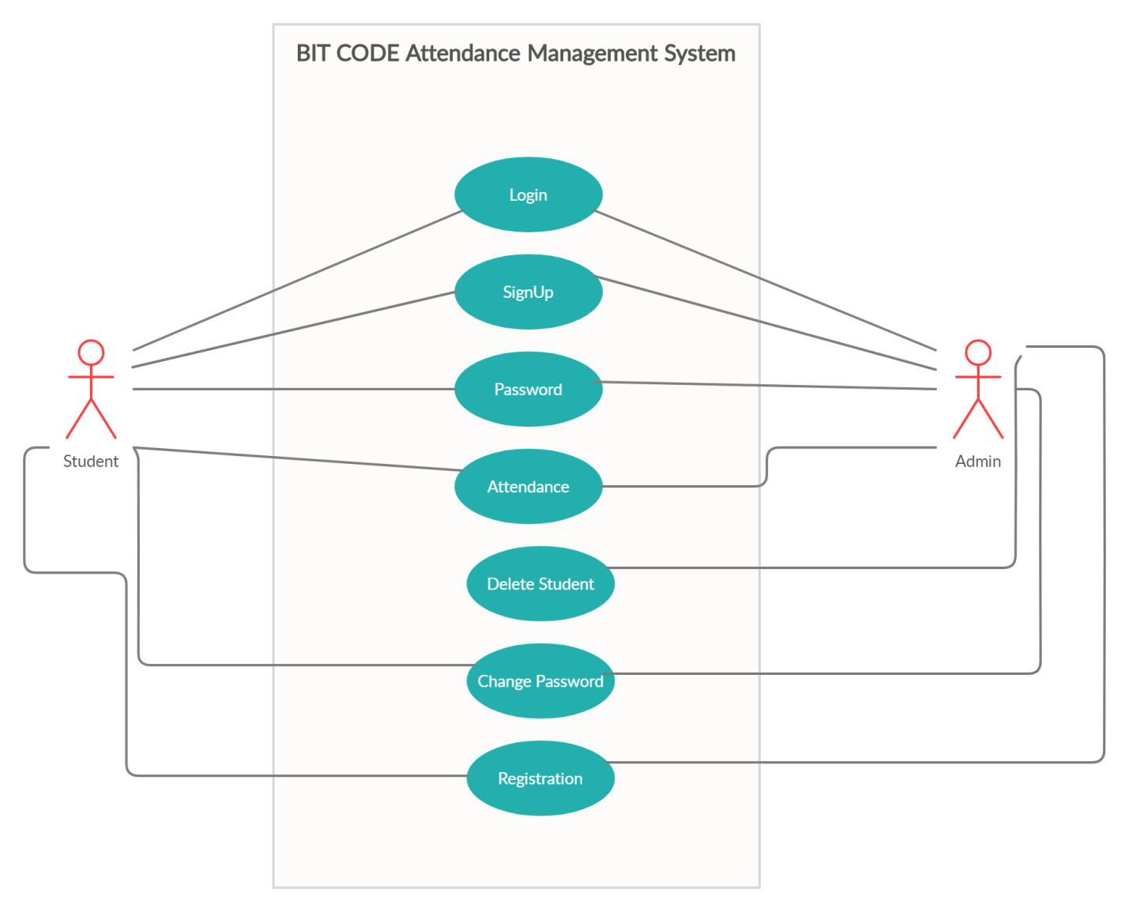

# 06.SCREENSHOTS OF ALL PAGES

**Well Come To BIT CODE**

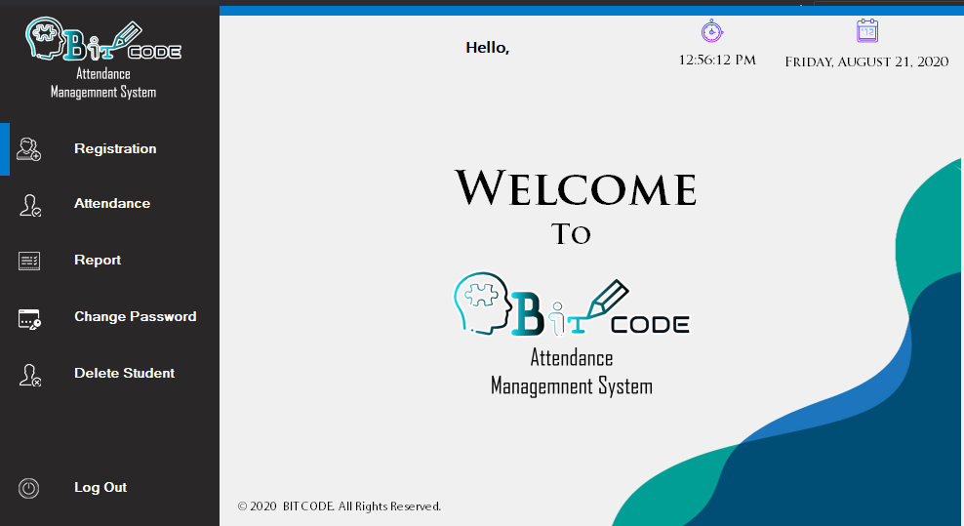

**Home page**

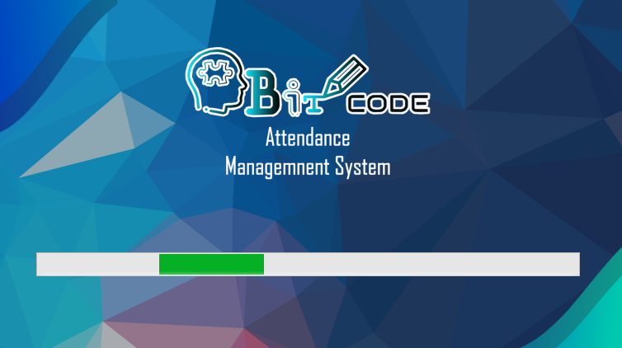

**This is the Welcome form of BIT CODE Company. We have built it very attractively.**

**Login page**

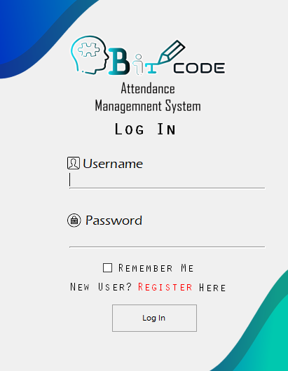

This is the login form. We designed it to open in the center of the welcome form. When the user clicks the Login button welcome text disappears and this login form appears on the center of the Welcome form.

**Sign Up**

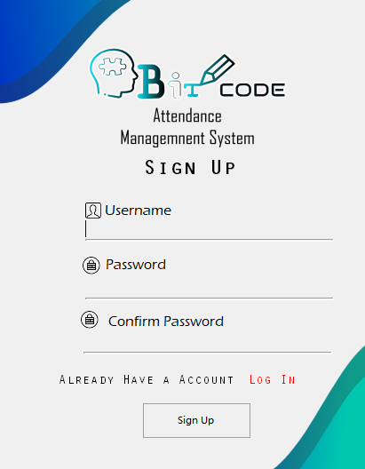

A registration page allows users and organizations to register independently and gain access to your Smart Simple event. It is common to have multiple registration pages, depending on the individuals and organizations you want to register with and the languages ​​your community speaks.

**Registration**

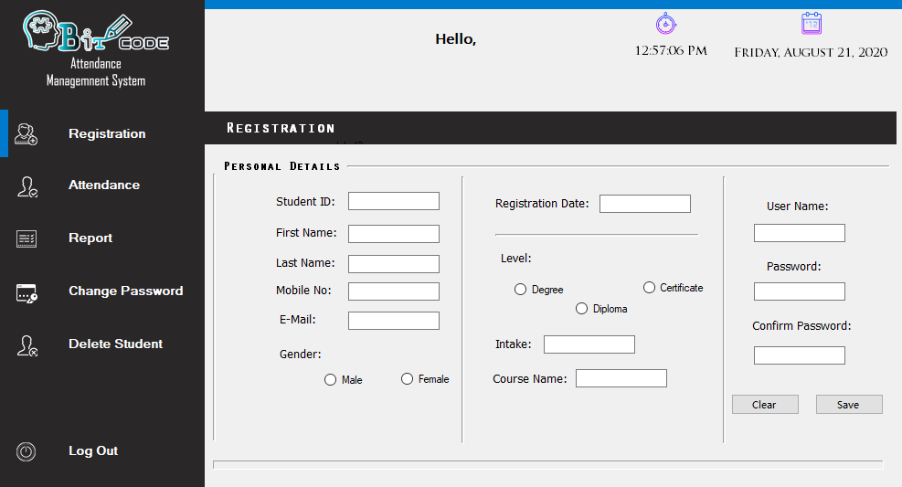

The above form is developed for new users. They need to fill all mandatory fields before clicks on the submit button. If they have missed any fields, we had developed to popup message as to show that.

**Attendance Management Application Main Form**

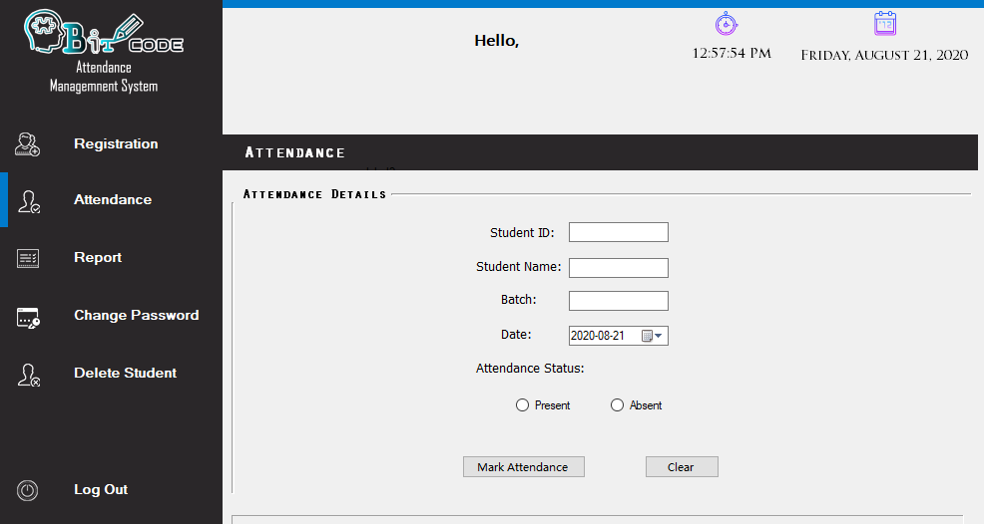

Student Attendance Management Software is one of the applications of school management software that is designed to maintain the accurate status of student daily attendance.

**Report**

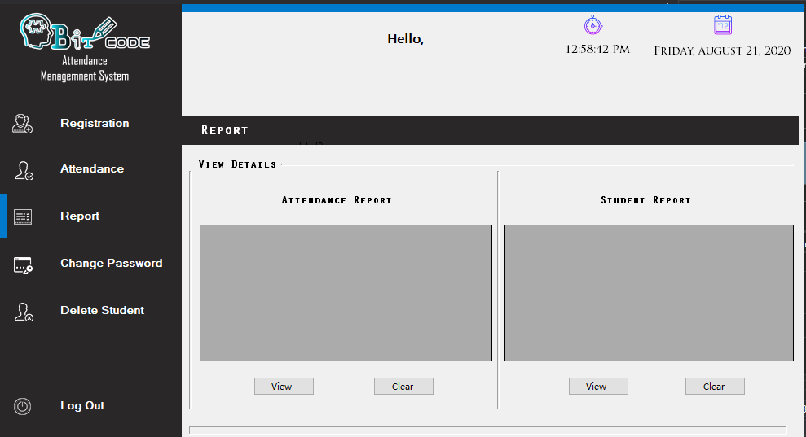

A report is a document that presents information in an organized format for a specific audience and purpose. Although summaries of reports may be delivered orally, complete reports are almost always in the form of written documents.

**Change Password**

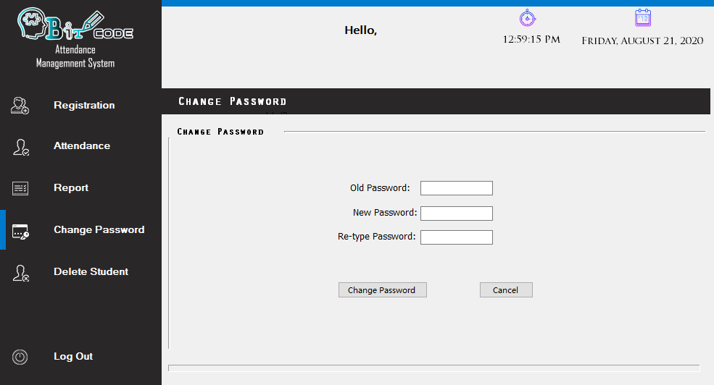

A password change is a user action, where a user enters a new password for his or her account. Windows authenticates the user before he or she is allowed to change the password. This means that a user must always first enter his or her old password before being allowed to change it.

**Delete Student**

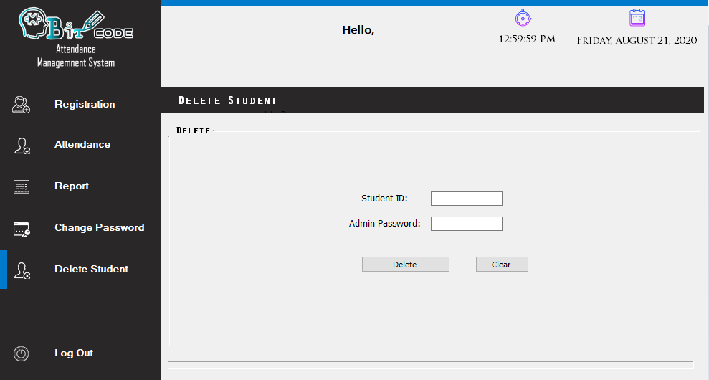

It can be access by only admin so he can see the users and remove them with his requirement through this form. Before delete it need student ID and admin password.

**Logout**

On the top right corner of this form, we can see the logout button. After clicking that button user automatically accessed the welcome form back again.

07. DISCUSSION

This application’s not easier to process make to our group because it happens to various code errors while we are coding this application. The error we faced to Connect to the database. To overcome this error situation, we get help from our seniors after discussing with our group members.

# 08.CONCLUSION

As per the course work in a C# course work for an application of include, Bit Code Company is made successfully with limitless help of group members of our team.

# 09.Work Load Matrix

|  |  |  |  |  |  |  |  |  |  |
| --- | --- | --- | --- | --- | --- | --- | --- | --- | --- |
| Index No | Login | Sign Up | Registration | Attendance | Main page report | Change Password | Delete Student | Crud Operations | Report of the project |
| 18199 |  |  | X |  | X |  | X | X |  |
| 18153 |  |  | X | X |  | X |  | X |  |
| 18207 |  | X |  |  | X | X |  |  | X |
| 18588 | X |  |  |  |  |  | X |  | X |