DAT602 Database Application Development
Assignment 1 - Project Proposal & Milestone One Report

Submitted by: Siyara
Student ID: [YourStudentID]
Date: [Date of Submission]

Contents
1.0 Game Description 3
2.0 Design and Analysis 4
2.1 Storyboard Sketches & Rationale 4
2.1.1 Login & Registration Screen 4
2.1.2 Main Game Screen 4
2.1.3 Administration Screen 5
2.2 User Stories 6
2.3 Logical Entity Relationship Diagram (ERD) 7
2.4 CRUD Analysis 8
3.0 SQL Implementation 9
3.1 Database DDL Script 9
3.2 SQL Implementation Rationale 11
4.0 C# .net Application Prototype 11
5.0 Conclusion 12
References 13

1.0 Game Description
The proposed project, "Grid Heist," is a prototype for a database-driven, multi-user 2D game application. The central design principle is the implementation of all game logic and state management directly within the database through TSQL procedures and functions, an approach consistent with layered application-architecture patterns that separate domain logic from the presentation layer (Fowler, 2003). The client-side application will primarily serve as a graphical interface for rendering the game state and capturing user input.
The game is a competitive "point-and-click" experience on a tiled grid where two players compete to be the first to collect a set number of "Gems". Gameplay revolves around turn-based movement to adjacent tiles. Core mechanics include item acquisition upon entering a tile and a competitive element where one player can "steal" a Gem by moving onto an opponent's tile.
This architectural approach, where the database serves as the authoritative source of truth for all game rules, ensures data integrity, consistency across multiple game clients, and a clear separation between the user interface and the core game logic. This aligns with the foundational transaction-processing principles of atomicity, consistency, isolation, and durability that underpin reliable multi-user database systems (Härder & Reuter, 1983).
To create a more dynamic and challenging environment, the game will also feature Non-Playing Characters (NPCs) whose behavior is entirely managed by database procedures. These will include "Patrol Bots" that move along fixed paths and can steal Gems from players, and "Glitches" that move randomly, capable of removing Gems from the board entirely. This design reflects common patrol-based NPC AI strategies used to add unpredictability and challenge to game environments (Kumar et al., 2019). These elements will force players to adapt their strategies and consider not only their opponent but also the changing state of the game board itself.

2.0 Design and Analysis
This section details the core design and analysis artifacts for the project, including the visual design of the user interface, the functional requirements expressed as user stories, the logical data model, and a comprehensive CRUD analysis.

2.1 Storyboard Sketches & Rationale
The following storyboard sketches provide a visual representation of the application's primary user interfaces. The accompanying rationale explains the design choices made for each screen, focusing on clarity, usability, and the logical separation of functional components.

2.1.1 Login & Registration Screen
This screen serves as the primary authentication gateway. The design is minimalist, presenting the user with distinct fields for their username and password. The interface provides two clear, primary actions: [Login] for returning users and [Register] for new users, ensuring an intuitive user journey from the outset. A dedicated feedback area is included to display error messages, such as invalid credentials or locked account status.

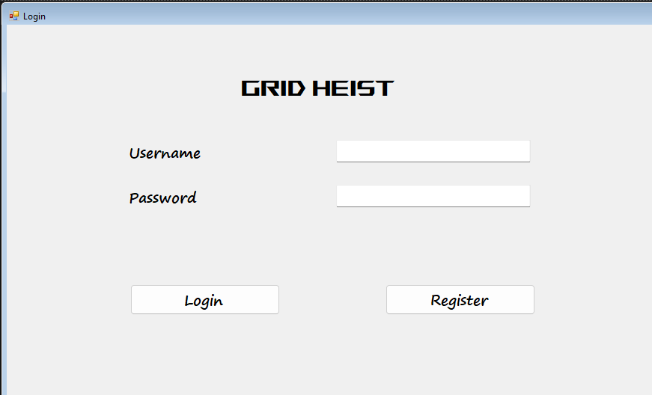
Figure 1: Login & Registration Screen Storyboard

2.1.2 Main Game Screen
The main game interface is structured using a zoned layout to present information clearly without overwhelming the player. The top portion is dedicated to displaying the critical game state: the current player's score and the opponent's score. The central area is dominated by the interactive game board, which visually represents players, items, and NPCs. A persistent action log at the bottom provides essential, real-time feedback to the user, confirming the results of their actions and NPC movements as processed by the database.
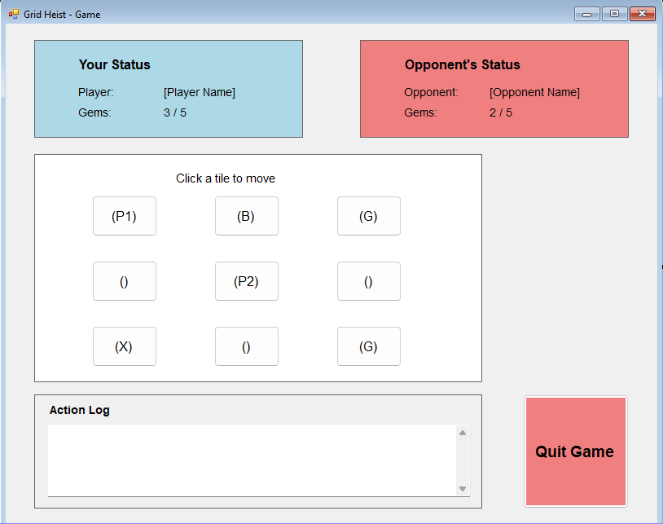
Figure 2: Main Game Screen Storyboard

2.1.3 Administration Screen
This interface is designed as a functional data management tool for an administrator, utilizing a standard Master-Detail pattern for efficiency and clarity. The "Master" panel on the left lists all players, allowing the administrator to select a user to manage. The corresponding user data is then populated in the "Detail" panel on the right, where edits can be made. High-risk, global actions ([Kill Running Game]) are separated and visually emphasized to ensure deliberate use.
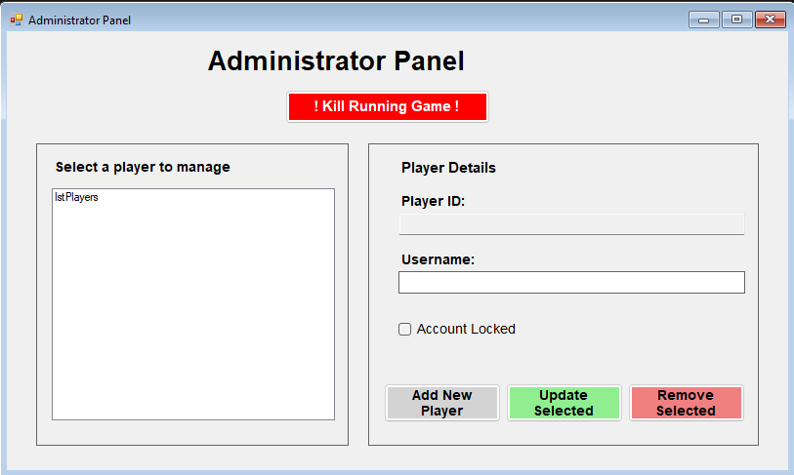
Figure 3: Administration Screen Storyboard

2.2 User Stories
To define the functional requirements of the system from a user-centric perspective, the following initial user stories have been formulated, using the standard "As a [role], I want [goal], so that [benefit]" format common in agile requirements gathering (Cohn, 2004).
Player Perspective:
- As a new player, I want to register an account with a unique username and a password so that I can create a persistent profile for playing the game.
- As a returning player, I want to log in with my credentials so that I can access my account and the game.
- As a player, I want to view the game board, including the positions of my character, my opponent, items, and NPCs, so that I can make informed decisions about my next move.
- As a player, I want to move my character to an adjacent tile by clicking on it so that I can navigate the game world.
- As a player, I want to automatically collect a Gem when I move onto its tile so that I can progress towards the winning condition.
- As a player, I want to observe the movement and effects of NPCs on the board so that I can plan my strategy to avoid risks and capitalize on opportunities.
Administrator Perspective:
- As an administrator, I want to view a list of all registered player accounts so that I can manage the user base.
- As an administrator, I want to update the details of a specific player, such as their locked status, so that I can manage individual accounts.
- As an administrator, I want to remove a player account from the system so that I can handle account deletion requests.
- As an administrator, I want to have the ability to terminate a running game session so that I can resolve potential system issues.

2.3 Logical Entity Relationship Diagram (ERD)
The logical Entity Relationship Diagram (ERD) for the "Grid Heist" application, depicted below, is designed to be fully normalized and provides a robust foundation for the database-centric architecture. It utilizes seven distinct entities to manage game state, player data, and game mechanics efficiently.
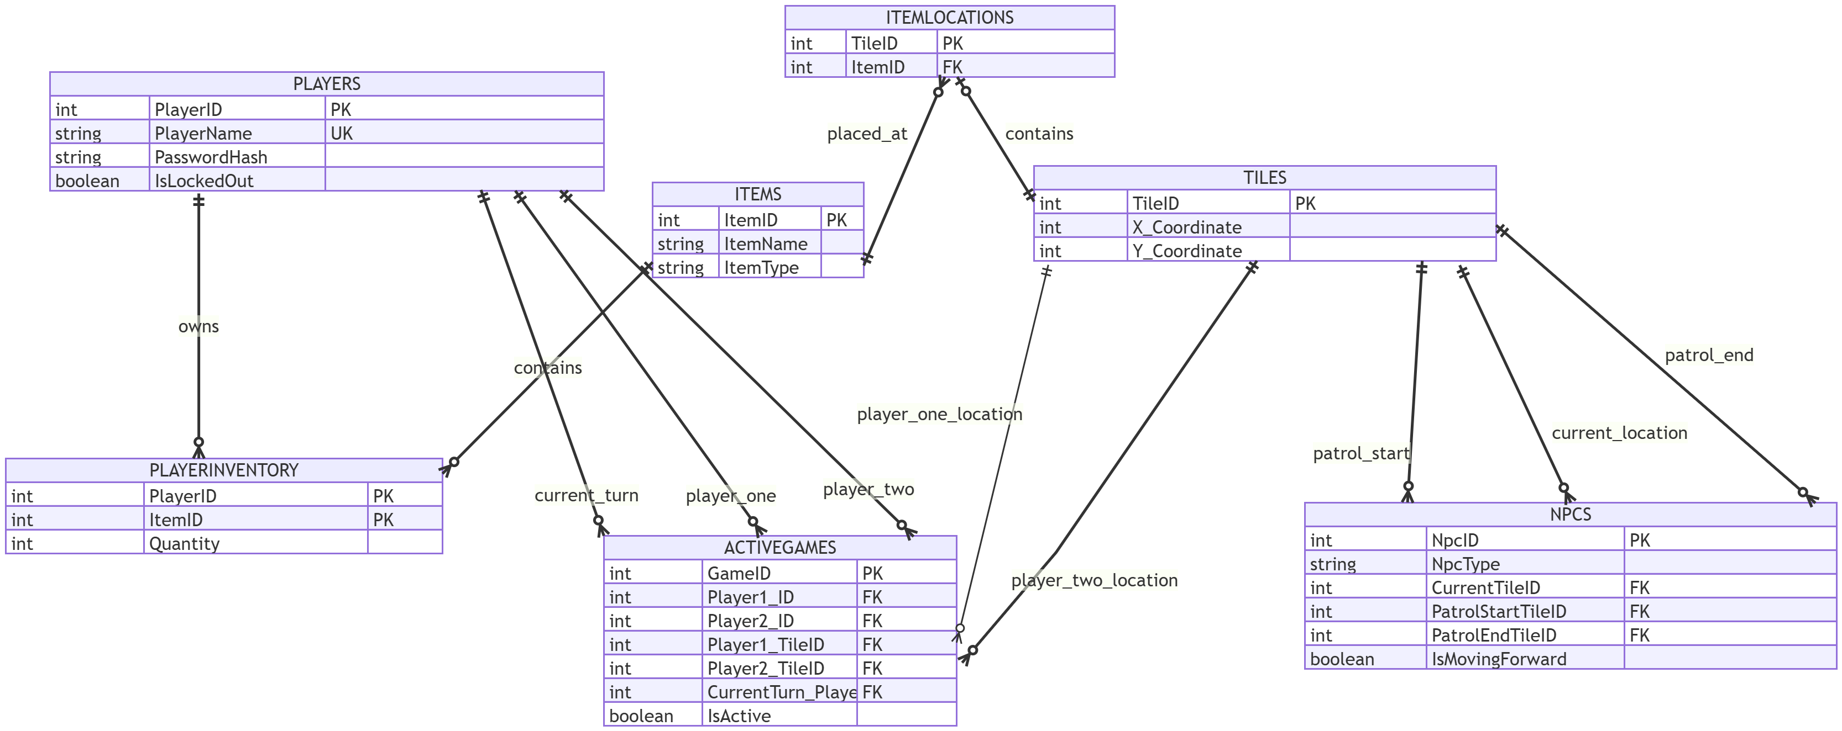
Figure 4: Logical Entity Relationship Diagram
ERD Rationale:
- Core Entities: The Players, Items, and Tiles tables serve as the foundational entities, storing primary data for user accounts, item definitions, and the static game board, respectively.
- State Management: The ActiveGames table is central to managing live gameplay. It decouples session-specific data, such as player locations and turn order, from the permanent Players table. The NPCs table similarly stores the dynamic state and properties of all non-playing characters.
- Junction Tables for Many-to-Many Relationships: The design employs two junction tables to manage complex relationships. The PlayerInventory table resolves the many-to-many relationship between players and items. Similarly, the ItemLocations table resolves the many-to-many relationship between items and tiles.
All relationships are enforced via foreign key constraints to ensure referential integrity, which is essential for the reliability of the game's database-driven logic.

2.4 CRUD Analysis
The following CRUD (Create, Read, Update, Delete) analysis details the database interactions for the 12 key processes required by the assignment brief. This analysis maps game functions directly to operations on the logical data model defined in the ERD.
Process / Function | Tables Accessed | C/R/U/D Action & Description
1. Player login, including lock out | Players | Read: The Players table is read to find a record matching the provided PlayerName. The PasswordHash and IsLockedOut status are checked.  Update: If the login fails, an implied login attempts counter would be incremented. If a threshold is reached, the IsLockedOut flag for that player is updated to 1 (true).
2. Player registration | Players | Create: A new record is inserted into the Players table with the new PlayerName and a hashed password. IsLockedOut defaults to 0 (false).
3. Laying out tiles on a game board | Tiles | Create: An initialization process where records are created in the Tiles table, one for each tile in the grid, defining its unique TileID and X_/Y_ coordinates.
4. Placing an item on a tile | ItemLocations | Create: A new record is inserted into the ItemLocations table, creating a link between a specific ItemID and TileID.
5. Player game play movement | ActiveGames, Tiles | Read: ActiveGames is read to verify CurrentTurn_PlayerID. The player's current TileID is read and checked against the Tiles table to validate the destination is legal.  Update: ActiveGames is updated to set the player's new TileID and to change the CurrentTurn_PlayerID to the other player.
6. Game play scoring | PlayerInventory | Create: To gain a point (acquire a Gem), a new record is created in PlayerInventory linking the PlayerID to the ItemID for a Gem.  Delete: To lose a point (Gem is stolen), the corresponding record is deleted from the PlayerInventory table.
7. Acquiring inventory | PlayerInventory, ItemLocations | Read: ItemLocations is read to check if an item exists at the player's new TileID.  Create: If an item is found, a new record is created in PlayerInventory.  Delete: The record is deleted from ItemLocations to remove it from the board.
8. Move an Item (NPC effect) | NPCs | Read: The NPC's current CurrentTileID and properties are read from the NPCs table.  Update: The CurrentTileID for the NpcID in the NPCs table is updated to its new location.
9. Kill running games (Admin) | ActiveGames | Update: The IsActive flag for a specific GameID in the ActiveGames table is updated to 0 (false).
10. Add new players (Admin) | Players | Create: Functionally identical to Player Registration. An administrator creates a new record in the Players table.
11. Update data of a player (Admin) | Players | Update: An administrator modifies fields of an existing record in the Players table, such as PlayerName or IsLockedOut.
12. Delete a player (Admin) | Players, PlayerInventory, ActiveGames | Delete: A record is deleted from the Players table. All related child records in PlayerInventory and ActiveGames must also be deleted (cascading delete).

3.0 SQL Implementation

3.1 Database DDL Script
The following T-SQL script contains the complete Data Definition Language (DDL) required to construct the "Grid Heist" database. It is encapsulated within a single stored procedure named sp_InitializeDatabase for reliable and repeatable execution. The procedure first drops any existing tables to ensure a clean environment before creating the new schema. It concludes by inserting a comprehensive set of test data to establish a functional game state.
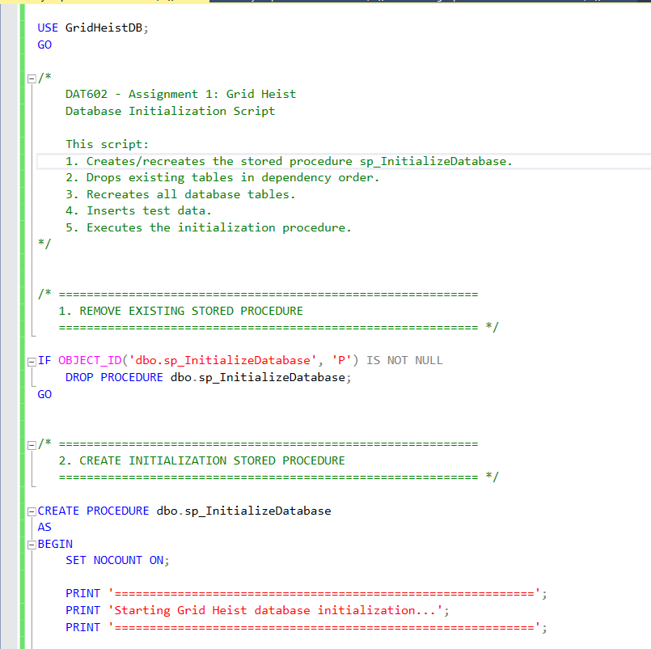
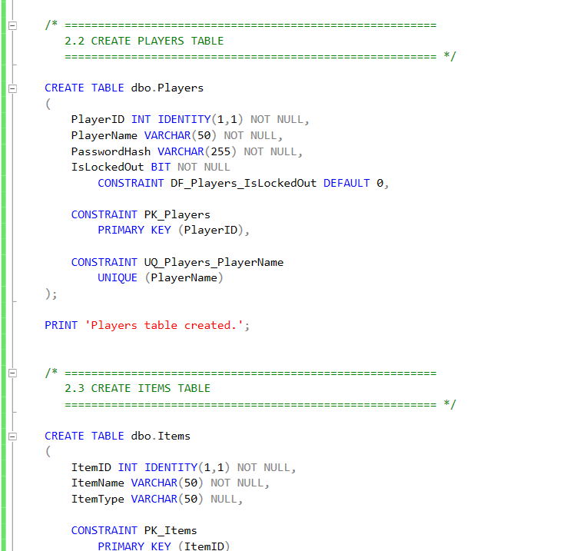

3.2 DDL Rationale and Table Explanations
This section provides a detailed explanation for the design of each table within the "Grid Heist" database schema. The design choices for data types, constraints, and relationships are explained to justify their role in maintaining data integrity and supporting the application's functionality.
3.2.1 Players Table
The Players table is the central entity for user account management.
- PlayerID (INT, IDENTITY): Serves as the surrogate Primary Key. An IDENTITY column is used to automatically generate a unique, non-null integer for each new player, which is ideal for foreign key relationships.
- PlayerName (VARCHAR(50), UNIQUE): Stores the user's public name. A UNIQUE constraint is applied to prevent duplicate usernames, which is essential for the login system.
- PasswordHash (VARCHAR(255)): This field is designed to store a cryptographically hashed version of the user's password, not the password itself, which is a critical security practice.
- IsLockedOut (BIT, DEFAULT 0): A boolean flag to manage account access. It defaults to 0 (false), and would be programmatically set to 1 (true) after repeated failed login attempts.
3.2.2 Items Table
This is a static lookup table that defines all possible items that can exist in the game.
- ItemID (INT, IDENTITY): The Primary Key for identifying item types.
- ItemName (VARCHAR(50)): Stores the descriptive name of the item, such as "Gem" or "Trap".
3.2.3 Tiles Table
This table represents the static physical game board.
- TileID (INT, IDENTITY): The Primary Key for each tile, used in other tables to reference a specific location on the grid.
- X_Coordinate / Y_Coordinate (INT): These store the integer coordinates for each tile. A UNIQUE constraint on this pair ensures that no two tile records can exist for the same physical location.
3.2.4 NPCs Table
This table stores the dynamic state of all Non-Playing Characters on the board.
- CurrentTileID (INT, FK): A Foreign Key referencing Tiles.TileID that tracks the NPC's current location.
- Patrol...TileID (INT, FK, NULL): These nullable fields store the patrol path for specific NPC types like the "PatrolBot". They are nullable because other NPC types, like the "Glitch," do not have fixed paths.
3.2.5 ActiveGames Table
This entity is crucial for managing live game sessions. It separates temporary, in-game data from permanent player statistics.
- GameID (INT, IDENTITY): The Primary Key for a unique game session.
- Player1_ID, Player2_ID, CurrentTurn_PlayerID (INT, FK): These Foreign Keys link to the Players table to define which players are in the game and whose turn it is.
- Player1_TileID, Player2_TileID (INT, FK): These Foreign Keys link to the Tiles table to track the real-time location of each player.
- IsActive (BIT, DEFAULT 1): A flag to easily query for games that are currently in progress.
3.2.6 PlayerInventory Table
This is a classic junction table designed to resolve the many-to-many relationship between Players and Items.
- PlayerID, ItemID (INT, Composite PK, FK): The combination of PlayerID and ItemID forms a composite Primary Key, ensuring that a player cannot have duplicate rows for the same item type. Both columns are also Foreign Keys to their respective parent tables.
- Quantity (INT): Stores how many of a specific item the player holds.
3.2.7 ItemLocations Table
This junction table resolves the many-to-many relationship between Items and Tiles, tracking where items are located on the board.
- TileID (INT, PK, FK): TileID serves as the Primary Key for this table. This is a deliberate design choice that enforces a critical game rule: only one item can exist on any given tile. It is also a Foreign Key to the Tiles table.
- ItemID (INT, FK): A Foreign Key to the Items table, defining which item is on that tile.

3.3 SQL Implementation Rationale
DDL and Test Data Rationale
The DDL for the "Grid Heist" database was encapsulated into a single stored procedure, sp_InitializeDatabase, to ensure a consistent and repeatable setup process. The table creation statements directly reflect the normalized structure defined in the ERD, with all primary and foreign key constraints established to maintain referential integrity. Following the table creation, a comprehensive set of test data is inserted via INSERT statements within the same procedure. This data is designed to establish a complete, functional game scenario for immediate testing, ensuring that the database is not just structurally sound but also populated with a meaningful state.
Test Queries and Application Connection Rationale
To satisfy the requirement of testing the connection from all three major display areas, three distinct stored procedures were created: sp_ValidatePlayer, sp_GetGameStatus, and sp_GetAllPlayerNames. These procedures serve as the interface between the C# application and the database. sp_ValidatePlayer handles authentication for the Login form. sp_GetGameStatus serves the Game Play form by retrieving session-specific data. sp_GetAllPlayerNames is used by the Administration form to retrieve a set of records for display. All procedures are called from a centralized Data Access Object (DAO) in the C# application, confirming the functionality of each display area and validating the overall architectural pattern.

4.0 C# .net Application Prototype
A prototype C# .NET Windows Forms application was created to serve as the front-end for the database. The prototype consists of three primary display areas (frmLogin, frmGame, frmAdmin), fulfilling the assignment requirements.
The core of the application's architecture is the Data Access Object (DAO) pattern, implemented in a DatabaseAccessor.cs class. This class centralizes all database communication, cleanly separating the data access logic from the user interface presentation logic in the forms. Each of the three forms contains functionality that calls specific methods within the DAO, which in turn execute corresponding stored procedures to interact with the database. This structure not only proves a successful connection from each required area but also establishes a scalable and maintainable foundation for future development.
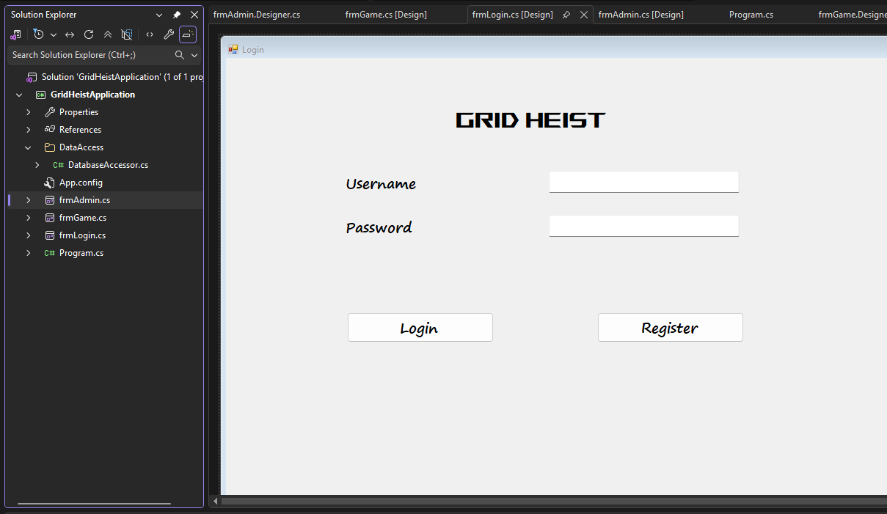

5.0 Conclusion
In summary, this project proposal and milestone report has outlined the complete design, analysis, and initial implementation for the "Grid Heist" game. A database-centric architecture has been established, supported by a fully normalized logical ERD, a detailed CRUD analysis, and a functional DDL script. The user interface has been designed for clarity and usability, and a working C# .NET prototype has been developed to prove a successful connection to the database from all required display areas.
All requirements for Milestone One have been met, providing a robust foundation for subsequent development. Upon approval, the next phase will focus on implementing the full game logic within T-SQL procedures and building out the complete functionality of the C# application.

GitHub Repo - https://github.com/Siyara11/GridHeistApplication.git

References
Cohn, M. (2004). User stories applied: For agile software development. Mountain Goat Software. https://www.mountaingoatsoftware.com/uploads/articles/User-Stories-Applied-Mike-Cohn.pdf
Fowler, M. (2003). Catalog of patterns of enterprise application architecture. https://martinfowler.com/eaaCatalog/
Härder, T., & Reuter, A. (1983). Principles of transaction-oriented database recovery. ACM Computing Surveys, 15(4), 287–317. https://doi.org/10.1145/289.291
Kumar, S., et al. (2019). Patrolling AI systems in video games. International Journal of Recent Technology and Engineering, 8(4), 3021–3025. https://www.ijrte.org/wp-content/uploads/papers/v8i4/D6957118419.pdf
Microsoft. (n.d.). Use the master-detail pattern with hierarchical data. Microsoft Learn. Retrieved July 29, 2026, from https://learn.microsoft.com/en-us/dotnet/desktop/wpf/data/how-to-use-the-master-detail-pattern-with-hierarchical-data

