Question1

A = 10,000 Disk pages. B = 1,000 pages. R = 502 buffer pages. No index, simple heap

For each strategy, provide the formulae you use to calculate your cost estimates.

1. Page-oriented Nested Loops Join. Consider A as the outer relation.  
   Formula: Since A is outer relation, R = 10,000, S = 1000  
   So
2. Block-oriented Nested Loops Join. Consider A as the outer relation  
   Formula =

Since A is outer relation, R = 10,000, S = 1000, Block size B = 502  
So

1. Sort-Merge Join  
   Formula:  
   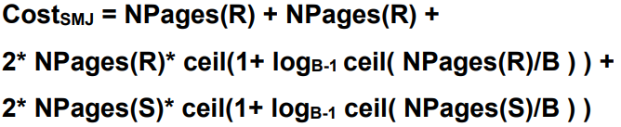

R = 10,000; S = 1,000; B = 52;  
So, = 11000+2\*10,000\*2+ 2\*1,000\*2 = 55000

1. Hash Join

Formula:   
R = 10,000; S = 1,000;

So,

1. What would the lowest possible I/O cost be for joining A and B using any join algorithm and how much buffer space would be needed to achieve this cost. Explain briefly.

The optimal case would be when buffer size = 1000. So this is the case that S can be fits in memory, therefore only hashing will happen.

So,