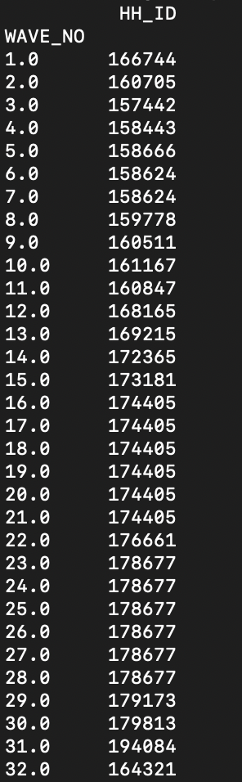

Count_per_wave.csv

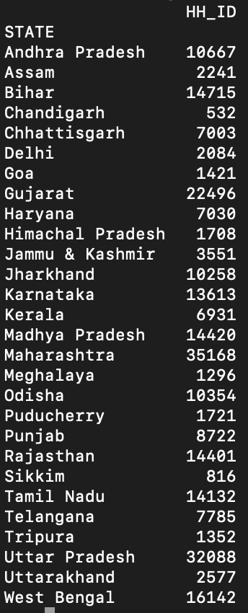

State_hh.csv

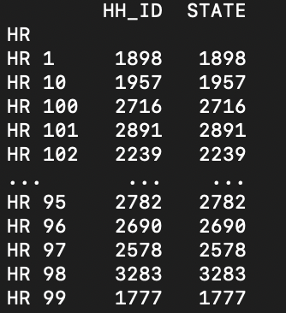

Hr_hh.csv

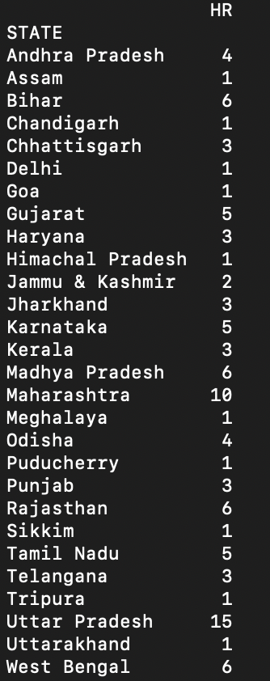

State_hr.csv

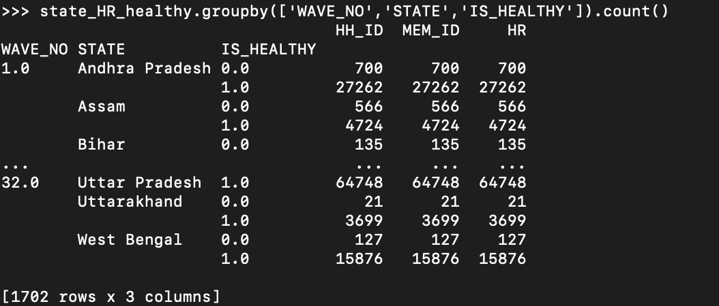

Healthy_distribution.csv

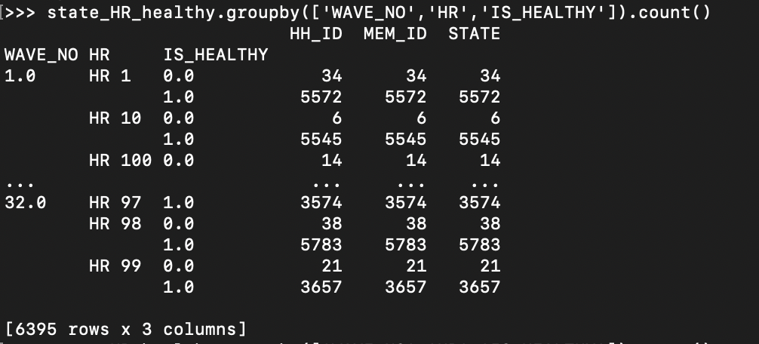

Healthy_distribution_by_hr.csv