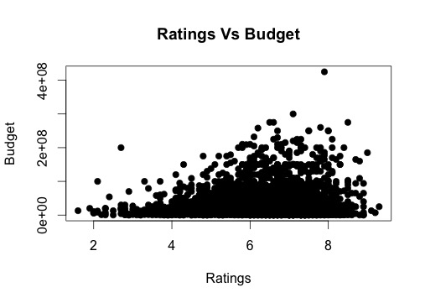In this graph, we are able to determine the correlation between ratings and budget. It shows the budget increases as the ratings increases as well. It seems steady until 8.5 and then decreases significantly. Although there are some outliers in some points, these outliers are not taken into consideration to judge the whole graph. Some movies have less rating but have high budget. What we assume is that some movies are not popular as others in the Internet, so that could have led to less ratings because people might not had a chance to rate them.