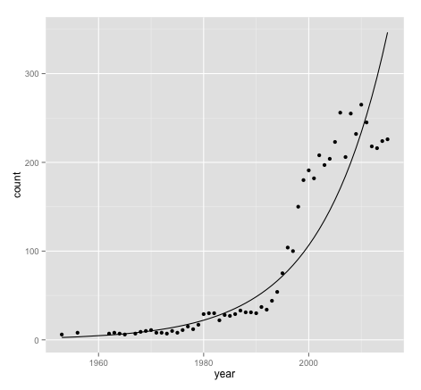

This graph shows relation between the ***year*** and ***number of movie*** released in that year. They are roughly in exponential relation, which means the total number of movies increases exponentially yearly. The year after 2015 and the year in which there are less than 5 movies released are excluded from the data frame since they are not representative, and the linear regression is significant statistically.

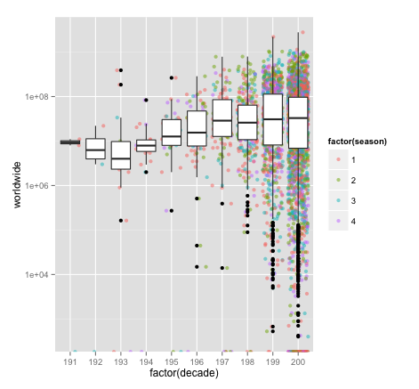

This graph shows relation between ***average worldwide gross*** and ***decades***, as well as rough relation between ***average worldwide gross*** and different ***seasons*** in one decades. Firstly, the average worldwide gross increases among years, they are in linear relation. However, there are an obvious decrease in 1930’s, it could be affected by The Great Depression. We can also see that the boxes are becoming bigger and bigger, which means the number of movies getting larger, their worldwide gross varies in a larger scale as well, which could be explained as the quality of movies varies in a lager and larger scale as well. There are more “better” movies and also more “worse” ones. Secondly, from the points behind the boxes we can see that green ones, which stand for movies released in the second season, are a little more likely to become the blockbuster.