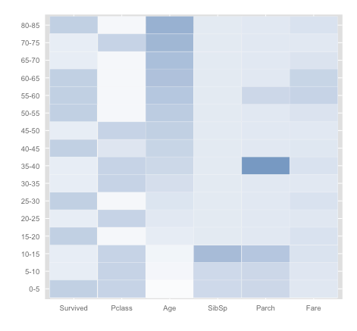

The graph is a Heatmap on different age level, it shows that:

* Kids and elders are more likely to survive (deeper blue);
* People in lower class cabins are more likely to survive (lighter blue);
* When comparing “Survived” with “Pclass”, some correlation appears: people in higher level of cabin are less likely to survived (Cells have lighter blue in “Pclass” have darker blue in “Survived”);
* People under age 15 are more likely to have Siblings/Spouses/Parents on aboard, meanwhile people age 35-40 and 55-60 are more likely to have Parents/Children on aboard;
* Fare paid by people age between 55-65 are higher than fare paid by people in other age.