Design Document

CustomerPro

Levi Garner (legarner)–Member

Siyu Miao(siyumiao) – Member

# Introduction

This design document outlines the high-level organization of your system, and it is what the programmers will refer to during implementation. Purpose of this design document is to describe the design and the architecture of CustomerPro. The design is expressed in detail so as to enable all the developers to understand the underlying architecture of CustomerPro (sample design document - iGraduate iPhone Application).

This Document Includes:

1. Date Requirements
2. Features & Functionality

## Target Audience/Purpose of the App

* CustomerPros main functionality is to enable service based companies to enter in customers, task, messages and jobs
* This functionality is important because it solves a problem for these types of businesses, which so many still use paper and are not tracking there information efficiently.
* CustomerPro offers a free solution to manage customers, task, phone messages and jobs seamlessly and efficiently verse the alternative.

## Data Requirements

We are going to be using SQLite as our database. Before, implementing the database we will create the Entity Relational Diagram and Relational Model.

All the data that is relevant to the app will be stored into the database.

### ERD

The following is the **Entity Relational Diagram:**

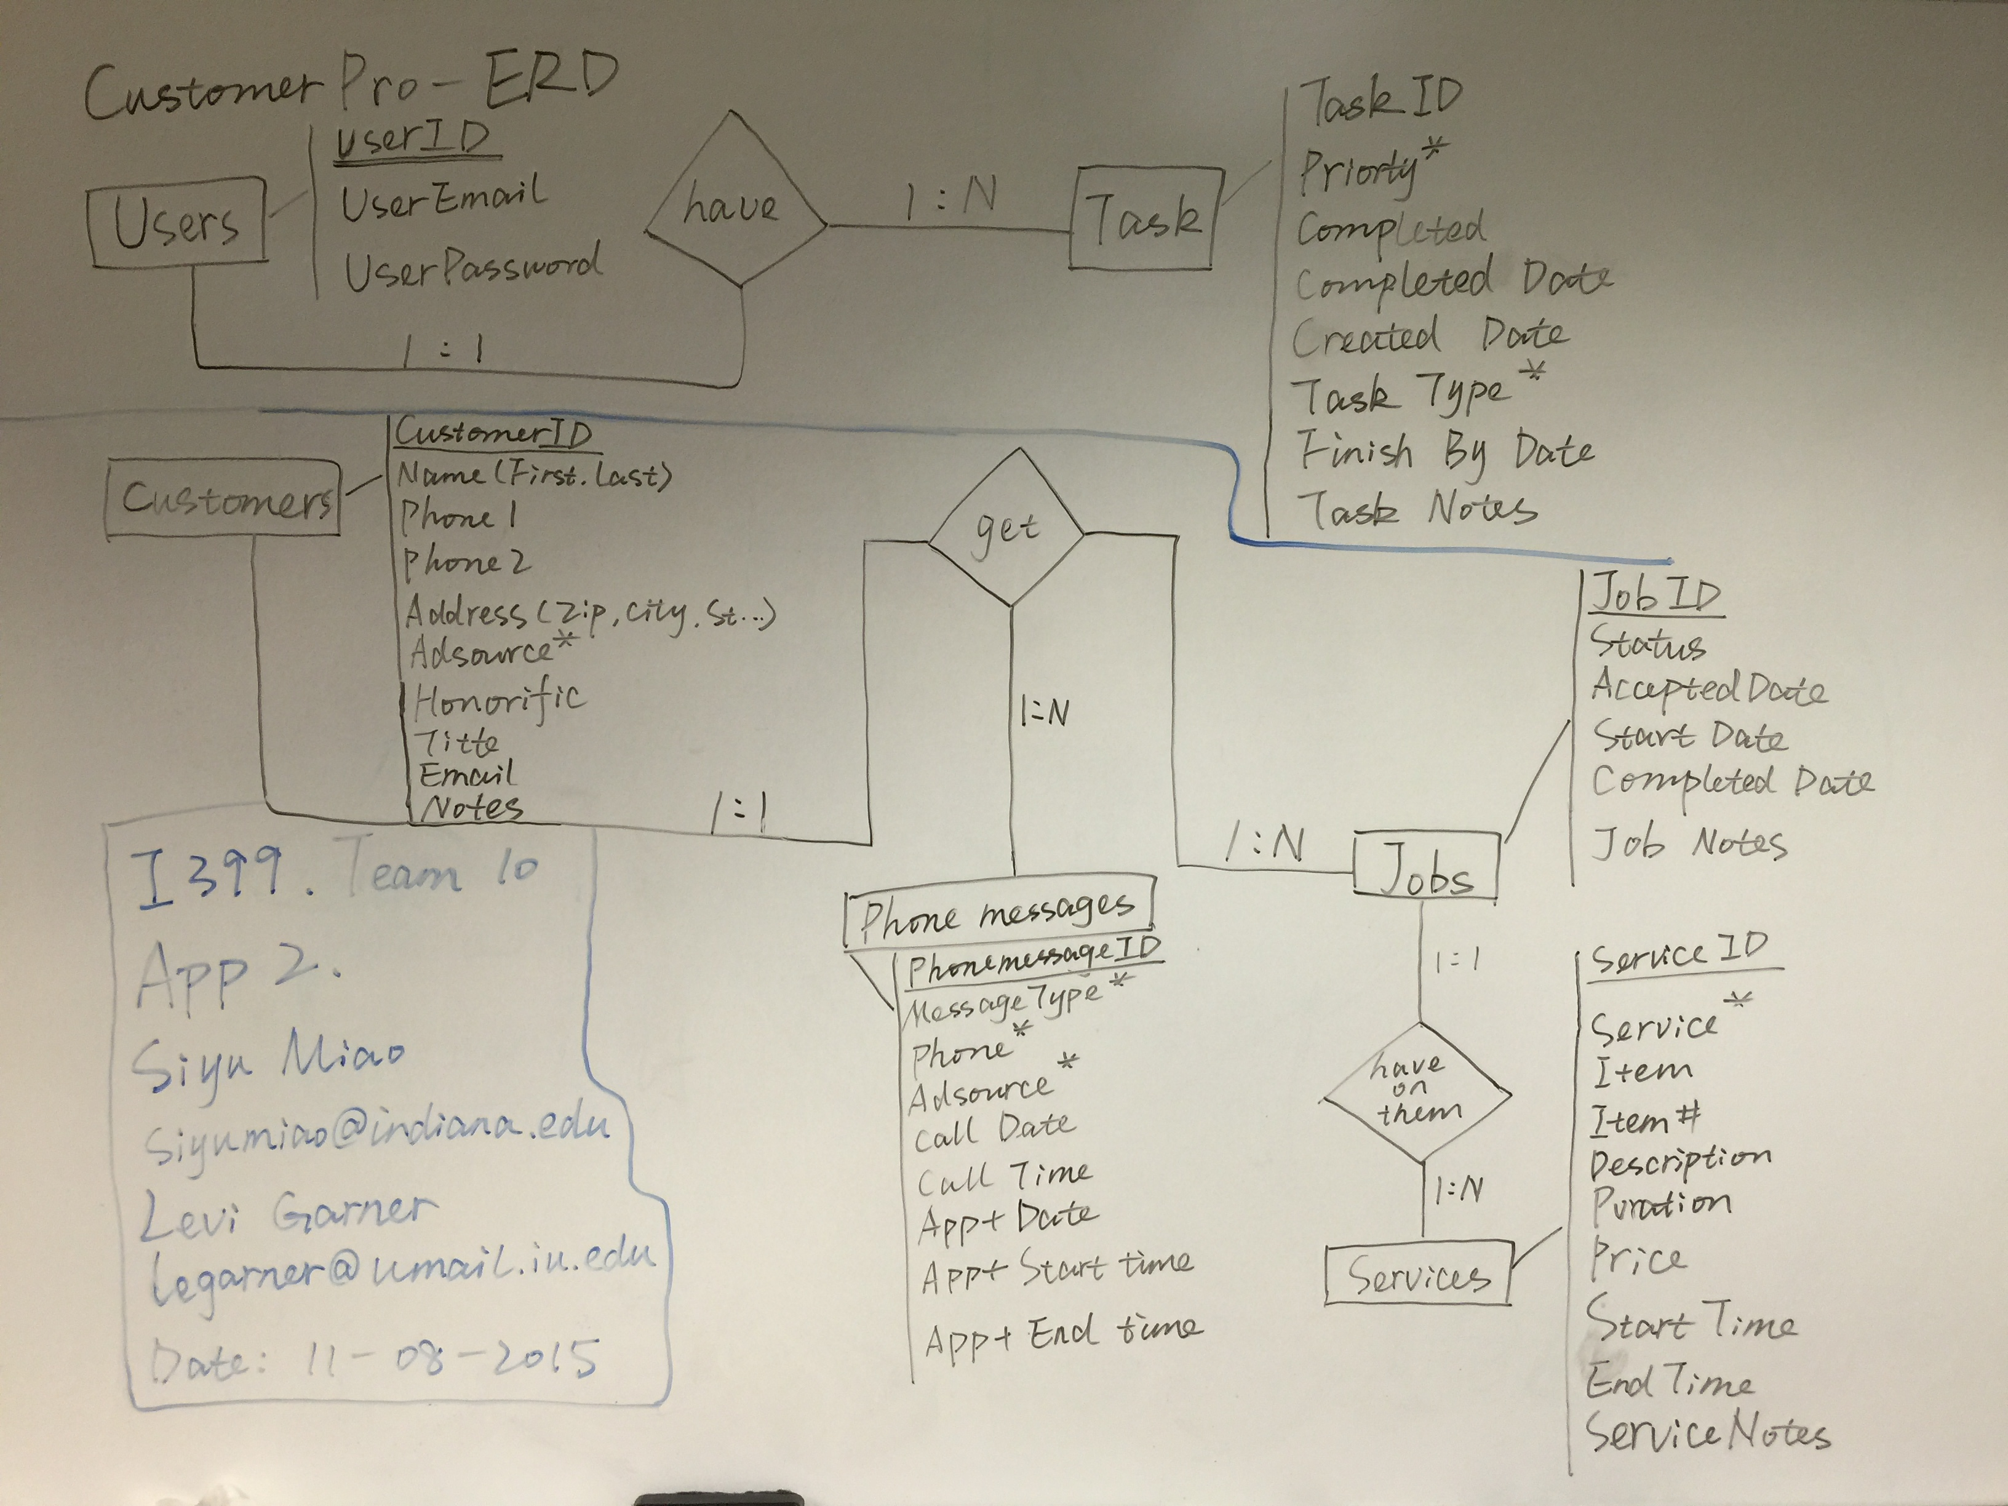

### Relational Model

The following is the **Relation Model**:

*The following are the primary tables*

**tblUsers**(UserID, UserEmail, UserPassword)

**tblTask**(TaskID, TaskPriorityID>, TaskTypeID>, CreatedDate, Completed, CompletedDate,

**tblCustomers** (CustomerID, AdSourceID>, Honorific, FirstName, LastName, Address, Zip, City, State, Email, Phone1, Phone2, Notes)

**tblPhoneMessage**(PhoneMessageID,> CustomerID>, AdSourceID>, MessageType>, CallDate, CallTime, ApptDate, ApptStartTime, ApptEndTime, Phone, Notes)

**tblJobs**(JobID,CustomerID>, Status, AcceptedDate, StartDate, CompletedDate, JobNotes)

**tblServices**(ServiceID>, JobID>, ServiceNameID>, Item#, ItemID>, Description, Duration, Price, StartTime, EndTime, ServiceNotes)

*The following are lookup tables, which will be drop downs in our App:*

tlkpAdSources(AdSourceID, AdSourceName)

tlkpMessageTypes(MessageTypeID, MessageTypeName)

tlkpServices(ServiceNameID, ServiceName)

tlkpItems(ItemID, ItemName)

tlkpTasks(TaskID, TaskName)

tlkpTaskTypes(TaskTypeID, TaskTypeName)

tlkpTaskPriorites(TaskPriorityID, TaskPriorityName)

## Features

The app will allow users to enter Customers, which have Phone Messages and Jobs. Phone Messages ultimately lead to an appointment. Jobs have any number of services on them. Users of the App can assign themselves Task.

*The following is a sample of CustomerPro’s interface:*

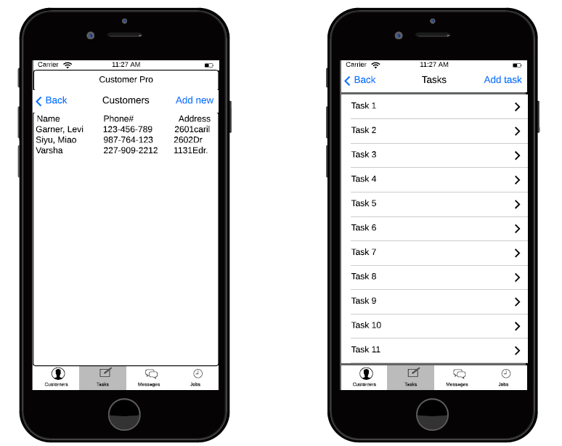

*The following is the UML (functionality for the App):*

