0

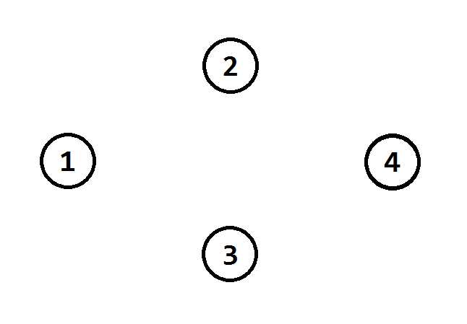

100

1

100

100

100



2

1

1

1

4

0

0

0

0

0