Assignment Report

Q 3.1

A: The test accuracy after 3000 iterations is 97% as shown in Figure-1 below.

 Figure-1

Q3.2

A: Two confusion matrixes are generated from two batches with 100 images per batch. In the matrix, numbers on the diagonal are the predictions that matched with the real number. From the chart we can see 2 numbers from the first batch and 5 numbers from the second batch are wrong predicted, but the overall accuracy is still above 95%.

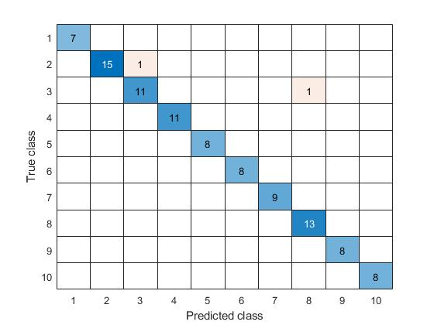Figure-2

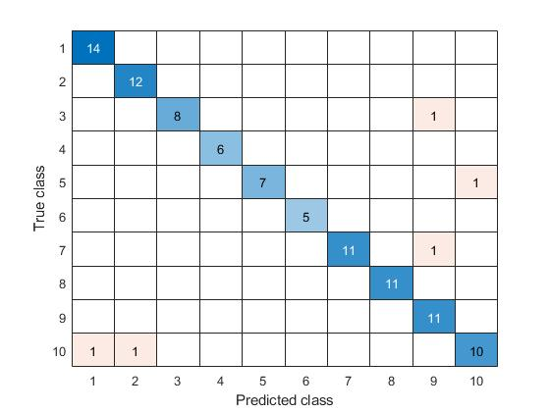Figure-3

Q3.3

For this part I used number images that I found online for testing. From the feedback shown in Figure-4, the accuracy is 100.

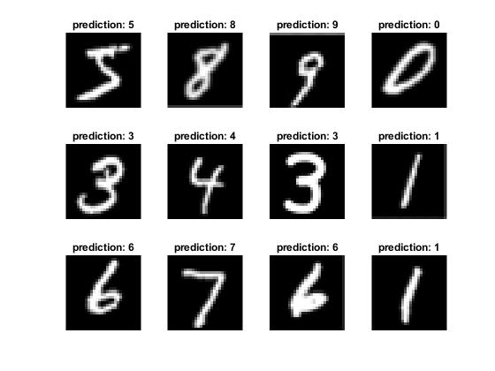Figure-4

Q4.1

A: Figure-5 is the original image. Figure-6 are images that run through convolution layer. Figure-7 are images that run through RELU layer. Figure-8 are images after normalization.

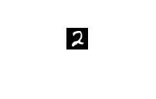Figure-5

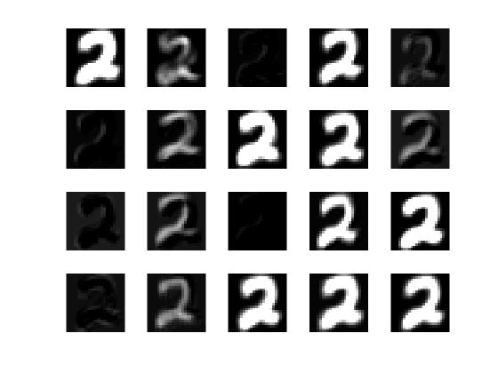 Figure-6

Figure-7

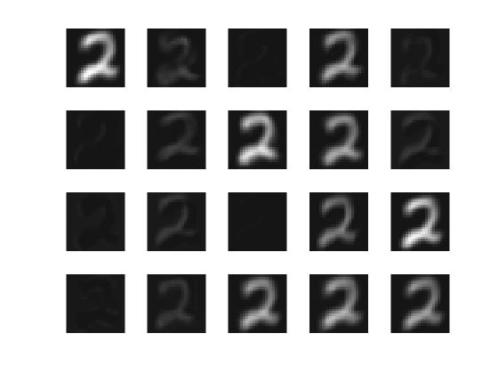Figure-8

Q4.2

A: The output of the convolutional layer can be classified into 4 categories, which are bolded stroke, shallow stroke, fuzzy stroke, and completely dark. As the filter size is smaller than the original input size, only part of the entire input will be in the activation map, therefore, the output images depend on which part of the input is passed through. In addition, the output of the convolutional layer and RELU layer is identical, because the built-in function in MATLAB converts all negative values in the image to 0. In another word, the built-in function is doing the same job as what the RELU layer does. Therefore, a normalized output is generated in Figure-8, which all the picture has been further shallowed.

Q5.1

A: For this question, three parts of the code must be manually selected. First, the file name and type must be entered each time as the file type is not consistent. Second, images 1 to 3 can use larger padding for better recognition, however, numbers in image 4 have lower resolution and don’t support large padding. Thus padding must be selected according to the picture. Lastly, the subplot size must be selected manually due to the content difference of pictures. Below are the prediction result of images. Beside ordinary recognition error caused by different writing styles or the position of the number in the image, unordinary errors happened in the third and fourth images. In the third image, the sixth picture is caused by mistakenly identifying impurities as a number, and the error in the fourth image is caused by having numbers with unconnected stroke. Finally, the prediction result has 65 out of 75 numbers correct, which the average accuracy is 86%.

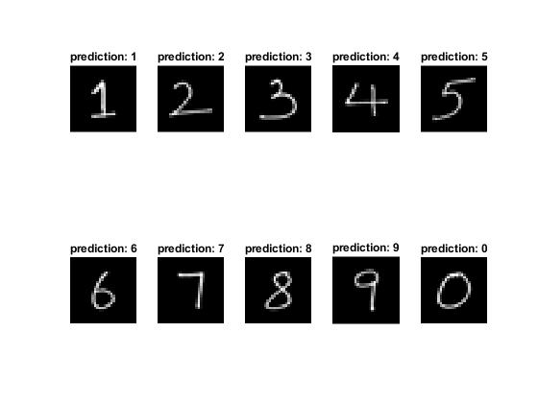Figure-9

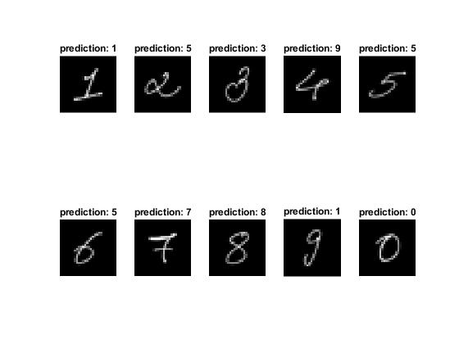Figure-10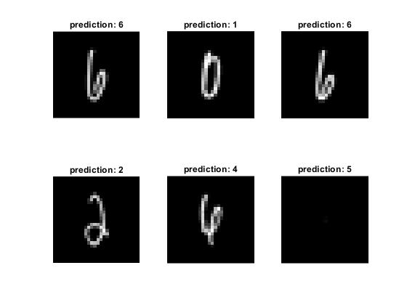Figure-11

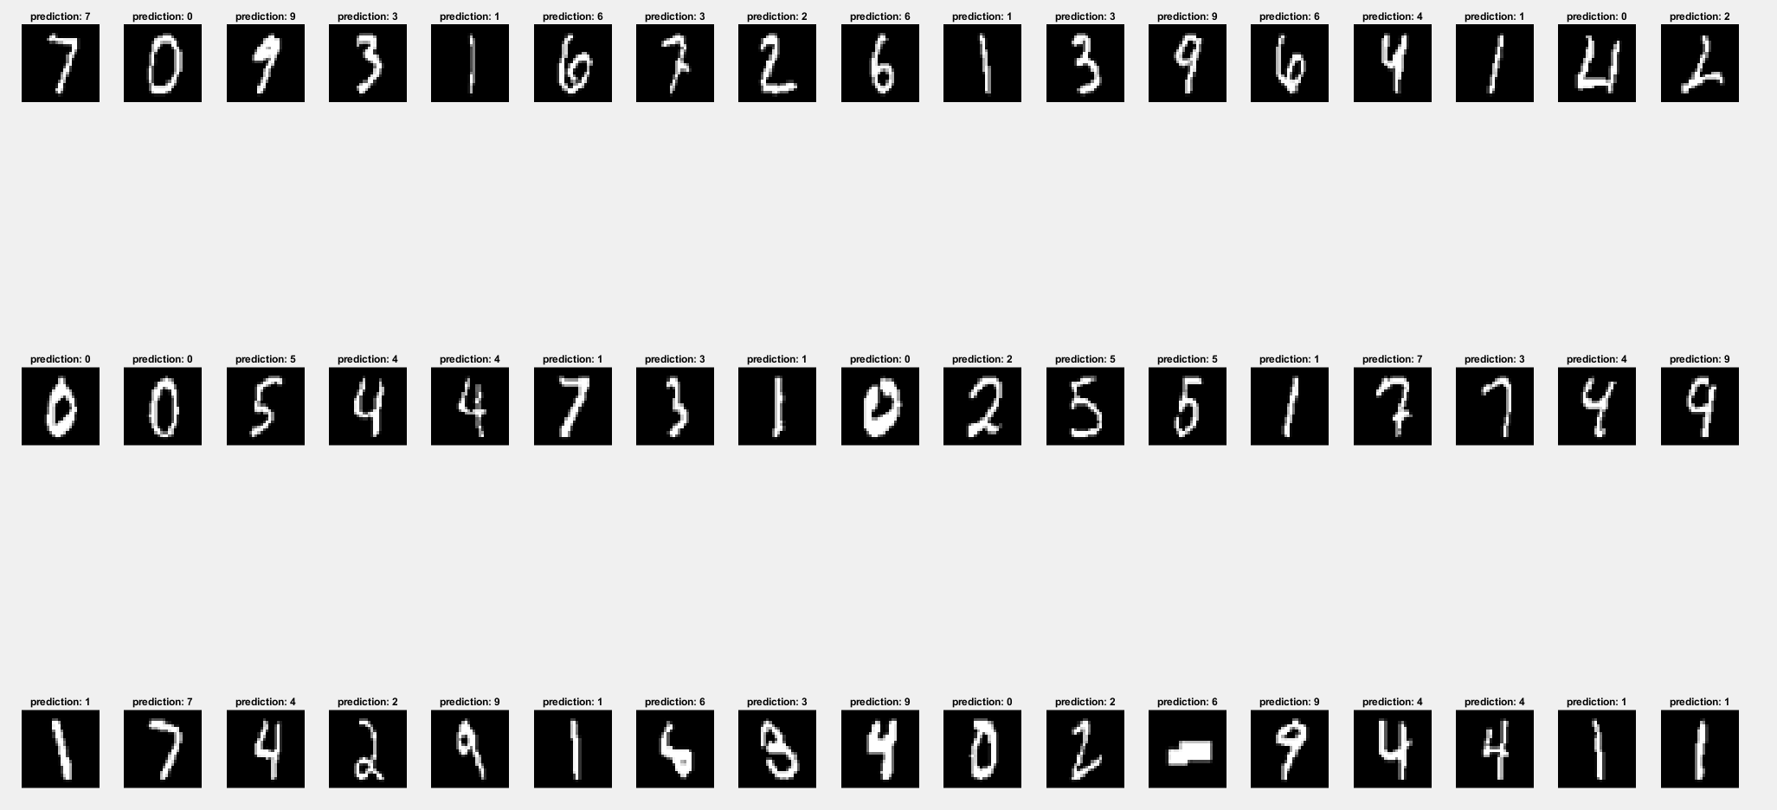 Figure-12