**Project Two Report**

**Siyuan Wu**

**Submission name on Kaggle: Siyuan(Leon) Wu**

**Best accuracy: 70.9%**

**Part 1**

**Layer Structure Table**

|  |  |  |  |  |
| --- | --- | --- | --- | --- |
| Layer No. | Layer Type | Kernel size | Input|Output Dimension | Input|Output Channels |
| 1 | Conv2d | 3 | 32|32 | 3|64 |
| 2 | Relu | - | 32|32 | - |
| 3 | Batchnorm | - | 32|32 | - |
| 4 | Conv2d | 3 | 32|32 | 64|64 |
| 5 | Relu | - | 32|32 | - |
| 6 | Batchnorm | - | 32|32 | - |
| 7 | Maxpool2d | 2 | 32|16 | - |
| 8 | Conv2d | 3 | 16|16 | 64|128 |
| 9 | Relu | - | 16|16 | - |
| 10 | Batchnorm | - | 16|16 | - |
| 11 | Conv2d | 3 | 16|16 | 128|128 |
| 12 | Relu | - | 16|16 | - |
| 13 | Batchnorm | - | 16|16 | - |
| 14 | Maxpool2d | 2 | 16|8 | - |
| 15 | Conv2d | 3 | 8|8 | 128|256 |
| 16 | Relu | - | 8|8 | - |
| 17 | Batchnorm | - | 8|8 | - |
| 18 | Conv2d | 3 | 8|8 | 256|512 |
| 19 | Relu | - | 8|8 | - |
| 20 | Batchnorm | - | 8|8 | - |
| 21 | Linear | - | 32768|2048 | - |
| 22 | Batchnorm1D | - | 2048|2048 | - |
| 23 | Relu | - | 2048|2048 | - |
| 24 | Linear | - | 2048|2048 | - |
| 25 | Relu | - | 2048|2048 | - |
| 26 | Linear | - | 2048|100 | - |

**Structure Explain**

Part of the structure is referenced from the VGG16 network model, but many modifications have been made to make the net tailored for picture size 32-by-32. First, the number of weight layers is reduced to 9 from VGG16’s 16 weight layers. This modification prevents the net from overfitting and reduces the training speed. Then, a 2d batch normalizing layer is added after the RELU layer of each convolution layer. Pooling layers are also reduced to 2 to avoid too much information loss. Moreover, the fully connected layer decrease from VGG’s 4 to 3, and the 1d batch normalizing layer is also used after a fully connected layer.

**Training and validation accuracy plot**

Stage One: During this stage, I was trying to optimize the structure and parameters of the network, therefore, the number of epochs is limited to 30.

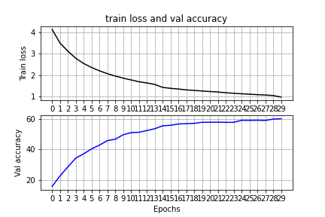

Stage Two: After the structure and parameters of the network are optimized, I try to use the data that augmented in different ways to fortify the net, and for each method, there will be 100 epochs. There were 400 epochs in total.

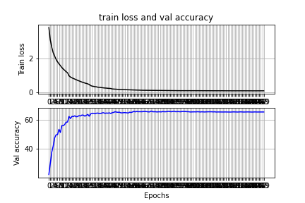

**Ablation Study**

Adding data normalization: accuracy increase from 23 % to 27%

Adding three more convolution layers and change all convolution layers’ kernel size to 3: accuracy increase from 27% to 33%

Increase filter size for all convolution layer, and the maximum filter in convolution layers become 512: accuracy increase from 33% to 37%

Increase filter size for all convolution layer once again, and maximum filter increase to 1024. Batch normalizing layer added after each convolution layer: accuracy increase from 37% to 49%

One additional linear layer with 1d batch normalizing was added: accuracy increase from 49% to 57%

Adapting VGG16 structure, with two convolution layers followed by a pooling layer. 6 convolution layers, 3 pooling layers, and 3 linear layers in total is used: accuracy increase from 57% to 62%

Removing the last pooling layer: accuracy increase from 62% to 64%

Changing the last convolution layer’s filter size to 512: accuracy increase from 64% to 66%

Training the net with different data augmentation methods. The net will be trained with all four kind of transformed data(random vertical flip, random horizon flip, random rotation, grayscale ) one by one for 100 epochs each: accuracy increase from 66% to 71%

**Part 2**

**Model and Hyperparameters**

For the second part, I used resnet50 as my pretrained net and my data transformation include random resize crop of 256, random horizon flip and normalization. The net trains with learning rate of 0.0005 and a batch size of 8. First the net is train only with the last layer. The training accuracy and test accuracy with 50 epochs are below.

**Training accuracy for RESNET_LAST_ONLY = True**



**Test accuracy for RESNET_LAST_ONLY = True** 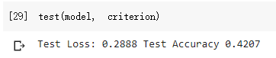

The second net is a fully trained net. The training accuracy and test accuracy with 50 epochs are below.

**Training accuracy for RESNET_LAST_ONLY = False**



**Test accuracy for** **RESNET_LAST_ONLY = False**

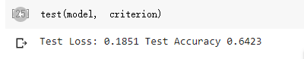

**Reference**

[1] VGG16 - Convolutional Network for Classification and Detection. (2018, November 21). Retrieved October 11, 2020, from https://neurohive.io/en/popular-networks/vgg16/