Siyuan Xu（001512861）

Program Structures & Algorithms

Spring 2021

Assignment No.4

* **Task**

Use two alternatives to implement Union-Find, one storing the depth rather than the size, another one do it with path compression with two loops and then benchmark them.

* **Output**

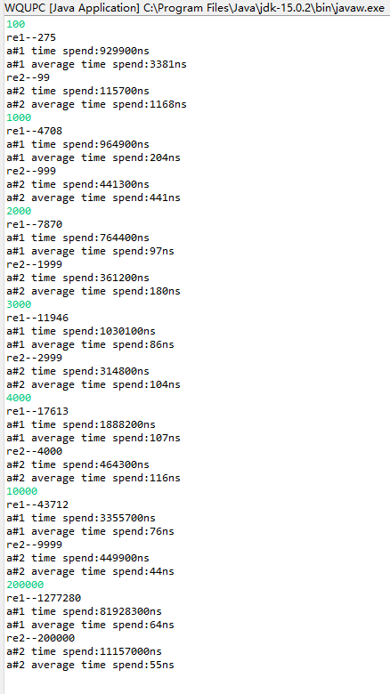

* **Relationship Conclusion**

We can see that after draw the trend line of the time spent for two alternatives. Alternative#1 costs less time than alternative#2 when n is low, however, it costs more time when n is quiet large. I predict that when n becomes larger and larger, the time spent by both methods would become closer.

* **Evidence to support above conclusion**
* **Screenshot of unit test**

