Siyuan Xu（001512861）

Program Structures & Algorithms

Spring 2021

Assignment No.3

* **Task**

Implement height-weighted Quick Union with Path Compression.

Develop a UF client that takes an integer value n from the command line to determine the number of “sites” and then generates random pairs of integers between 0 and n-1. Use this client to determine the relationship between n and the number of pairs of integers(m).

* **Output**

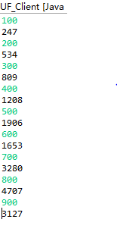

* **Relationship Conclusion**

We can see that from the graph that m increases substantially as n increases. There are some points far from the trend line because we are using random integer pairs. However, points are really closer to the exponential relationship`s trend line m = 267.39e0.0033n

So I think that n and m have a positive exponential relationship.

* **Evidence to support above conclusion**
* **Screenshot of unit test**

